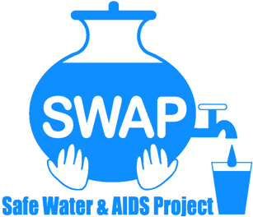

GLOBAL GIVING REPORT
SONDU WATER ENTERPRISE
MAY 2019

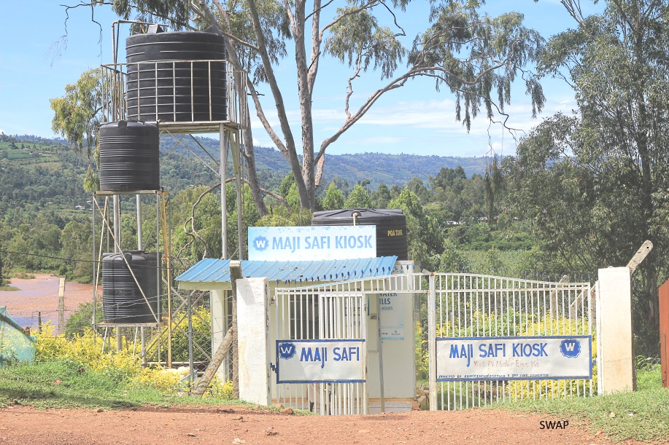

Safe Water & AIDS Project (SWAP)
Email: info@swapkenya.org
Website: www.swapkenya.org
P.O. Box 3323-40100 Kisumu, Kenya.
Tel (+254) 20-2030712/ 0738039901/ 0714761268
Main office: Off Aga Khan Road, Behind Royal City Hotel, Milimani Estate, Kisumu, Kenya
Introduction
Safe Water & AIDS Project (SWAP) uses an integrated entrepreneurial approach addressing a number of public health issues by working with already existing community structures. SWAP has been operating in Western Kenya since 2005 with public health programs and research contributing towards the achievement of sustainable development goals.
SWAP’s vision is to see a healthy and empowered community where everyone enjoys high quality of life.
SWAP’s mission is to provide innovative solutions for improved health and economic status of our communities
Background Information
Sondu Water Enterprise is located at Sondu in Kisumu County, bordering Kericho, Nyamira and Homabay Counties in Western Kenya. The population residing in Sondu largely depend on the river source water for domestic use, which is highly turbid and contaminated. The river traverses three counties thus increasing contamination along its channel before emptying into Lake Victoria. Laboratory tests on microbiological quality have revealed that the source has high coliform count and fecal contamination.
Maji Safi Kiosk
The Safe Water Enterprise was launched in July 2016. This was a collaborative initiative between Skyjuice Foundation (Australia) and Siemens Stiftung (Germany) in partnership with SWAP. Through this intervention the surrounding community members now have access to safe water, which has significantly reduced waterborne diseases such as diarrhea, cholera, typhoid and amoeba and as such reduced morbidity and mortality especially in children under five.
Activities
Water sales
Sale of water continued during this reporting period. However, the sales in April and were low due to the onset of the rainy season. The monthly water sales were KES. 14690 in February, KES. 10,625 in March and KES. 11,130 in April.
To help in promoting water sales, 100 clean water jericans were introduced from Siemens Foundation. Each of the Jericans goes for KES. 200 and are sold at the water kiosk to local community members. Therefore, the jericans will help in encouraging local community members to use clean safe water from the water kiosk and collect and store this in a clean storage vessel.

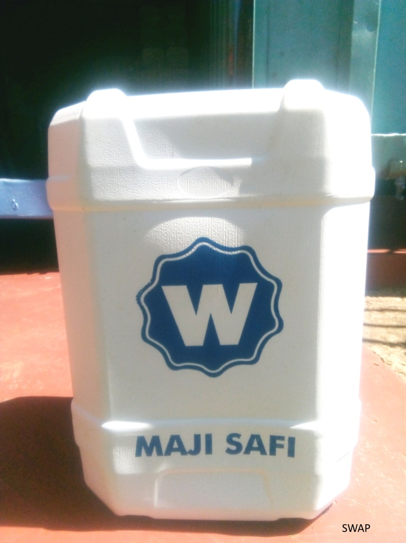
Maji safi Jerican
Monitoring
Continued support through frequent visits to the water kiosk has ensured sustained quality of work and operations through offering feedback to the CBO. Also, water quality monitoring was done led by SWAP’s lab Manager Jared Oremo.
Partnerships and networking
On 3/05/2019 SWAP’s Monitoring and Evaluation manager Penina Ogendo attended a Global Giving meeting. This forum was aimed at sharing experiences by projects that are fundraising through Global Giving and she managed to share about the Sondu Maji Safi Kiosk. Other major issues that emerged during the meeting were:
- Introduction of the revised Global Giving outlook and how to navigate the online site.
- Plans to introduce local fundraising system in partnership with Safaricom’s MPESA money transfer system. Hopefully this will encourage local donors.
- Most local donors give money only once and not repeatedly

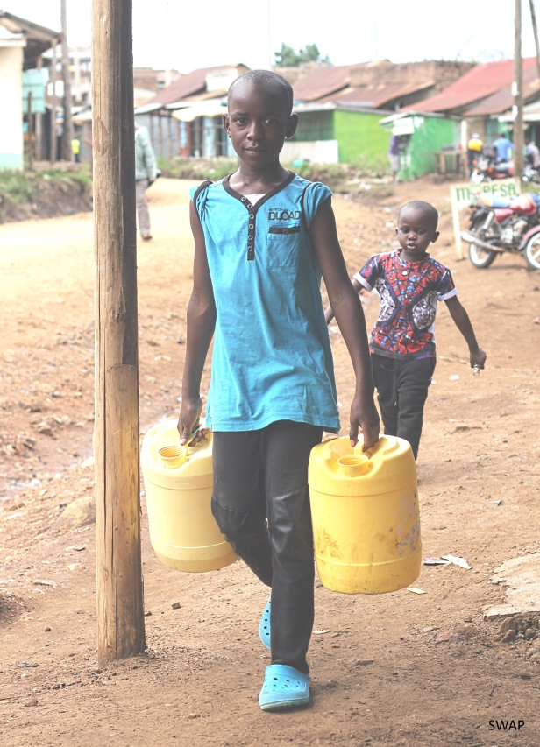
Children taking jericans to the water kiosk
Way Forward
- Training
Twenty Community Health Volunteers (CHVs) will be trained on health marketing and sanitation by Siemens Stiftung. The CHVs manage the water kiosk on a rotating basis.
- Technical support
The Siemens Stiftung will continue offering technical support to the Community Based Organization. This support will focus on the water pumping system from the river.
- Promotion of Water sales
To ensure sustainability of the water kiosk, members of the CBO continue selling branded water jericans to promote use of clean and safe water within the community.
- Handing over to the community
There are plans to fully hand over management of the water kiosk to the CBO by the end of 2019

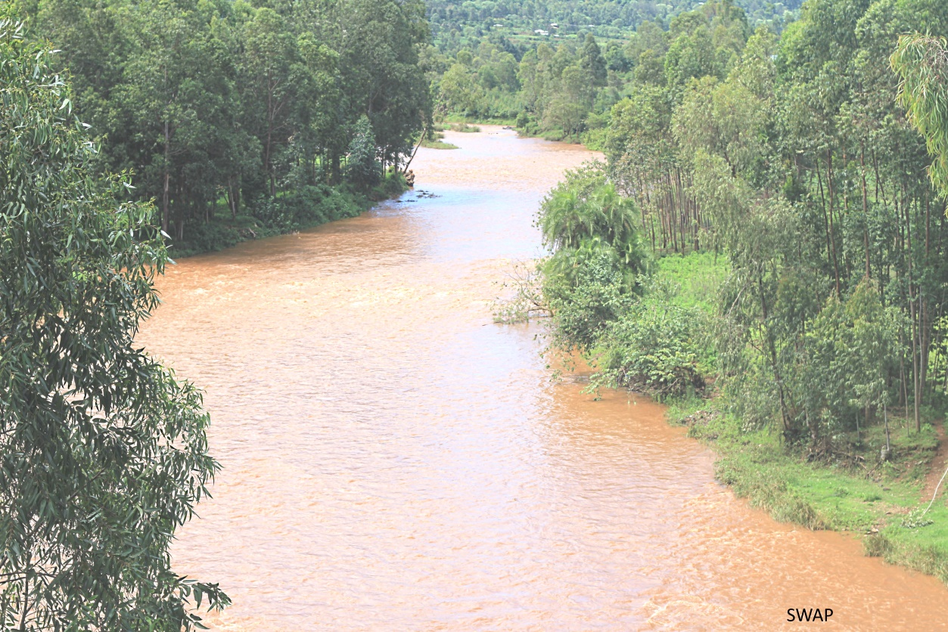
River Sondu water before treatment

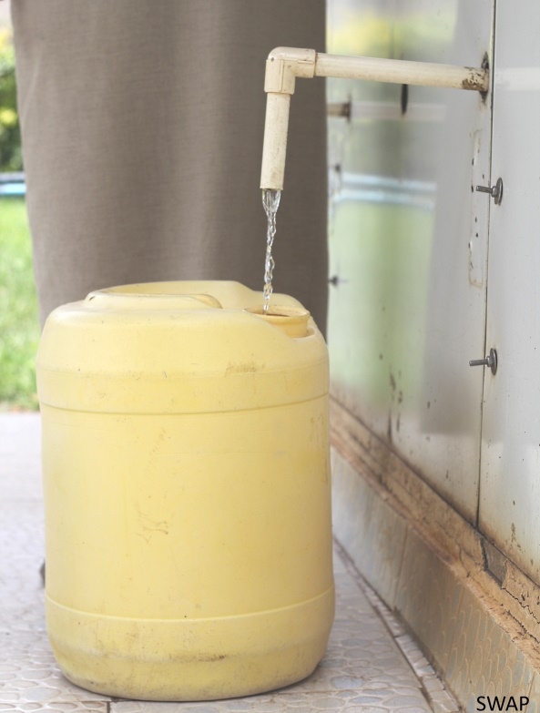
Clean water collection after treatment at the kiosk

