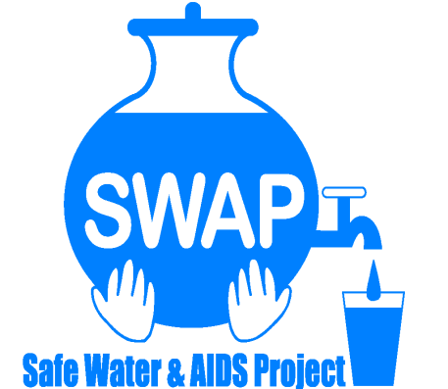
GLOBAL GIVING REPORT - SONDU WATER ENTERPRISE

MARCH 2017
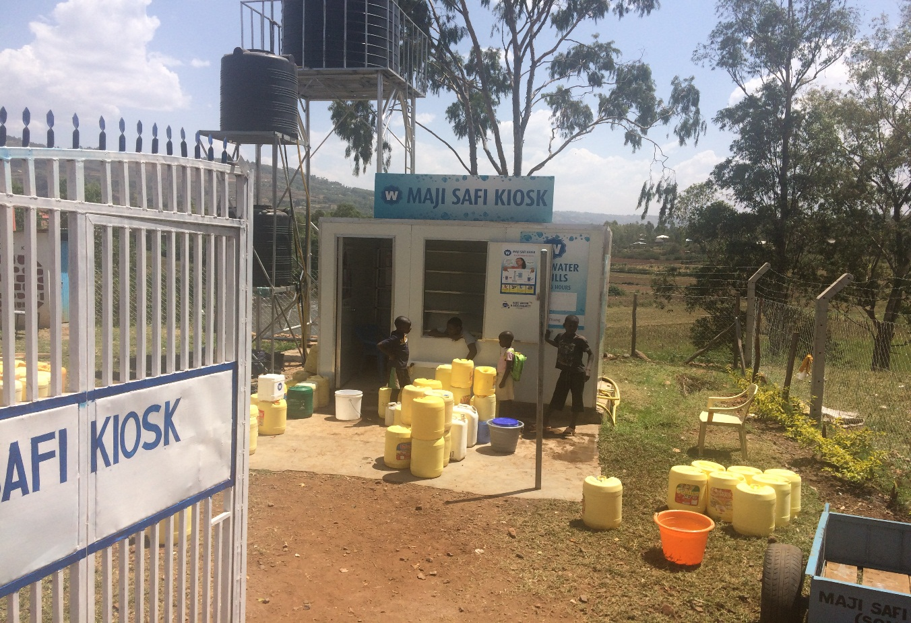
Safe Water & AIDS Project
Email: info@swapkenya.org
Website: www.swapkenya.org
P.O. Box 3323-40100 Kisumu.
Tel (+254) 20-2030712/ 0738039901/ 0714761268
Main office: Off Aga Khan Road, Behind Royal City Hotel, Milimani Estate, Kisumu, Kenya
Table of Contents
1.0 Introduction: 3
2.0 Problem Statement: 3
3.0 Reasons for raising funds from Global Giving 4
4.0 Achievements made with Global Giving between January and Mid March 2017 6
4.1 Business Permit 6
4.2 Fencing and Installation of a gate 6
4.3 Sale of Clean Water Vessels – 20 liter jerry-cans 9
4.6 Monthly water Quality testing 10
5.0. Way forward 13

1.0 Introduction:
Safe Water and AIDS Project (SWAP) is a Kenyan registered NGO, with its headquarters in Kisumu and implements public health programs, research and emergency response in 6 counties in Western Kenya. SWAP aims to improve the health and socio-economic status of vulnerable communities through disease prevention, and socio-economic empowerment. SWAP’s mission is to improve the quality of life of the vulnerable population by supporting them to develop profitable health oriented micro-enterprises. In partnership with the Sondu community members, the Ministry of Health, Ministry of Water, Siemens Stiftung and Skyjuice Foundation, SWAP established the Sondu Water Enterprise which was formally launched in July 2016. Community health promoters were trained on safe water systems and they assisted to mobilize the communities, while they promote and sell household water treatment and soaps.
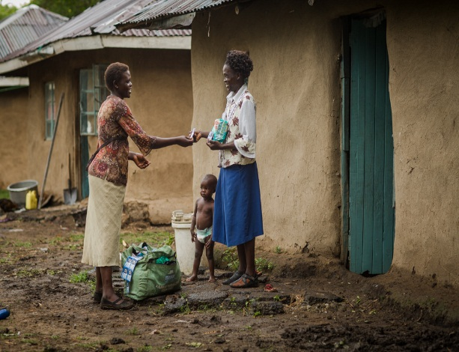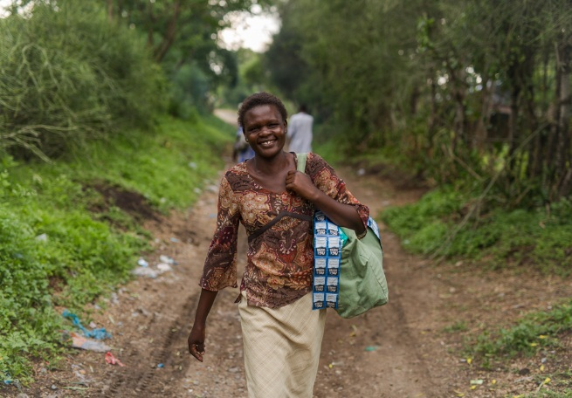

2.0 Problem Statement:

Sondu is a community with high burden of disease and with diarrheal illness as one of the leading causes of morbidity and mortality, specifically among children under 5. This is due to poor water and sanitation practices and limited access to improved services. The Sondu, river where communities used to draw water from for household use is highly contaminated. The improved water supplies in Sondu are limited with irregular and interrupted services. There was no public toilet in the market area where the Sondu Water Enterprise is located. The main objective of the Safe Water Enterprise, is to increase access to clean and safe drinking water and sanitation for the vulnerable community. The enterprise is managed by a local water operator and is run under the supervision and mentorship of SWAP.
During the period between January and March 2017 we faced severe drought in the area with communities at risk of contracting diarrheal illness. Water sources were running dry and were contaminated and shared with animals as well as used for washing clothes and bathing.
During this period there have been overwhelming demand for water from the enterprise, with people lining up for water as early as 5 am in the morning and the center staying operational during evening hours and weekend.

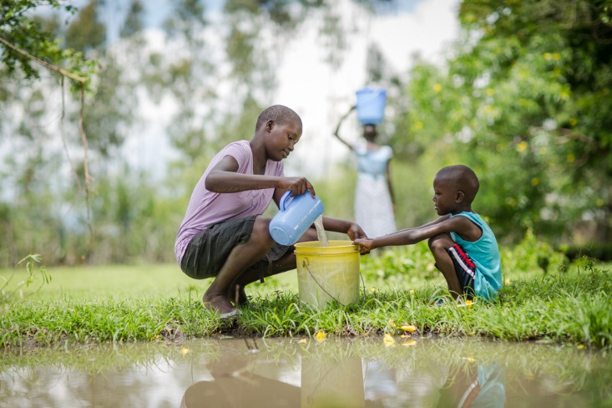
Children drawing water from a contaminated source

3.0 Reasons for raising funds from Global Giving
SWAP received the sky-hydrant filtration unit by Sky-juice Foundation and an initial start-up funding and technical support from Siemens Stiftung to launch the enterprise. However, SWAP realized that there were a lot of pending requirements and improvements needed as well as ongoing operational costs. It also needed more investment and time before the center can be sustainable. The Ministry of Health approval required the construction of a public toilet with hand washing station at the site. The money raised so far through Global Giving enabled SWAP to make major improvements at the site and pay for ongoing costs.
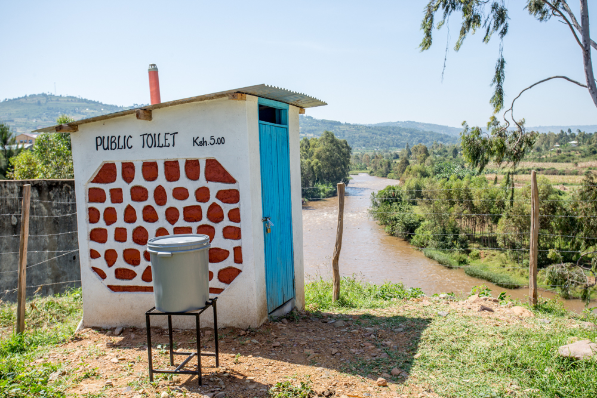
Public toilet at the water kiosk with Sondu River at the background

SWAP addressed their partners, donors, friends and well-wishers to donate through Global Giving and received so far two disbursements as follows:
- USD 6,118.65 – September 30th 2016
- USD 900 – October 31st 2016

Following several management meetings to prioritize the most urgent requirements, SWAP management settled on the following, which needed funding.
- Business Permit
- Fencing and installation of a gate for security reasons.
- Additional 5000 liter tank to increase capacity and provide more water
- Distribution of IEC materials / Calendars incentives for customers
- Sale of Clean Vessels – 20 liters jerry cans
- Monthly water quality water testing of the water sold to the communities
- Monthly Wages of the water operator and security operator
- Monitoring visits by the Management Team of SWAP and ongoing mentoring
- Provision of cleaning materials, toilet tissue, hand washing soap.

4.0 Achievements made with Global Giving between January and Mid March 2017

4.1 Business Permit
A business permit was acquired in January 2017 which is a requirement for any business operating within the Sondu Municipal Council. Annually businesses in the area need to register for this to enable them to get approval to operate small enterprises.

4.2 Fencing and Installation of a gate

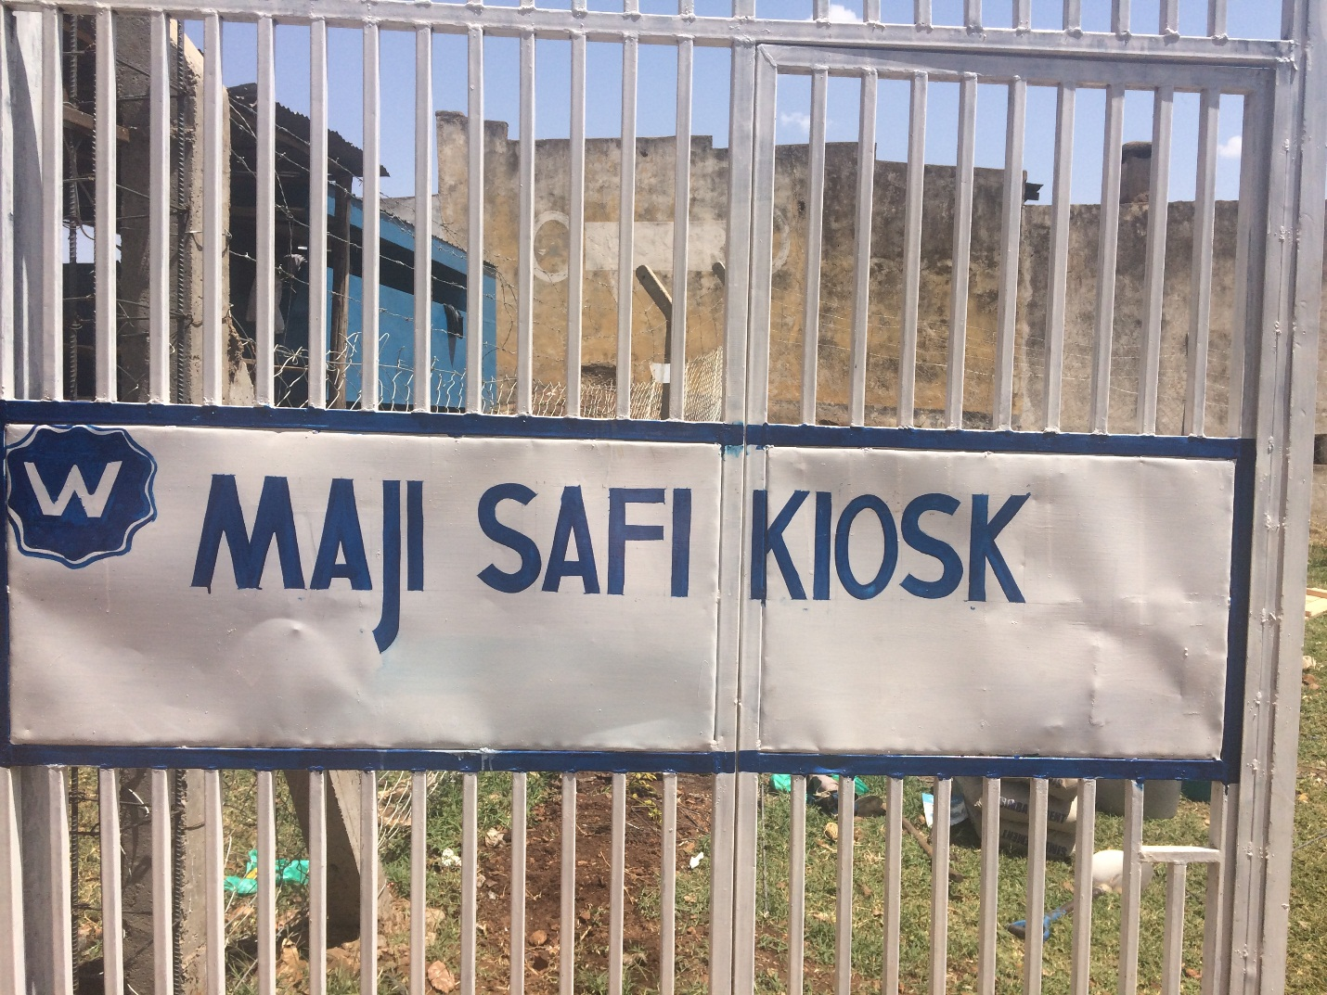
Gate installed at the site of the Sondu Water Enterprise (Maji Safi – Swahili for Clean Water)
SWAP installed a gate at the entrance of the premises and did fencing. This is to secure the kiosk and skyhydrant filtration unit as well as to enhance visibility of the site. After closure the gate is locked and a watchmen is hired to secure the place at night.

4.3. Procurement and Installation of a 5000 liter tank
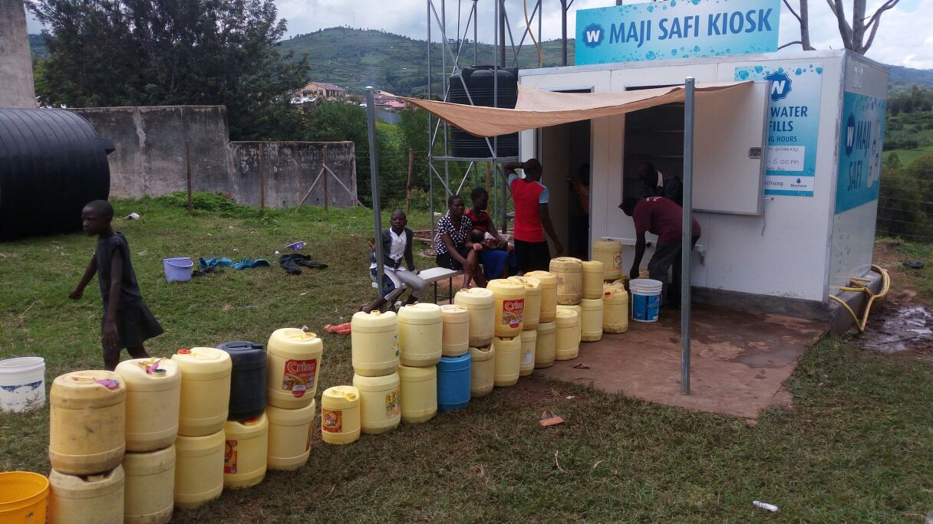
Long lines of jerry cans for water collection
There have been many prolonged waiting hours for costumers due to the limited capacities of the existing tanks. SWAP procured another 5000 liter tank to enable all three taps to be running continuously and not only one or two taps running when facing low pressure during filling the tanks and pumping water from the river. The operator has been receiving costumers at 5 am in the morning and at times stopped operation late evening hours. The tank is being mounted in few days time but already procured and brought to the site. Details and photo’s of the tank mounted will be shared in the next report.
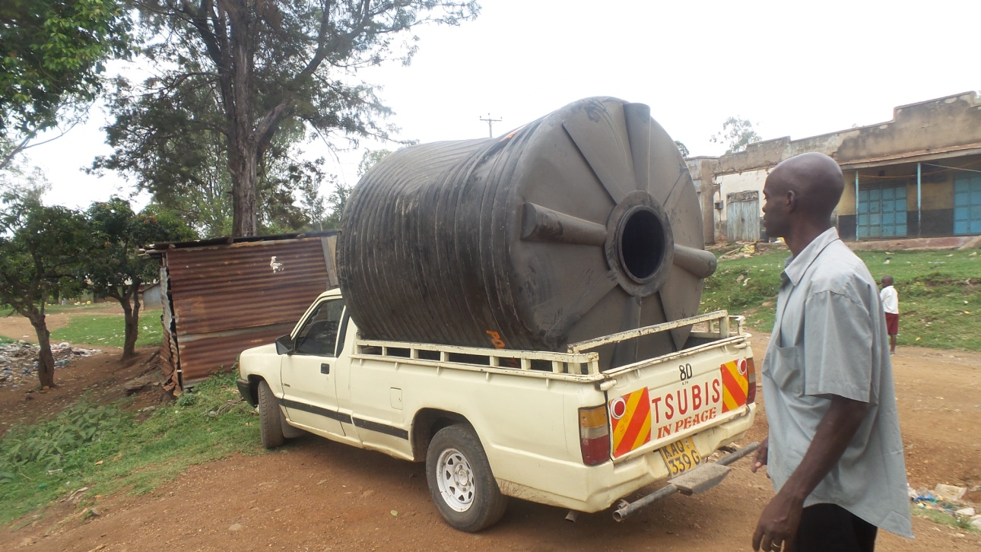
The water operator receives the 5000 liter tank
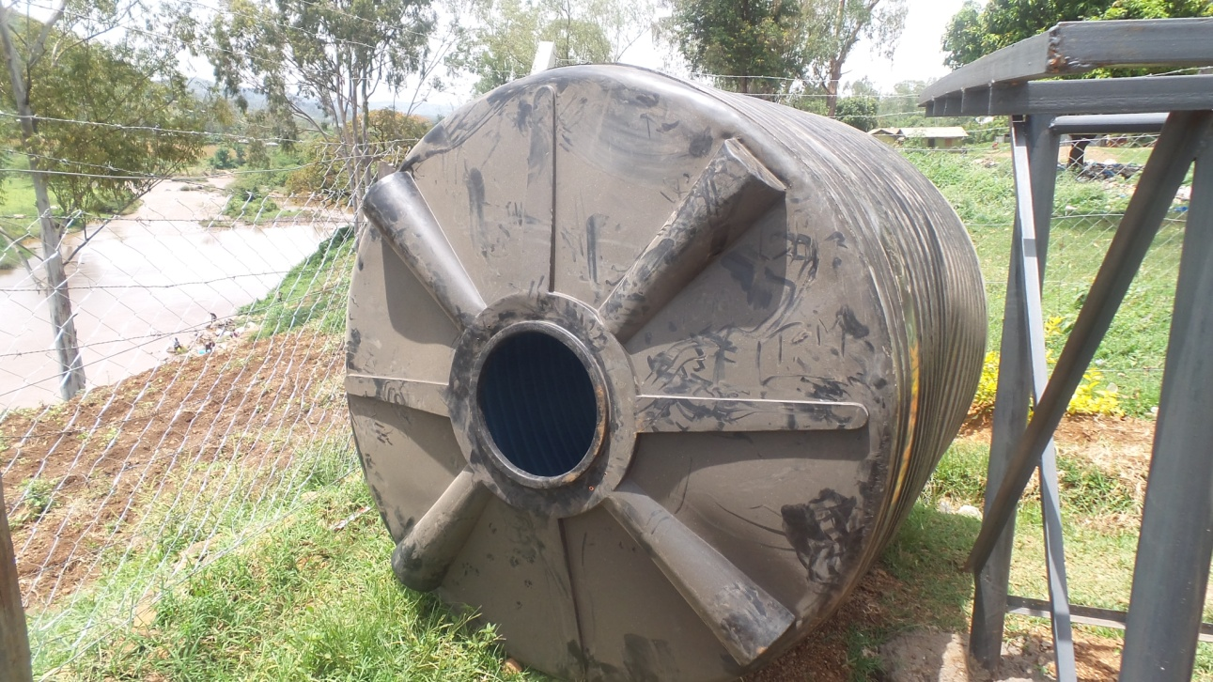
The tank next to the stand where it will be mounted

4.4. Calendars for Costumers
SWAP received a donation of calendars from the Siemens Stiftung, the partner who provided start up seed money and capacity building. The picture shows the Sondu Water Enterprise. These calendars are given as incentive to loyal costumers, who frequently buy water from the kiosk.
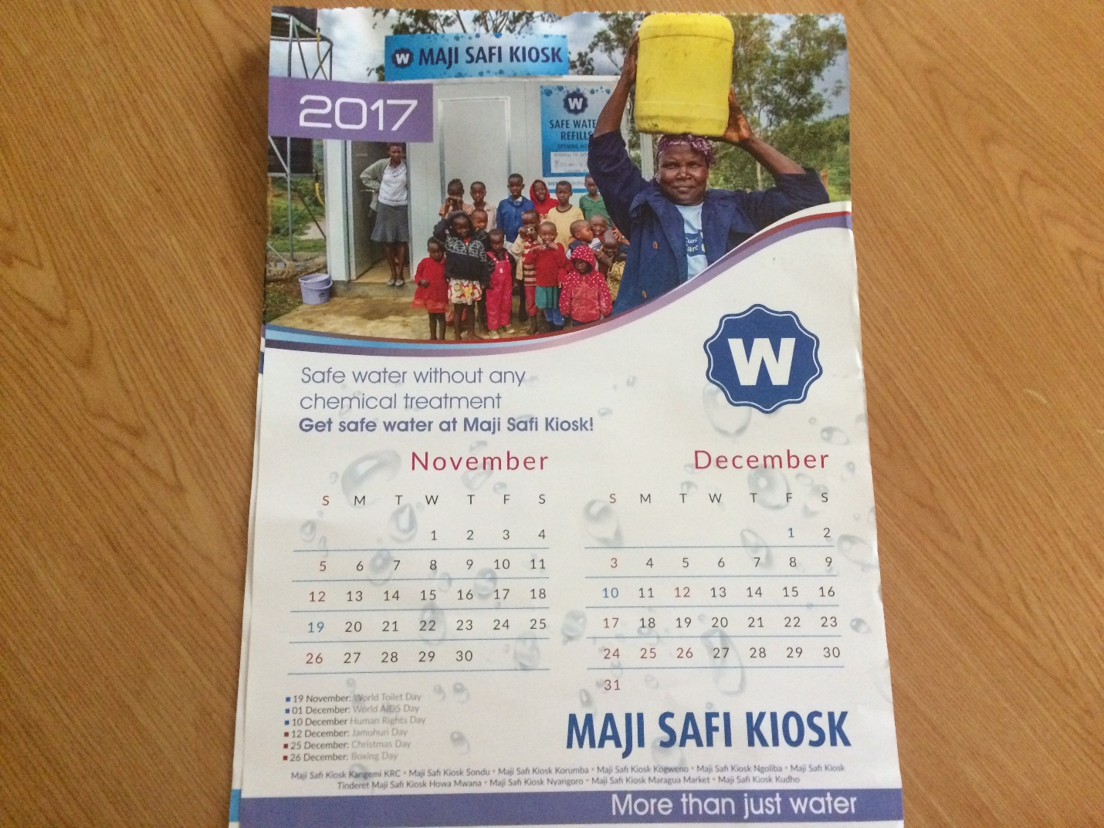
Calendar distributed to loyal costumers promoting safe water

4.3 Sale of Clean Water Vessels – 20 liter jerry-cans

SWAP received a donation of clean jerry cans to be used for water collection and storage from Siemens Stiftung. The agreement was to promote and sell these jerry cans at the enterprise in order for communities to utilize clean jerry cans. Often water is collected in dirty jerry cans which puts the family at risk of drinking contaminated water unfit for human consumption.
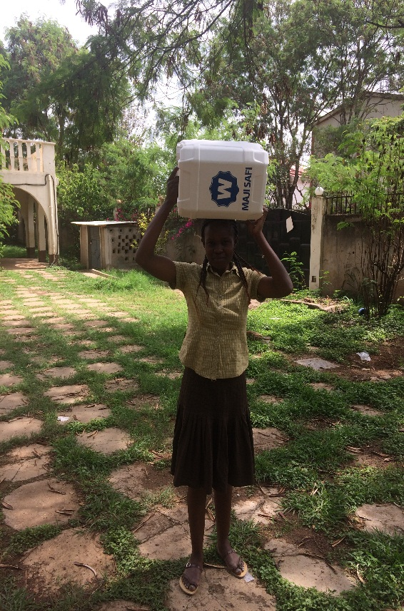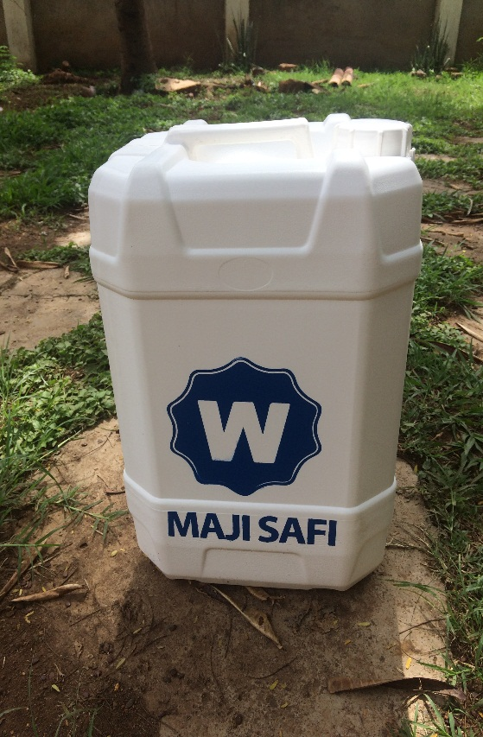
Clean Water Vessel

4.6 Monthly water Quality testing

The purpose of the monthly quality assurance and testing is to ensure that the water provided to the community meets the highest quality standards test. For this reason, monthly samples of the water at the main taps are taken for quality control and analysis. This is done at SWAP’s water lab. Below is the SWAP's Lab Manager, conducting the tests in SWAPs water lab. SWAP is able to do bacteriological and full chemical analyses. The test below shows the most recent test done and its results.

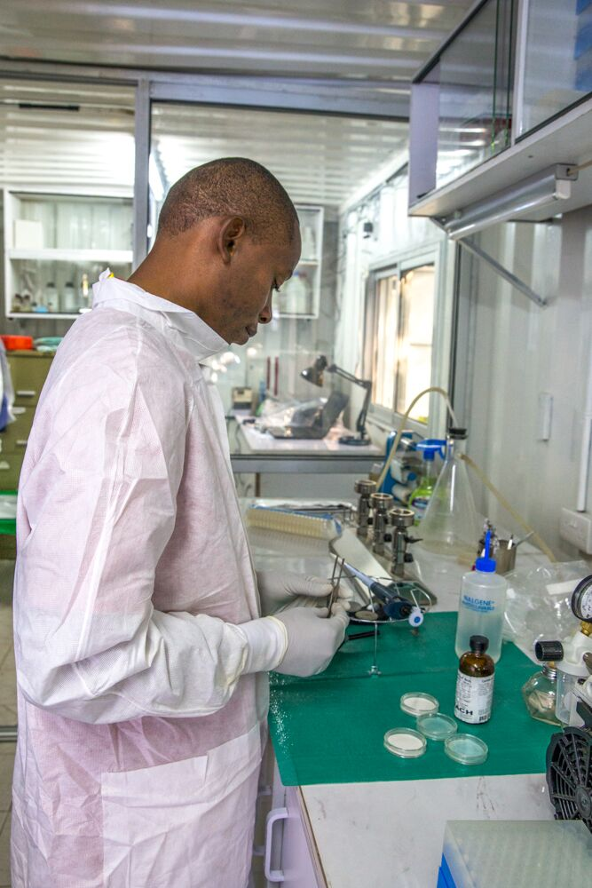

Bacteriological Tests
Escherichia Coli is abundant in human and animal faces; the absence of E-coli or thermo tolerant coli form bacteria indicates that the water is safe for human consumption and meets WHO standards.

Date sample collected was 11th February 2017
Full chemical analysis
Sondu Water Enterprise
 | SONDU SKYHYDRANT
Lab Sample ID # | Parameter | Units | WHO STD |  | KEBS STD | MCL (mg/L) | Test 1 | Result (mg/L)
L_001 | Magnesium | mgMg²⁺/L | max 100 |  | max 100 | max 100 | 0.87 | 0.9
L_002 | Calcium | mgCa²⁺/L | max 100 |  | max 250 | max 250 | 0.57 | 0.6
L_003 | Magnesium Hardness | mg/ca/CO3/L | max 100 |  | max 100 | max 100 | 3.58 | 3.6
L_004 | Calcium H | mg/ca/CO3/L | max 100 |  | max 100 | max 150 | 1.43 | 1.4
L_005 | Total Hardness | mg/CaCO₃/L | max 500 |  | max 500 | max 500 | 5.01 | 5.0
L_006 | Nitrate | MgNO₃/L | max 10 |  | max10 | max 10 | 0.1 | 0.1
L_007 | Fluoride | MgF⁻/L | max 1.5 |  | max 1.5 | max 1.5 | 1.61 | 1.6
L_008 | PH |  | 6.5-8.5 |  | max 8.5 | 8.5 | 8.06 | 8.1
L_009 | Temperature | ⁰C | 25⁰C |  | 25⁰C | 25⁰C | 24.4⁰C | 24.8⁰C
L_010 | Turbidity | NTU | max 5 NTU |  | max 5 | max 5 | 0.94 | 0.7
L_011 | Total Alkalinity | mg/CaCO₃/L | max 500 |  | max 500 | max 500 | 48.2 | 48.2
L_012 | TDS | ppm | max 1500 |  | 1000 | 1000 | 59.1 | 59.1
L_013 | Color | mgPt/L | max 5 |  | max 15 | max 15 | 4 | 4.0
L_014 | Conductivity |  |  |  | 2500 | 2000 | 89.3 | 89.3
L_015 | Zinc | mg/L | max 5 |  | max 5 | max 5 | 0.21 | 0.2
L_016 | Cupper | mg/L | max 3.00 |  | max 3 | max3 | 0.04 | 0.0
L_017 | Iron | mg/L | max 3.00 |  | max 3 | max 3 | 0.06 | 0.1
L_018 | TSS | mg/L | max 450 |  | max 450 | max 450 | Not Detected | Not Detected
L_019 | Sulphate | mg/L | max 70 |  | max 70 | max 70 | 1 | 1.0
L_020 | Phosphate | mg/L | max 3.00 |  | max 3 | max 3 | 0.18 | 0.2
L_021 | Ammonium | mg/L | max 5 |  | max 5 | max 5 | Not Detected | Not Detected
Full chemical analysis

The full chemical tests meets all the standards, showing acceptable levels and safe water for human consumption.

5.0. Way forward
- SWAP will continue to invest in marketing, capacity building and community engagement to enhance ownership and efficient running of the center.
- The 5000 liter tank will be mounted to increase quantity of water
- Monthly monitoring will be ongoing as well as water quality testing of the water.
- Strengthening of partnerships with WASH partners and attending of stakeholders forums. SWAP will renew its membership with KEWASNET, a Kenyan Water and Sanitation Network and attend forums organized by them.
- SWAP will welcome the Global Giving Field traveler on the 12th of April 2017 who will visit the site for monitoring.

