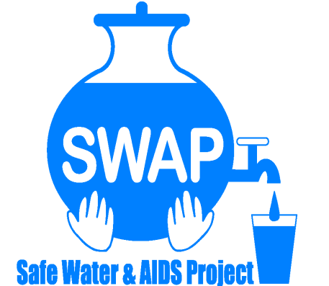
GLOBAL GIVING REPORT - SONDU WATER ENTERPRISE

MAY 2017
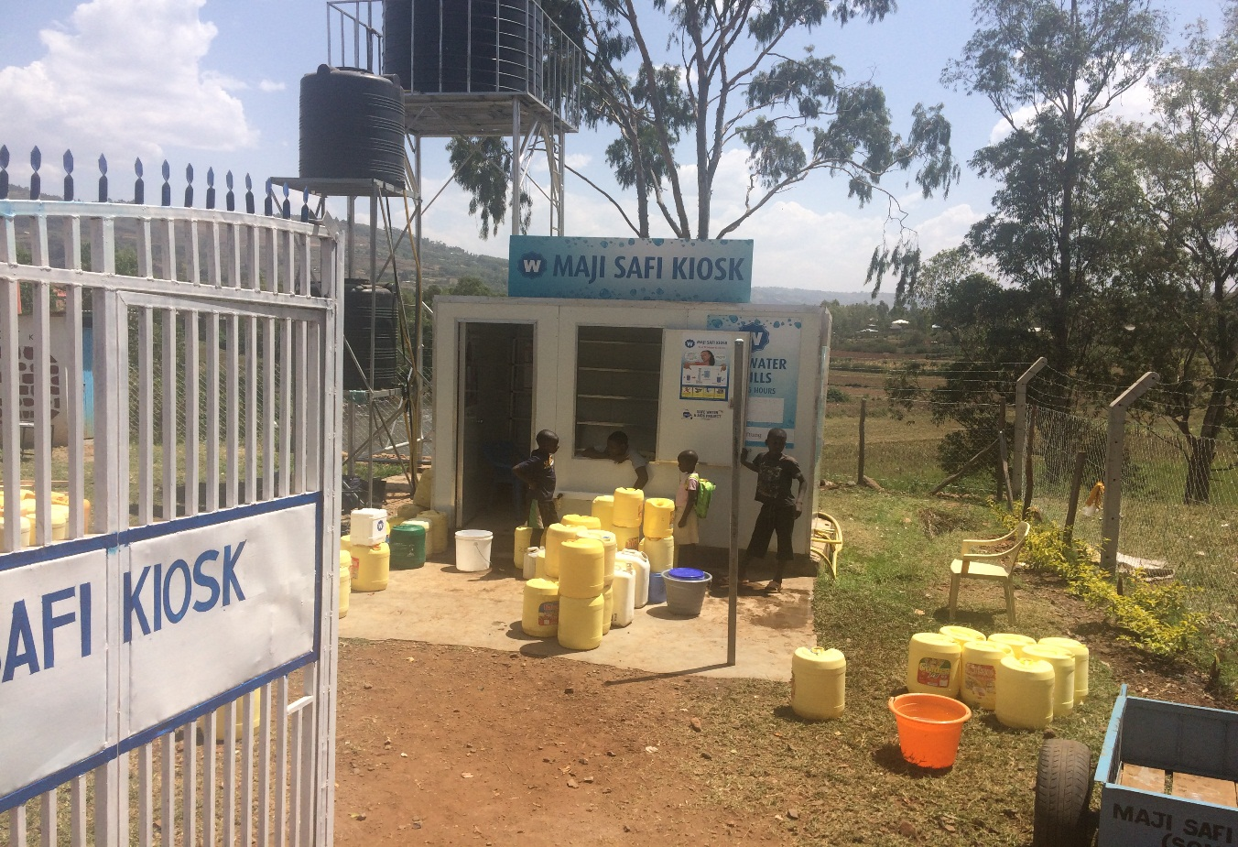
Safe Water & AIDS Project
Email: info@swapkenya.org
Website: www.swapkenya.org
P.O. Box 3323-40100 Kisumu.
Tel (+254) 20-2030712/ 0738039901/ 0714761268
Main office: Off Aga Khan Road, Behind Royal City Hotel, Milimani Estate, Kisumu, Kenya
Introduction
Safe Water and AIDS Project (SWAP - http://www.swapkenya.org/) is a Kenyan registered NGO, with its headquarters in Kisumu and implements public health programs, research and emergency response in 6 counties in Western Kenya. SWAP aims to improve the health and socio-economic status of vulnerable communities through disease prevention, and socio-economic empowerment. SWAP’s mission is to improve the quality of life of the vulnerable population by supporting them to develop profitable health oriented micro-enterprises. In partnership with the Sondu community members, the Ministry of Health, Ministry of Water, Siemens Stiftung and Skyjuice Foundation, SWAP established the Sondu Water Enterprise which was formally launched in July 2016. Community health promoters were trained on safe water systems and they assisted to mobilize the communities, while they promote and sell household water treatment and soaps
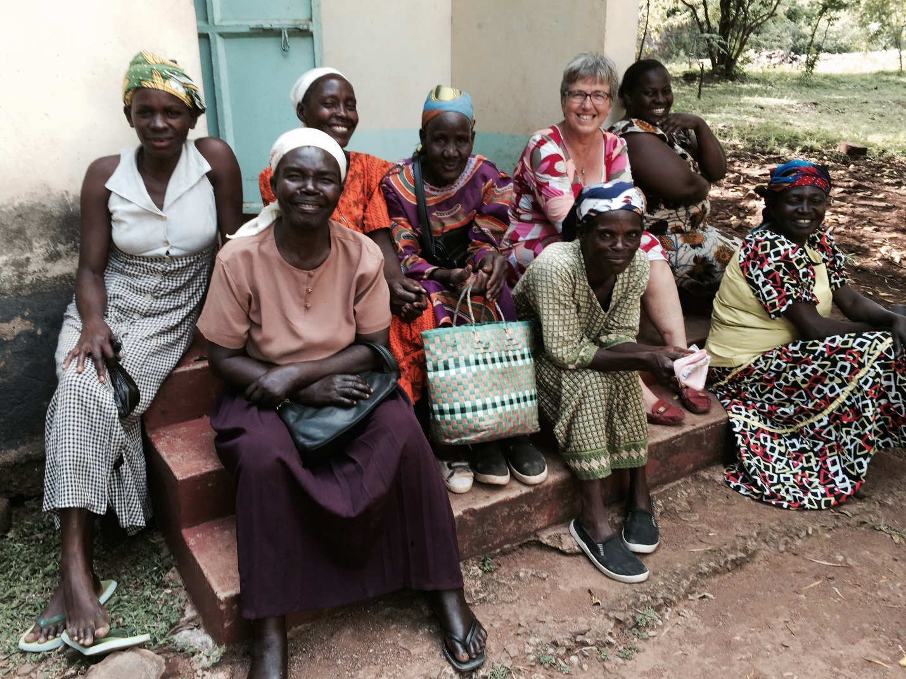

Problem Statement:

Poor hygiene practices and drinking contaminated water remain the biggest underlying factors contributing to the prevalence and incidence of diarrheal diseases which is one of the leading causes of morbidity and mortality in children. It is estimated that 80 per cent of diseases in children are related to water hygiene, personal hygiene, food hygiene and open defecation. Most of the people in Sondu in Kisumu County, only have access to polluted water, which has caused cholera epidemics and multiple other diseases that affect health and livelihoods.

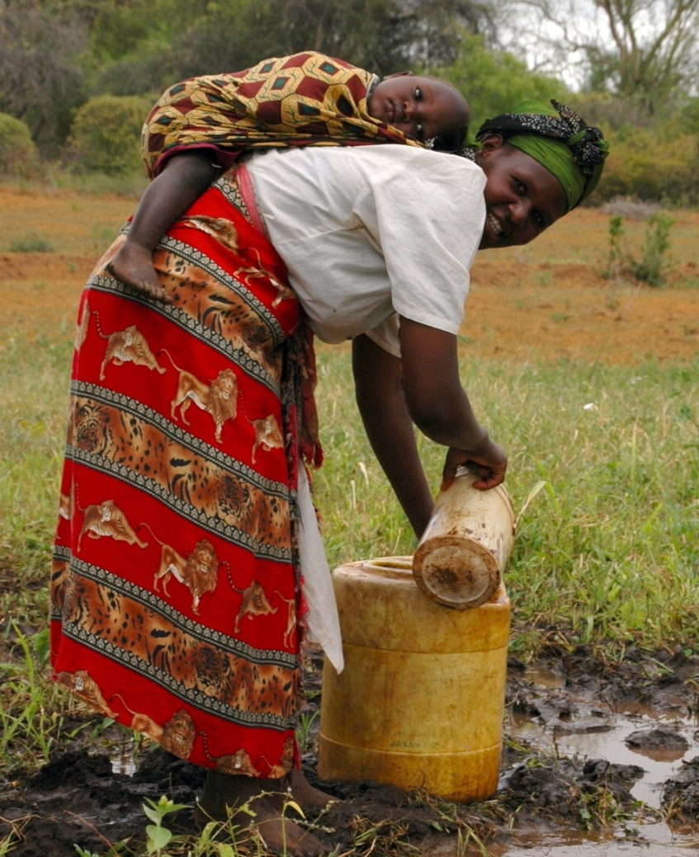
Sondu is a community with high burden of disease and poor water and sanitation infrastructure and practices.
The river is the main source where communities draw water from for household use, but it is as well used by cattle, for laundry, bathing and for irrigation. The river is highly contaminated due to agricultural activities using fertilizers and raw sewage entering into the river with the increased population growth.
By increasing suspended solids, turbidity and color, nitrates and phosphates from fertilizer application, and animal wastes, agricultural activity causes deterioration in both the hygienic and aesthetic aspects of water quality.
Sondu Municipality has made few efforts to provide safe drinking water, but are providing irregular and interrupted services. Often the taps run dry, especially during periods of drought and when there is electricity black out, which makes them fail to pump the water. Other sources are saline or not protected, which affects the taste and quality of the water. During rain water some households harvest rain water, but many do not have the infrastructure and money to do so. The market offers no sanitation service, no public toilets which encourages people using the river for defecation.

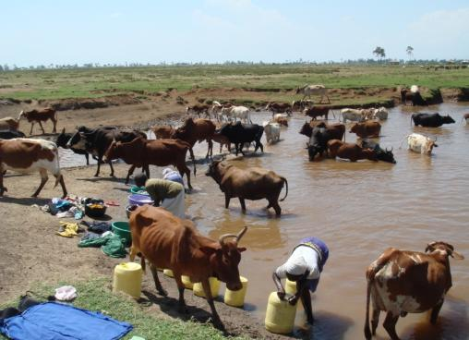

The Project
The main objective of the Safe Water Enterprise in Sondu, is to increase access to clean and safe drinking water and sanitation for the vulnerable community. The enterprise is managed by a local water operator and is run under the supervision and mentorship of Safe Water and AIDS Project (SWAP).
The technology is Skyhydrant Filtration. Raw water is pumped from the river and collected in a water tank after which it is filtered through the membranes of the skyhydrant filtration unit. It is then channeled to outlets and sold to the communities at an affordable rate.

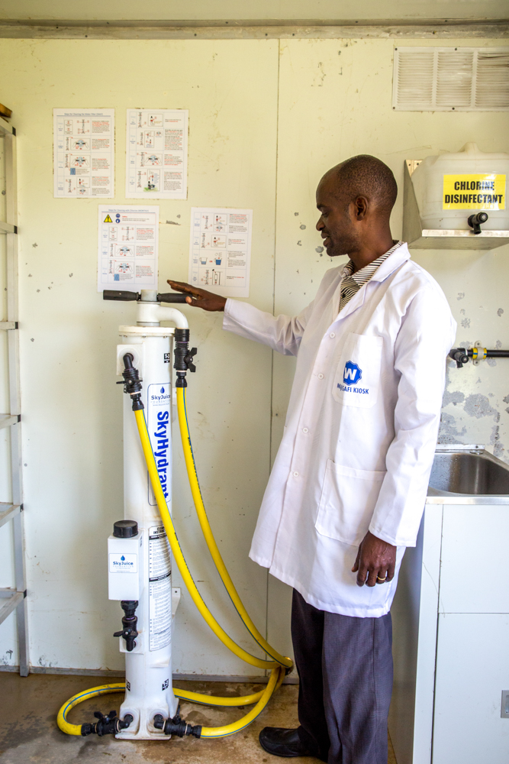
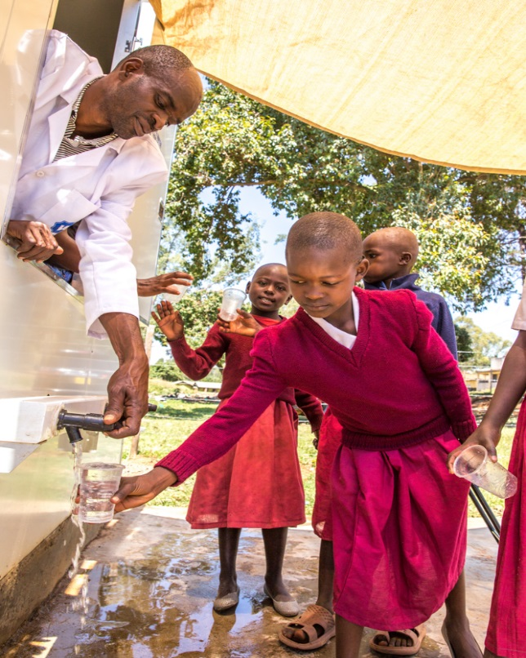
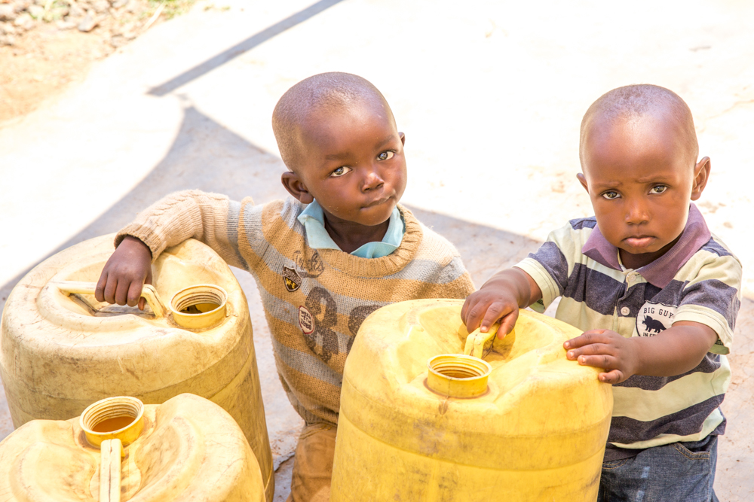

Reactions from customers
Sondu Water Enterprise has changed my life, my family often used to suffer from diarrhea and we would spend a lot of money on hospital bills and feeling sick and weak all the time.
I lost my first child due to diarrhea when I was using water from the river. Now that I take water from the Sondu Water Enterprise, my family is healthy. I wish I had known before what I know now.
My child is in class 4 and last year did not do well, due to frequent sickness. Now that we drink clean water, our health has improved and the teachers are very happy with her performance. She is no longer frequently absent from school and has a lot of energy.
I am a widow and HIV infected, I need to take care of my health so that I can be there for my children and therefore drink clean water from Sondu Water Enterprise. They also taught me about hygiene and how to stay healthy.
Even though I am paying for the water now, I save a lot of money because we do not get sick as often. I know can use that money for food for the house.
I used to walk long distances to get water but sometimes would reach and find the taps are dry. At Sondu Water Enterprise I will never fail to get and am served quickly. The staff are very friendly. The time saved I can now spend with my family. I told all my friends about it.
I am a head teacher of a primary school and I use the center for school trips to teach them about the importance of safe water and hand washing.

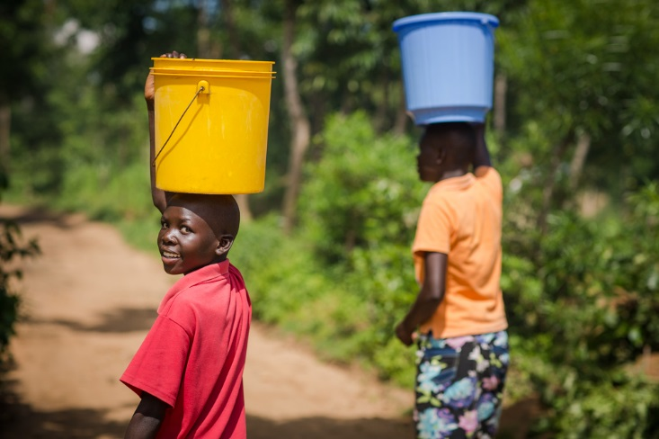

SWAP further provides health education and mobilizes communities to use the service. The leaders of the communities are sensitized and provide support. These include the local chiefs, assistant chiefs, village elders, manager from local organizations, representatives from the Municipal council, Ministry of Health and Water. Community Health Volunteers are engaged to reach out to households to educate them on safe water and hygiene including hand washing.

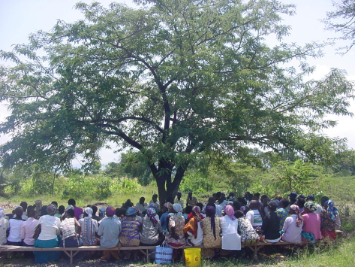

To address the sanitation needs at Sondu Market, SWAP built a public toilet at the water kiosk site to serve customers and those living around the market. Next to the toilet is a hand washing station to demonstrate hand washing and hygiene promotion.

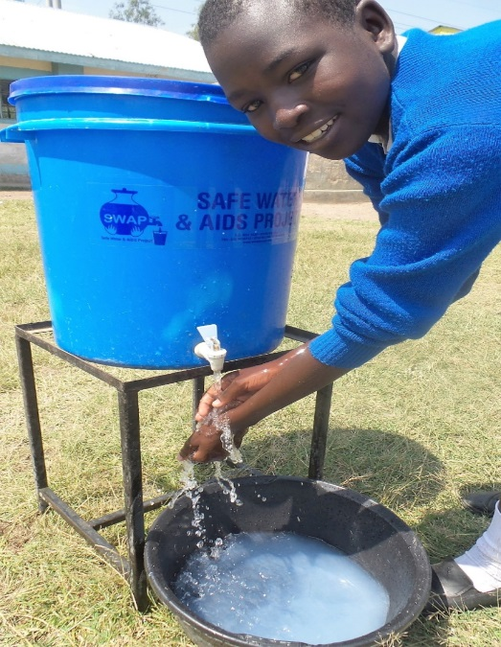
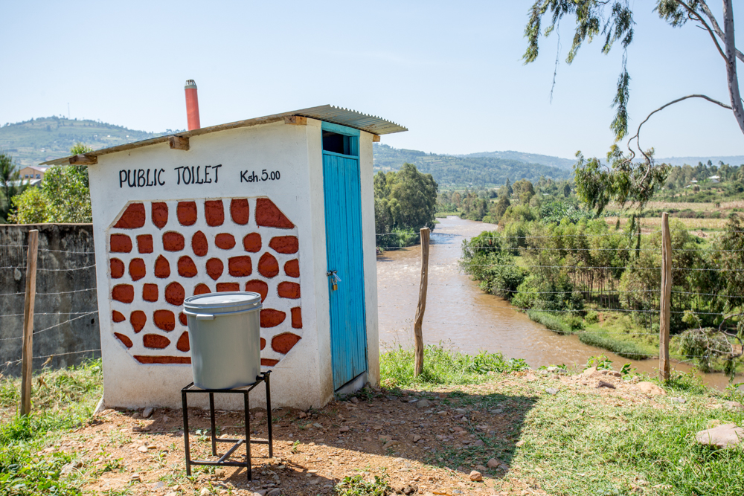
Public toilet at the water kiosk with Sondu River at the background

Monthly water Quality testing

The purpose of the monthly quality assurance and testing is to ensure that the water provided to the community meets the highest quality standards test. For this reason, monthly samples of the water at the main taps are taken for quality control and analysis. This is done at SWAP’s water lab. Below is the SWAP's Lab Manager, conducting the tests in SWAPs water lab. SWAP is able to do bacteriological and full chemical analyses.

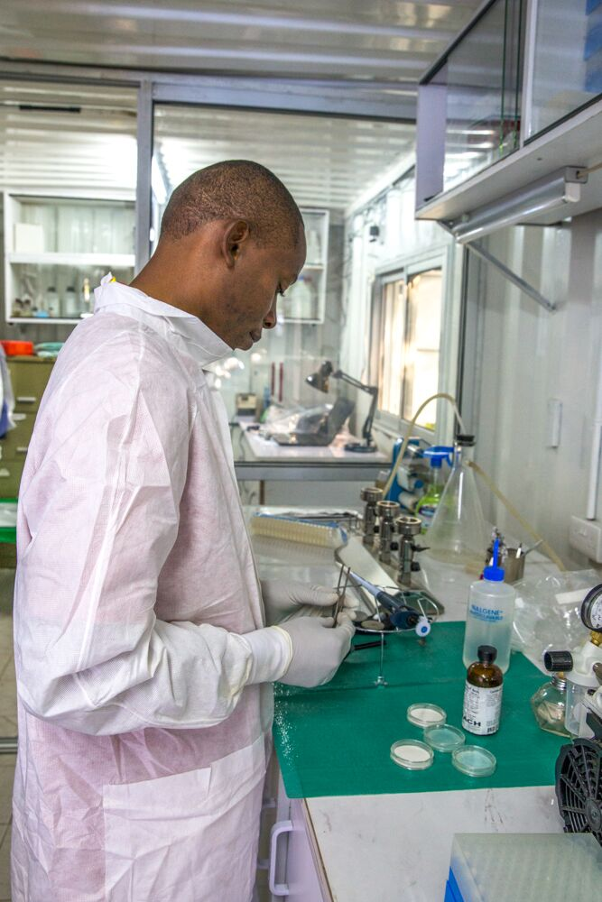

SWAP addressed their partners, donors, friends and well-wishers to donate through Global Giving and received so far two disbursements as follows:
- USD 6,118.65 – September 30th 2016
- USD 900 – October 31st 2016
- USD 329.50 – February 2017

WHAT DID WE DO WITH YOUR MONEY
- Additional tanks and reinforcement of the structure
- Provided a shade for customers
- A public toilet
- A hand cart for commercial use which carries 8 jerry cans of water
- A bicycle for the water operator to market around the area
- Fencing and a gate for security
- Monthly quality water tests
- A lockable cage for the generator
- Protective gear for the operator and watchman
- Monitoring visits
- Cleaning materials and chlorine
- Casual hire of grounds men
- Paid for approval and business permits
- Hand washing station and a drinking water station at the site for walk ins and school children
- Training sessions on safe water, hygiene, business skills, record keeping
- Wages for the water operator and the security guard
- Marketing materials and stationery
- Monitoring visits by SWAP management

WHY ARE WE ASKING FOR MORE FUNDS
We would like to improve and scale up our services to have a bigger health impact and chance of sustainability of the Sondu Water Enterprise in the near future.
- Costumers are already reaching the enterprise for water. We would like to take advantage of this and offer few health products for sale, such as hand washing soaps, household water treatment, jerry cans, ceramic filters, toilet tissue, sanitary pads, solar lamps, clean cook stoves, nutritional supplements and mosquito nets and repellent soaps. These products are already available at SWAP and can be introduced to Sondu.
- Monthly Stipend for a Community Health Promoter, who would focus on health education and sales of products while assisting with the water sales.
- Refresher trainings of the team on business skills, record keeping, social marketing and social behavioral change communication, product, health and hygiene promotion and safe water systems interventions.
- Community and partners engagement, regular chiefs meeting, meetings with community health volunteers to enhance ownership and support.
- A smart phone for the water operator and community health volunteer for transmission of sales data and mobile money transfer (Mpesa).
- Branded T shirts and leso’s used by mothers as wrap around skirts and to carry their babies. Also branded riding gears for the motorbike riders who sell water to households. This can be used as marketing tool and incentive for regular customers.
- Solar panels to facilitate the water operator to continue operations and sales in the evenings and increase sales and revenue
- Solar security lights for the night
- Solar pump to avoid the cost of fuel ongoing.
- Training of a reliever during leave or sickness of the water operator
- Monthly water quality tests and monitoring
- Monthly wages of the water operator and security guard
- Continued maintenance of the site

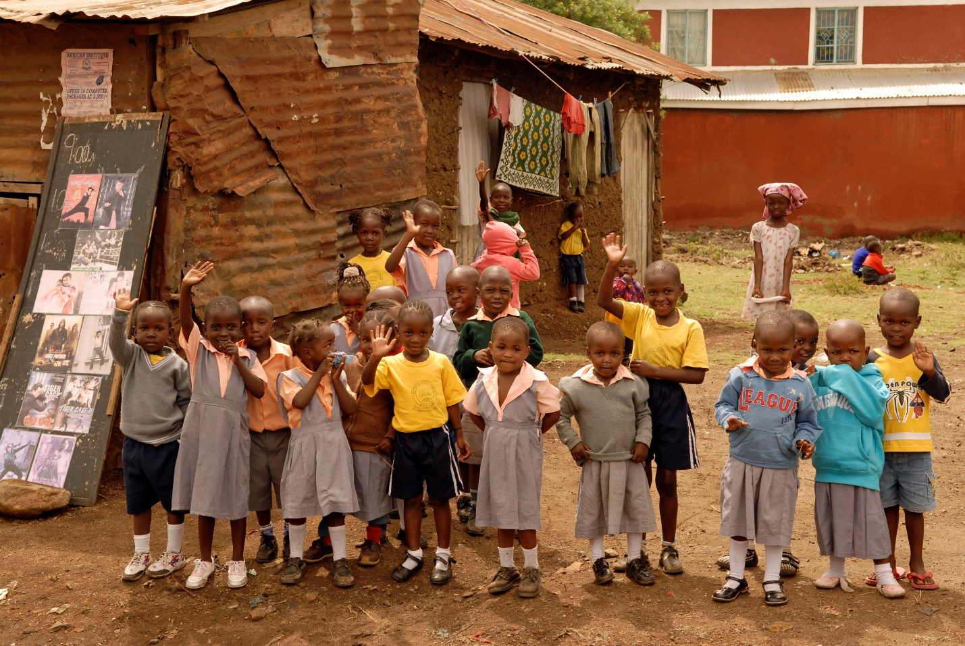

THANK YOU FOR ALL YOUR DONATIONS ON BEHALF OF SWAP AND THE SONDU COMMUNITY!!!

