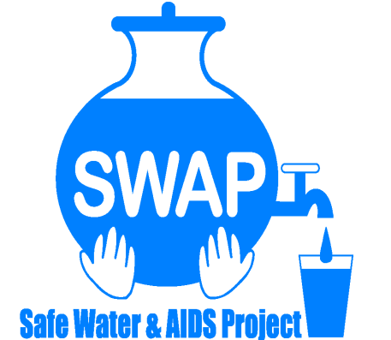
GLOBAL GIVING REPORT
SONDU WATER ENTERPRISE

FEBRUARY 2018

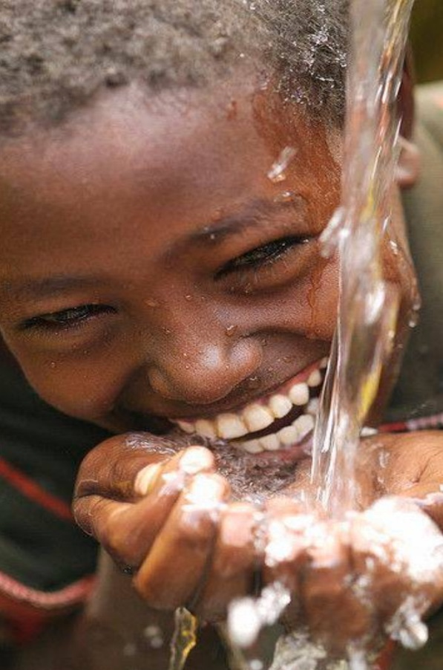

Safe Water & AIDS Project (SWAP)
Email: info@swapkenya.org
Website: www.swapkenya.org
P.O. Box 3323-40100 Kisumu, Kenya.
Tel (+254) 20-2030712/ 0738039901/ 0714761268
Main office: Off Aga Khan Road, Behind Royal City Hotel, Milimani Estate, Kisumu, Kenya
Introduction
Safe Water & AIDS Project (SWAP) uses an integrated entrepreneurial approach addressing a number of public health issues by working with already existing community structures. SWAP has been operating in Western Kenya since 2005 with public health programs and research contributing towards the achievement of sustainable development goals.

SWAP’s vision is to see a healthy and empowered community where everyone enjoys high quality of life.
SWAP’s mission is to provide innovative solutions for improved health and economic status of our communities.
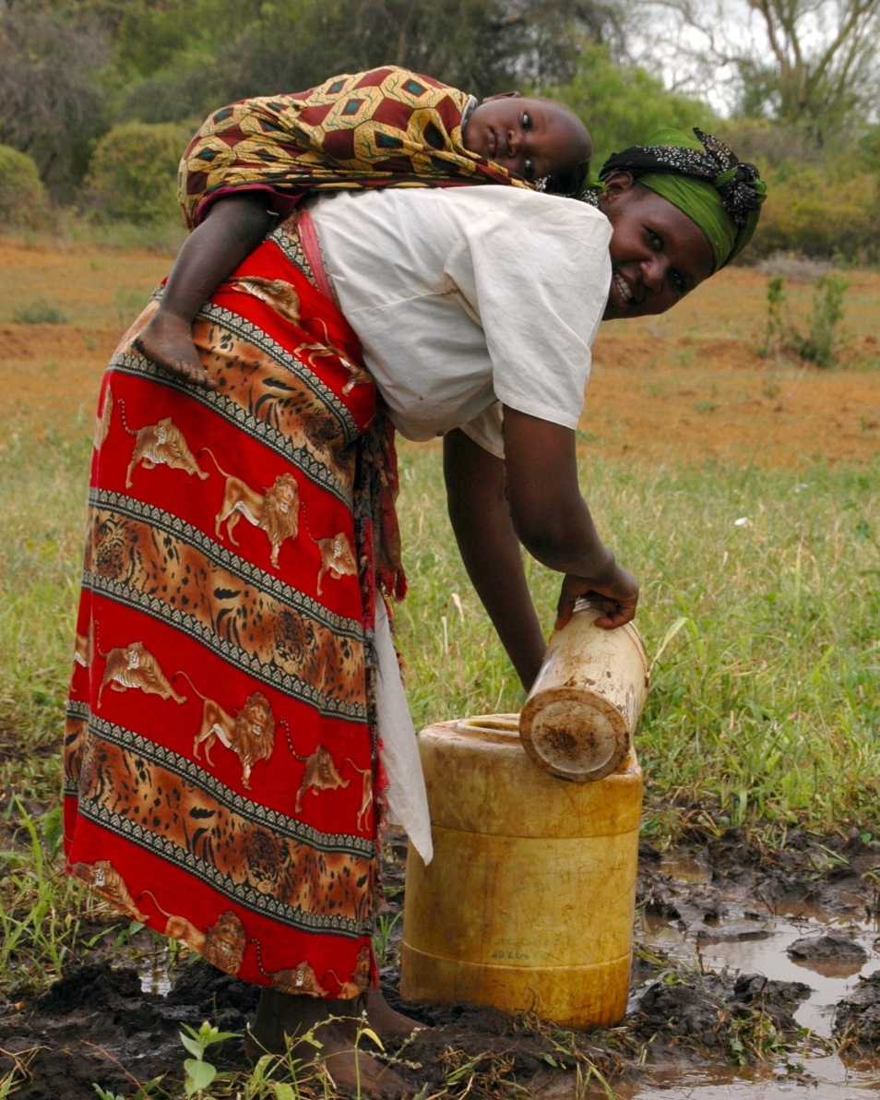
Children under five at risk due to contaminated water sources

Background Information
Sondu Water Enterprise is located at Sondu in Kisumu County, bordering Kericho, Nyamira and Homabay Counties in Western Kenya. The population residing in Sondu largely depend on the river source water for domestic use, which is highly turbid and contaminated. The river traverses three counties thus increasing contamination along its channel before emptying into Lake Victoria. Laboratory tests on microbiological quality have revealed that the source has high coliform count and fecal contamination.

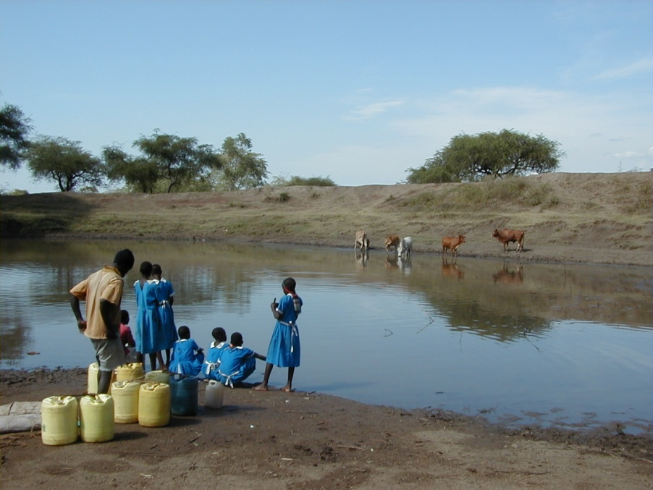
School children drawing water from the contaminated river also used by animals
There is a piped water scheme in the area which is not reliable and the supply is intermittent. Occasionally, the electricity supply is disconnected due to failure in settlement of the bills and due to drought there has been frequent rationing of water supply.

The Safe Water Enterprise was launched in July 2016. This was a collaborative initiative between Skyjuice Foundation (Australia) and Siemens Stiftung (Germany) in partnership with SWAP. Through this intervention the surrounding community members now have access to safe water, which has significantly reduced waterborne diseases such as diarrhea, cholera, typhoid and amoeba and as such reduced morbidity and mortality especially in children under five.

The Solution
The technology is Skyhydrant Filtration. Raw water is pumped from the river and collected in a water tank after which it is filtered through the membranes of the skyhydrant filtration unit. It is then channeled to outlets and sold to the communities at an affordable rate.

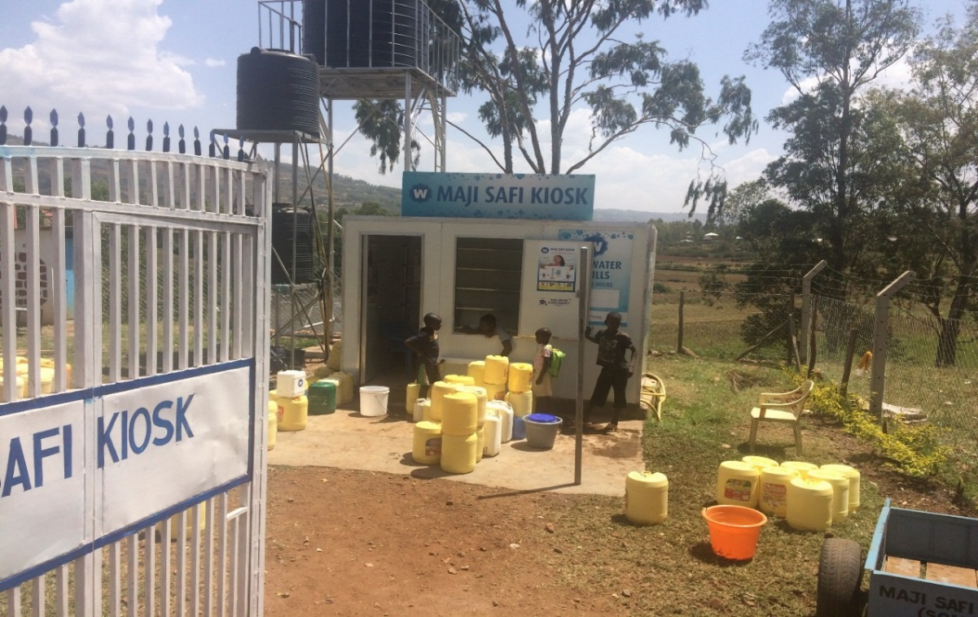
The Sondu Water Enterprise
Hygiene Promotion is done by the Water Operator and trained community health promoters. SWAP established a public latrine on the premises with a hand washing unit to promote hygiene, since there was no toilet facility at the entire market place. Many traders and visitors were instead using the river.

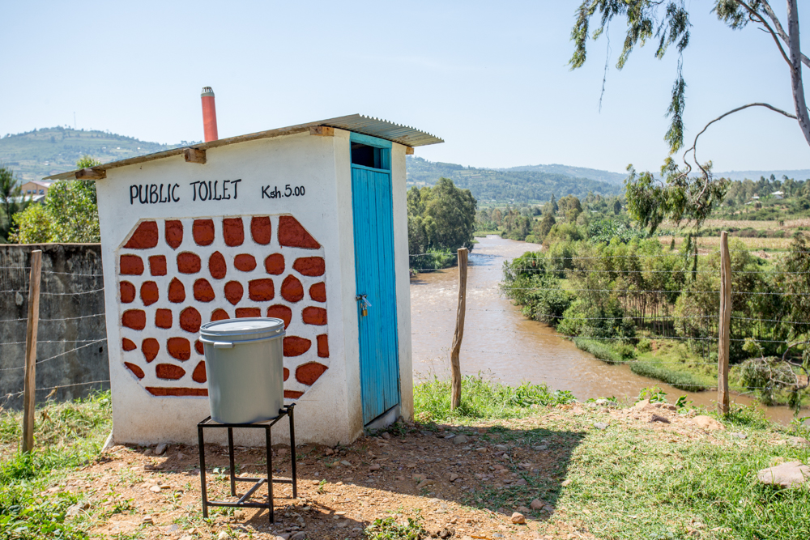
Public Toilet with Hand Washing Station at the Sondu Water Enterprise
Beneficiaries of the Sondu Water Enterprise
- Traders at Sondu market
- Water Vendors on motorcycle or handcart owners
- School going children in nearby schools
- Residents/tenants within Sondu and its surroundings
- Patients at nearby health facilities

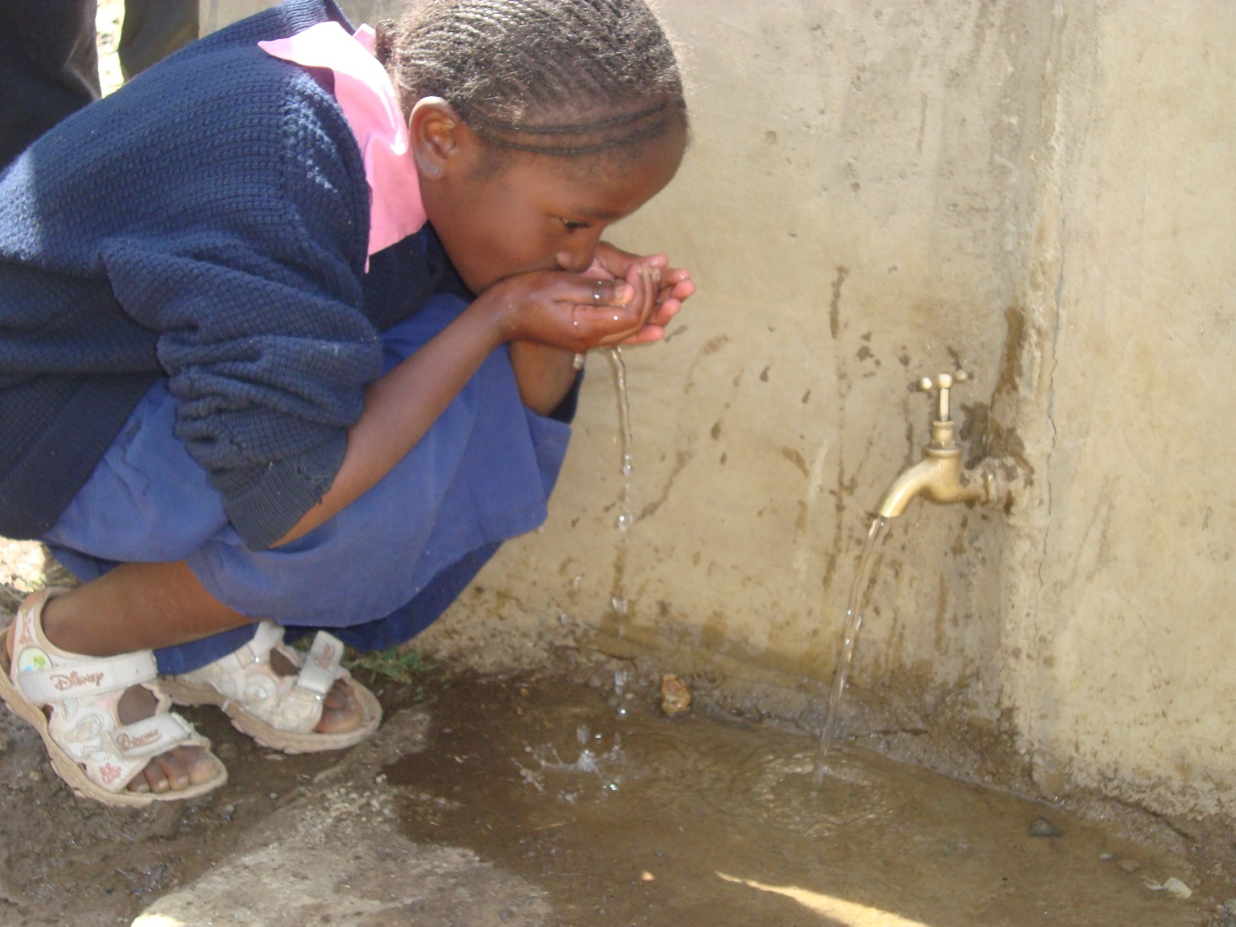
School girl tasting the filtered water on her way to school

Several schools have used the enterprise for educational purpose to teach children and hygiene.
The below picture shows a school girl doing a demonstration on proper hand washing. Community health volunteers and the water operator apart from marketing the enterprise are engaged in health and hygiene promotion.

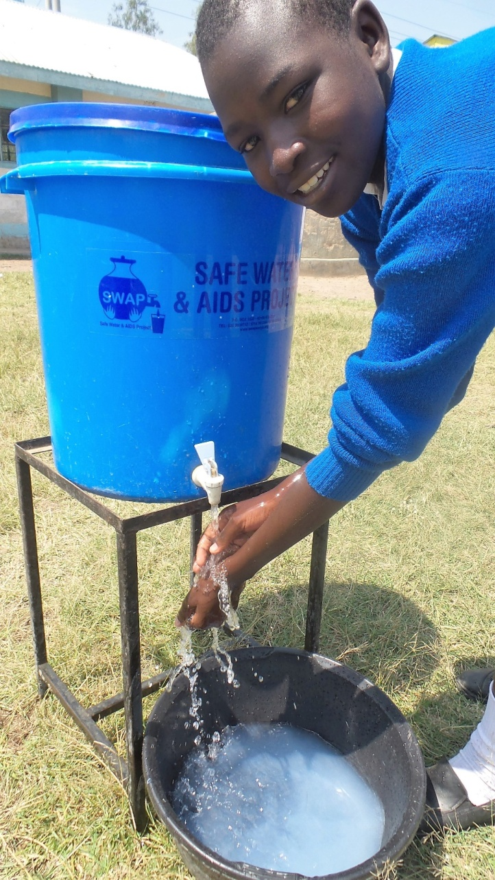

Recent Partnerships

Kenya Integrated Water, Sanitation and Hygiene -KIWASH – is a USAID funded program which has expressed interest to support Sondu water enterprise. The Water Operator and SWAP employee supervising the Sondu Water Enterprise participated in a training and together worked on a business plan which is shared with KIWASH. They will offer support and ongoing capacity building to help the Enterprise run more efficient towards sustainability in the near future.

Siemens – They assisted with seed funds and technical support for the initial start-up of the Sondu Water Enterprise and have paid regular visits and still offer technical support and maintenance on the technology. They further supported SWAP with some calendars and other incentives for the regular customers.

Kenya Water and Sanitation Network – KEWASNET – SWAP has been marketing its service through the KEWASNET newsletter, which has a country wide membership of WASH partners.

Kenya Water for Health Organization – KWAHO – KWAHO was engaged by Siemens to support the hygiene promotion and community mobilization to help market the Sondu Water Enterprise.

Way forward
SWAP is working with the Sondu authorities and the Sondu Water Enterprise Committee to eventually hand over ownership of the enterprise after it is sustainable. Last year was a difficult year due to insecurity in the area with the prolonged elections. In 2018 the service is on high demand due to the drought as a result of climate change, whereby people come from far to access the service.

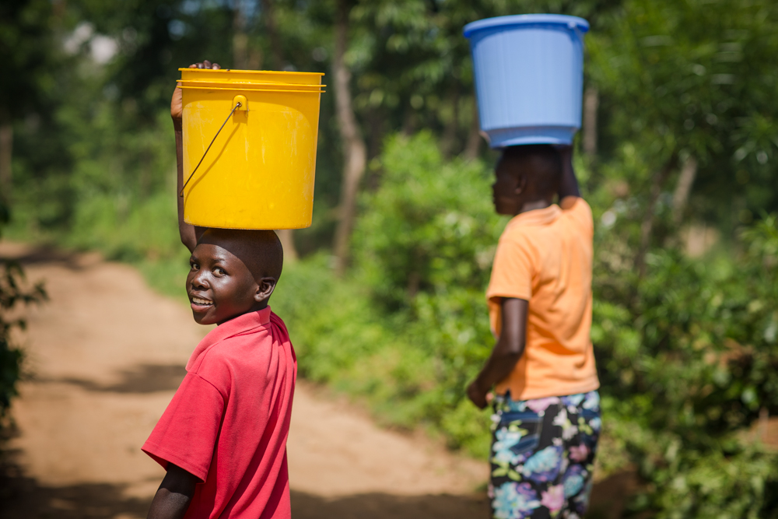
Happy Costumers

THANK YOU FOR YOUR GENEROUS DONATION TO PROVIDE CLEAN WATER IN SONDU !

