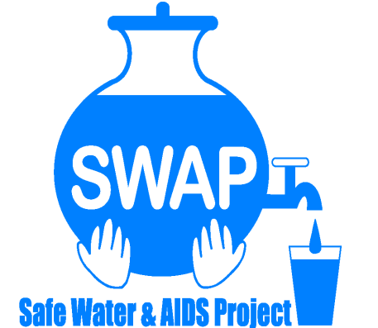

GLOBAL GIVING REPORT
SONDU WATER ENTERPRISE
FEBRUARY 2019

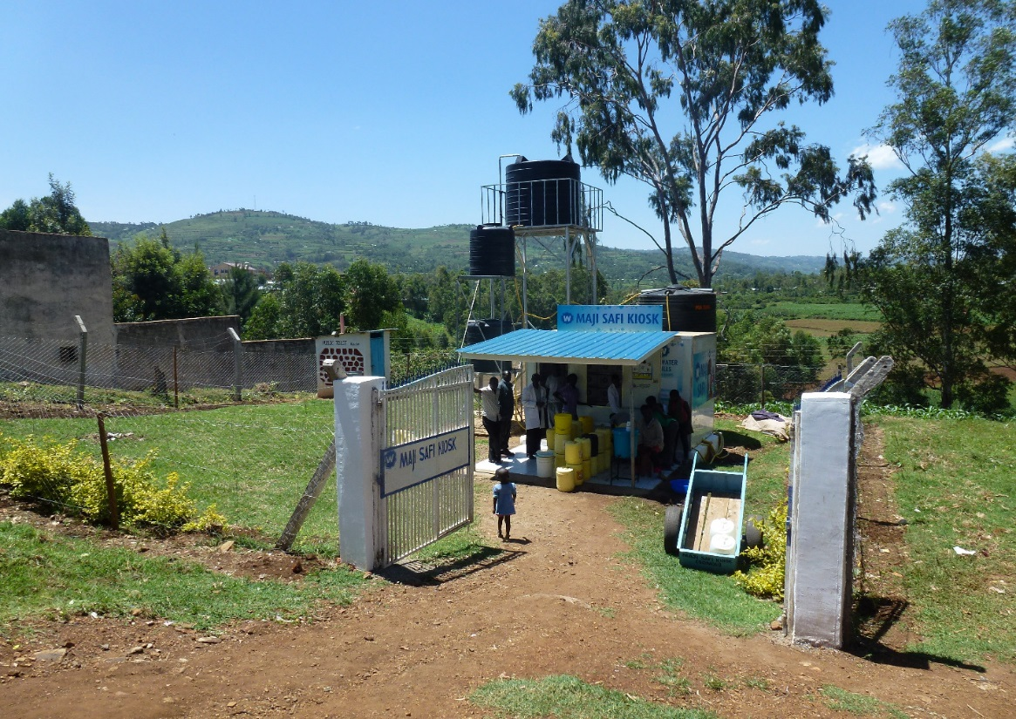

Safe Water & AIDS Project (SWAP)
Email: info@swapkenya.org
Website: www.swapkenya.org
P.O. Box 3323-40100 Kisumu, Kenya.
Tel (+254) 20-2030712/ 0738039901/ 0714761268
Main office: Off Aga Khan Road, Behind Royal City Hotel, Milimani Estate, Kisumu, Kenya

Introduction
Safe Water & AIDS Project (SWAP) uses an integrated entrepreneurial approach addressing a number of public health issues by working with already existing community structures. SWAP has been operating in Western Kenya since 2005 with public health programs and research contributing towards the achievement of sustainable development goals.

SWAP’s vision is to see a healthy and empowered community where everyone enjoys high quality of life.

SWAP’s mission is to provide innovative solutions for improved health and economic status of our communities

Background Information
Sondu Water Enterprise is located at Sondu in Kisumu County, bordering Kericho, Nyamira and Homabay Counties in Western Kenya. The population residing in Sondu largely depend on the river source water for domestic use, which is highly turbid and contaminated. The river traverses three counties thus increasing contamination along its channel before emptying into Lake Victoria. Laboratory tests on microbiological quality have revealed that the source has high coliform count and fecal contamination.

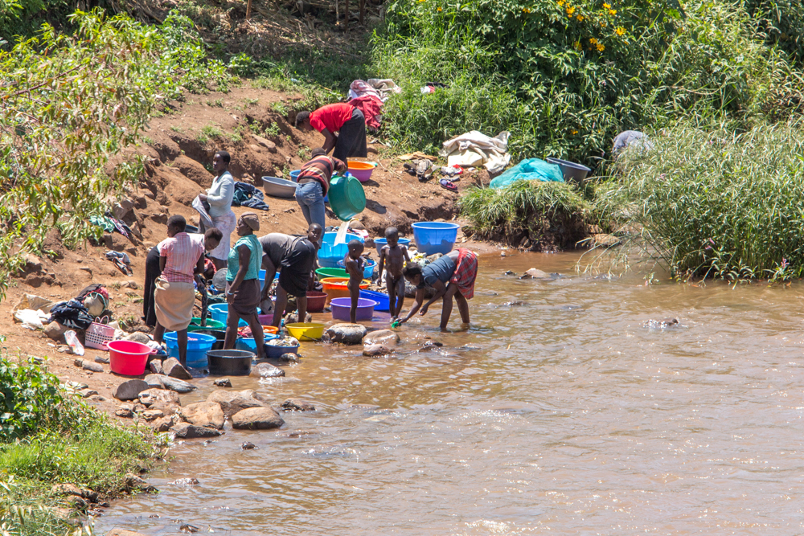
Activities at River Sondu

The river is used for bathing, washing and drinking. Animals use the same river. Raw sewage and run off water finds is way in the river as well. Diarrheal illness is still one of the leading causes in the area and it has been prone to cholera outbreaks. Women and children spend valuable time collecting water from the river, which is unsafe for human consumption.

There is a piped water scheme in the area which is not reliable and the supply is intermittent. Occasionally, the electricity supply is disconnected due to failure in settlement of the bills and due to drought there has been frequent rationing of water supply.

Other use surface water for household use and drinking. This has put especially young children at high risk of diarrheal illness and mortality.
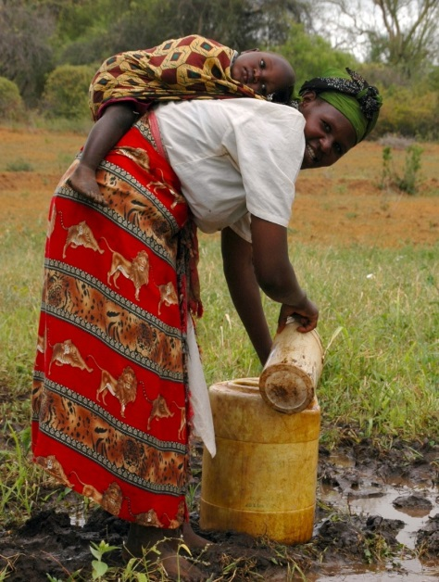
Drawing surface water for household use

The Solution

The Safe Water Enterprise was launched in July 2016. This was a collaborative initiative between Skyjuice Foundation (Australia) and Siemens Stiftung (Germany) in partnership with SWAP. Through this intervention the surrounding community members now have access to safe water, which has significantly reduced waterborne diseases such as diarrhea, cholera, typhoid and amoeba and as such reduced morbidity and mortality especially in children under five.

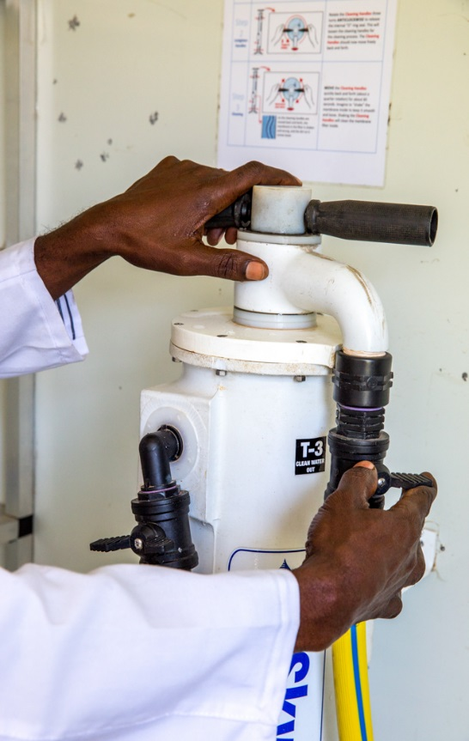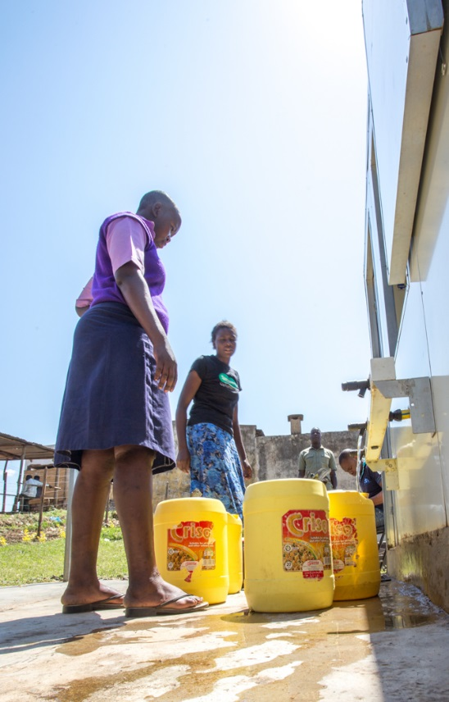
The Skyhydrant filter used to filter raw water and children and women collecting water

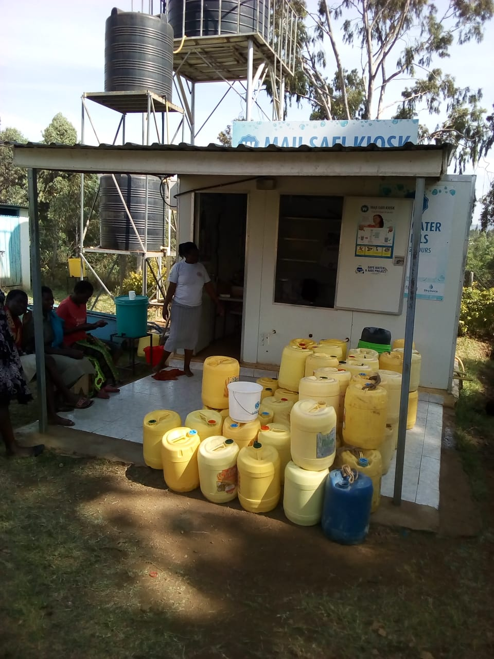
The Sondu Water Enterprise with costumers waiting to be served

The technology is Skyhydrant Filtration. Raw water is pumped from the river and collected in a water tank after which it is filtered through the membranes of the skyhydrant filtration unit. It is then channeled to outlets and sold to the communities at an affordable rate. Women collect water in plastic vessels of 20 liters and carry on their head to their houses. Others use bicycles or motorbikes to transport water. Traders collect and use handcarts to resell in the community.

To take care of the sanitation SWAP built a public toilet since there was none at the Sondu Market where the Sondu Water Enterprise is established. Community members can use this toilet at a fee, which is to generate some income to facilitate the procurement of toilet tissue, cleaning materials and hand washing soap. Next to the toilet there is a hand washing station which is used for demonstration.

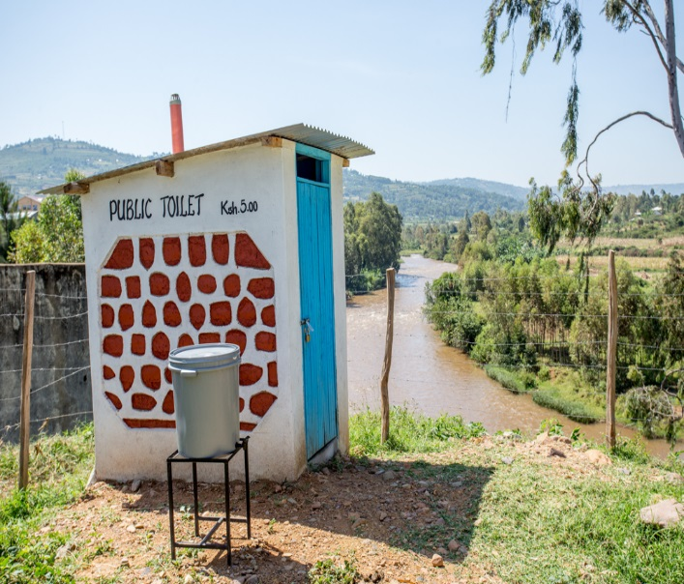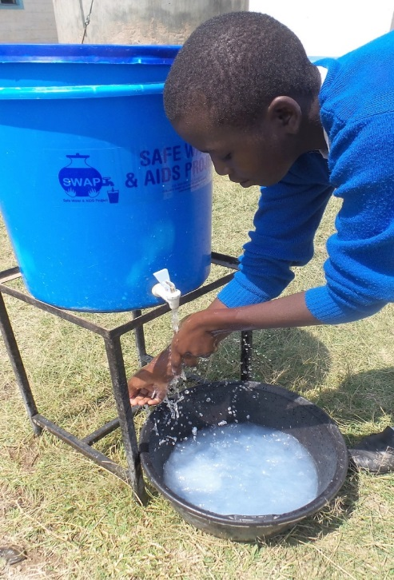

Public toilet and demonstration of hand washing by school kids

Beneficiaries of the Sondu Water Enterprise
- Traders at Sondu market
- Water Vendors on motorcycle or handcart owners
- School going children in nearby schools
- Residents/tenants within Sondu and its surroundings
- Patients at nearby health facilities
- Community Health Volunteers

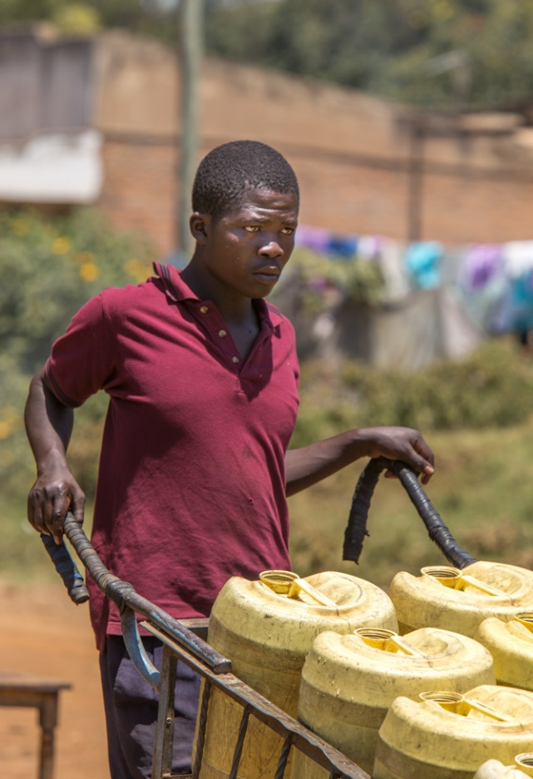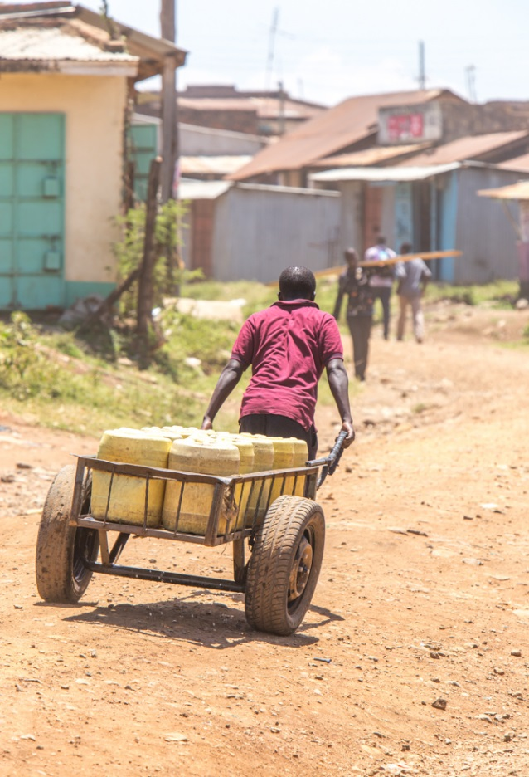

Traders collect water in handcarts and resell to households, hotels and small businesses on the market
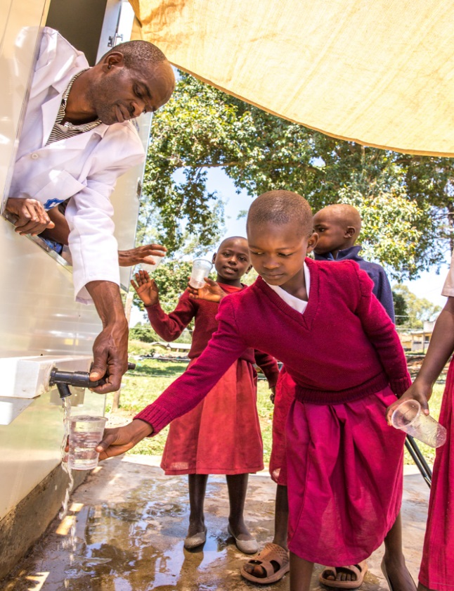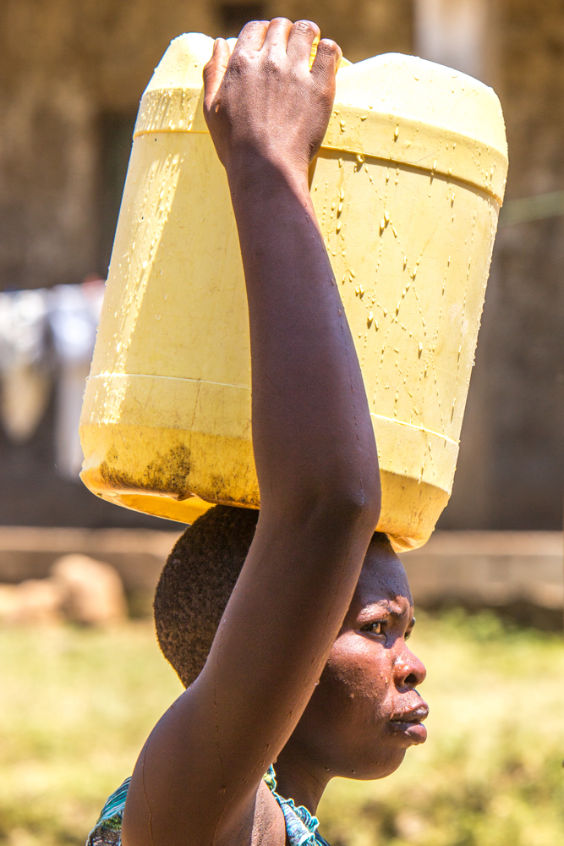
Beneficiaries of the Sondu Water Enterprise – water mostly collected by women and girls

Partnerships and Achievements

SWAP has established strong partnerships with various Water and Sanitation partners who each played a role and made invaluable contributions with supplies, training, capacity building and marketing.

We realized the need for more marketing of the service and received from Siemens Stiftung 150 calendars to market the enterprise. The Sondu Water Enterprise was captured on the front page of the calendar. These calendars were distributed to loyal costumers, the community health volunteers, members of the Community Based Organization, traders on the market among others.

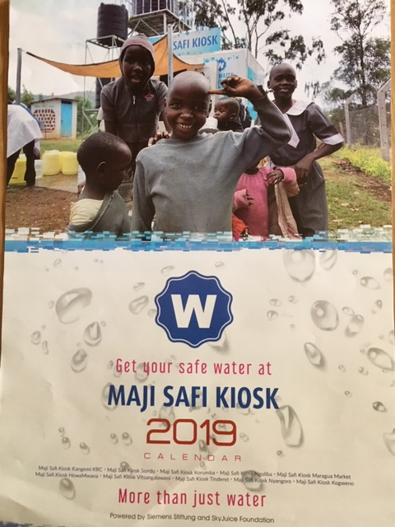
Calendars printed and distributed to market the services

KWAHO – Kenya Water for Health Organization – supported further with training in December 2018 to local community health volunteers to assist to market the enterprise to the local community.
Following this we noted an increase in water sales.

SWAP provided continues mentoring and on the job training on the use and service of the Skyhydrant filter and collecting of water samples for testing in the SWAP Water Lab.

Siemens provided further technical support, after the electrical pumping system failed. There was need for a new electrical pump which was provided and connected by Siemens.

KIWASH – Kenya Integrated Water, Sanitation and Hygiene Project provided a training to the CBO members and the water operator in November 2018 on the operations, maintenance and monthly monitoring of sales.

In February 2019 an induction workshop was organized by KIWASH for WASH partners. This was attended by Jared Oremo, SWAP Lab Manager and Supervisor of the Sondu Water Enterprise and George Nyanji, the Sondu Water Enterprise Chairman. The training was on basic accounting systems and billing.

Challenges
In January 2019, the main pipes connected to the Skyhydrant system and water tanks were stolen and vandalized. SWAP replaced these with income from Global Giving and reinforced the security.

SWAP Water Laboratory

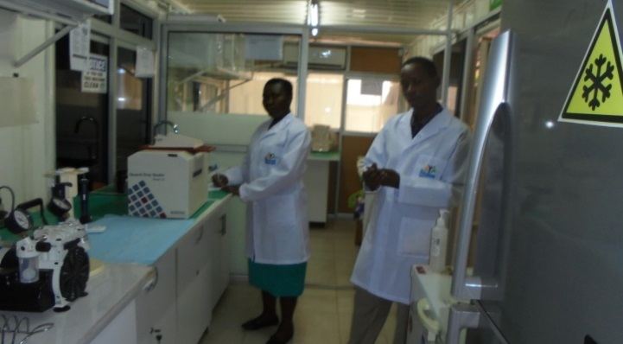

The water lab at SWAP

The water lab at SWAP was established in 2007 for research purposes. Initially the lab could only provide bacteriological water testing, but later also offered full chemical testing after investing in more equipment and training of staff following international standards.

The Laboratory has a capacity to process and analyze about 60-70 samples per day. The technology used in the lab is ISO 9308 specifies a method for the enumeration of E. coli and coliform bacteria in water using colilert reagents and ISO 9308-1:2014 membrane filtration method technology (coli-blue broth). SWAP’s water lab offer services using modern equipment to analyze real time analysis in water to it’s clients at cost Kenya Shillings 7,000 (USD 70) and 3,000 (USD 30) for full chemical and bacteriological analyses respectively.

SWAP continued to do regular water quality testing of the water sold to the communities. This to ensure that the water is free from pathogens and fit for human consumption. Water testing was done in SWAP’s water lab which can perform bacteriological and chemical tests. To keep this control measure SWAP ensured that the CBO members and the water operator is well trained on hygiene promotion and service and maintenance of the Skyhydrant filter as well as costumer relations.

Sales Graph

In April and May, Kenya experiences long rains, which affected the sales at the enterprise. People harvest rain water for household use during this period.

In June and July there were technical problems with the pump which needed replacement. After the new pump was installed the sales improved. The pump used during this time frequently broke down and was replaced by a new and improved version in November 2018.

Way forward
SWAP is working with the Sondu administrative leaders and the Sondu Maji Safi CBO to eventually hand over ownership of the enterprise after it is sustainable. In 2018 the service has been on high demand due to the drought as a result of climate change, whereby people come from far to access the service.
The plan is to do the handing over by the end of 2019. SWAP will work with the various partners to continue to build the capacity of the Sondu Maji Safi CBO members and the water operator towards sustainability.

Sondu Water Enterprise will need to renew its business permit, which is paid to the County Government of Kisumu.

SWAP seeks still more funding through Global Funding to support the process of handing over. It requires more investment in training such as business skills, record keeping, group dynamics, financial management, marketing. SWAP would still need to support the regular water testing for quality control.

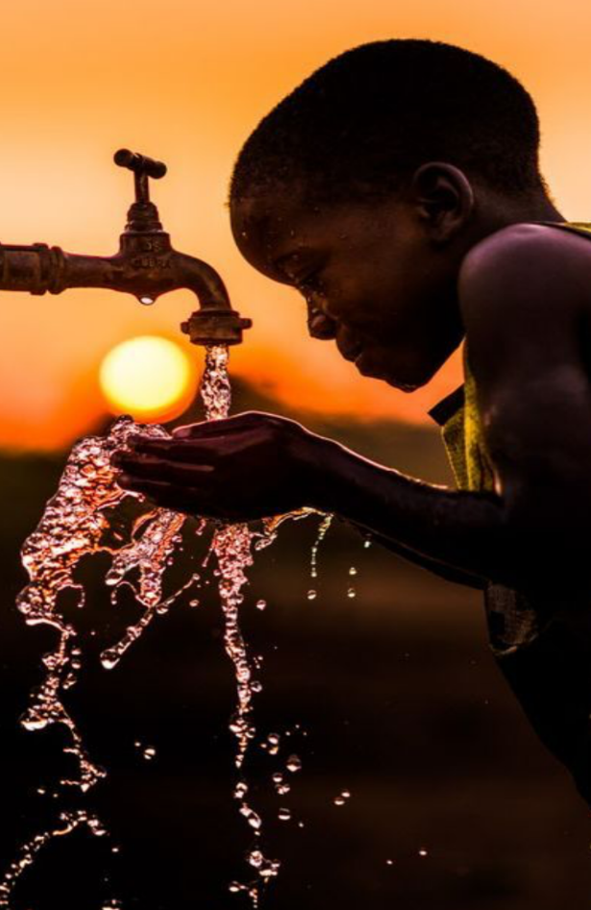
THANK YOU FOR YOUR SUPPORT

