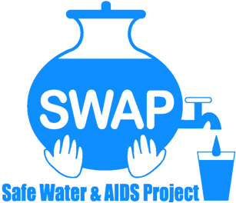

GLOBAL GIVING REPORT
SONDU WATER ENTERPRISE
AUGUST - OCTOBER 2019
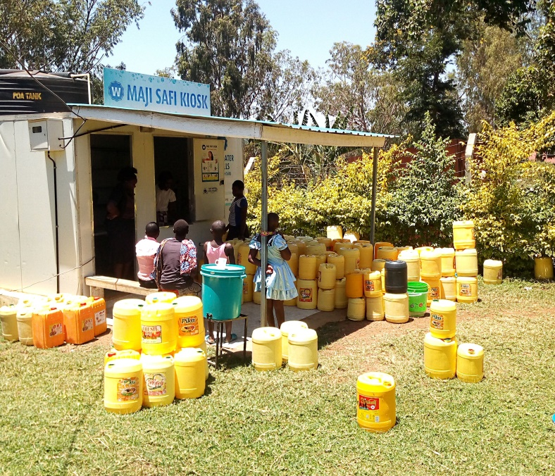

Safe Water & AIDS Project (SWAP)
Email: info@swapkenya.org
Website: www.swapkenya.org
P.O. Box 3323-40100 Kisumu, Kenya.
Tel (+254) 20-2030712/ 0738039901/ 0714761268
Main office: Off Aga Khan Road, Behind Royal City Hotel, Milimani Estate, Kisumu, Kenya

Introduction
Safe Water & AIDS Project (SWAP) uses an integrated entrepreneurial approach addressing a number of public health issues by working with already existing community structures. SWAP has been operating in Western Kenya since 2005 with public health programs and research contributing towards the achievement of sustainable development goals.

SWAP’s vision is to see a healthy and empowered community where everyone enjoys high quality of life.
SWAP’s mission is to provide innovative solutions for improved health and economic status of our communities

Background Information
Sondu Water Enterprise is located at Sondu in Kisumu County, bordering Kericho, Nyamira and Homabay Counties in Western Kenya. The population residing in Sondu largely depend on the river source water for domestic use, which is highly turbid and contaminated. The river traverses three counties thus increasing contamination along its channel before emptying into Lake Victoria. Laboratory tests on microbiological quality have revealed that the source has high coliform count and fecal contamination.
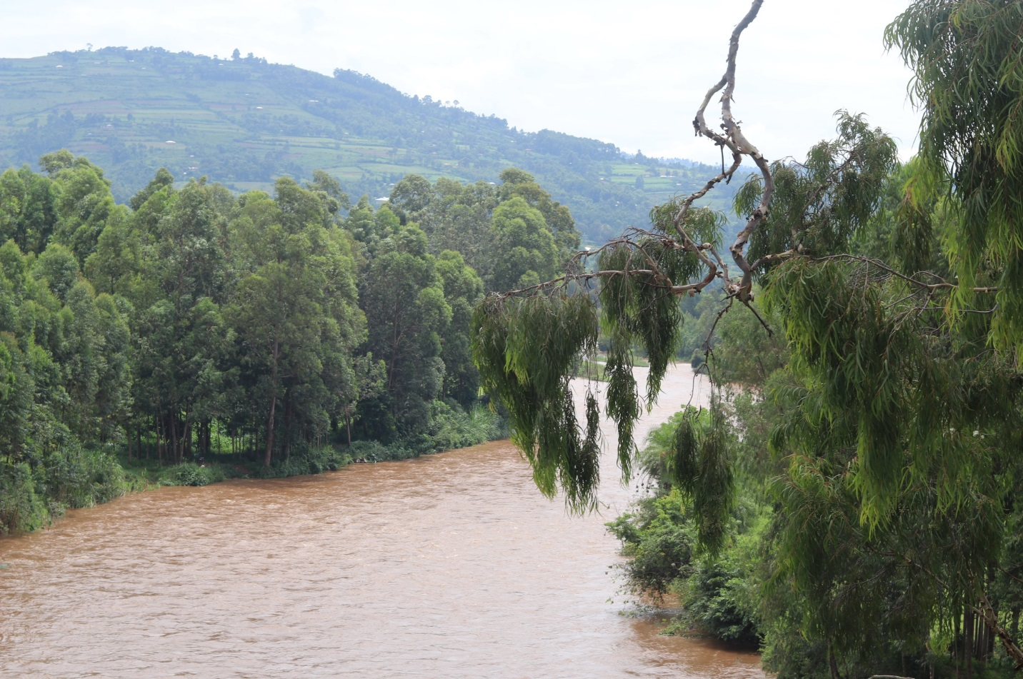
River Sondu, highly contaminated and turbid water source

Sondu Water Enterprise
The Safe Water Enterprise was launched in July 2016. This was a collaborative initiative between Skyjuice Foundation (Australia) and Siemens Stiftung (Germany) in partnership with SWAP. Through this intervention the surrounding community members now have access to safe water, which has significantly reduced waterborne diseases such as diarrhea, cholera, typhoid and amoeba and as such reduced morbidity and mortality especially in children under five. Besides the access to safe water, the community members are also offered health education on hygiene and safe water systems and services of a public toilet with a hand washing station which has been established for public use at the site.

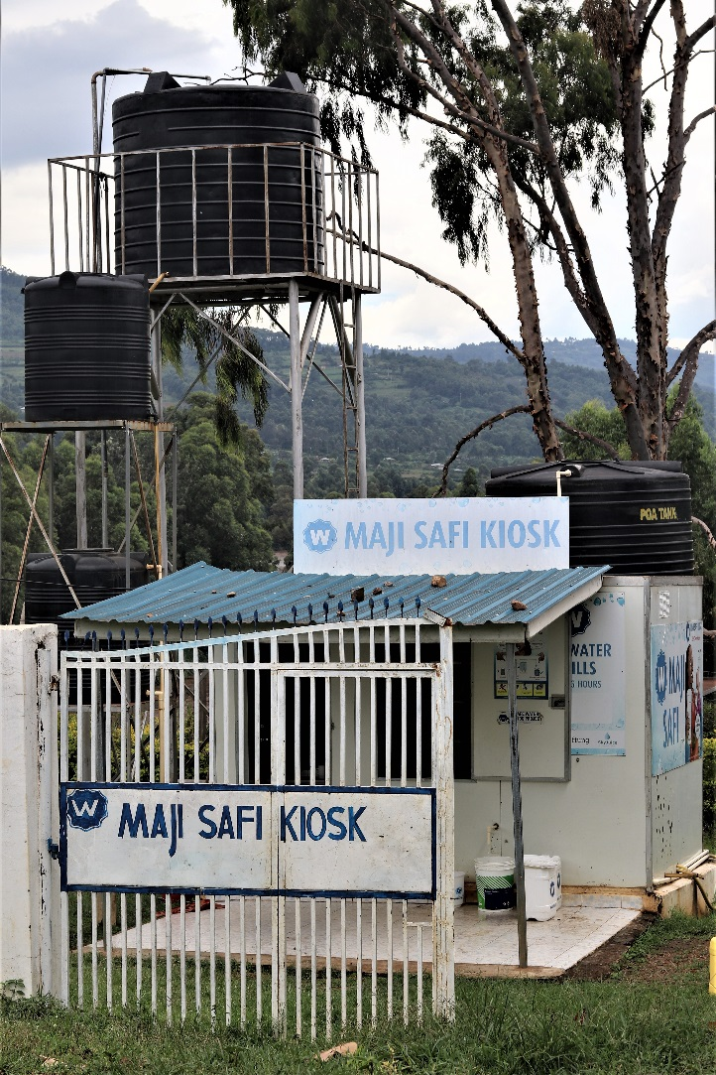
Maji Safi Kiosk – Sondu Water Enterprise
Activities
During this period the communities were sensitized on the importance of the use of safe water following a cholera outbreak in the region. SWAP worked in collaboration with the Ministry of Health and other partners to intervene and prevent the spread of the epidemic. This increased demand for services at Sondu Water Enterprises for clean water and safe storage.
SWAP supported the Ministry of Health with surveillance by testing water to check for contamination and the community health volunteers in the region referred families at household level to buy water from the enterprise. Hygiene promotion was done at the site and in the community.
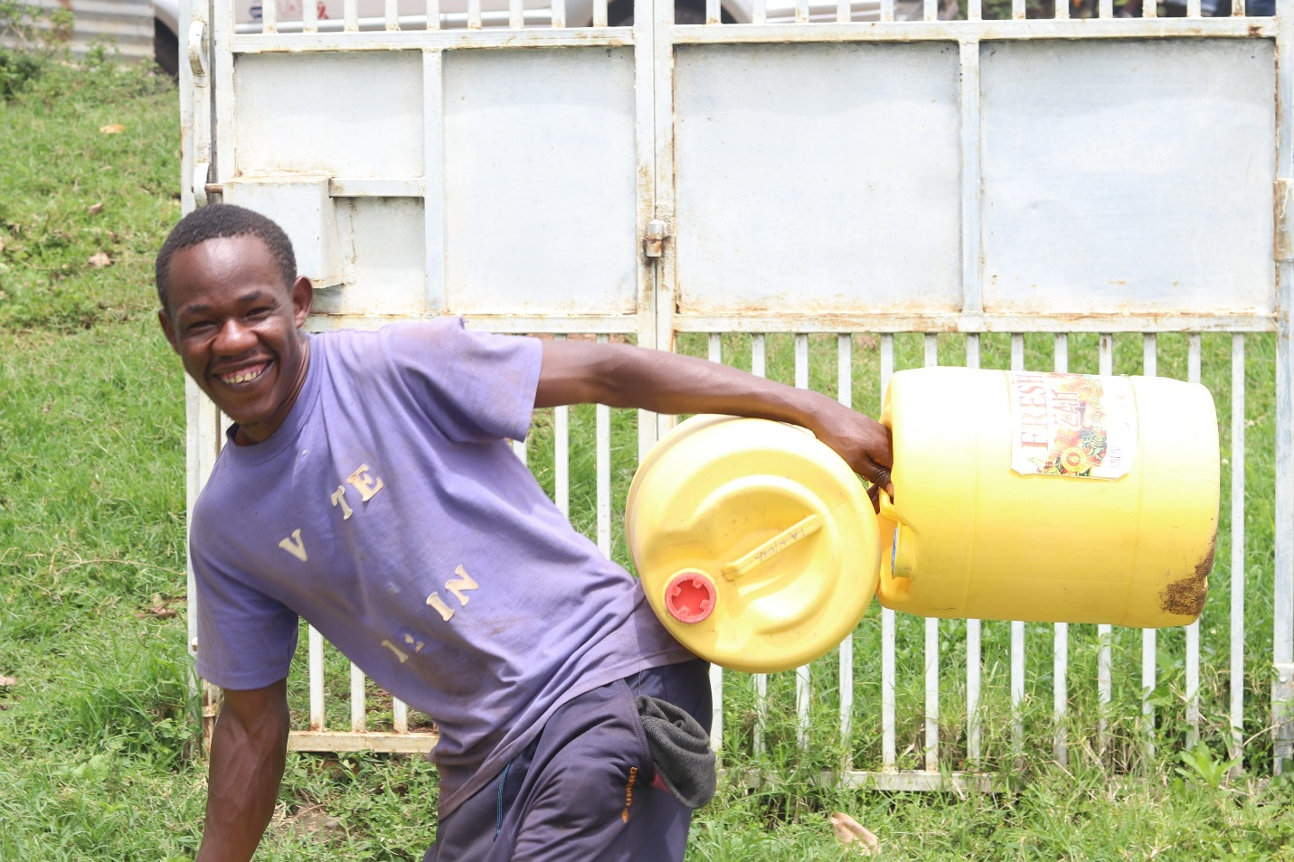
A happy costumer

The two female water operators rotate at the site to do sales and promotion of the services. They target potential costumers from the market place, schools, health care facilities and other institution as well as individuals at the households.

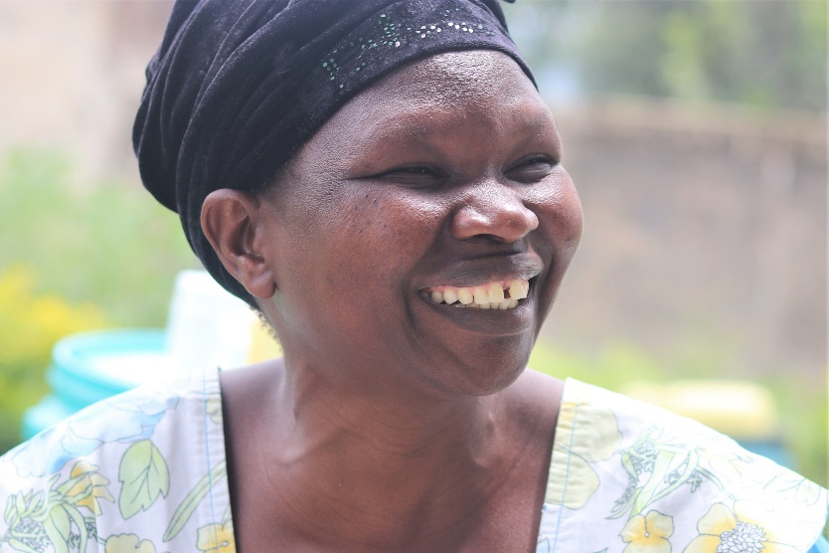
The Water Operator, a community health volunteer
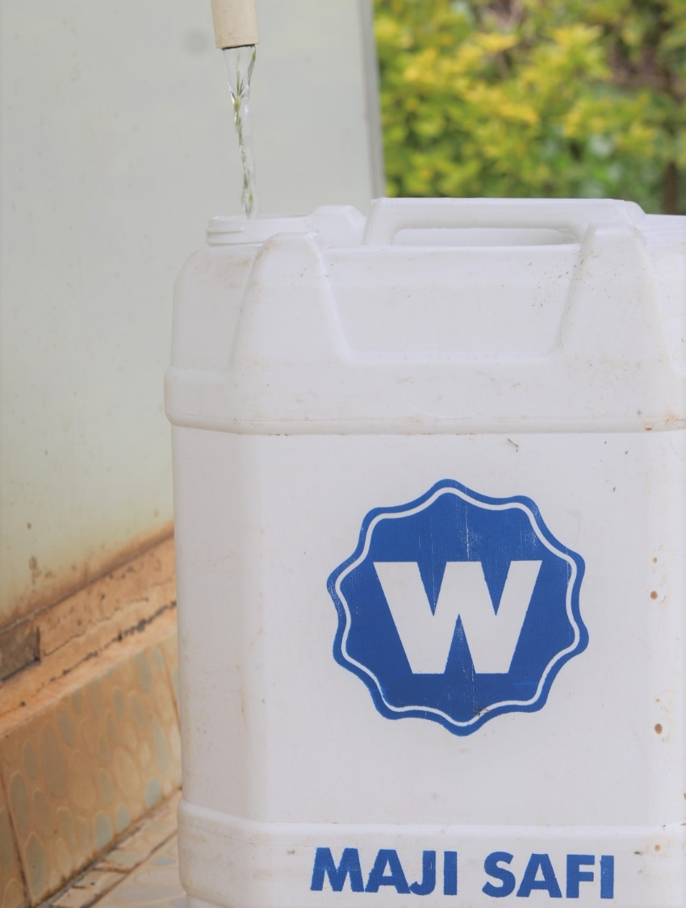
Branded Safe water storage vessels sold to the Community

The Maji Safi Community Based organization took the initiative to organize a clean-up of the environment of the Sondu Water Enterprise. There had been crude dumping of waste which was a health hazard. The place has now been cleaned by the community members.

Monitoring
Continued support through frequent visits to the water kiosk has ensured sustained quality of work and operations through offering feedback to the Maji Safi Community- Based Organization. Also, water quality monitoring was done led by SWAP’s lab Manager Jared Oremo. For this period bacterial tests showed zero presence of E.coli and coliforms, which means the water is suitable for human consumption.
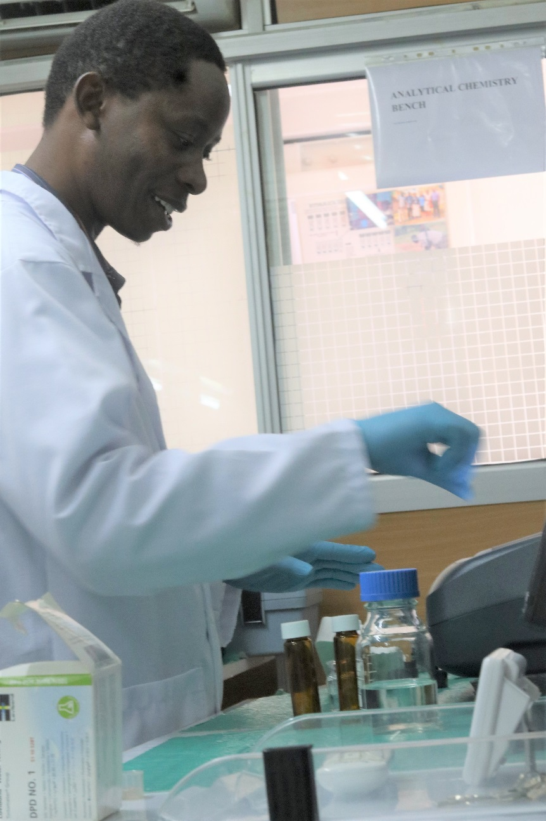
Jared Oremo, Lab Technician testing the quality of water

Partnerships and networking
SWAP received ongoing support from Siemens Stiftung in Germany and Kenya. A team came from Germany with the Kenyan team to SWAP to discuss achievement, challenges and the way forward. The electrical pump which is used for pumping water from the river was giving some problems and was replaced by the Siemens team. Discussion was focused on how to further build the capacity of the Maji Safi Committee, the local community based organization who are prepared to take over the Sondu Water Enterprise. Agreed was that more training was needed up to December and the plan is that they would take over the management on probation from January to March 2020 with close monitoring from SWAP and Siemens. If the probation is successful the handing over would take place by the end of March 2020. The Siemens team also visited the site to have discussions with the Maji Safi Committee members and the water operators.

KIWASH, the Kenya Integrated Water, Sanitation and Hygiene project has been supporting with business trainings to the Maji Safi Committee and Water Operators in the past and have continued to visit the Sondu Water Enterprise on regular basis to do on the job training on record keeping and data collection. The data collected is on income generated and sales from Water, Safe Storage Vessels, Public toilet and hire of a push cart which can carry several water vessels. Income is recorded and send daily to SWAP’s Paybill Number. This supports the payment of the water operators, cleaning materials and other expenses.

Way Forward
Training

A training will be done in December 2019 by Siemens with the objective of preparing the Maji Safi Community Based Organization for management of the Sondu Water Enterprise. The groups will be prepared on roles and responsibilities. Business management, financial management and technical maintenance of the Skyhydrant filtration unit and the water pump.

KWAHO, Kenya Water and Hygiene Organization will with support from Siemens train the teachers and student community surrounding the Sondu Water Enterprise on hygiene promotion and sanitation and mobilize them to utilize the site for collection of safe water.
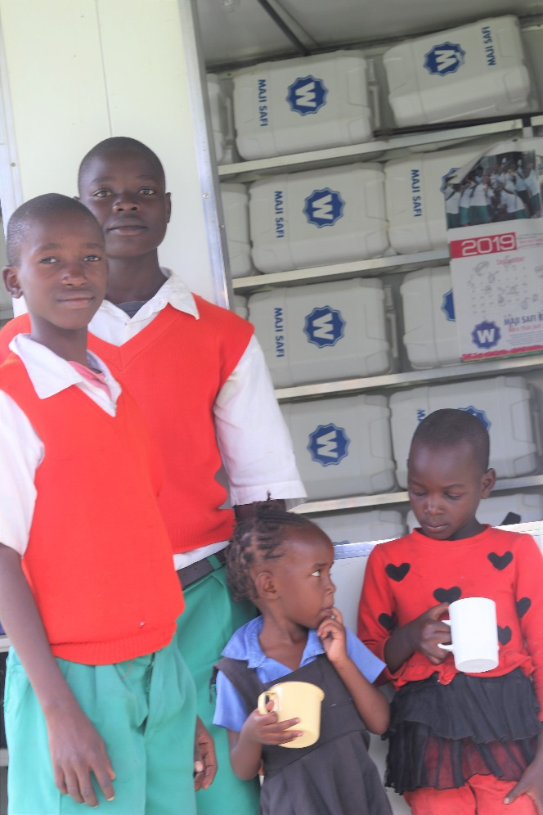
School children passing by for some water

Promotion of Water sales and Use of Public Toilet Services
To ensure sustainability of the water kiosk, members of the CBO continue selling branded water jericans to promote use of clean and safe water within the community. The public toilet is the only one at the market, so is another way of generating income. The push cart is rented out to vendors who want to sell multiple vessels of water to hotels and institutions.
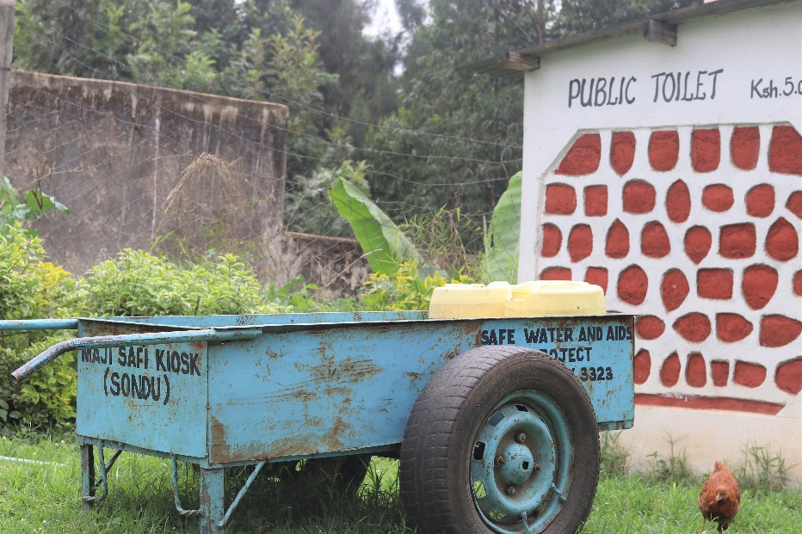
Push cart and public toilet
Handing over to the community based organization, Maji Safi.
There are plans to fully hand over management of the water kiosk to the CBO by March 2020. But the group will manage the site on probation between January to March 2020, with close monitoring of SWAP.

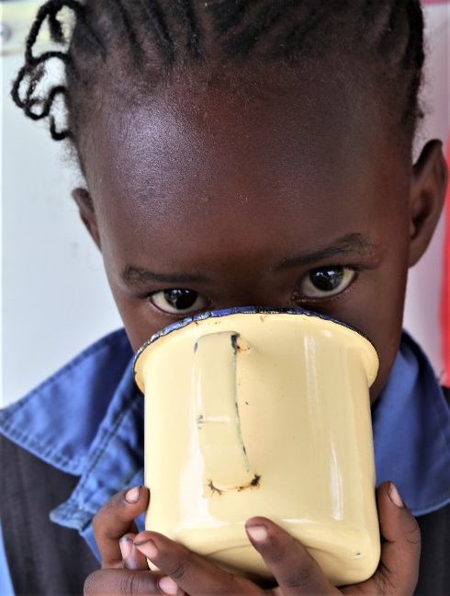
A happy costumer

