**PROPOSAL ON**

**BACK TO SCHOOL PACK PROJECT**

**BY**



**Plot 1032 Anthony Ani road , Finance Quarters Wuye District Abuja**

**Email:** [**vaccinenetwork@gmail.com**](mailto:vaccinenetwork@gmail.com)**, chikaoffor@thevaccinenetwork.org**

**Telephone No: 08022228935**

**Website: www.thevaccinenetwork.org**

|  |  |  |
| --- | --- | --- |
| 1 | Project Title | BACK TO SCHOOL PACK PROJECT |
| 2 | Implementing Organization | VACCINE NETWORK FOR DISEASE CONTROL |
| 3 | Correspondence address | PLOT 1032 ANTHONY ANI ROAD OPPOSITE FINANCE QUARTERS WUYE DISTRICT ABUJA |
| 4 | Name of Chief functionary | MRS. CHIKA OFFOR |
| 5 | Target Area | NORTH CENTRAL( PILOT PHASE) |
| 6 | Target | TO GET MORE CHILDREN BACK TO SCHOOL |
| 7 | Project date/Timeline | SEPTEMBER 2016 |
| 8 | Total Budget of the project | **10,000 US DOLLARS** |
| 9 | Banking Details | VACCINE NETWORK FOR DISEASE CONTROL  GT BANK NATIONAL ASSEMBLY BRANCH ABUJA  AC NO 0025388881 |

**GENERAL INFORMATION**

**INRODUCTION**

Vaccine Network for Disease Control is a non- governmental organization committed to eliminating the burden of diseases in rural communities through vaccination and education. Vaccine Network promotes a community based model of health care delivery, working with the poor as partners and equals.

The [Community Health Approach](http://www.phac-aspc.gc.ca/ph-sp/approach-approche/index-eng.php) which has been adopted by Vaccine Network for Disease Control is simple” Do all it takes to make a difference in the lives of the poor and vulnerable communities”. We focus mainly on health and education as this is the key to reach the Sustainable Development Goals. By focusing on these determinants, we address the root causes of poor health and education in other to get positive health outcomes of these vulnerable communities. We sustain the relationship through trust and mentorship. Our relationship is unending. Vaccine networks locate poor Settlement where mothers are not able to get adequate health care system and Education for their children and then support them. We will do all it takes until every last child is immunized and educated.

Vaccine Network for Disease control aims at improving the educational standards of poor disadvantaged children. The “Back to school Pack Project” is aimed at encouraging children from very poor background to go to school by providing them with School bags, School shoes and Writing Materials such as; pencils, erasers, books, pencil cases,. When they receive these materials from Vaccine Network their parents are motivated to send the children to L.E.A. Primary School Damangaza which is the closest Government primary school around them. The other parents who do not believe in education would further be motivated seeing the incentives given would be encouraged to enroll their children as well.

**DEMOGRAPHY**

Vaccine Network has chosen to carry out this project in Damangaza Angwausawa Settlement, Located in Damangaza, Durumi II FCT-Abuja.

Population: Over 4,000 people, with over 2,500 school age children.

**STATEMENT OF NEED**

Damangaza Angwausawa has a very high population of poor people who do not want to send their children to school, out of about 2,500 school age children only about 200 children go to school.

The parents complained that the reason why they don’t take their children to school is because they don’t have the finances to buy writing materials for them, school bags and school shoes since the tuition fees in the government school is free.

They are not motivated to send their children to school because the children can as well do other things to bring income such as hawking petit food stuffs, farming etc. The major problem is that the parents don’t understand what education means, education cannot be underestimated.

**PROJECT BACKGROUND:**

Research and analysis has shown that when children are given school bag, school shoes they are encouraged and the parents have stated that they would send their children to school if they are given these materials.

The “Back to school Pack Project” is aimed at encouraging children from very poor background to go to school by providing them with Writing Materials such as; pencils, erasers, books, pencil cases, school bags and school shoes. When they receive these materials from Vaccine Network their parents are motivated to send them to the closest Government school around them.

Vaccine Network is carrying out a pilot phase, to provide 500 pairs of shoes, 500 school bags and 500 writing materials including books, pencils, math’s-set etc. for 500 poor disadvantage children who would be encouraged to go back to school this September. The total cost for this project would require the sum of **10,000 US Dollars.**

**Objectives of the project:**

* .To motivate Parents to send their children to school
* To support the government efforts on their bid to educate every Nigerian child
* To increase the number of children who have undergone primary and secondary school education by the year 2018.
* To reduce illiteracy among the poor disadvantaged Nigerian children.
* To merge education and health as that is the key to sustainable development.

**MONITORING AND EVALUATION PLAN**

|  |  |
| --- | --- |
| Indicator | The pilot phase would be said to be successful if the number of children that would resume primary school this September are more than 300 children |
| **Purpose** | To motivate parents to send their children to school.  To assess the number of school children who go back to school as a result of the incentives given. |
| **Baseline** | 300 school age children |
| **Target** | 500 school age children |
| **Data Collection** | Vaccine Network will continue to go to the settlement to see how many children go to school from the 500 that have been motivated, and also go to the school to see how the children are received in the school and what they are being taught, because the result will determine whether the next set of children will agree to go school. |
| **Frequency** | Once every month |
| **Responsible** | Vaccine Network Team |
| **Reporting** | Vaccine Network would monitor the project and give back reports to the sponsors of the project. |
| **Quality Control** | An advocacy would be carried out to educate the parents on the importance of sending their children to school, so that even after they receive the incentives from Vaccine Network they would not only send the children to school, but allow them to remain in school. Vaccine network is aware of the probability that the parents may want to withdraw their children from school and send them back to the farm or to hawk petit food stuff because they believe their children are more productive in that way than going to school |

**BENEFITS FOR SPONSORS**

* Your organization would be mentioned in all our advocacy projects, our website, electronic and print media. All the journals and reports of all the projects would be sent intermittently.
* This would be part of your corporate social responsibility.
* Your organization would assist in reaching the Sustainable Development Goals in the area of health and education.

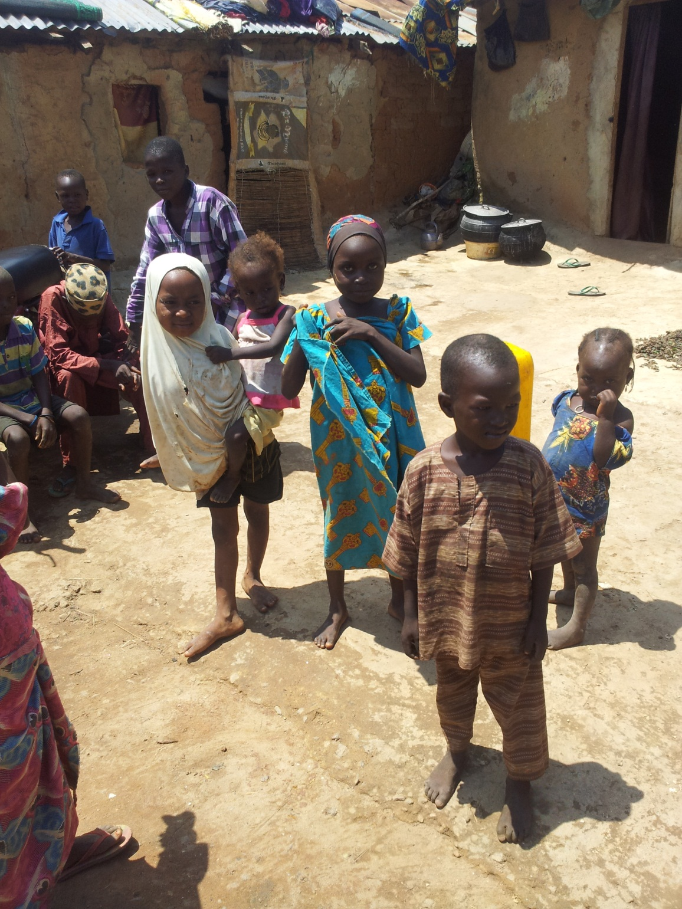

Children who need encouragement, to be able to go school.

