Global Giving Report from December 2018 to February 2019

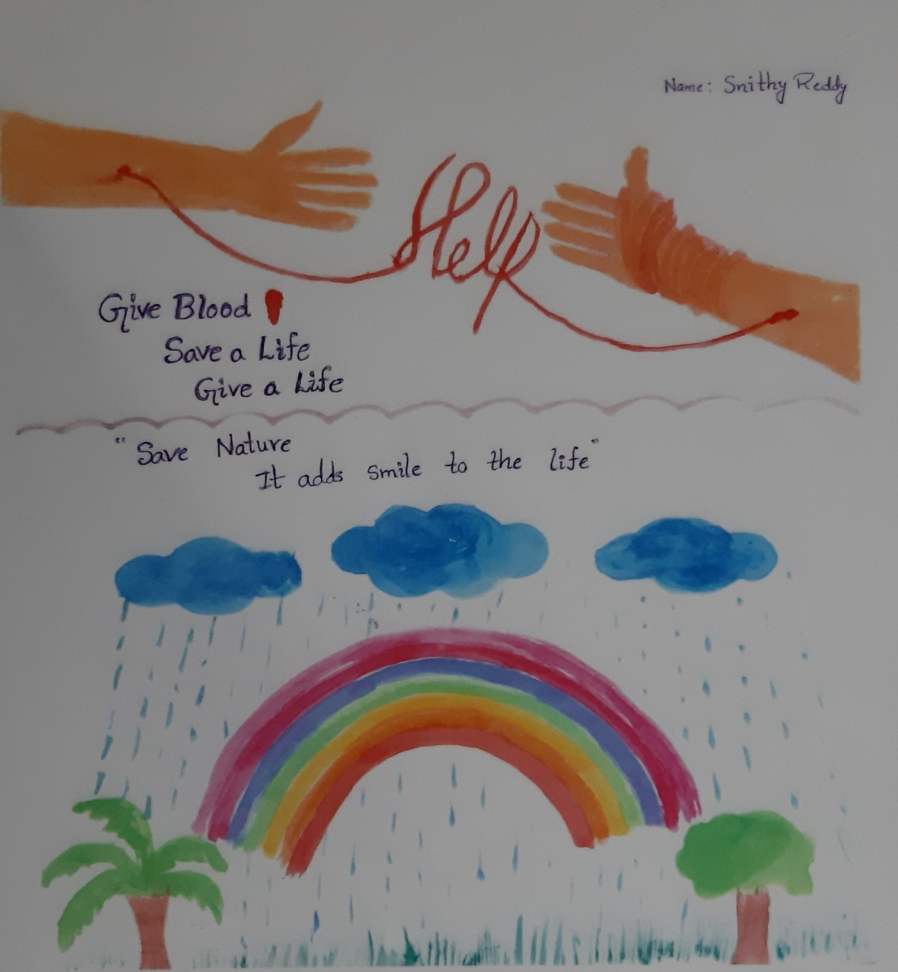

Give Blood…Save A Life…Give A Life…

Snithy Reddy, a 7 year old thalassemia patient, has been a regular at our blood bank. At a point where she thought there was no hope of her survival, Snithy and we fought for the life she deserved to have, no matter what. To attest to that fact, this colorful drawing shows her dedication to fighting the life she wants to have, no matter the kind of setbacks and drawbacks she has with regards to her health.
We, at Aarohi, realise Snithy is just one out of so many children suffering from a serious blood disorder and sticking to our mission, we aim bettering the lives of other Snithys all over India. Don’t just donate your blood, but also save Mother Nature at the same time!

Celebrating the Spirit of Volunteerism…

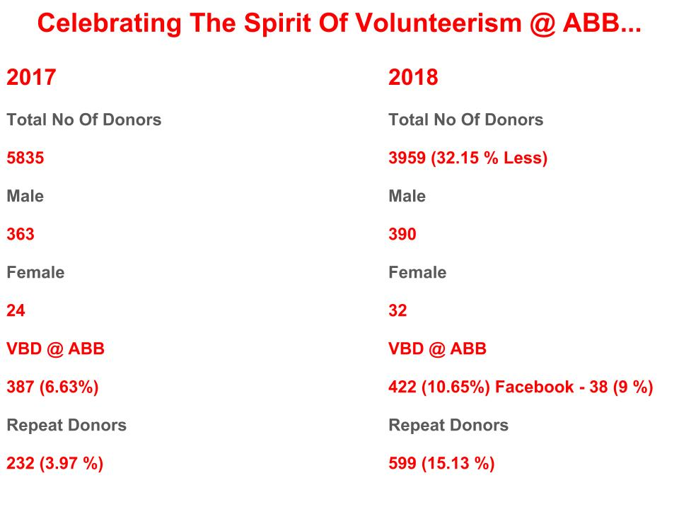
Despite being asked to stop camps without taking prior permission for each and individual camp by government organizers, Aarohi has managed to push through all obstacles with her head held high. Denied permissions? It’s okay. We have a solution. Worry not! We have just the right place which is looking for your valuable blood! At Aarohi, the walk in Voluntary Blood Donor, come what may, is our priority.

If we had not believed in improving the lives of those around us, we would not have grown from 6% of Voluntary Blood Donors (VBD) in 2017 to 10.6% of walk in VBD in 2018.

We are also happy to share that after partnering with Facebook for a pilot project to enhance the usage of Facebook tool for Blood Donation we could see an increase in footfalls of Voluntary Blood Donors in the period September 2018 to February 2019. With one of the largest social media platforms backing our growth and walking with us to fulfill our mission, we at Aarohi could not be more grateful for the support given. Thank you for being a part of this mission.

All these developments give us hope that we can strive together towards achieving WHO’s Goal of 100% Voluntary Blood Donation till 2020. We believe, like you do, that people are inherently good. We believe that you are working with us to help children live their lives to the fullest, with no inhibitions. Thank you for supporting us so far and thank you for supporting us into making the world a thalassemia friendly place!

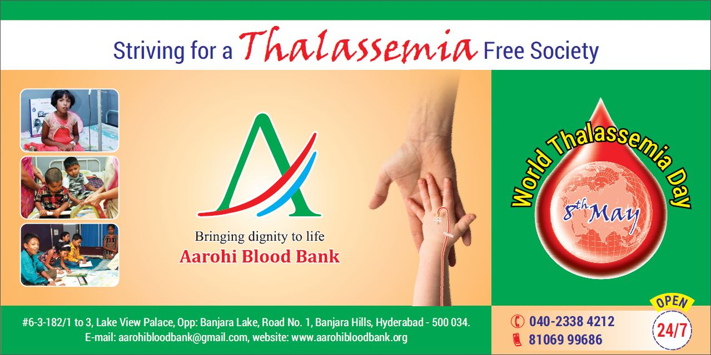

Regards,
Dr. Aditi
Project Leader

