GLOBAL GIVING REPORT FOR THE MONTH APRIL 2019 TO JUNE 2019
Aarohi Blood Bank creating awareness about World Thalassemia Day - 8th May 2019
To create awareness on Thalassemia and promote Voluntary Blood Donation in the community Aarohi Blood Bank (ABB) in collaboration with Seal The Smile group led by Usha K. made a short film titled “ECHOES – 2”. This film is special as all the characters played in the film are not professional actors but residents of a gated community and staff of ABB who volunteered to be a part of this mission. The film would be released soon on various social media platforms.
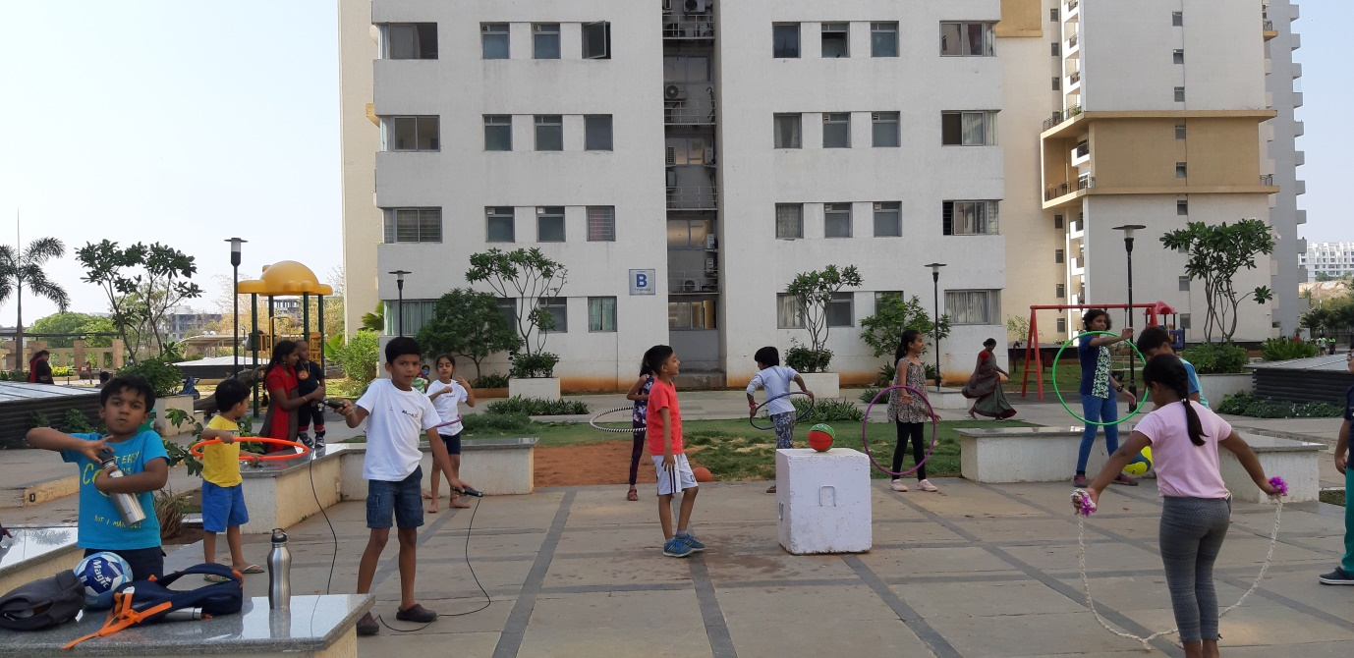
Pic: Echoes In The Making
Aarohi Blood Bank celebrating World Blood Donors Day on 14th June 2019
ABB runs its activities revolving around these 2 objectives:
- Support Thalassemia Children
- Promote Voluntary Blood Donation
With this objectives we insists on conducting Awareness Sessions on Thalassemia & Voluntary Blood Donation few days before each camp so that more people know about the severe need for Blood for Thalassemia patients as well as more people get ready to become a regular voluntary blood donors.
We conducted such a session at Conduent India Hyderabad office on 7th June 2019 before our scheduled camp on 14th June 2019. Dr. Aditi gave presentation on Thalassemia and how to prevent this genetic disease whereas Dhiraj spoke about the benefits of Voluntary Blood Donation and clarified some of the Myths on Voluntary Blood Donation. The response to the sessions was positive and a plan of good turnout of donors on the camp day.

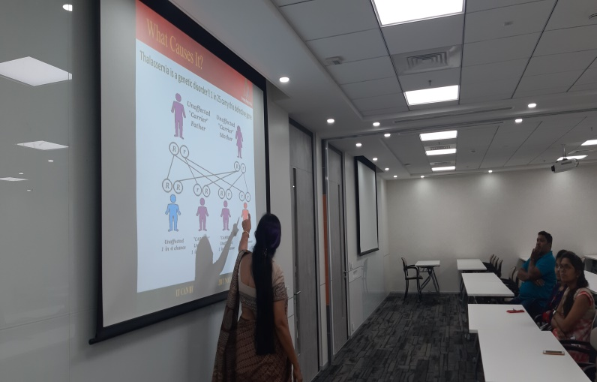
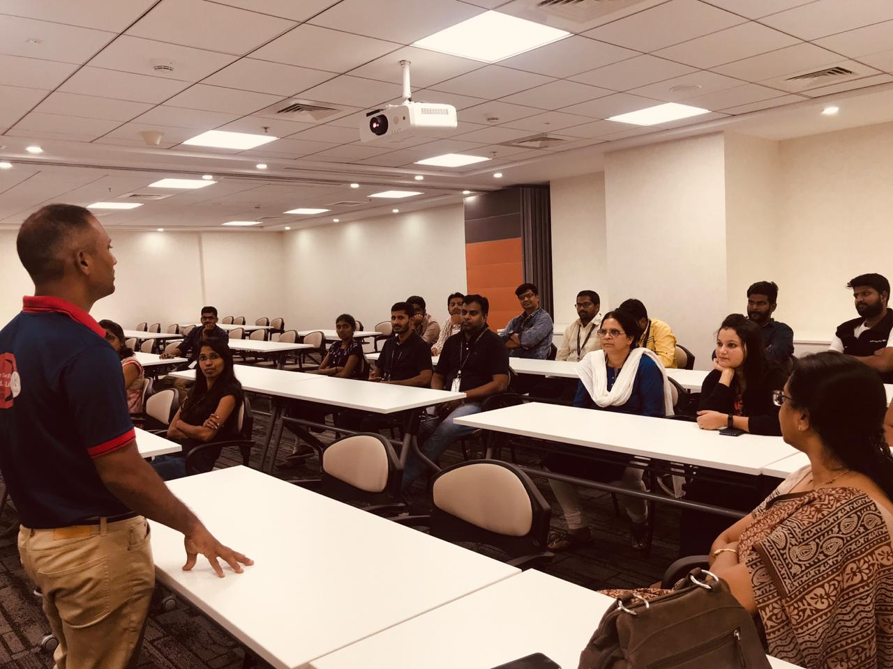
Pic: Dr Aditi & Dhiraj conducting the Awareness Session
Celebrating the Spirit of Volunteerism:
Chaitanya is a student of Hindi Mahavidyalam, Hyderabad who regularly visits Aarohi Blood Bank to donate blood and has also motivated his family and friends to donate blood.
As a token of appreciation we presented him with a small artwork done by one of our Thalassemia child Snithy Reddy.
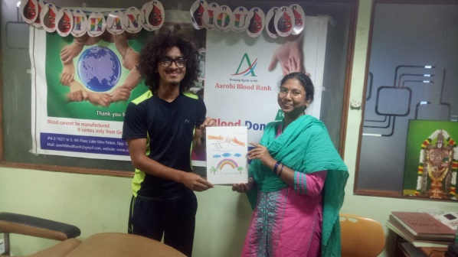
Pic: Medical Officer Dr. Sarita presenting the artwork to Chaitanya
We thank Global Giving and all the Volunteers who come forward regularly and support us in our endeavour to create more and more awareness !!!

