Project Report for August to October 2018

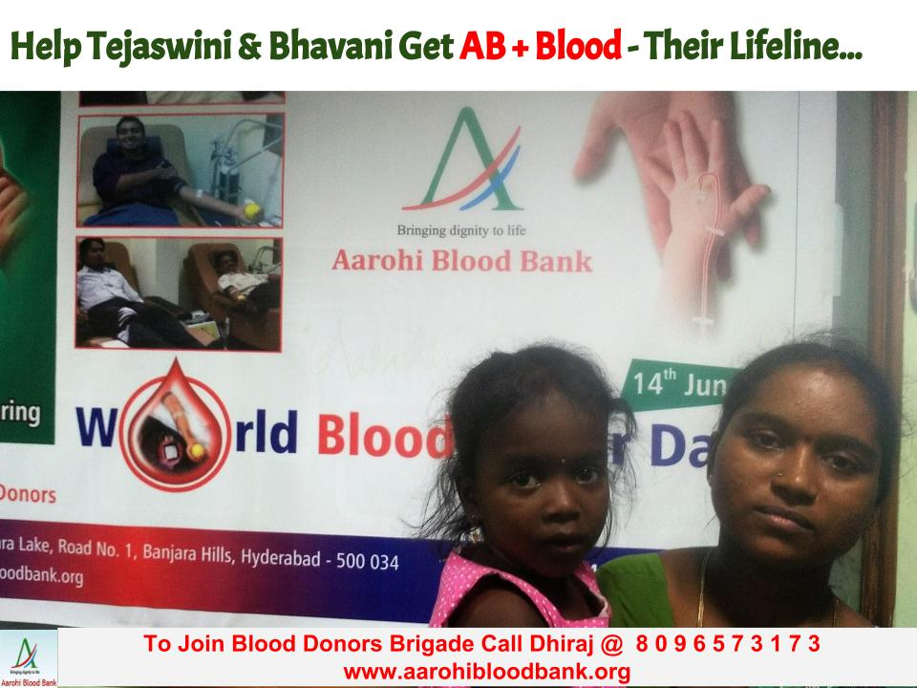

A mother of a 5 year old and 2 year old girls calls the blood bank at regular intervals. Her ask is "a unit of AB +ve blood for each of her daughters". With both the daughters requiring AB +ve blood for transfusion every 3 weeks she has to put in double the efforts for getting blood. With this, she is constantly under stress.
Only she knows how difficult it is to get blood on a regular basis, month after month since more than 5 years now. The blood transfused brings a smile on the face of the parents and the child.
Watch Anuradha appealing for blood for her daughters:

https://youtu.be/ON7WBcRFPEw

Aarohi has made efforts to get Blood, process it and issue it for transfusion to these siblings on a regular basis.
This is possible only because committed donors who comes either individually to the blood bank or in camps.
The funds donated by you all, helps in procuring, processing and issuing Blood free of any charges.

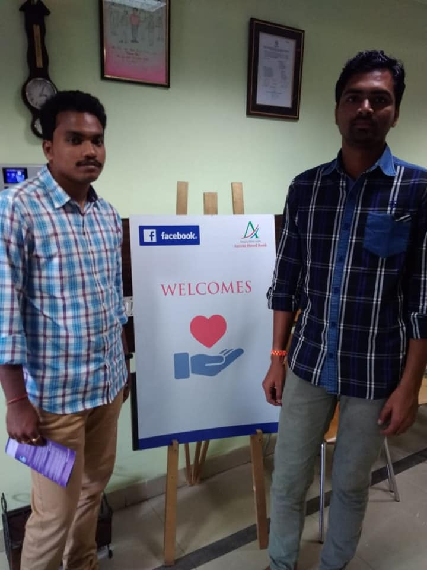

Facebook Blood Donation Project:
Aarohi Blood Bank's partners with Facebook on a 3 month project between August to October 2018 to reach out to Voluntary Blood Donors through Facebook Blood Donations Tool. Good response was shown from donors who came forward to donate blood.
Thanks a Lot each and every Donor. Without you, we don’t have a chance of continuing with this work !!!
Happy Thanks Giving to One and All !
Happy New Year !!

