**GLOBAL GIVING REPORT FOR THE PERIOD MARCH TO MAY 2018**

**Thalassemia Fund Raising Event in US:**

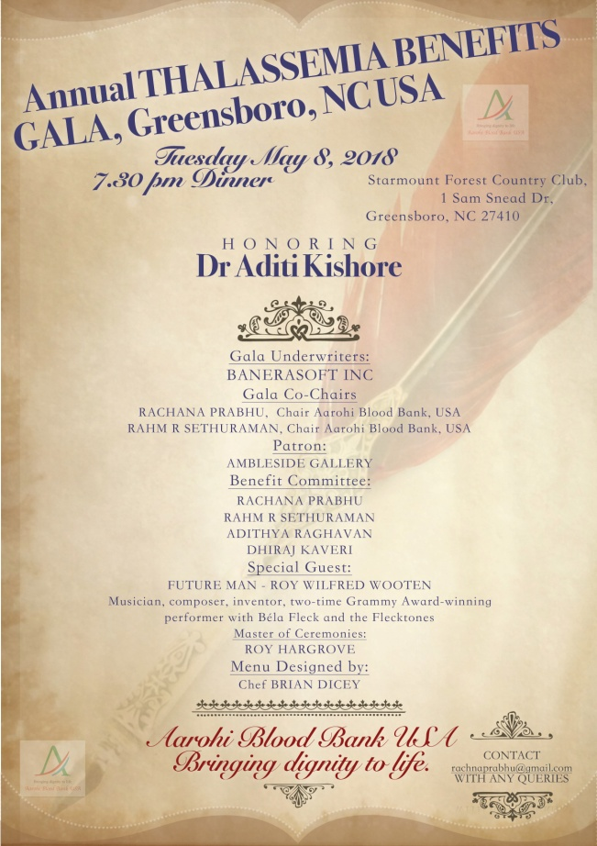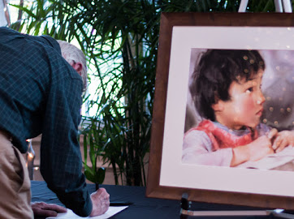

Some of Aarohi's well wishers who are from US decided to help us raise funds for Thalassemia children. With this aim the local group based in Greensboro, NC USA led by Ram Sethu organized a Dinner with Music by Roy Vutton. Ram is a regular blood donor and a marathoner who promotes Voluntary Blood Donation and creates awareness on Thalassemia through his runs.

Ram with his team of volunteers Rachana and Adithya organized an Annual Thalassemia Benefits Gala fund raising dinner for the locals of Greensboro on World Thalassemia Day 8th May 2018.

The event was an invite only with 60 people attended. There was a musical performance by 2 time Grammy award winner Roy Vutton.

The organizers also conducted a silent auction of 2 paintings by Chinese artist Guan Weixing.

The event altogether helped the team raise awareness on Thalassemia while also helped collect funds of approximately US $8000.

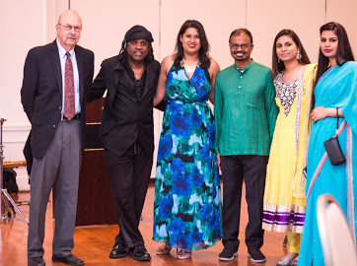

**Story of Ashish:**

Ashish from Jaipur finished his Master of Fine Arts Course from Hyderabad Central University.

In the last 2 Years from 2016 to 2018 while he was in Hyderabad Aarohi Blood Bank

almost every time ensured he get his 2 Units of AB+ Blood every fortnight.

We could give 26 Free Blood Issues to Ashish to help him during his academic years.

We thank all the Voluntary Blood Donors who helped us help Ashish & many others who are in need for Blood regularly through our project “Help Thalassemia Children Get Blood - Their Lifeline.”

Each of Ashish’s self portrait artwork reflects his mental status as a Thalassemia sufferer.

Ashish sharing his journey and the details of his work in this You Tube video:

<https://youtu.be/qaNHgbZZ9Co>

We have reached this milestone in our journey of helping Thalassemia children get blood all because of the generous individual donations and also the partnership of Global Giving.

Regards

Dr. Aditi Kishore

Founder - Aarohi