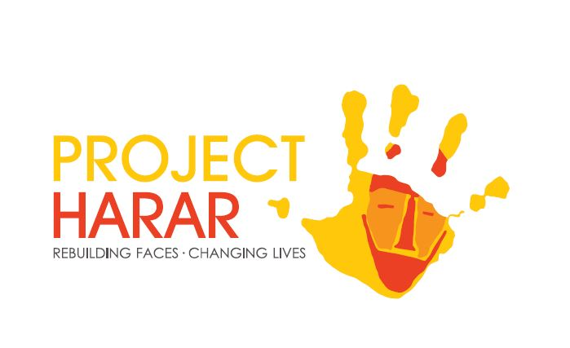
Nutrition Mission
Who are we?
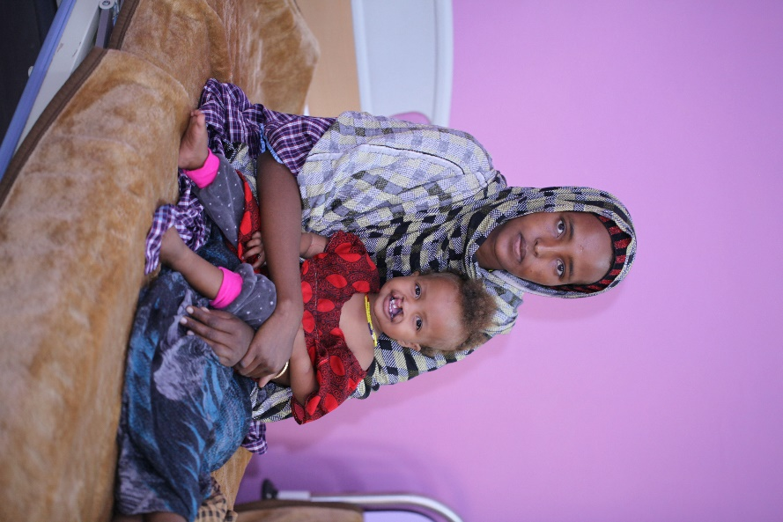
In rural Ethiopia many people living with facial disfigurements - be it cleft lips, animal attack injuries, or noma - are unable to access medical support. This can result in them becoming marginalised from their own communities. The outcome of this is that people suffering from a facial disfigurement may be denied education, the opportunity to marry, or even to get a job and earn a living. In a country where community is so important, someone being stigmatised for the way they look can be hugely detrimental to their way of life.
Project Harar exists to ensure that as many people as possible living in rural Ethiopia do get access to that treatment and are not denied much of what we take for granted. Our year round programme supports predominantly children (84% of our surgeries are on children) who otherwise would not be able to receive these medical operations either from lack of funding or lack of knowledge that these surgeries are available.
What is the Nutrition Mission?
In October Project Harar will send NHS dietician Natasha Mir to Ethiopia to deliver a series of training seminars to Project Harar staff and local healthcare workers in East and West Hararghe regions on how to create a balanced, nutritious diet for young children, and how to take accurate Body Mass Index (BMI) measurements.
Information on nutritious meal planning will help to dispel some of the myths which abound in Ethiopia surrounding what constitutes a nutritious diet, helping parents to keep their children at a healthy weight. Accurate BMI measurements will help healthcare workers to identify children who need special attention for being underweight, or who are rapidly losing weight, and enable extra food or dietary supplements to be allotted to these children.

Why is the work important?
Children who are born with cleft lip and palate in Ethiopia are unable to breastfeed. Due to a lack of knowledge of how to give a small child with cleft a nutritionally balanced diet, babies with cleft often become stunted and wasted as they do not consume enough of the food they need to grow properly. This can result in them being too small or thin to undergo an operation to correct their cleft, which they could get easily and for free through Project Harar. If children born with cleft do not get corrective surgery by the time they get to school age, it is unlikely they will go to school or receive an education.
Why are we working in East and West Hararghe?
The research that we conduct through our cleft programme has shown that a great number of children with cleft lip and palate in East and West Hararghe are being turned away when they come for operations due to being underweight or malnourished. Project Harar intends to trial nutrition training in this area, to monitor the numbers of children with cleft lip and palate who are turned away for reasons relating to their nutrition and – if the project is a success – to roll it out over a wider area within Ethiopia.
Muaze’s story
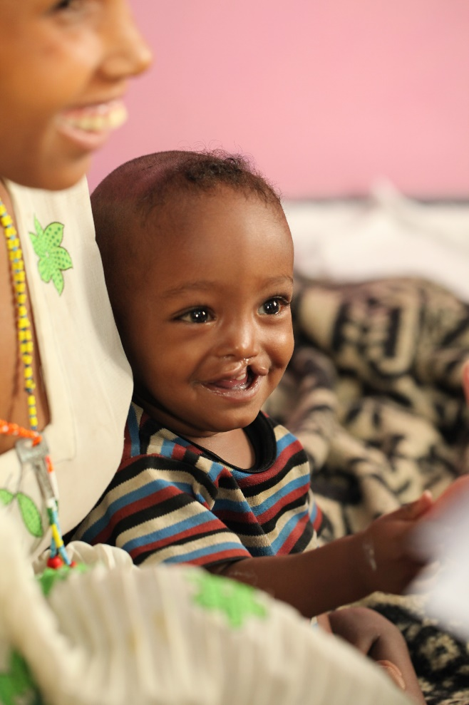
‘Muaze is our only child. When Muaze was born with cleft lip and palate I was very shocked. He was my first and when I saw this problem I immediately covered him with a blanket. I didn’t know what to think. I don’t drink or smoke or chew chaat, I thought I always ate properly when I was pregnant. We thought to ourselves over and over again, how could we have this problem?
‘I was ashamed and I felt as if it was our fault he was born this way. But the officials told us that there was a free service from Project Harar to get surgery for him so he could look normal, so he could have a normal life like other children.
‘When I heard this I breathed a sigh of relief and stopped worrying! He’s a lovely baby, he’s never any trouble and he smiles all the time. He’s a very happy child and I know I am very lucky.
‘Feeding him has been hard as he can’t latch on to my breast to feed. I ended up boiling milk for him and feeding him with cups. A nanny helped us to do this as we weren’t sure what to do. Our whole family has helped us with Muaze so we haven’t felt alone. We will look after him very carefully always.
‘I want him to be a pilot when he grows up! It would be unthinkable if he still had a cleft lip, but now he’s having the operation I can dream these kinds of things.’
Project Budget
Budget Item | Cost
4x4 and driver for 6 days to reach outlying areas for training | £468.00
Travel costs and per diem for healthcare workers and Project Harar staff | £624.00
Equipment to give to healthcare workers | £1,060
Hotel and food per diem for dietician for 14 nights | £504.00
Training costs (including venue hire and food for all trainees) | £392.00
Sundries (taxis, phone credit etc) | £77.00
TOTAL: | £3,855.00

Monitoring and Evaluation
Project Harar monitors cleft patients as a matter of course as part of our normal data collection. Following training we will collect data on patients from East and West Hararghe as they come into us, and monitor any changes in the number of patients who are turned away for being underweight or malnourished.
Our target is to reduce – down to as close to zero as possible - the numbers of children being turned away from having cleft lip and palate surgery for being too underweight to undergo the surgery safely.
Future of the mission
Our plan is to roll this mission out across East and West Hararghe, followed by other areas through Oromia, SNNPR and the Somali region over the coming three years depending on the success of this first mission.

