Grant Application Cover Sheet
Main Project Title:
Living Well Program for PD Patients
(KEEPING IN RHYTHM WITH LIFE)

Medical Doctors Capacity Building Project

Implementer: Parkinson Patients Support Organization – Ethiopia
Contact Details:
Founder: Kibra Kebede
Address: Tel: 0911-70-1362
Director: Talemos Data
Address: Tel: 0916-82-5331
Email: parkinsonsethiopia@gmail.com
parkinsonassociation11@gmail.com
Web: www. Parkinsonsethiopia.org
P. o.box: 31 code 1032, Addis Ababa, Ethiopia
Project Period 2016/17-2018 G.C
Project fund USD 11,006

Bank Account:
Commercial Bank of Ethiopia: 1000002963462
SWIFT: CBETETAA

Executive Summary

This very brief project designed to address the knowledge gap of Medical Doctors about Parkinson Disease. It is part of “LIVING WELL PROGRAM FOR PD PATIENTS-KEEPING IN RHYTHM WITH LIFE” where this specific project is entitled “Medical Doctors Capacity Building Project.

PPSO-E plans to train 60 doctors out of which 20 will be from A.A and the remaining 40 will be from SNNPR (10), Tigray (10), Oromia (10), & Amhara (10). This training will be conducted for 2 days in Addis Ababa by trained neurologist doctors from Black Lion & Zewditu Hospitals from Department of Neurology (Addis Ababa University Faculty of Medicine) collaboration with Ethiopian Medical Association (EMA).

The output from the training will be improved skill of medical practitioners and better diagnosis and treatment for PD patients.

The total estimated budget for the project will be birr USD 11,006

- Organizational Context

Parkinson Patients Support Organization-Ethiopia (PPSO-E) is an organization that works on Parkinson patients and their care givers. It was established as an association in May 22/2011 and later became local NGO in November 17/2014. It was registered by Ethiopian Charity & Societies Agency (CSA) with registration no. 2322.

PPSO-E was established with the purpose to fight against Parkinson Disease in Ethiopia. Parkinson disease (PD) is a progressive degenerative disorder of the central nervous system. The most obvious symptoms are shaking (resting tremor), rigidity, and slowness of movement and postural instability. PPSO-E is composed of the General Assembly (Supreme Organ), Board of Management, and team of experts. The pilot project activities of the organization are principally funded by contributions from international & local NGOs, and individual donors. Its staff includes 4 female and 3 male.

- PPSO-E Goal & Objective

Goal: Improvement of the quality of life for Parkinson patients and their care givers.

Objective: Parkinson’s Patients as well as their care givers handle the disease and their life situation confidently and successfully by applying their profound knowledge of the disease and its management.

- Problem Statement

As defined by World Health Organization (WHO), it is a "State of complete physical, mental, and social well being, and not merely the absence of disease or infirmity." Health is a dynamic condition resulting from a body's constant adjustment and adaptation in response to stresses and changes in the environment for maintaining an inner equilibrium called homeostasis. From this definition we can clearly see that everybody should enjoy completeness. However, PD patients are not enjoying physical, mental, and social well being due to Parkinson Disease.

Parkinson disease is a progressive degenerative disorder of the central nervous system. The most obvious symptoms are shaking (resting tremor), rigidity, slowness of movement and postural instability, constipation, sleep problem and a lot others. In the early stage patients can function independently in carrying out daily activities. As the disease progress, disability increases and quality of life deteriorates. In advanced stage caregivers assistance becomes essential. The worst scenario to observe about this disease in Ethiopia is that medical practitioners know little about the nature & treatment of this disease.

The interesting, yet sad thing about the disease in Ethiopia is that not only the patients but also the other health personnel do not know about Parkinson except few Neurologists in Addis Ababa. More ever, due to lack of information researchers do not get interest to do research on Parkinson. Hence Parkinson patients do not get diagnosed properly. In Ethiopia, almost all patients except Addis Ababa (where neurologist doctors concentrated) do not visit modern health institutions. That is why they are forced to go to traditional healers, holy water and others for treatment. If they do not get cured, they are forced to stay at home without any medication, and hope. Parkinson patient usually suffers until death or until situation gets worst without getting enough attention.

Also there is no other NGO, Associations, foundations or government body or other charity organization working on PD. PPSO-E is the only organization supporting more than 300 PD patients which need close medical attention. These are patents that get proper diagnosis. But almost all PD patients do not get proper attention. This is due to
- Parkinson is a nerve problem, has to be treated by Neurologist
- Neurologists in Ethiopia are very few and almost all of them are stationed in Addis Ababa
- To get Neurologist the patient has to pass through health station due to the referral system & that is why we are planning to train medical doctors. For the patients to get early diagnosis & care, the knowledge of health professionals (Medical Practitioners) has to be upgraded. To this end support is expected from donors, individuals, organization both at local & international level. New suffering patients should be diagnosed as early as possible. This requires training for medical doctors.

The goal to bring improvement in the quality of life for the patients and their families requires well trained medical professionals for treatment & diagnosis of the disease. Already diagnosed patients should receive continued medical checkup support.

If you think that you can help raise funds to support this project, even if it just a few Birr/dollars, please donate via the account information (Dashen Bank: C/A 5039781372002 and CBE: 1000002963462). If you would like to have a more personal connection with the project you are very welcome to contact the Founder (0911-70-1362) & the Director (0916-82-5331).

- Specific Objective for this Project

Improved capacity of Medical Doctors for early diagnosis of Parkinson Disease

- Expected Results/Outcomes
- General raise of awareness of the community and other relevant stakeholders
- Improved referral of PD patients to health stations/hospitals
- Quality of life for patients will improve
- Satisfaction and inner peace for the patients due to information.

- Project Activities

PPSO-E will undertake the following activities for this specific project:
- Select Doctors in collaboration with Ministry of Health, A.A Regional Health Bureau, Regional Health Bureaus
- Train doctors using specialist Neurologists
- Certify Doctors
- Follow-up Activities

- Who are the Project Beneficiaries?
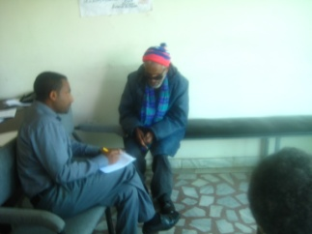
300 PD patients and their care givers in 10 sub cities of A.A Administration will be one of the key beneficiaries.

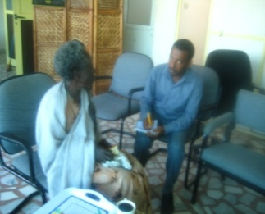
Medical doctors from A.A and other regions will be the beneficieries of this project. PPSO-E plans to expand its interventions to the other regions also (SNNPR-Hawassa, Orogmia-Adama, The Tigra-Mekele, Amahara-Bahir Dar). Parkinson disease affected families are living in all parts of the country.

The magnitude of the problem is so vast, but the resources available at the disposal of PPSO-E are very limited. Our organization is seeking support both locally and internationally to help the patients improve the standards of living for PD patients and their families.

By so doing they might not only cope with the effects of the disease, but also gain the knowledge and skills to empower them to take charge of their own future.

- Stakeholders

The main stakeholders for the project are PPSO-E, Parkinson patients and their care givers, Federal Charities & Societies Agency, Bureau of Finance & Economic Development, A.A Regional Health Bureau, CCRDA, Ethiopian Health Forum, Consortium of Non Communicable Diseases (NCDs), World Parkinson Coalition (WPC), Ethiopian Medical Association (EMA),

- Estimated Budget

A total of birr USD 11,005 is needed for 2 year project activities to be implemented by the organization.
No | Activity | Days | Qty | USD | USD
1 | Doctors Tuition Fee | 2 | 60 | 44 | 5333
2 | Doctors Transport | 2 | 40 | 13 | 1067
3 | Lunch | 2 | 60 | 18 | 2133
4 | Refreshments | 2 | 60 | 9 | 1067
5 | Trainer fee | 2 | 4 | 50 | 889
6 | Patient Diagnosis Expense) | 2 | 10 | 14 | 220
7 | Training Materials |  |  | 61 | 297
 | Total of Costs |  |  |  | 11,006

ANNEXES:
- Pilot Project Activities

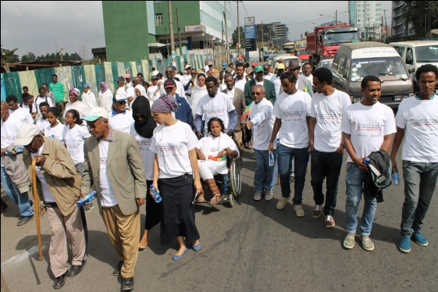
Since its establishment, PPSO-E brought hope to many PD patients & their families. Patients are helped to keep in rhythm with life. The organization has been rendering various services to PD patients, patient family members, medical doctors, health extension officials, health journalists, health extension workers, the general public and media.

2.1 Awareness Creation...PD Walk
One of the key intervention areas of PPSO-E is creation of Awareness. Because of absence of Information, PD patients exposed to different but intermingled challenges. These include poverty, social isolation, lack of empowerment and stigmatization.
PD Walk Nov 2015
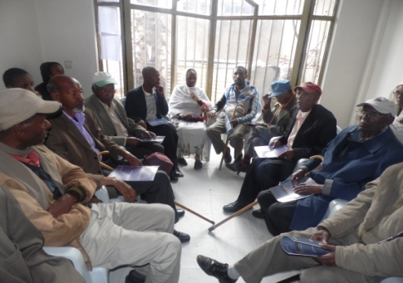
Not only the patients, but also the doctors and other health personnel do not know about Parkinson. Hence Parkinson patients do not get diagnosed in timely manner,. Researchers do not get interest to do research on Parkinson. In Ethiopia, almost all patients except Addis Ababa ( where neurologist doctors concentrated) do not visit modern health institutions. That is why they are forced to go to traditional healers, holy water and others for treatment. In most of the times they do not get cured. So they are forced to stay at home without any medication. World PD Celebration at Office

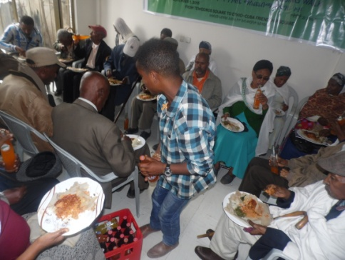
Key to the empowerment of marginalized community members like PD patients is unfettered access to relevant information on Parkinson disease, its symptoms and the innovative management techniques. Development of skills and capacity that would equip these communities to utilize such information is important.

In the light of the above facts PPSO-E conducts several workshops meetings, Parkinson awareness Walk as well as celebrates World Parkinson day each year in the Month of April as it is internationally dedicated day to think & talk about Parkinson. Lunch sharing experiences and at Office

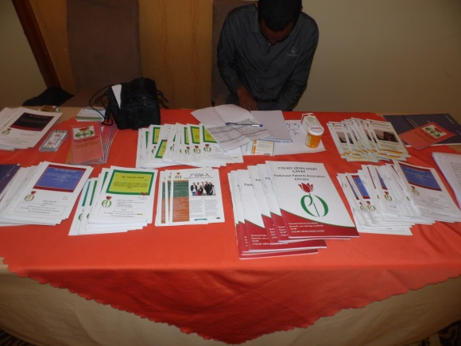
Reading Materials
PPSO-E also produces reading materials for Patients and care givers so that they may read and manage their life. Reading materials are helpful for the general public as well as researchers who might be interested to conduct further research.

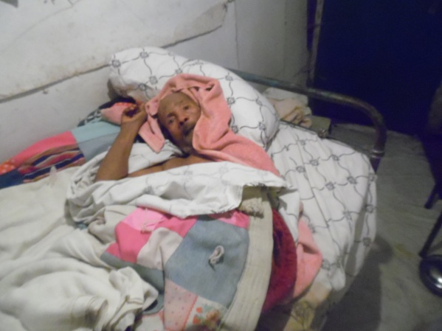
2.2 Care & Support Component Activities

Since its establishment, PPSO-E has been fighting the disease through awareness creation activities. However, PPSO-E came to realize that that raising the awareness without providing supportive physical, material and is equivalent to giving a very beautiful car without the key, the right to drive and the fuel to run the car. We pay house to house visit to some patients who are economically very poor and unable to walk. We provide drugs & some amount of money to sustain them
Bed Ridden PD Patient---Ato Bogale

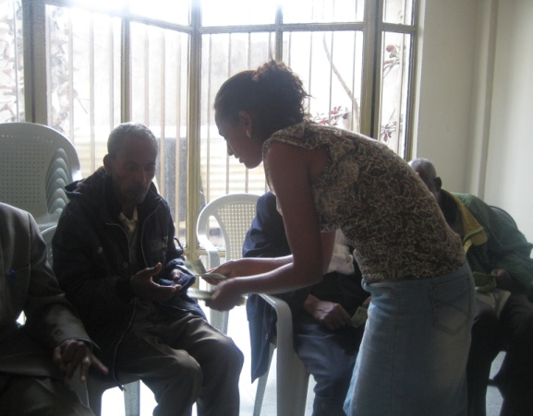
PPSO-E has been supporting over 300 PD patients so far by providing trainings, consultations, reading materials etc. Out of these 40 chronically affected beneficiaries are receiving financial support. Some of whom are bed Ridden, forgotten by family members, neighbors and the community because people do not clearly understand the nature of the disease. Once PD starts, it proceeds to worst stage with no cure. The way to help them keep in rhythm with life is provide continued financial and material assistance.

Income Support Photo:

2.4 Capacity Building Component:
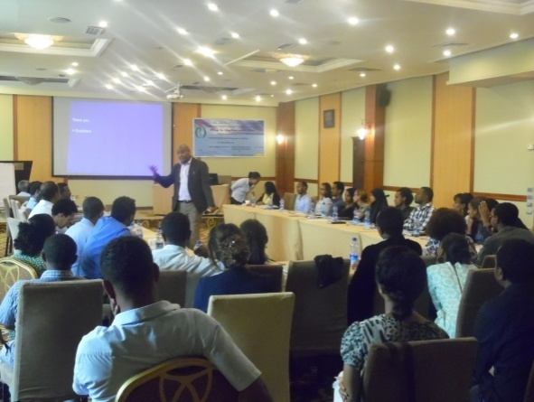
Doctors Training
PD patients are either misdiagnosed or totally not diagnosed in Ethiopia. This happens because medical practitioners themselves are not well equipped in the knowledge & skill of Parkinson Disease Diagnosis, and Management. Because of this Patients are forced to take wrong medication for years or they continue without any medication/treatment. To help general practitioner doctors understand the nature, symptoms & management of disease, PPSO-E provided capacity development training to 47 medical doctors on diagnosis of PD disease. Medical Doctors Training

Patient & Care Givers Training
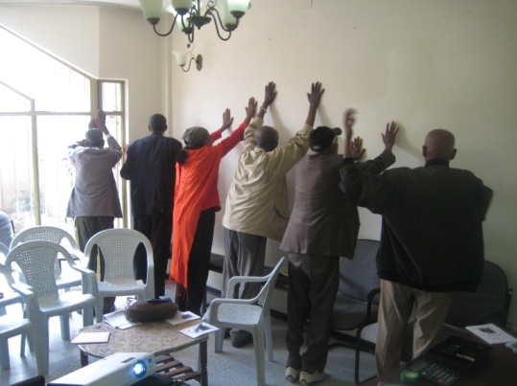
One of the key issues in Parkinson Disease management is developing the capacity of patients and their care givers on the disease management.

PPSO-E had been delivering disease management training, experience sharing opportunity, speech therapy training, consultation & motivation, care taking for PD patients so that they may improve their knowledge & skill to maintain their hope and keep rhythm with life.

Patient Training

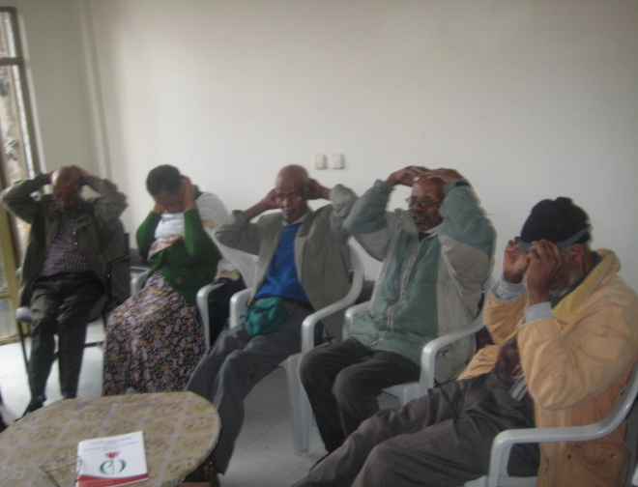
Care givers training specifically focuses on how to provide proper care to the patients without forgetting themselves.

- About the Founder (Kibra Kebede)

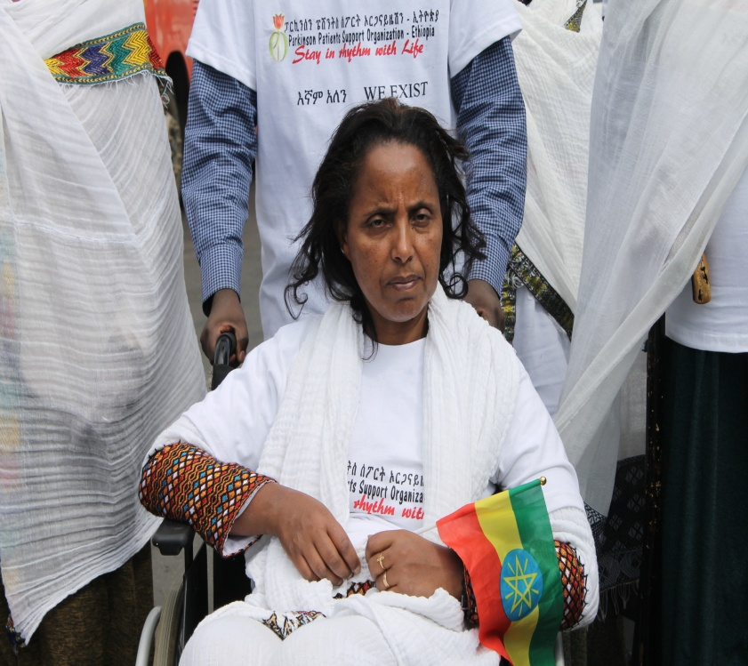
Kibra Kebede has been a Parkinson patient for the past 18 years. Parkinson is a degenerative and progressive disease of the central nervous system. It affects people over the age of 60. However, about 10 % of the patients are below the age of 50 starting from late 20s. Kibra was among those young onset patients. Kibra was affected by PD few years after she got her MSC and has suffered for at least 3 years before she got treatment..She was also a victim of stigmatization until she travelled abroad and got diagnoses. The reason for the suffering was the lack of information and knowhow on the cause and effect of Parkinson both by patients and the general public.

Based on her experience she wants to help people with Parkinson’s. KIBRA WAS the 1st PERSON with Parkinson’s THAT CAME OUT IN PUBLIC here in Ethiopia. Then, she and her family and few other patients started laying out plans and strategizing the establishment of Parkinson’s Patients Support Organization – Ethiopia (PPSO-E) and operational since, 2011.

Ever since, Kibra has been busy creating awareness about the disease and encouraging members to follow through their treatment. PPSO-E is now working with various FM radio stations and print media. In addition massive capacity building has been given to patients and other stakeholders. Kibra is never tired producing reading materials in Amharic, giving interviews, speeches and bringing hope to the people with Parkinson’s. A magnificent achievement was observed. However, she still does not want to give up helping the poor. She realizes that it is difficult to achieve the goal of the organization that is helping PD patients and care givers to live quality life. Unless other programs are implemented such as care & support & IGA, awareness raising only is insufficient to combat against the disease and its associated impacts.

TO DONOR COMMUNITY: SUPPORT PPSO-E & MAKE THE HOPE OF KIRBA AND HER DEDICATED STAFF FULLFIL THE GOAL OF THE ORGANIZATION.

- Patient Case Study (W/o Yetayesh)

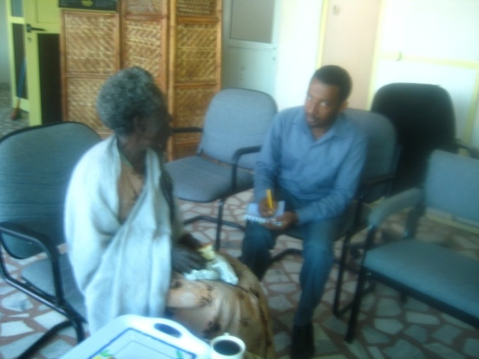
W/o Yetayesh came to our (PPSO-E) attention 4 years ago when our staff met her in black lion hospital, She was remembered by her comic comments she made on her condition. She had a dream of visiting her only son in Dire Dawa. She said they didn’t meet for ages.

Few years ago she became one of our active beneficiaries. She used to represent us in media for her good articulated speech before her PD symptoms became severe.

She lives in a very small rented room with very limited cooking utensils. W/o Yetayesh had no permanent job. She has been working for people going home to home. She had a number of customers in her surrounding until she becomes Parkinson patient 10 years ago.

As the nature of Parkinson, the health of W/o Yetayesh was getting worse and worse, she couldn’t manage to come to office and join us in our several meetings. Now she is suffering several acute Parkinson symptoms, she has walking and freezing problems, constipations, speech problem, drooling, etc.

The other challenge she faced is the absence of care giver to look after her. So she is by herself now. No one helps her or supports her. She has to feed herself, wash her cloth, clean her house, and dress herself. In addition to difficulty moving to inside and going outside her house, her sanitation is also greatly affected.

With regards to medicine, she takes free of charge care from Black Lion Hospital. She also gets 300 birr per month medication assistance from Parkinson patients Support Organization-Ethiopia to purchase medicine; With regards to food she has no permanent source. It is provided by her neighbors’ and former customers. In order to secure her meal she has to be seen by her former customers.

The above mentioned activities were performed by her every time but problems start to be exhibit nowadays due to progressive nature of her disease. Especially activities related with movement are greatly affected due to freezing and walking problems. Several PD patients have this type of problems looking for financial & material assistance. PPSO-E looks for helping hands to fight the disease & its recurring effects.
- Patient Case Study (Ato Bogale Gebretsadik)

Ato Bogale G/Tsadik lives in the compound of YMCA in Addis Ababa. He lives in a house of made up of corrugated Iron Sheet (2m x 2m). He reports that the house is very cold during the night and extremely hot during sunny days. Realizing his situation Ethiopian Bank Club assisted him in covering the inner side of the house with a view to reduce heat & cold. The floor is covered by old plastic that has holes everywhere. It Is full of dust and has a lot of crawling & other insects.

He was born in Hadiya zone near the city of Hosana. His age is around 56 years. He attended school up t grade 8th after which he became a box player. He had been playing box for 10 years and he managed to become champion for 7 times in Ethiopian mid 1980s. According to him, he began to feel health problems associated with mobility disorder since 1986. He visited few health institutions but he didn’t get any proper diagnosis and treatment. Consequently, he only knows he has a problem in his nerve system.

He has no one to look after him. He neither has a wife nor any children to take care of him. He did not save any money for bad times as he was not well paid. Due to progressive nature of the disease within four to five years time, he couldn’t be able to generate income for food and accommodation. He petitioned the Ministry of Culture & Sports at the time for assistance. Feeling very sad at the incident and being disturbed by his condition, the Minister gave an instruction to YMCA management to arrange food and accommodation to him. Since then he got the present location to feeding and sleep.

Recently Ato Bogale suffers from severe tremor, pastoral instability; in general he has got all symptoms of Parkinson. But he had not been diagnosed for that as he has no money. He didn’t know that he has a Parkinson Disease. He has no information about Parkinson. The word itself is new to him. Fortunately he got a place to sleep and food to eat due to permanent instruction given by the Minister some 25 years ago. But now that his mobility is progressively diminishing, he has no one to bring him food from the cafeteria to his dormitory. More often than not, he spent days without food due to lack of a care giver. He has no money for tea, soap, and other basic necessities which are not covered within the instruction from the Minister.

Had he been in possession of some money, he could have hired someone to bring him food from the cafeteria to his dormitory, clean his room and wash his clothes. Ato Bogale leads a miserable life with no diagnosis and medication, without advice and comfort from patients, without care giver and without money. He is only a little bit above the dead ones

