PROJECT SUMMARY

Bugema Community Child Based Organization (BCCBO) UGANDA is helping 120 children with special needs from poorest families in Rural Uganda by providing Health Care, Special Education, Legal Assistance, Housing, Food, Clean & Safe-drinking water. Among these children, there are four lame children with Heart Complications who need urgent Operation in India. Their health condition is worsening! Your urgent Donation will help to take George, Doreen, Arthur and Linda to India for Heart Operation.

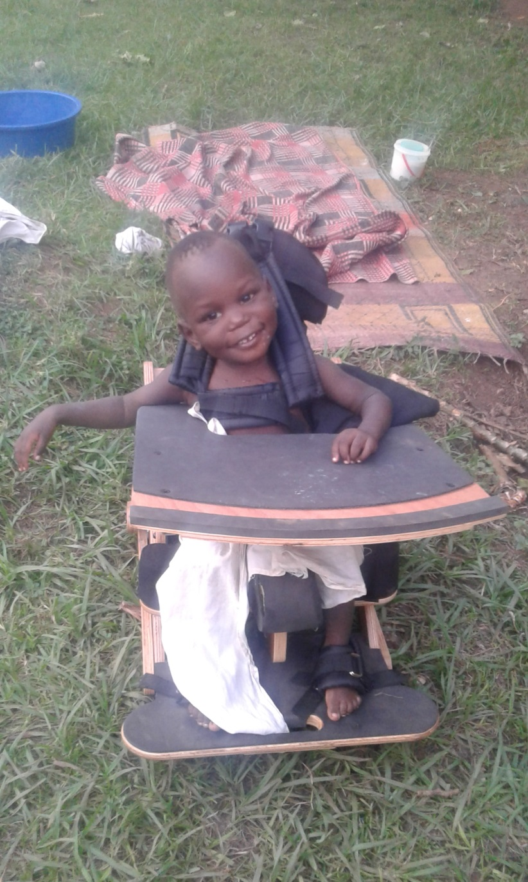
WHAT IS THE CHALLENGE/ PROBLEM
George, Doreen, Arthur and Linda are disabled and orphaned children in Rural Uganda. They come from the poorest families in Remote Uganda. Bugema Community Child Based Organization (BCCBO) UGANDA, Put George, Doreen, Arthur and Linda into orphanage home where they are being provided with food, water, clothing and health care. However, these children were diagnosed with Heart Complications. Their health condition is worsening, so they need urgent Heart Operation in India, through your donation.

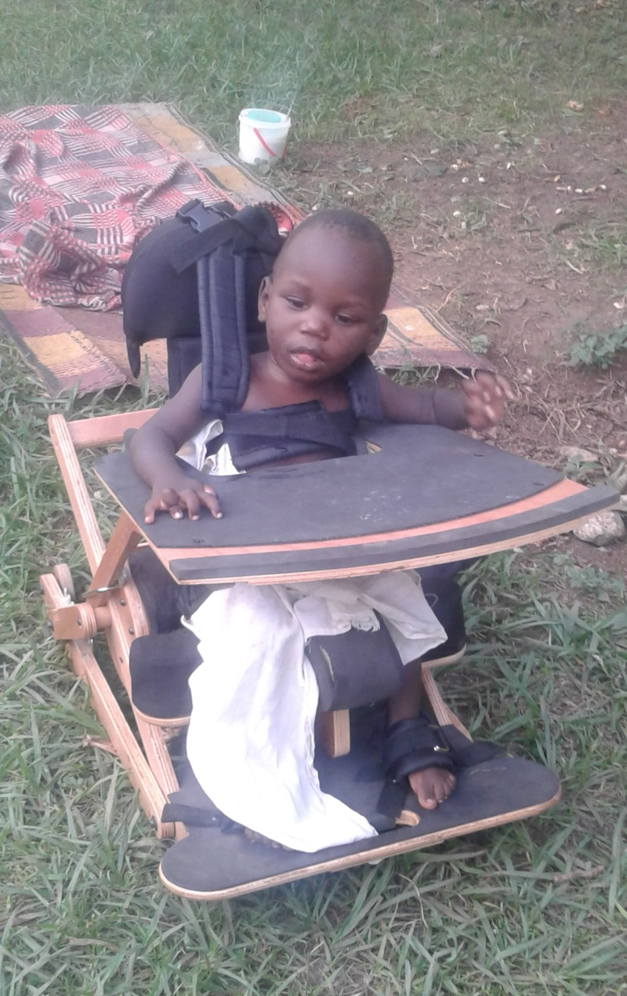

HOW WILL THE PROBLEM BE SOLVED
Through your generous heart (Donation), George, Doreen, Arthur and Linda are taken to India for Heart Operation, their health status will improve, and they will resume school, and live a happy and healthier life! Remember, you are the ONE making this happen in the life of Doreen, George, Linda and Arthur!

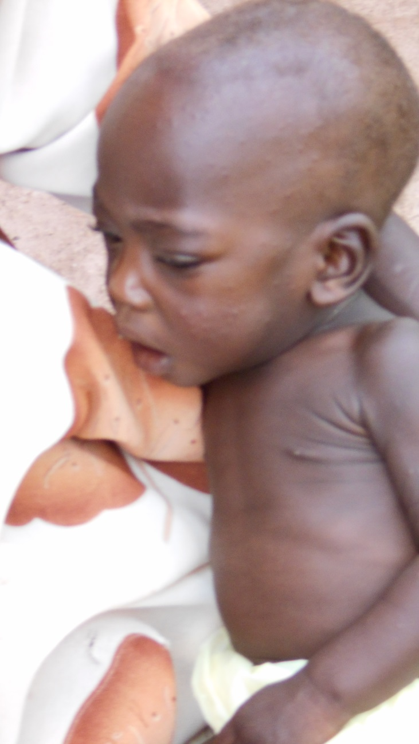

LONG-TERM IMPACT
This project of reaching out children with Heart Complications will continue. Bugema Community Child Based Organization (BCCBO) UGANDA will continue training more trainers in Home Care and Support for people with Heart Problems in Rural Uganda. BCCBO will also continue soliciting for support from other generous people like you to help children with Heart Complications to seek medical treatment in India.

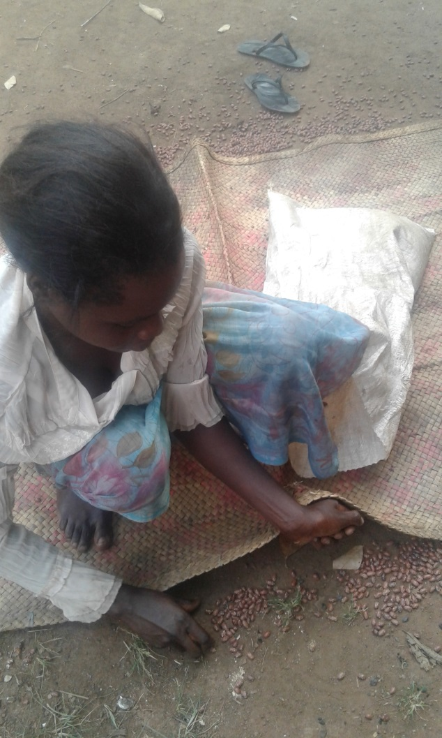

(THIS IS ADDITIONAL INFORMATION ABOUT THIS PROJECT)
Bugema Community Child Based Organization (BCCBO) is giving a hand up to thousands of the most deprived orphaned and disabled children in Rural Uganda , to ha Education to have access to Quality Education, Better Health Care, Clean and Safe drinking water, Better Nutrition and Legal Assistance. We also take unique Holistic Human Rights -Based Approach to ending the cycle of poverty that also incorporates nearly 850 elderly grandmothers.
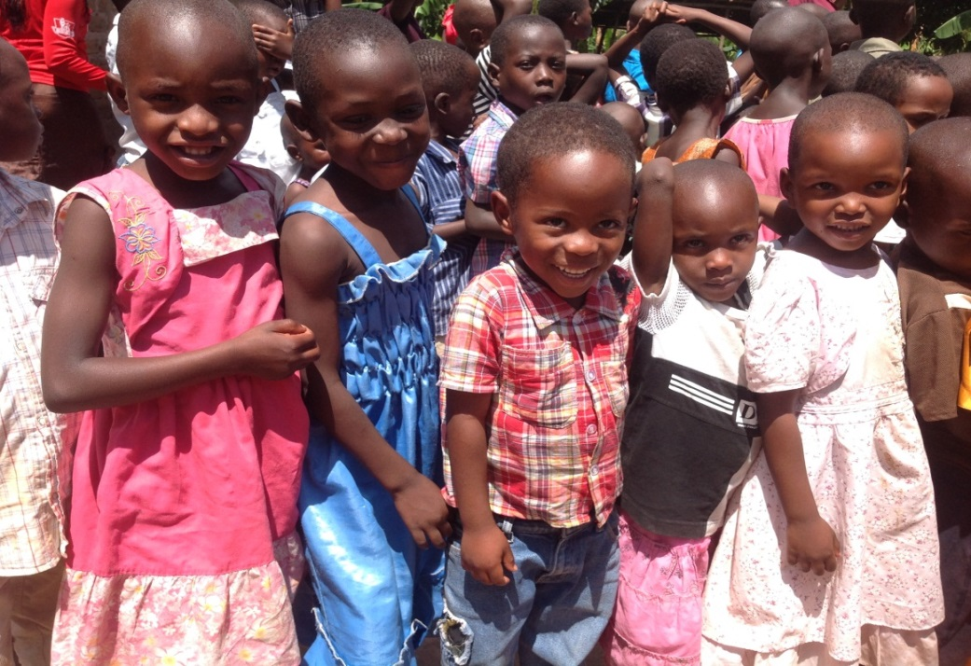

Out a population of approximately 34 million, Uganda’s HIV/AIDS Out of a population of approximately 34 million people, Uganda’s HIV/AIDS pandemic has resulted over 2.5 million orphaned children who have lost one or both parents. In addition to stigmatization and traumatization they experience for losing their parents, orphans and disabled children in Rural Uganda go without many basic human needs, such as food, shelter, health care, clothing and education. While the African extended family has traditionally stepped in to support orphans, the devastating impact of HIV/AIDS pandemic has overburdened this traditional safety net. 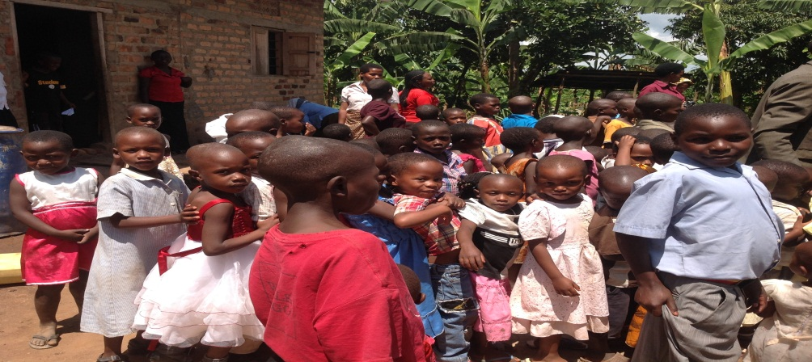
The BCCBO (Bugema Community Child Based Organization) AIDS Orphans and disabled children Project was born out of this crisis. The BCCBO Orphans and disabled children Project is working on behalf of orphaned children in Rural Uganda to address systemic deprivation, poverty, hunger and suffering through a holistic approach to Community Development, Education and Healthcare.

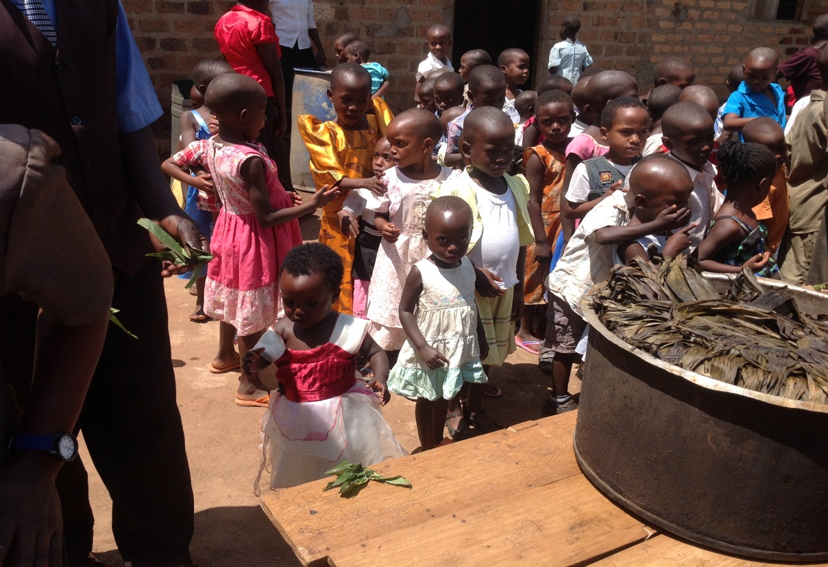

We envision the Rural Communities of Uganda are able to build strong community and family structures using holistic and sustainable approaches that address challenges they face due to the HIV/AIDS pandemic and disabilities with on children and women.

YOUR DANATION MAKES A DIFFERENCE IN A CHILD’S LIFE IN RURAL UGANDA!

Yes, together we can

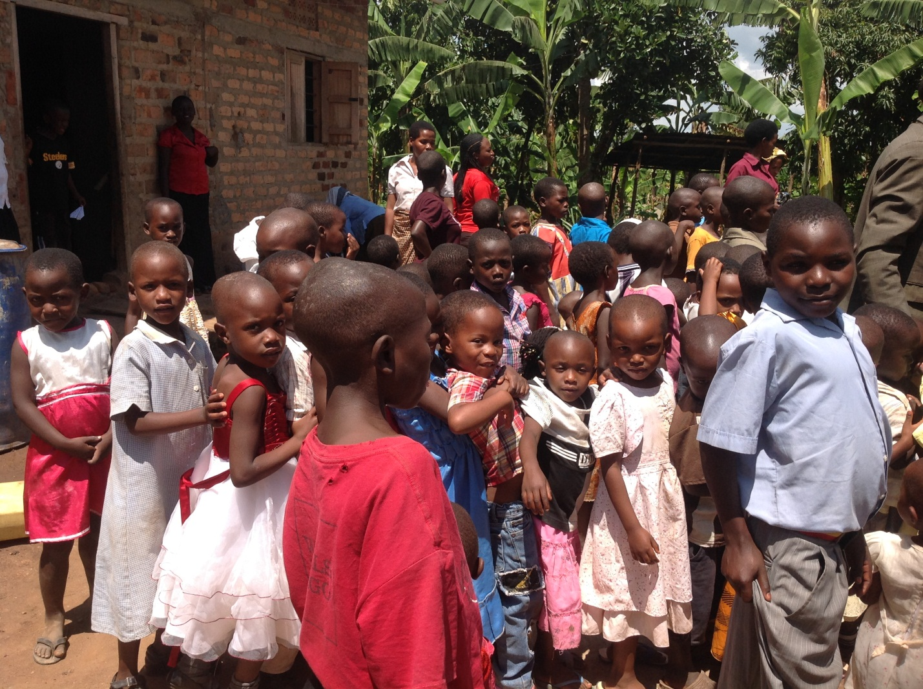

YOUR DANATION MAKES A DIFFERENCE IN A CHILD’S LIFE IN RURAL UGANDA!

Yes, together we can

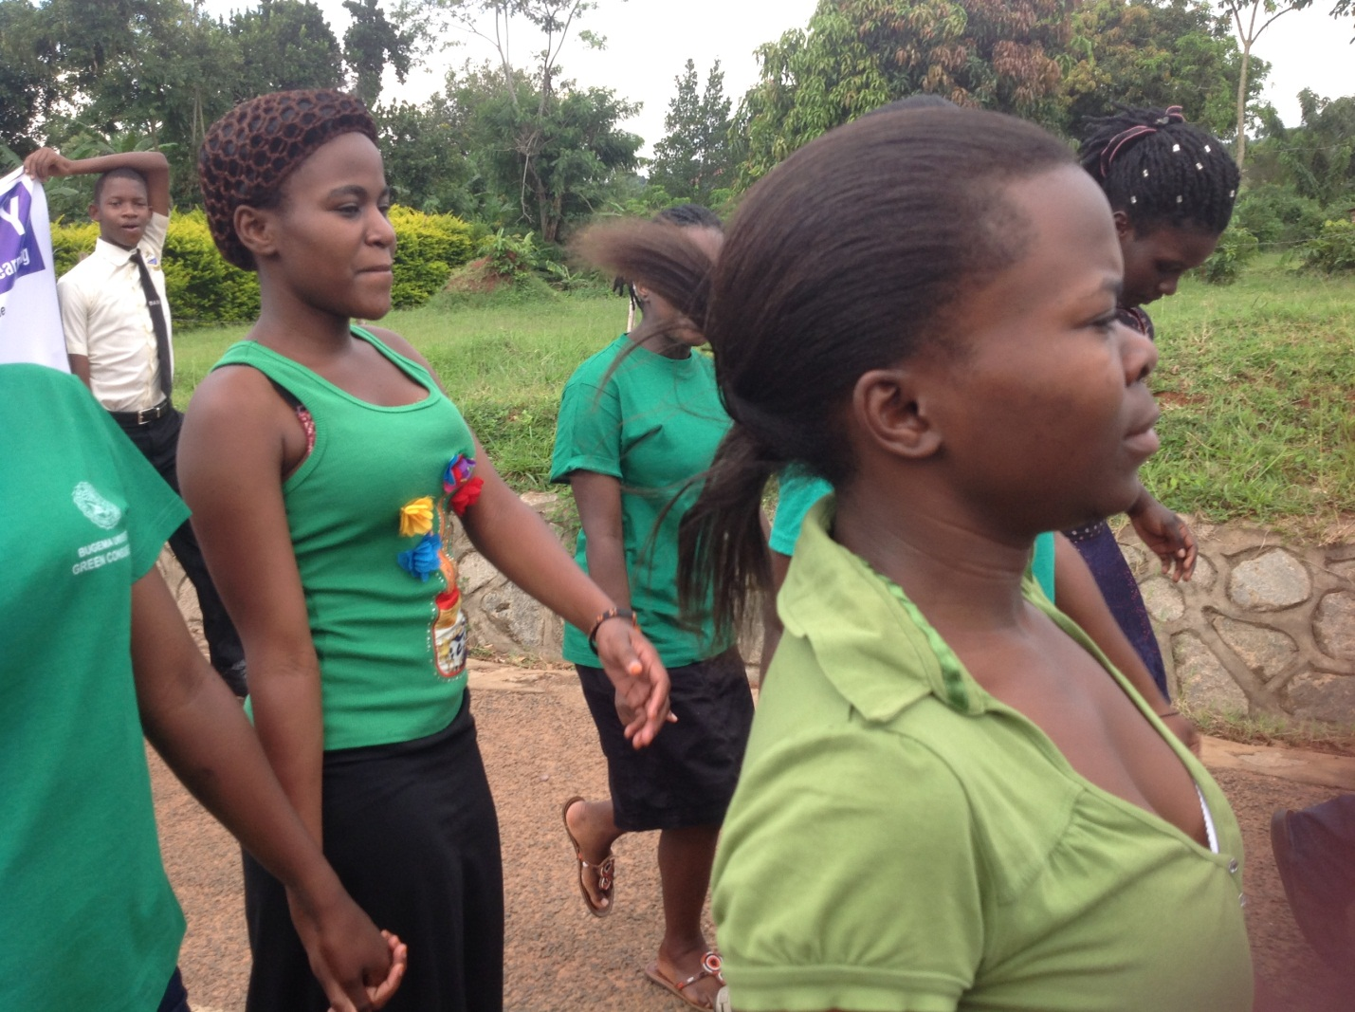

YOUR DANATION MAKES A DIFFERENCE IN A CHILD’S LIFE IN RURAL UGANDA!

Yes, together we can

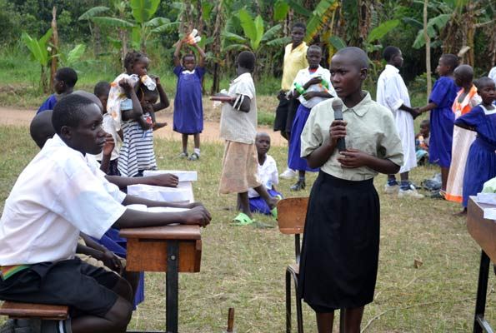

YOUR DANATION MAKES A DIFFERENCE IN A CHILD’S LIFE IN RURAL UGANDA!

Yes, together we can

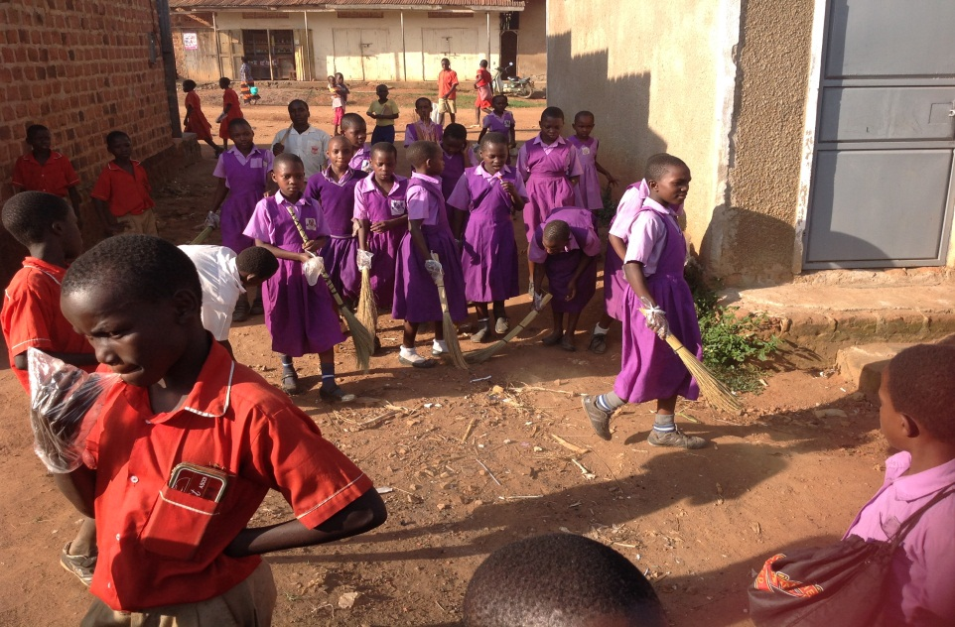

YOUR DANATION MAKES A DIFFERENCE IN A CHILD’S LIFE IN RURAL UGANDA!

Yes, together we can

