Project Information - Agriculture Development Initiative in Tribal Areas
Personal Information of Head of Organization/Applicant
First Name | Dr. Mukesh
Last Name | Goswami
Email Id | janmitram@gmail.com
Contact Number | (+91)9826144243
Country | India
Grantee Organization Information
Organization Name | JanMitram Kalyan Samiti
Date and year of registration | 31st October, 2002
Nature of organization | Society, Registered under CG societies registration act 1973
Country | India
State/ Province | Chhattisgarh
City/Town | Raigarh
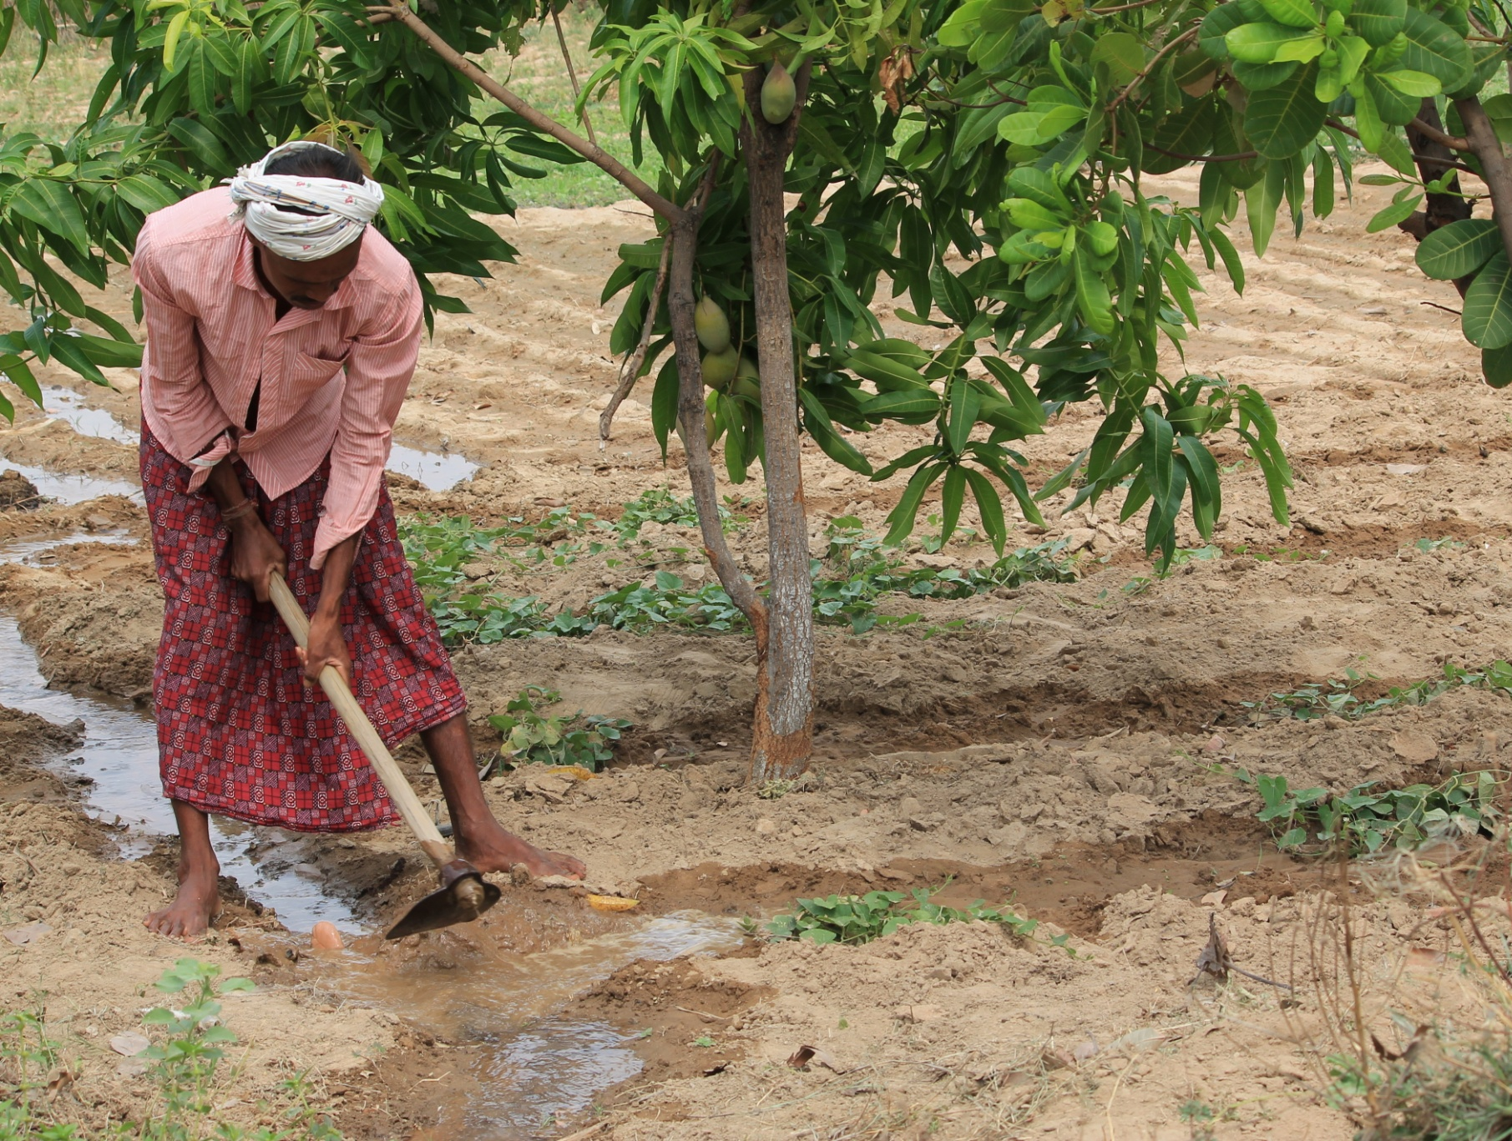

- Executive Summary
JanMitram Works with farmers and tribal for livelihoods and natural resource Management. Our intervention includes NTFPs, farmland development and Soil-water conservation through watershed techniques. CAPART, NABARD, National Medicinal plants board, Chhattsigarh forest department and Govt. of India have funded such projects that has been successfully translated their objectives into impacts. This project concept have evolved from the experiences of NABARD Wadi project (2011-2016) implemented with 700 farmers,
In this region, Agriculture and forest products are chief source of livelihood. Farming is subsistence and yield is low. Scarcity of irrigation leaves agriculture for rain-fed; hence single crop is norm. Agriculture has also suffered of uncertain rains and climate change. Food and nutritional security have been threatened. Tribal are most vulnerable of these changes and most affected. Stringent forest laws and depleting forests have skewed their option. They are getting more and more depend on farming, over small landholding. Youth, including girls are migrating outwards where often they are subject to exploitation and harassment.
This project is to take-up 500 such tribals (100 Acre land) to provide a respectable way of living, of which they are accustomed and comfortable. With Help of Kind hearted GLOBAL GIVING Doners, our organisation will bring families together to develop their land through Fruits plantations and Vegetable farming. Donors shall be supporting plantations and first cycle of vegetable farming. you will be supporting water sources and other assets to be commonly used by group of families. Our organisation will supplement efforts with tech-dissemination, advocacy and institution building.
- Problem Statement
As stated, depleting forests and stringent forest laws have increased dependency, on already suffering agriculture. Tribes depend on small holding and cursed to spend entire life in misery. Goud, Uraon, Kanvar and hill korvas are poorest, resource-less and venerable tribal communities. They lived on forests and whatever small landholding they encroached. Recently amend laws has recognized land rights through Van-Patta. But lands are unfit for normal farming. Minor millets and inferior pulses grown normally cannot meet ends. Therefore, Agriculture development initiative in these tribal areas is necessary for uplift-ment.
We can recognize the basic reasons or bottlenecks to achieve this, as follows:
- Unfertile, uncultivable land: Hilly, sloppy, eroded, undulating tracts comprise a large part of land resources and they are not under cultivation. Wastelands comprise 30-60 % of a village area; a sizable part of it can be developed and brought under cultivation with investment and efforts
- Lack of irrigation facilities: Whatever harvest is presently taken, is rainfed. It means land is cultivated once in year, adding its underutilization. Electricity, which is either supplied intermittently or missing at all, is not helpful to utilize well, pond, river, and ground water.
- Lack of farming skills: farmers do not have skills and know how to utilize available resource. Regional research in agriculture is dismal and extension work is not yielding. Farmers need to learn not only new techniques but need to improve basic skills, from tilling to harvesting. Conservation of soil moisture, watershed approach, multi-cropping and multilayer cropping, farm planning, crop planning, organic inputs, and adoption of improved tools are the key solutions which can improve productivity and agriculture production.
- Lack of organization: Farmer’s organization and cooperation is not common. Common action, common planning and common assets are need of hour for small farmers. This not only hampers resource mobilization and costing, but that reduces bargaining capacity of farming group with market, exposing for exploitation. There voice is remains unheard to authorities where they could have fetched many entitlements meant to them only, in many government schemes.
- Lack of investment capacity: Access to timely credit is not easy. It’s almost non-existent for big investments on tools, equipments, irrigation facility and else.
Apart from above stated reason, un-awareness and Lack of commercial mindset is also a big reason needs to mention here. There is also need to interwoven allied activities with farm which is seldom practices in these areas.
- Proposed strategy to address the problem
The strategy is to harness available resources and opportunities, from beneficiaries and government coupled with trainings and community organizing initiatives. Multi-storey farming is best way to utilize land resource, and 500 people with very small landholding will add their income substantially, by this successful model. Perennial trees of fruits and silvipastoral species will be planted in tribe's land, thereby reducing dependency on forest. Subsidiary activities and training will ensure climate resilient Techniques in farming. Thereby project improves afforestation, and adapts community for climate change. Tribal youth migration will also stop.
Mejor activities under this project are-
- To increase area under crop-
  - Identifying barren land clusters under legal ownership of farmers, cleansing-leveling-tilling operations to bring under cultivation.
  - Land development and soil moisture conservation works: Contagious tract will be treated with watershed techniques to stop runoff and erosion. appropriate SMC works will be taken up.
- Increasing per unit production
  - Surveying the farmers land, topography, soil type, water availability etc and preparing (I) resource development plan, spanning not more than project duration and (II) Crop plan, spanning not more than a farming year.
  - Subsidized pumps, bore wells, Dug-wells, Water Pipes are available to ST/SCs. Also huge subsidies are available for Drip system, farm equipments, tillers, solar power sources etc. Farmers groups shall be encouraged to share the costs and creating farm equipment banks.
  - Individual and group loan will be provided by project to deposit initial cost to harness departmental subsidy.
  - Minimum usage of chemicals will be a key feature in farming taken-up under this project. Every farmer shall create vermin-pit and produce bio fertilizers on their farms.
  - Maximising average yield per acre and cropping will improved by Utilization of skills learnt during trainings.
- Community organization
  - Farmers will get aggregated into “cluster planning committee”- CPC. It will oversee farm development plans and ensure consorted efforts to avail facilities/subsidies from different departments/schemes i.e. documentation, filing, advocacy. CPC shall oversee crop planning of all members and discuss immediate requirements of input purchase, or sale of produce, transport etc. it shall become farmer’s forum to share experience and best practises, threats/ solution of plant diseases or insect attacks or any other biological/ social issues (like open grazing) that affect crop production.
  - Self help groups of Women folks in families of farmers and also farm labours shall be promoted to join in self help groups, to bring in mobilization and empowerment. Apart from regular saving credit activity, SHGs will be helpful to ensure timely availability of trained HR at farms on time.
- For Farming Skill enhancement
Skill development in key farm skills is required to get proficiency in different aspects of farming knowing techniques which reduces cost and gives higher returns in short or long term. 09 skills have been identified of which training will be delivered to beneficiaries for to complement with resource mobilization.
- Basic cultivation of cereal crops
- Repair, Maintenance and Field operation of tillage equipments
- Landscaping and floriculture
- Fruit cultivation
- Mushroom cultivation
- Bio-fertilizer
- Medicinal Plants
- Vermi-culturing and Vermi-composting
- Preservation of Fruits and vegetables
- Financial* (max 1000 characters)

As we plan to transform 100 Acre wasteland, following will be cost components
Donation option | One Donation will Cover | Total Cost INR | Total Cost UDS($)
Providing 15 HY Grafted Fruit plants for plantation which starts fruiting 5th year onward, ensuring sustainable high income for life. 3 type fruits plants given for round the year income | (0.33 Acre) | 266640 | 4000
Providing HYV vegetable seeds for inter-crop in space remained among fruit plants. its sustains a farmer for initial 5 years when fruit harvest is absent. | (0.33 Acre) | 266640 | 4000
Providing barbed wire to fence that saves farm from wild animals and grazing. Minimum Barbed wire supports live-hedge fence until that grows fully in two years. | (0.50 Acre) | 333300 | 5000
Providing Development of farmers land, cutting and filling soil. preparing bund, Contour line treatment. checking erosion and/or water logging | (0.50 Acre) | 333300 | 5000
Contributing a pump to lift water from Well and irrigate plants and intercrop. | (0.50 Acre) | 1333200 | 20000
Contributing a farm Equipment Bank at community level, with essential modern tools for tillage, harvesting, spraying etc | (One Village) | 666600 | 10000
Contributing Towards creation of permanent water source for round the year irrigation (Dug-well/Bore-well as per site recommendations) | as per site | 1333200 | 20000
Providing Electricity Connection to farmers site, by Paying Minimum (Subsidized) Charges to Government Electricity company, benefiting whole village or a cluster of beneficiaries. | (One Village) | 266640 | 4000
GT |  | 4799520 | 72000

The Model Orchard layout

The model orchard layout takes care of farmers livelihood requirement and horticultural aspects, i.e.
- Spacing decided on canopy size of fruit tree when fully grown, and to facilitate vegetable intercrop (multistory cropping)
- Number of plants based on requirements, calculation of harvest and potential value in future
- Varieties of plants selected to ensure round the year harvest from one of species, and they are fit (grow well) in this floristic region.
- Sequence decided to ward off Fungal/microbial or any infectious attack
- Boarder strengthened with live hedge, bamboo and local species will also supplement for fuel wood and small construction needs, erlier fulfilled from forests

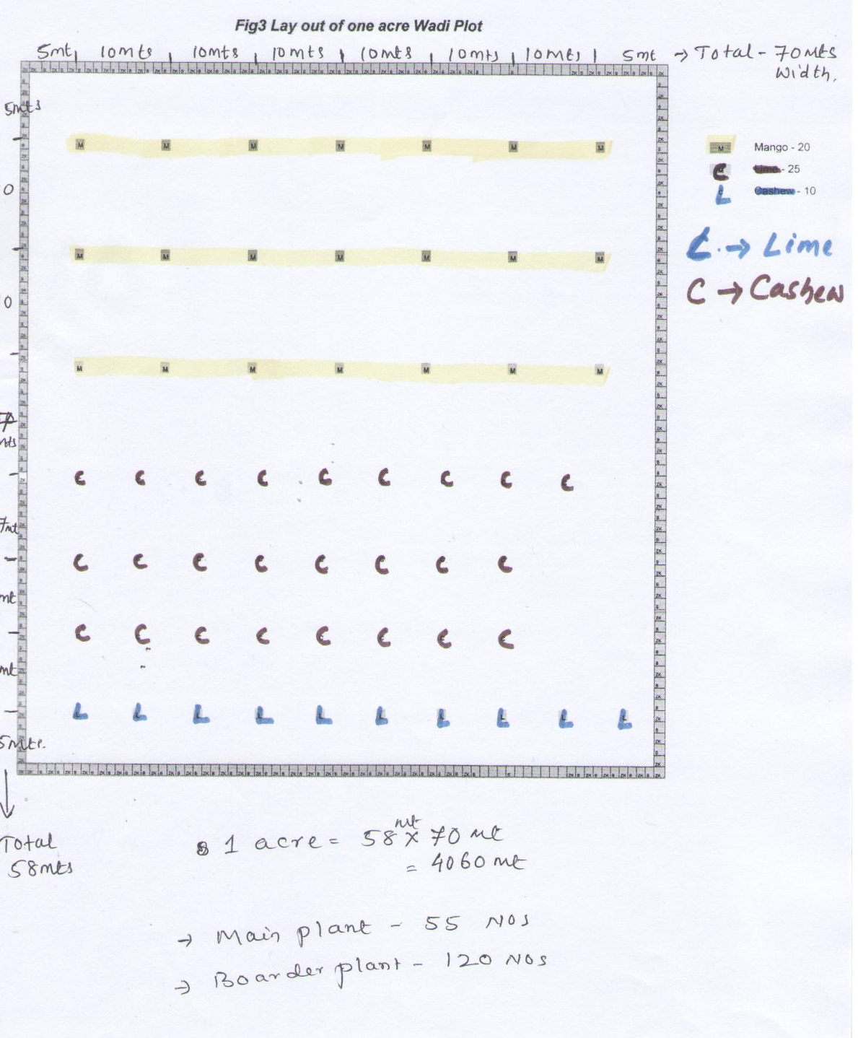
A Wadi unit having One acre of Land is planted with 55 Plants As details given below
Species 1 | 25 | Preferably Mango
Species 2 | 20 | Preferably Cashew
Species 3 | 10 | Preferably Lime or Guava
Boarder Plants | As per need | Common Silvi-pastoral species
- Ideal plot size of Wadi unit – 70m X 58 M
- Size of the Pitt – 1x1x1 Meters
- Distance Plant to Plant/ Row to row – 10 meters

