Pakistan earthquake: Thousands displaced as death toll rises to 300

The death toll from an earthquake in a remote area of Pakistan has risen to 300 with rescuers still scouring mountains for survivors.
By Isambard Wilkinson in Islamabad
Last Updated: 5:37PM GMT 30 Oct 2008 http://www.telegraph.co.uk/news/worldnews/asia/pakistan/3283320/Pakistan-earthquake-
Thousands-displaced-as-death-toll-rises-to-300.html

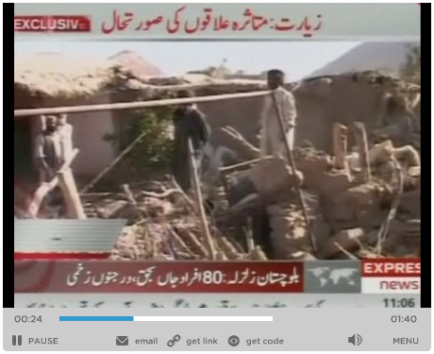
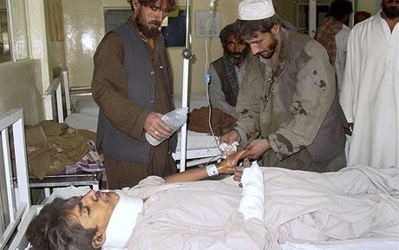
Many of the injured were taken to hospitals in Quetta Photo: AP
The 6.4-magnitude earthquake, that hit before dawn on Wednesday, flattened mud-brick houses and triggered landslides in Ziarat in the province of Baluchistan bordering Afghanistan.
Some estimates calculated that up to 600 people may have died and 2,000 homes been destroyed.
“The death toll may be 300 or even more,” said a provincial official.
“The search for bodies is still going on,” Faisal Edhi of the Edhi Foundation, the country’s largest ambulance service, said by telephone from Ziarat, one of the worst-affected areas of Baluchistan province.
“We think by the end of the operation the total number of deaths may approach 400.”
Officials said hundreds had been injured and at least 20,000 had been made homeless.
“We have reports that dozens of people died in villages after villages and the family members in most cases did not shift the bodies to hospitals, so there is no official record of these casualties.”
The International Committee of the Red Cross said it was distributing 2,500 tents while a medical team with one ton of supplies was helping at overcrowded hospitals.
“Overall, we think the situation is under control though there is urgent need for shelter and blankets because it is freezing up there,” said a Red Cross spokesman.
He added that families of the wounded had moved patients into the car parks of hospitals in the provincial capital of Quetta because of fears that aftershocks could collapse buildings.
The devastation hit the outlying area shortly after the third anniversary of Pakistan’s worse earthquake.
A 7.6-magnitude earthquake in northwest Pakistan and Kashmir killed 74,000 people and displaced 3.5 million in October 2005.
International and Pakistani agencies were struggling to get help to survivors who spent the night in the open, with rescuers discovering more victims as they reached remote villages that had still not seen any aid.
“Only one truck of tents and blankets has reached the affected areas as we were told that helicopters could not land because of the aftershocks,” said the Ziarat district chief, Dilawar Khan.
“It’s very disappointing, we are badly in need of tents. It’s extremely cold out in the open,” he added.
Emergency tents had not arrived in many areas by Thursday morning, forcing exhausted villagers to seek shelter in the ruins of their homes.
More than 24 hours after the temblor struck the impoverished region, residents and emergency workers mounted a final search for survivors or bodies buried in the rubble.
The Pakistani military says soldiers, helicopters, tents, blankets, food and medical help have been sent from Quetta, the provincial capital, to Ziarat and an aerial assessment of the damage has begun.
Major General Tariq Rasheed Khan, who supervised the relief and rescue operation, said about 50,000 of the 100,000 people in the region around the historic hill town of Ziarat had been made homeless or badly hit by the quake.
“We are distributing 9,500 blankets, 2,000 tents and 5,600 warm jackets,” said Major General Tariq Rasheed Khan, who supervised the military relief and rescue operation.
He said about 50,000 of the 100,000 people in the region around the historic hill town of Ziarat had been made homeless or badly hit by the earthquake.
“The requirement is much more than that. It is in fact less than 50 percent of the total requirement,” he added.
The World Health Organisation said it was sending enough medical aid and supplies for 50,000 people. It is also flying trauma supplies stored at the UN Humanitarian Response Depot in Dubai to treat 400 people into the region.
In Geneva, the International Committee of the Red Cross said thousands may have lost their homes and hundreds may have died in the temblor.
The earthquake comes at a precarious time for the Muslim country, with the civilian government battling al-Qaeda and Taliban militants as well as a looming economic crisis.
At least three hard-line Islamic organisations also were quick to aid quake survivors.
Among them was Jamaat-ud-Dawa, designated a terrorist group by the US government for links to Muslim separatists fighting in India’s portion of the disputed Himalayan region of Kashmir.
Pakistan is prone to seismic upheavals since it sits atop an area of collision between the Eurasian and Indian tectonic plates, the same force responsible for the birth of the Himalayan mountains.
Baluchistan’s capital, Quetta, was devastated by a 7.5-magnitude temblor in 1935 that killed more than 30,000 people.

