
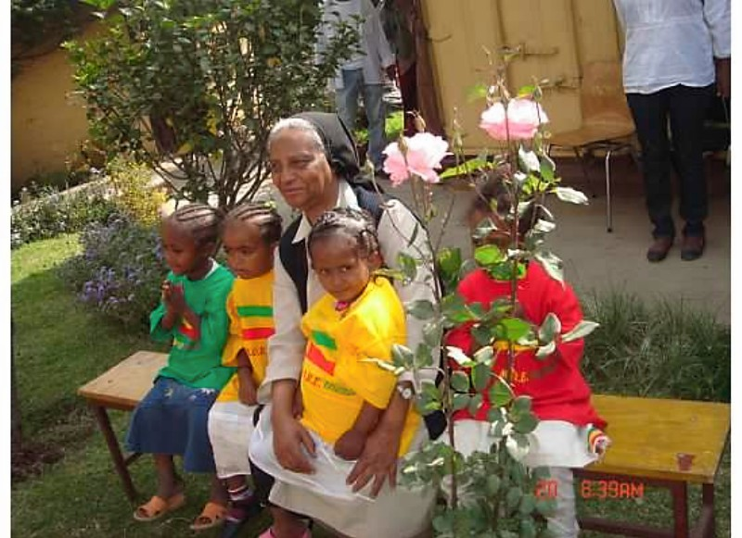

10 FACTS ABOUT
M.O.R.E.
(Medhen Orphan Relief Effort)

1. M.O.R.E. is a New Jersey 501(c)3 non-profit organization formed in 2007.

2. M.O.R.E.’s sole purpose is to provide financial support to the Orphans and Vulnerable Children Program (OVC) of the MEDHEN SOCIAL CENTER located
in Addis Ababa, Ethiopia.

3. M.O.R.E.’s unique OVC program is directed with great compassion and love by
Sister Senkenesh G. Mariam who has devoted her life to living among and helping
the poorest of the poor. Sister Senkenesh lovingly matches families with orphans
to create a caring family and a nurturing support system.

4. M.O.R.E. currently is providing support for over 1000 beneficiaries, including the
children, their families and the community.

5. M.O.R.E. is an all volunteer organization. There are no paid positions.

6. M.O.R.E. is a small grassroots charity and currently has 11 Board Members living
in the NJ/NY area, Washington, D.C. and Chicago. ALL of M.O.R.E.’s Board members
have visited The Medhen Social Center and have met Sister Senkenesh and the children.

7. M.O.R.E. ensures that all money raised goes directly to supporting the children.
There are no paid fundraisers.

8. M.O.R.E. will use your donation of $246.00 to feed, clothe, educate and provide basic medical care and housing for one orphaned child for one year.

9. M.O.R.E.’s website www.morechildren.org will provide you with more information
about the organization and how you can help.

10. LAST BUT NOT LEAST ~ A PICTURE IS WORTH A THOUSAND WORDS!
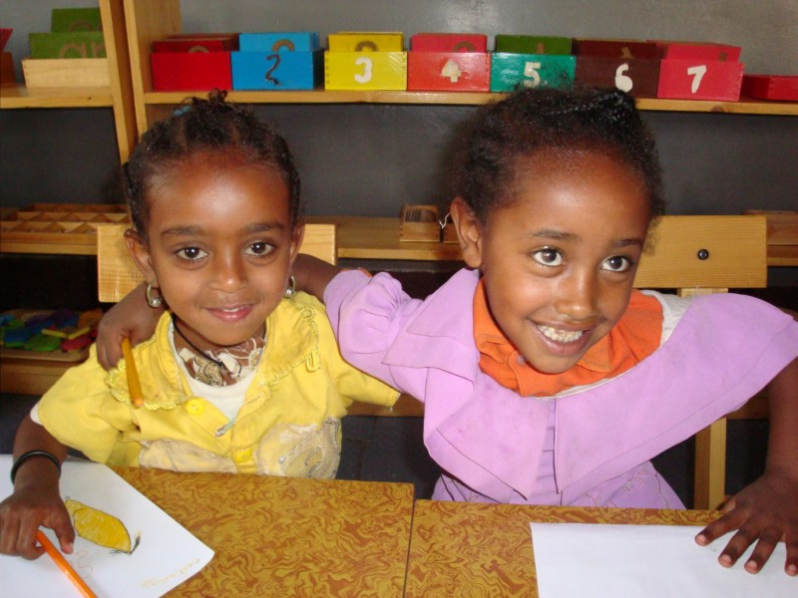
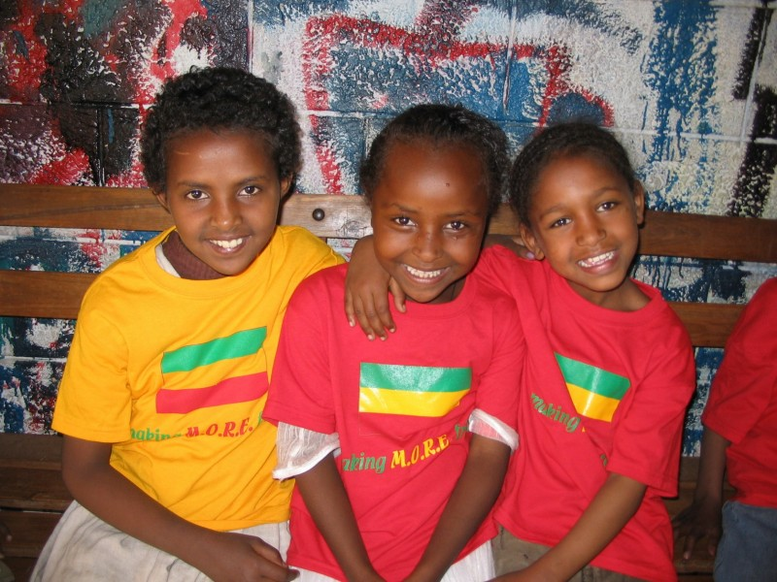
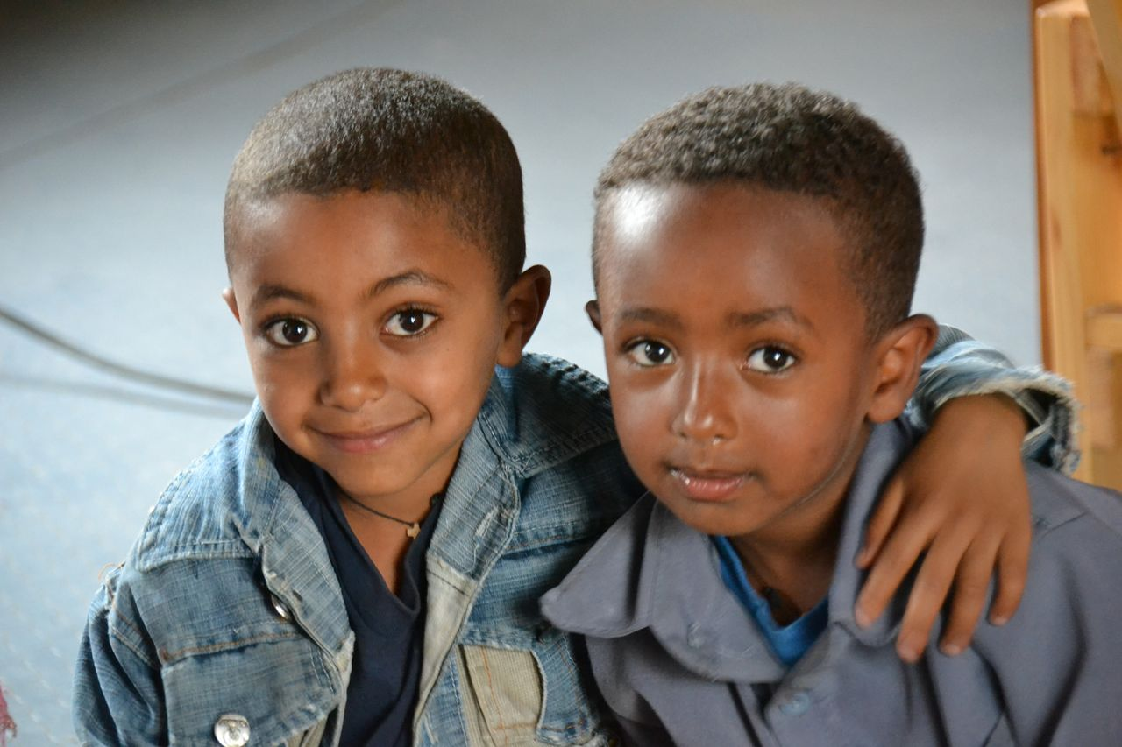

~ Giving Hope to M.O.R.E. Children ~

