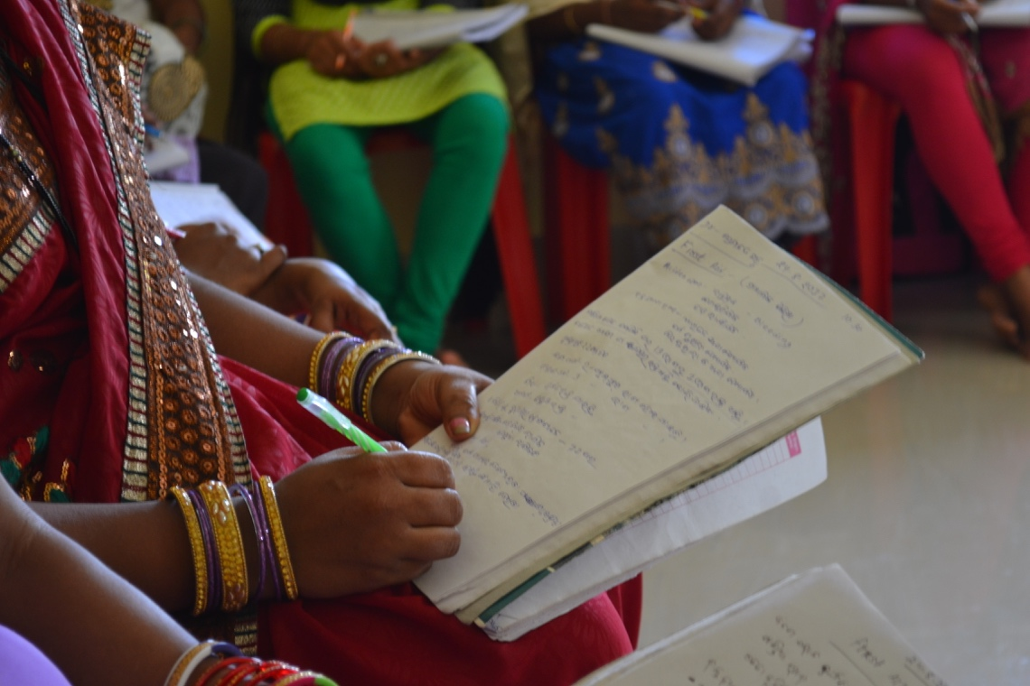

GDA trainees getting clinical experience at the hospital.

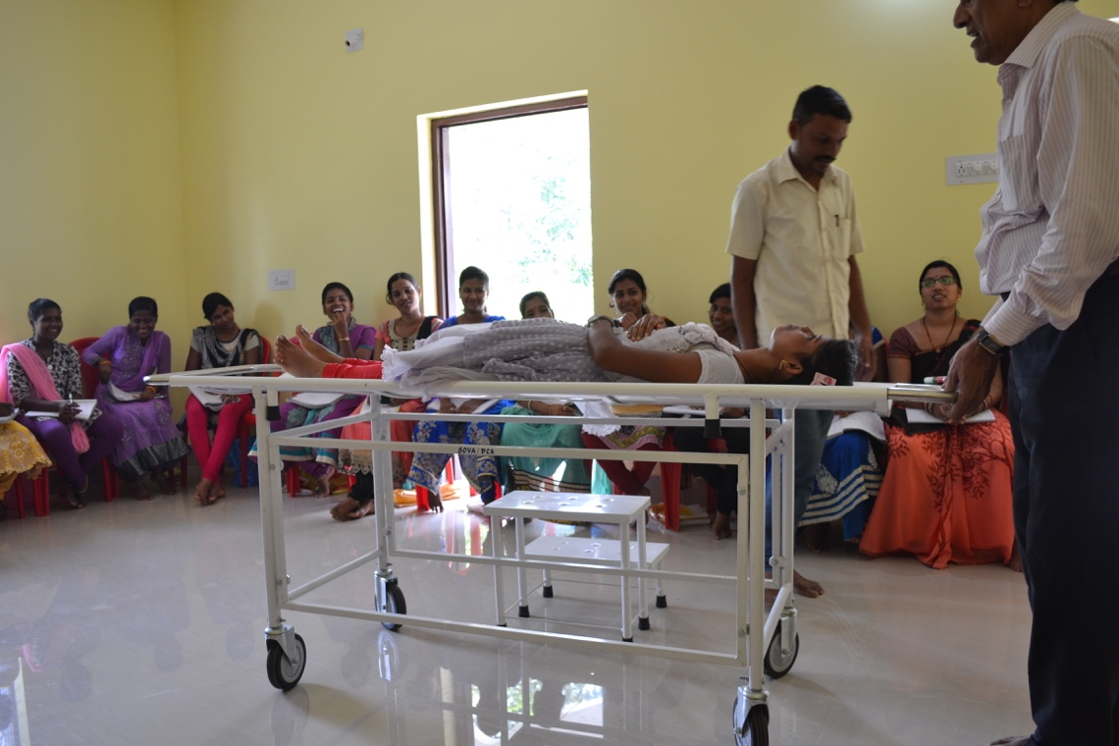

GDA trainees getting clinical experience at the hospital.

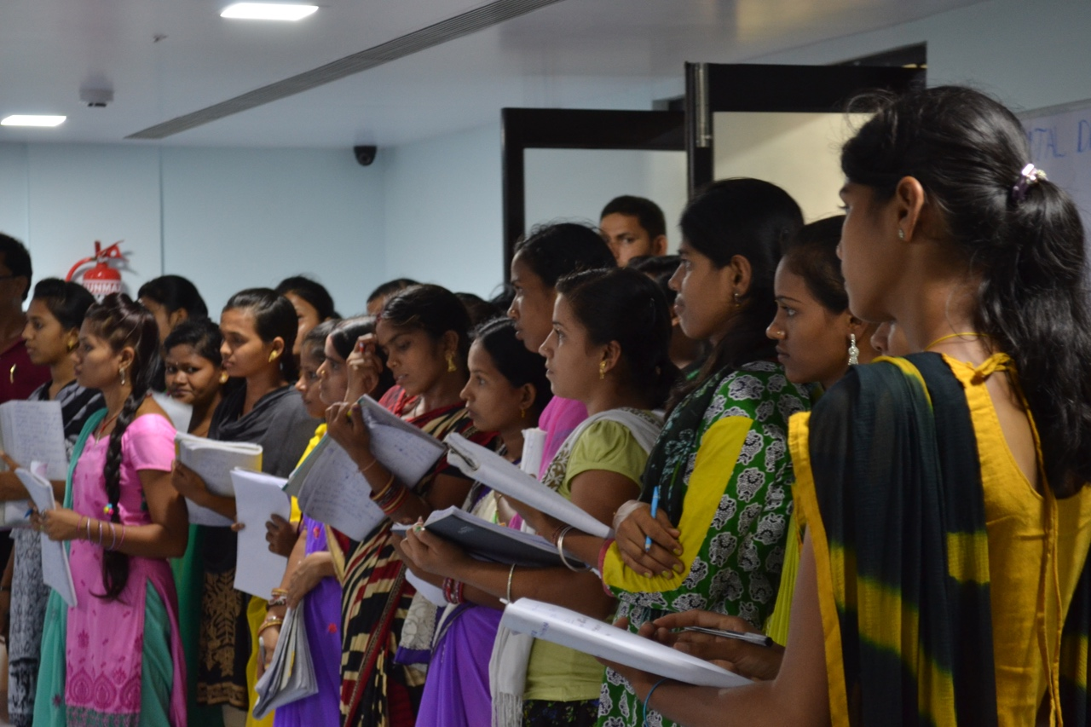

Trainees taking a first aid class given by a visiting doctor.

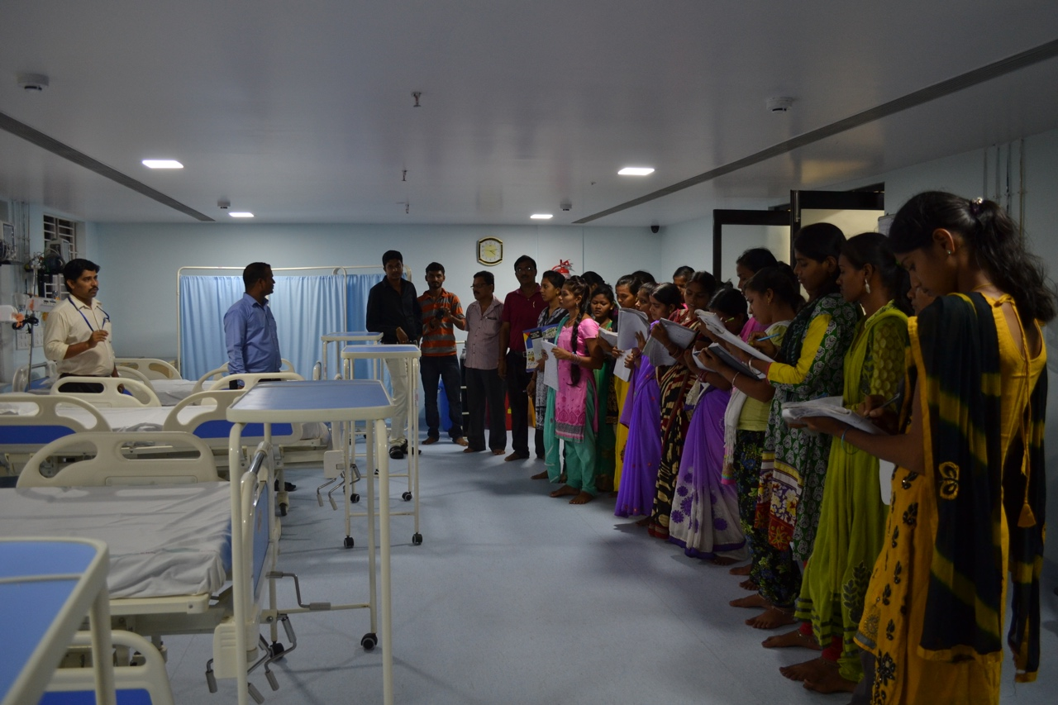

Trainees taking a first aid class given by a visiting doctor.

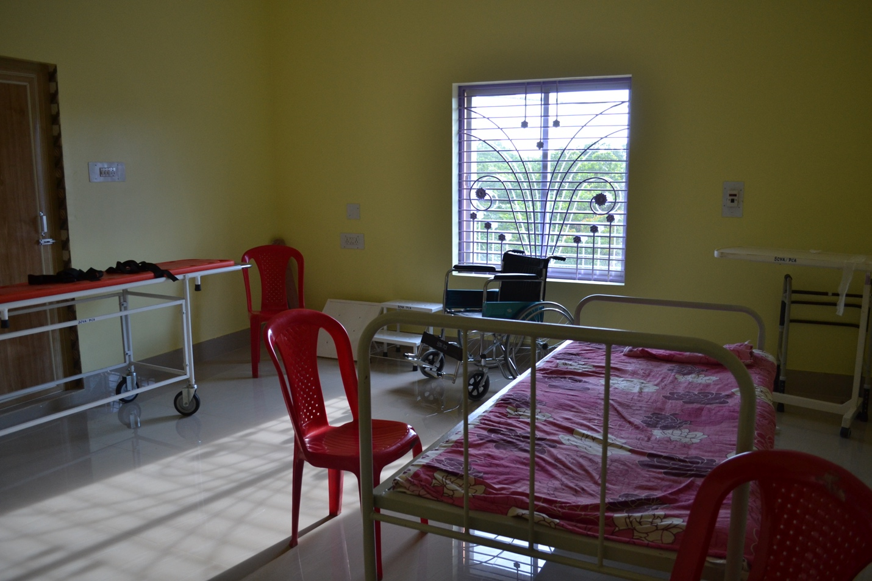

This is some of the medical equipment that the trainees use to practice.

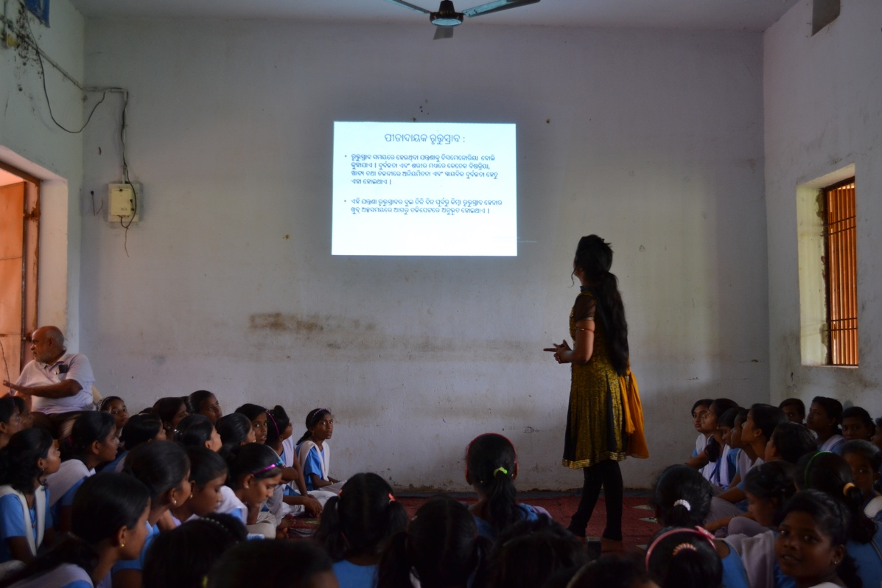

GDA graduate giving a sexual reproductive health course to girls (aged 12-14) at a local school.

