SDOFW PROFILE

SUSTAINABLE DEVELOPMENT ORGANIZATION FOR WOMEN (SDOFW)
Presents
Management & Technical Profile

For our
Prospective Clients

2016

Office Address: Bismillah Health Plaza 3rd Floor Room No. 14-15 Next to DoA Jalalabad City of Nangarhar Province- Afghanistan
Nangarhar Province- Afghanistan

Contact Details
Contact Person: Ajmal Hussain Alkozai
E-mail: sdofwafg@gmail.com
Mobile: 0093-765 650 300

- What is Sustainable Development Organization for Women (SDOFW)?
Sustainable Development Organization for Women (SDOFW) is an Afghan Non-profitable, non-political, non-governmental civil society organization established in 2013, registered with the Ministry of Economy of the Islamic Republic of Afghanistan as registration # 2880. SDOFW works for advocacy, election & DEMOCRACY, peace building & conflict resolution, anti-corruption and good governance, human rights & social protection and access to justice through civic education, public awareness, youth development interventions, women empowerment activities, livelihood support and emergency response interventions.

The organization’s principle objective is to contribute to the creation of sustainable economic and social systems which are controlled by rural communities and which respond to their needs. The organization is thus committed to the creation of a critical mass aware of their human rights and obligations as citizens.
Recognizing the importance of good governance, respect for human rights and democracy as necessary conditions for human development, SDOFW has strong advocacy and human rights education components in its programs and activities.
Its existence as an Afghan NGO is based on the principle of non-partisan collaboration with civic, political and other organizations on matters concerning the development of rural communities.
- Vision, Mission and Objectives
Vision:
A society where there is gender equality in social, political and economic development.

Mission
SDOFW’s Mission is to facilitate community development and empowerment through capacity building and policy research and advocacy with community participation for ending violence & abuse against Women, Girls and Children.
Strategic Goals
- Increased participation of women and youths in leadership and decision making at household, community and national levels.
- Improved sustainable livelihoods for communities in SDOFW operational areas, especially women and children.
- Increased access to basic rights in SDOFW operational areas.
- Improved financial, administration and human resource management for effective implementation, monitoring and evaluation of SDOFW programs.

- Organization Values
In line with the mission of working with and empowering rural communities especially women to contribute to the eradication of all forms of poverty and also its vision of contributing to the creation of sustainable economic and social systems which are controlled by rural communities and which respond to their needs. SDOFW uphold the following values.
- Gender sensitivity
- Team Spirit
- Rural Focus
- Participatory
- Self-Reliance
- Transparency and Accountability
- Justice and Human Dignity
- Non-partisan
- Non-membership
- Structure
Sustainable Development Organization for Women’s structure consists of four major components:
- Board of Trustees
The main function of the Board of Trustees is that of custodian of Sustainable Development Organization for Women property. It consists of two independent members chosen from civil society and the third trustee being the Chairperson of the Board of Directors.
- Board of Directors
This is the main body which oversees Sustainable Development Organization for Women (SDOFW) programs. Members of the Board of Directors constitute the executive committee. There are seven members of the Board. These are selected by virtue of their expertise and experience which is considered relevant to the needs of SDOFW. The Chairperson is elected by the seven members of the board. SDOFW staff and groups are represented on the board by the Executive Director of SDOFW. The Board has the following positions:
Chairperson
Dr. Gul Mohammad
Vice Chairperson
Ms. Tajrean
Board Legal Advisor
Mr. Ale
Board Treasurer
Mrs. Nadia
Board Member
Ms. Zakera
Board Member
Mrs. Balqessa
Board member
Ajmal Hussain Alkozai

- Staff/Management Team
SDOFW staff constitutes the chief organ for the implementation of policies and plans of the organization. The staffs consist of the following;
- The Executive Director
- Programs Staff
- Administration and Finance Staff

SDOFW exercises a participatory system of management whereby staff discusses and makes decisions together.
- SDOFW Rural Groups
This is the most important component in the SDOFW structure. It justifies the existence of the organization. The groups participate in decision making processes. They assess their own needs, identify projects, plan, implement and monitor them.
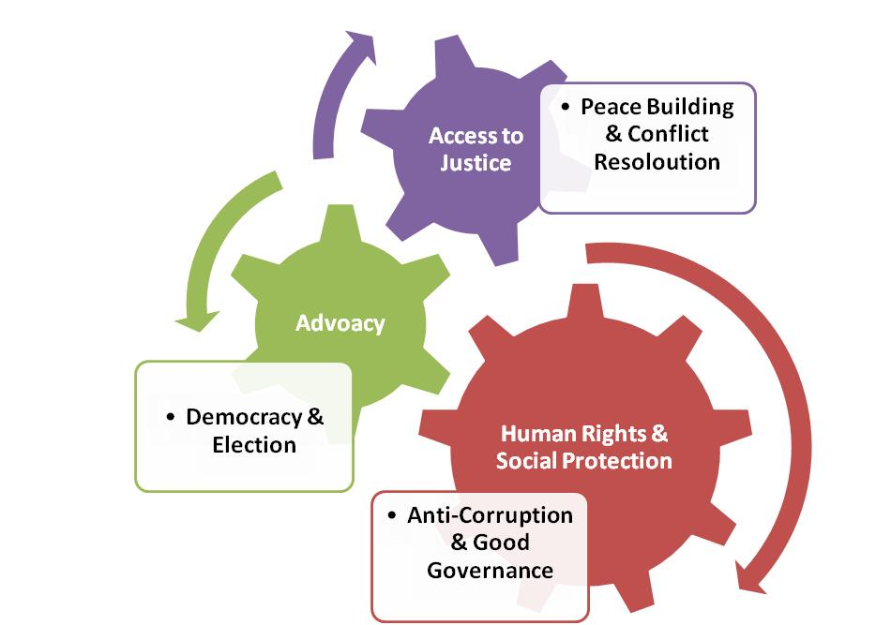
- SDOFW’s Main Sectors:

- SDOFW’s Core Competencies:

- SDOFW’s Past and Current Donors/ Funding Sources:
- British Council/ TAWANMANDI
- United Nations World Food Program (WFP)
- USAID’s Community Cohesion Initiative (CCI) Project
- Department of Public Health-Nuristan (DoPH-N)
- The Asia Foundation
- Independent Election Commission (IEC)
- Ministry of Women Affairs (MoWA)
- European Commission
- Embassy of Japan/ JICA
- Counter Part International
- IOM&IRD
- U.S Embassy- Kabul
- Australian Embassy- Kabul
- CZECK Embassy- Kabul
- Canadian Embassy-Kabul

- SDOFW’s Registration Certificate:

