REMEDIAL SCHOOLS PROJECT FOR THE
CHILDREN LIVING IN SLUMS

Even though the government is attempting developmental activities, it is not fulfilling the need of the community. The Puducherry government is trying to convert thatched houses into concrete buildings but still people are living in poor housing facility. There are plenty of children left with poor education and with poor health condition. We have chosen these two villages namely Ezhil Nagar and Kuruchikuppam to run two remedial schools. Certain activities of social welfare and payment of self-sufficiency programs are planned, so that this program will be continued on its own.

Sector of Intervention
Children’s education and to support women

Description of the Project
Education is considered to be a very potent instrument for children especially for those coming from poor and disadvantaged communities as it empowers them to transform their future lives for the better, both financially and socially. It is with the aforesaid intention that Prime Trust introduced its Enrichment Schools in Puducherry. The goal of this project is to reach out to school going children (from all classes) in a poor community and to help them be at par with the curriculum being taught in school. Not all children can keep up with the speed at which they are taught by their teachers and have the tendency to fall behind the others in class, and not all children have a good working environment to study at home. These children can therefore enroll in an enrichment school where dedicated teachers hired from the community clarify their doubts and problems; teach them core concepts and principles and help them with their homework. The minimum criterion for the selection of teachers is to have graduate degree in any discipline. We also have international volunteers from time to time, who help these children in improving their English skills and help them with Mathematics and Science problems. Owing to the success of our first Enrichment School, there has been an increasing demand from other communities/localities in Pondicherry to create similar schools in their area. Therefore, we intend to expand the Enrichment School concept to other localities in Puducherry, so that more and more children can partake in this wonderful remedial education concept. The rationale for setting up the school in different localities as opposed to one centralized location is that from past experience, we know that it is very location sensitive. Parents send their children to such schools only if they are very close by and in their own locality.

The Enrichment School is an extremely promising project in terms of its qualitative impact on the beneficiary children. Our past experience with Enrichment Schools has been quite successful in reaching out many school going children of the community who are in need

of remedial teaching. The children have been quite happy with the quality of teaching/coaching offered and are also very happy to be occasionally tutored by visiting international volunteers.

Beneficiaries
This project is aimed at school going children from all classes, coming from poor/disadvantaged communities in Pondicherry such as Ezhil Nagar, Kuruchikuppam and Varagapet. Each center will be able to accommodate almost 25 students.

Duration
Infinite.

Expected Sustainability of the project
The 3 enrichment schools will follow the same successful and self-sustainable model running for the past 8 years in Puducherry and therefore be financially self-sustainable. The only major costs associated with the project are the rent for the building, the salary of the teachers, and the stationary costs. Here is how we have made the Pondicherry remedial school self-sustainable and how we are planning to make these new remedial schools sustainable. We will combine a Day Care Centre (to support children of employed parents by making them stay in our center) and the proposed Enrichment School. The Day Care Centre fetches a small revenue as it is meant for those who can afford to pay for their children. The target population is therefore different from the one from the remedial schools. There is a big demand for this program as most of the parents seek employment for better life style. For this sustainable solution to be a successful, location will be crucial. It needs to be at the junction between a slum area and a richer area, respectively for the remedial school and the Day Care, in order to attract both target populations with an easily reachable facility. The support required will go towards start-up costs to initiate the project and its virtuous circle. One-year support will be enough to start this project which will then continue further with its own income generating activities, and run for many years in a self-sustainable manner.

Our future goals

- To convert these free tuition centers into a full free school for underprivileged children.
- To improve the literacy rate among rural children.
- To provide access to education and exposure to possibilities for less-privileged children

DETAILS OF THE PROGRAM

No | Details
1 | Working hours of the school | 5.30 P.M – 9.00 P.M
2 | Name of the Teacher | Miss. Sylvia / Miss. Anbarasi / Mrs. Saraswathi
3 | Educational qualification of the teacher | Miss. Sylvia – B.Com  Miss. Anbarasi – B.Sc  Mrs. Sarasu – Higher Secondary
4 | Experience of the teacher | 2 years
5 | Total number of children on role | 25 on each school
6 | Age group of the children | 5-16
7 | Economic status of the children | First generation learners and from poor back ground
8 | Assessment of studies | Regular assessment is being made and special attention is offered to slow learners
9 | Medical check-up | Regular medical check-ups on dental and eye were offered
10 | Parents Meeting | Once in a month parents meeting was conducted
11 | Events organized | - Annual Day Celebrations  - World Environmental Day  - Birth Centenary celebrations of our former President of India  - Children’s Day Celebrations  - Children’s Parliament Program  - Awareness Generation on Health and Hygiene, Personal Hygiene, Child Rights, Child Labor, Personality Development, Leadership Qualities, Interpersonal Skills
12 | Other support made | - Providing stationary  - Providing food on special occasions

PICTURES OF EZHIL NAGAR REMEDIAL SCHOOL
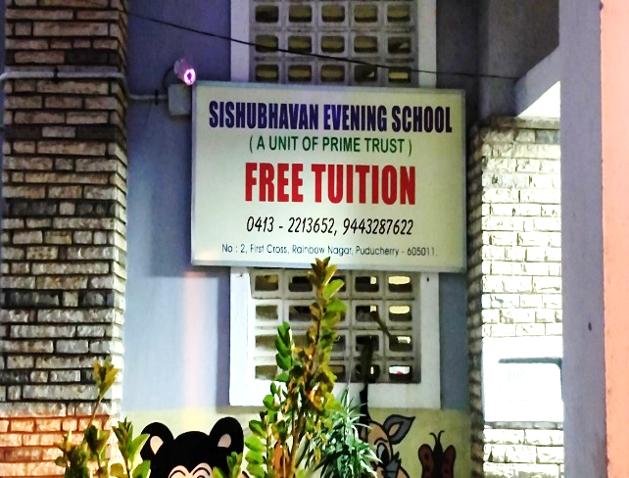
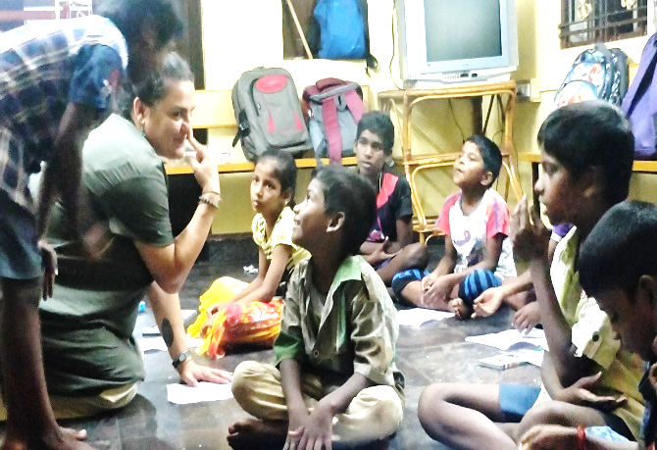
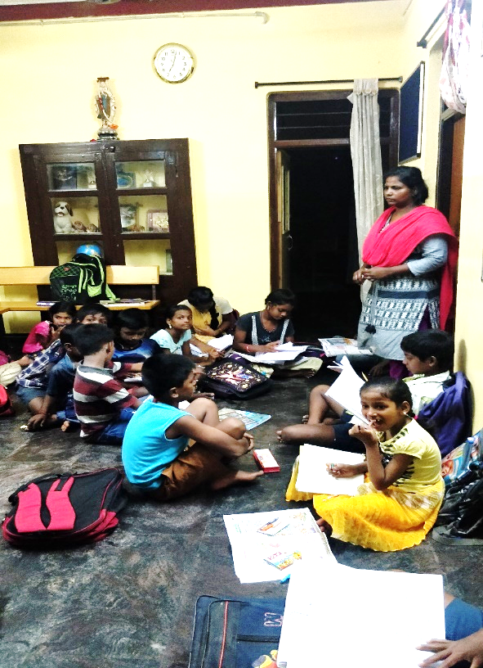

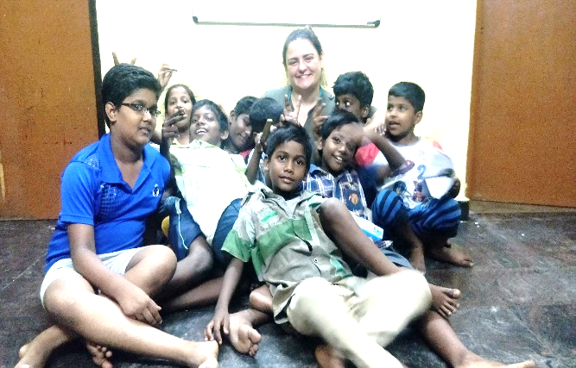
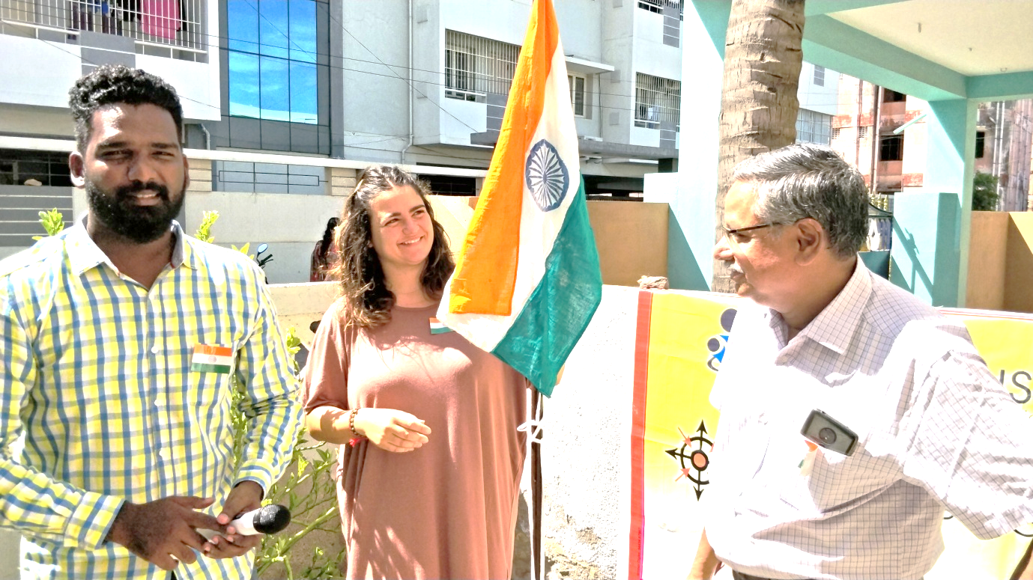

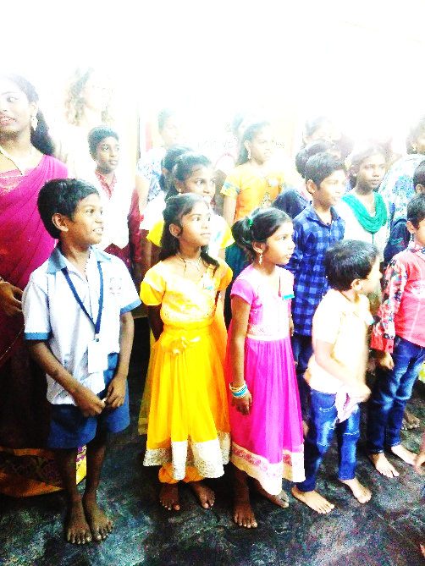

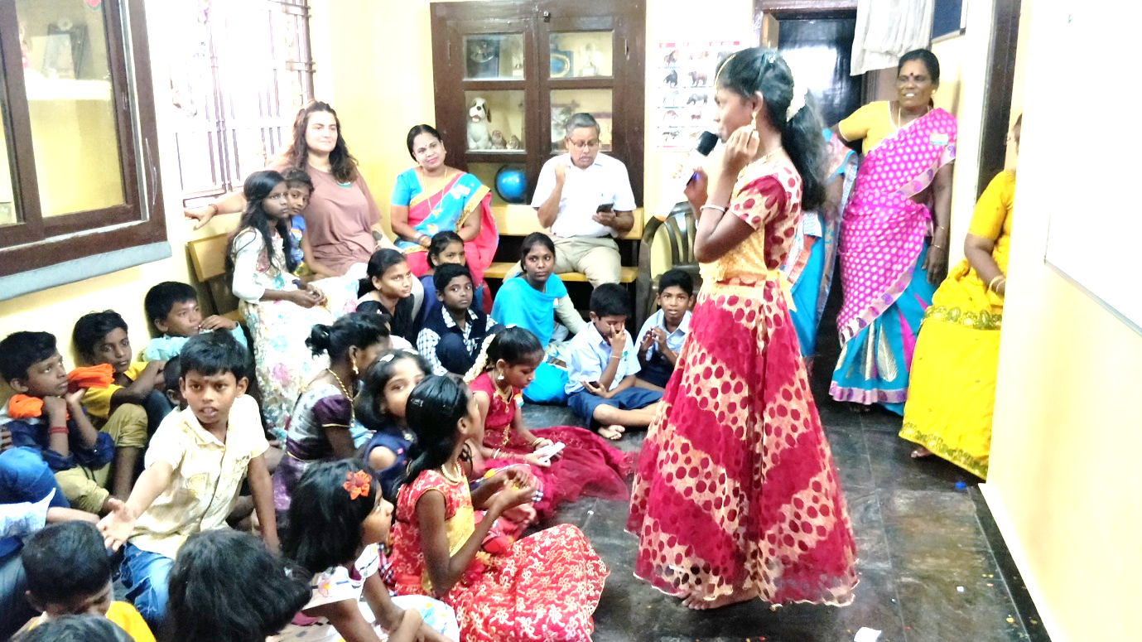
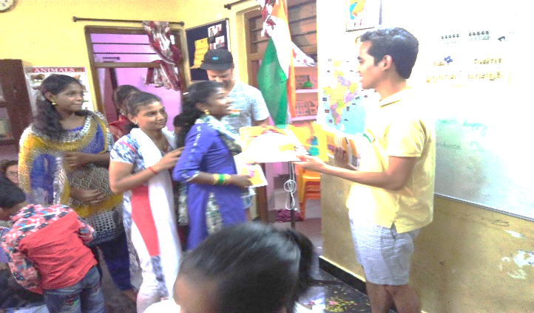

PICTURES OF KURUCHIKUPPAM REMEDIAL SCHOOL
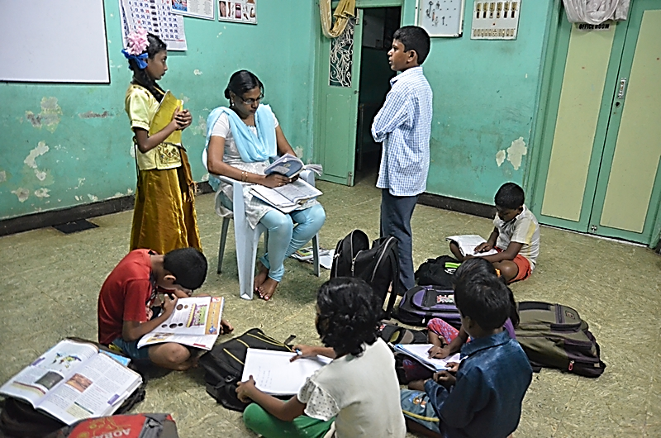
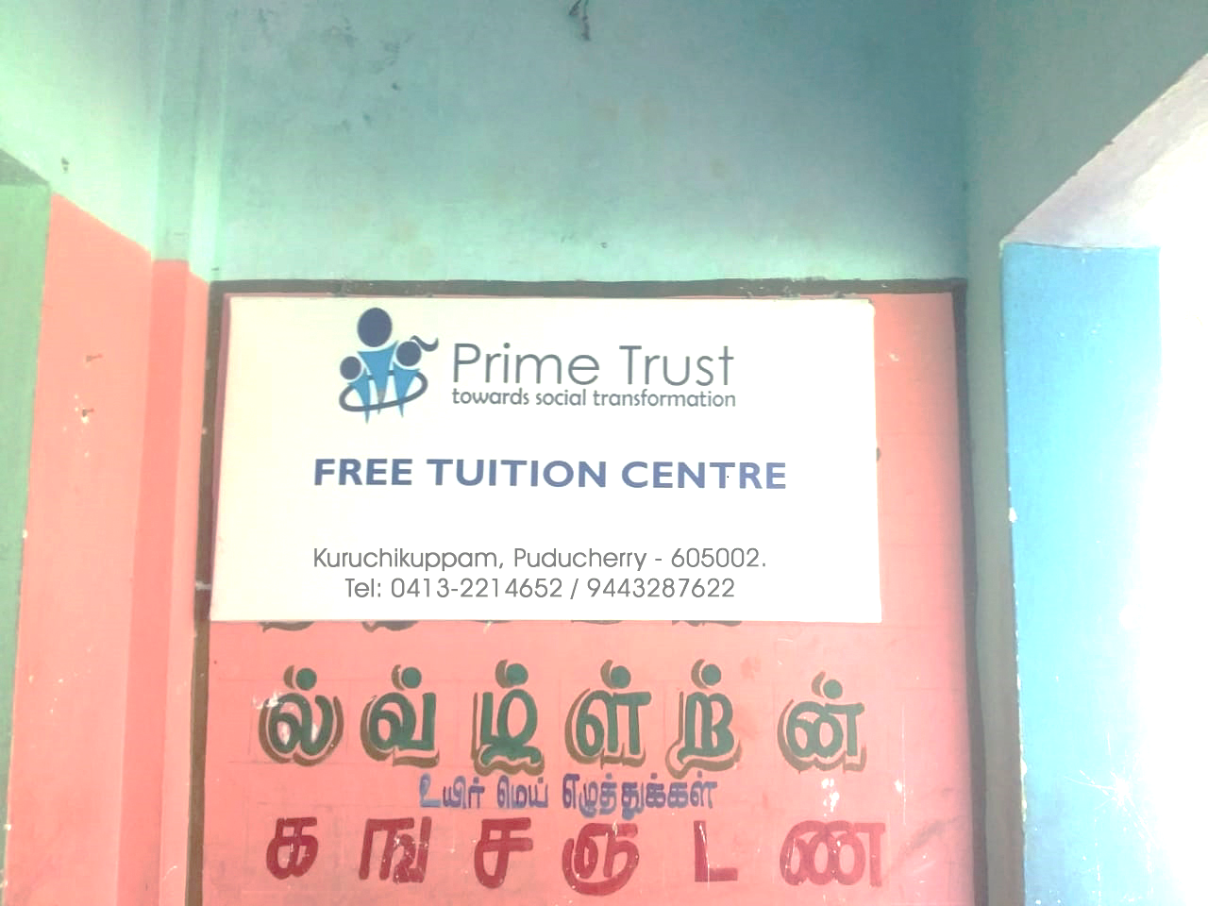

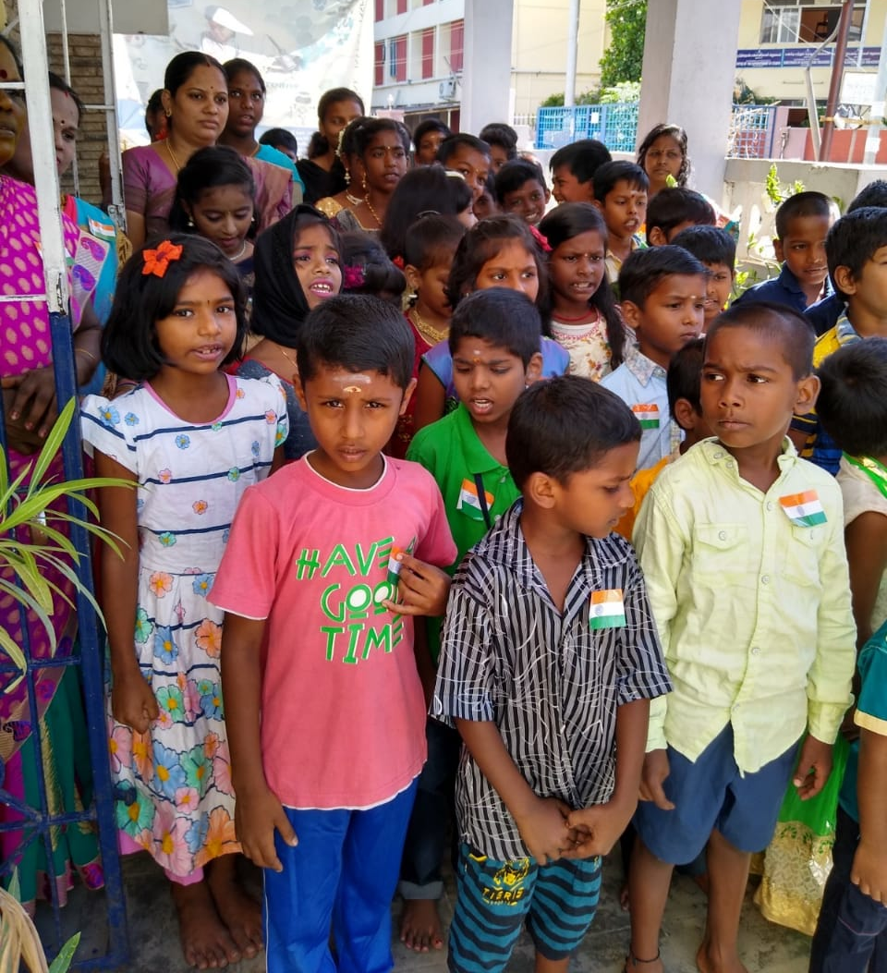

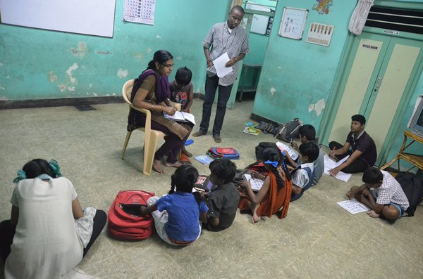
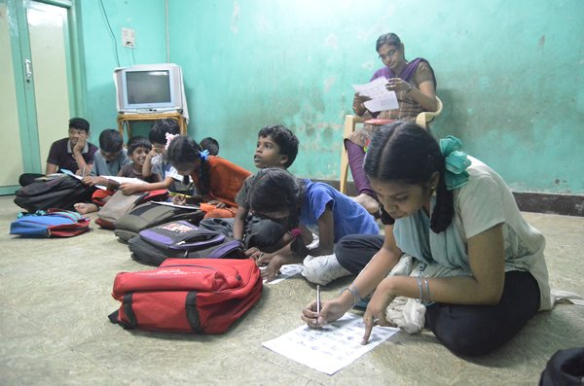

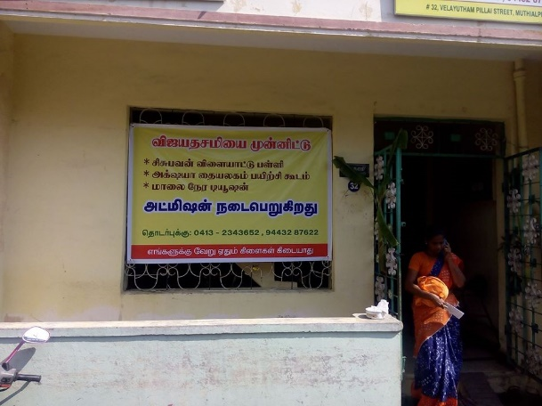
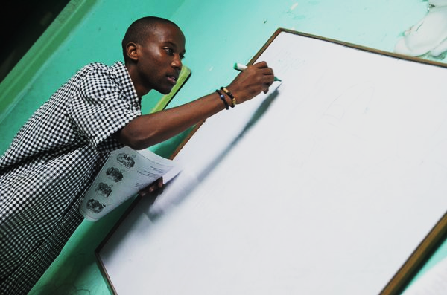

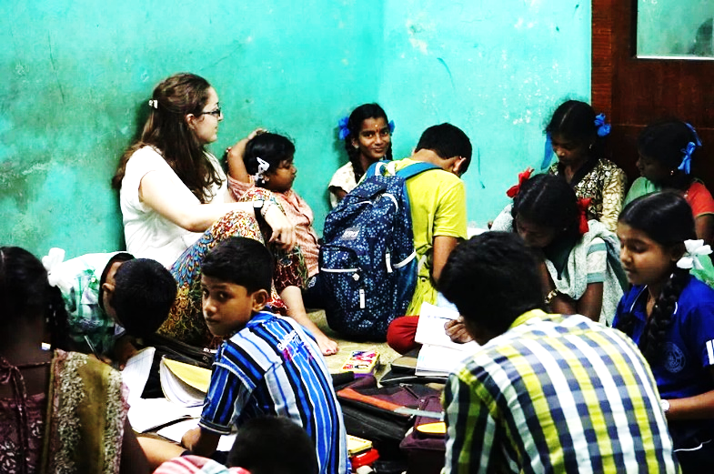

PICTURES OF VARAGAPET VILLAGE
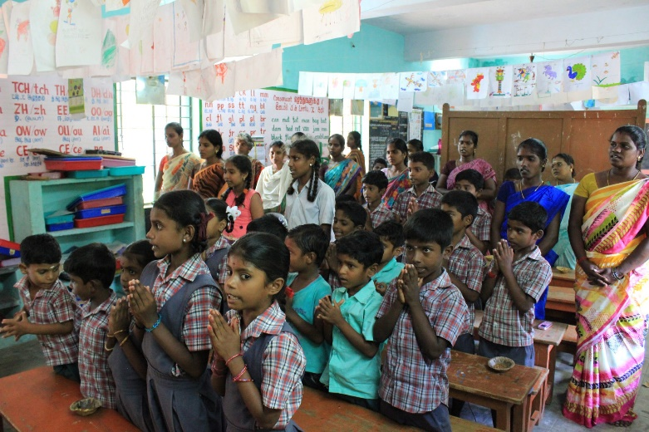
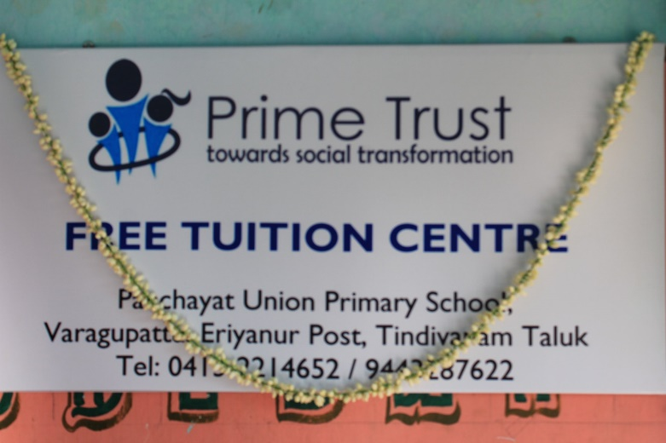
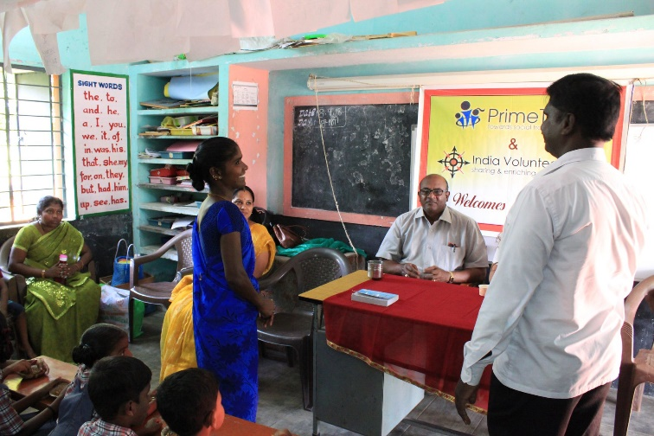

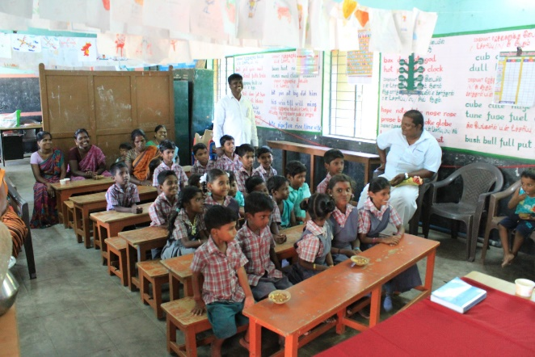
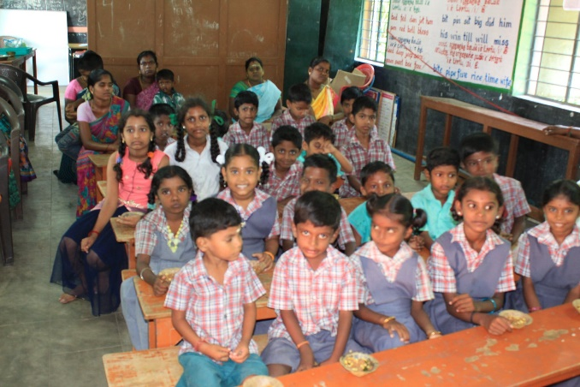

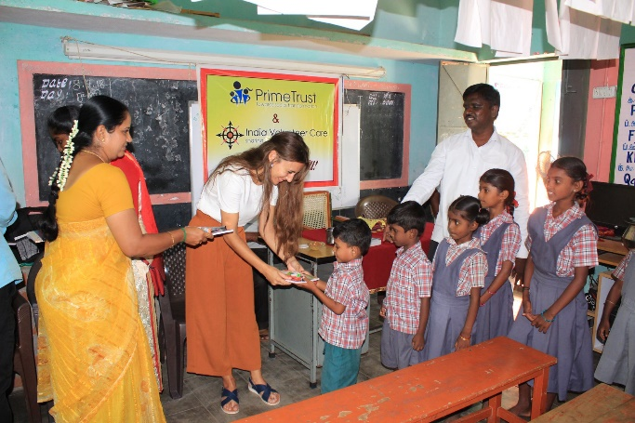

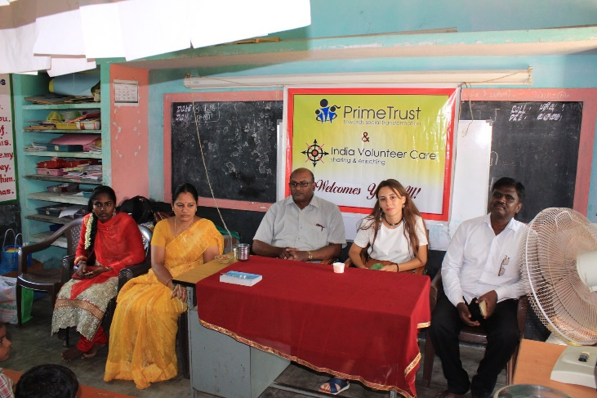

BUDGET FOR TWO SCHOOLS 12 MONTHS

No | Name of the expenditure | Amount spent from April 2019-March 2020 | Total amount for 2 schools
Recurring Expenditure
1 | Salary for the staff members | 5000 x 12 x 3 | 180,000
2 | Rent | 3000 x 12 x 3 | 108,000
3 | Educational Support | 1000 x 30 x 3 | 90,000
4 | Electricity and Water | 1,000 x 3 | 3,000
5 | Stationary for the schools | 12,000 x 3 | 36,000
 | TOTAL |  | 417,000

DONATIONS FROM OVERSEAS
(FCRA ACCOUNT)

Name of the organization | Prime Educational and Social Trust
Name and address of the Bank | FCRA Cell, IVth Floor,  State Bank of India, New Delhi Main Branch,  11, Sansad Marg, New Delhi-110001
Account No. | 40096256689 (FCRA Savings Account)
Branch Code | 00691
Swift | SBININBB104

DETAILIS OF THE BANK FOR TRANSFER OF FUNDS
(LOCAL FUNDS-AXIS BANK)

Name of the organization | Prime Educational and Social Trust
Account Number | 914010003832032
Bank Name | Axis Bank
Bank Address | 6, St. Ange Street, Puducherry – 605 001
Branch Code | 00209
IFSC | UTIB0000209

(Donors can enjoy tax benefit by making a donation to us)

