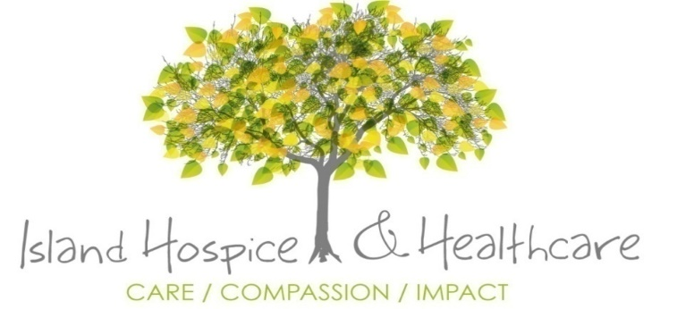

Island Hospice Project Report
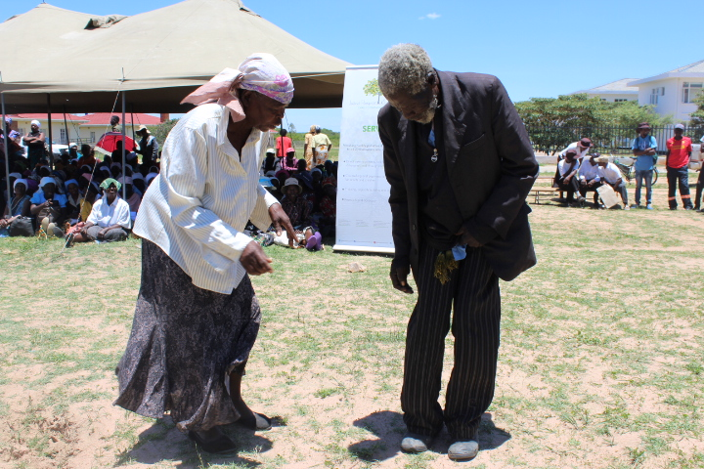Old Persons Day Commemorations

Introduction
Island Hospice and Healthcare (Island) continued its mission of providing a positive change in the lives of many individuals faced with life threatening illnesses and the bereaved. This was achieved through capacity building and direct care. The following report provides an overview of progress for the period under review. This includes updates on direct care, challenges, and lessons learned.

Zimbabwean Context
Zimbabwe’s junior doctors are on a national strike since the beginning of March protesting against poor remuneration and unsatisfactory working conditions, leading to the closure of almost all central hospitals, children’s units, provincial hospitals and the cessation of emergency lifesaving procedures throughout the country, according to their representative body, the Zimbabwe Hospital Doctors Association.
This has negatively affected our patients and clients. As a result Island has experienced high demand for service from non- palliative care patients, a situation that is attributed to the problems being faced in the public health delivery system. The government has failed to provide adequate medication and other medical sundries in the public hospitals. Despite the economic downturn palliative care (PC) patients and clients have continued to receive the much needed services from Island
Palliative Care Awareness to Private Doctors
Island provided a talk to create awareness on pc issues to private medical doctors. There was convergence of purpose on the need for Island to continuously provide sessions to the private sector on pc key issues such as breaking bad news, bereavement support, communication etc. During the awareness session it was agreed that the referral pathways for patients should be strengthened so as not to lose patients to loss of follow up. The doctors expressed their frustration with the doctors’ strike. They indicated that patients they were referring for specialist services were not getting assistance due to the on-going strike. They called upon government to address the doctors’ concerns for the sake of the patients and to remove some barriers to access such as high and unattainable fees charged for some services.
Caregivers Capacitation Programme
Island works with volunteers who provide care in various communities. These act as the eyes of Island as well as the primary health facility to alert patients and clients on the availability of service and how to access them. They also provide basic pc service to patients and clients.
oung carers are often found in sole-parent families and it appears they often provide care because they are the only ones available to fulfil this
role at home. They are offered little choice about their role, but once given the responsibility, most young carers seem to embrace it and want to
continue to provide care for as long as it is needed
Island holds monthly meetings to support caregivers and strengthen their caring skills.

Table 2: Shows the number of caregivers by site who attended monthly meetings in November.
Activity | Males | Females | TOTAL
Chitungwiza CHBC Meeting | 3 | 36 | 39
Mutare CHBC Meeting | 0 | 15 | 15
Marondera CHBC Meeting | 1 | 9 | 10
Goromonzi CHBC Meeting | 1 | 25 | 26
Chikwaka CHBC Meeting | 3 | 32 | 35
Harare CHBC Meeting | 2 | 11 | 13
Mufakose CHBC Meeting | 0 | 31 | 31
Table 2 Volunteer/CHBC Meetings
CHBCs continue to come for the monthly meetings and receive support and refresher courses on how to better help the patients that they reach. A total of 169 caregivers attended compared to 175 in October.

2.2 Outcome two: Improved quality of life of people suffering from life-threatening illnesses.
This section presents the work of Island towards improving the quality of life of people suffering from life threatening and life limiting illnesses. Several graphs below provide an overview of patients reached, disaggregated by variables such as gender, site, et cetera.
Graph 1: Number of patients/clients reached by gender and site
There is a downward trajectory in the number of patients and clients reached, from 613 in September to 525 in October and 469 in November.
Graph 2: Patient/client type by site
The graph above summarises the total number of patients reached, disaggregated by type of patient/client (new, existing, single consultation). There was a marginal decrease in the total number of new patients, from 85 in October to 79 in November. Number of existing patients marginally dropped from 347 to 345.
Graph 3: Contacts by Place of Contact
Island continued to provide services through home visits, clinics, hospitals, telephone and office visits to improve the quality of life of people with life threatening illnesses. There has been a gradual decrease in the total number of contacts, from 732 in September to 592 and 524 in October and November respectively.

Graph 4 shows trend analysis of Island patients and clients by month.
Graph 4 above shows Island’s trend analysis for patients and clients reached, aggregated by month, total deaths by month, new patients and clients and the cumulative number of Island patients and clients by month. There is need to address the gap between the number of patients being reached per month vis a vis the total number of patients reached.
Table 3 below shows the number of patients reached by community caregivers in June 2019, disaggregated by site.
Site | Males | Females | November | October
Chitungwiza | 60 | 113 | 173 | 180
Mutare | 19 | 53 | 72 | 103
Marondera | 21 | 49 | 70 | 74
Mufakose | 76 | 185 | 261 | 266
Mabvuku | 44 | 46 | 90 | 73
Chikwaka | 21 | 34 | 55 | 111
Harare | 2 | 5 | 7 | 12
Mutoko | 73 | 46 | 119 | 120
Goromonzi | 57 | 62 | 119 | 113
Total | 371 | 588 | 966 | 1040

In October and November our CHBCs reached 1040 and 966 patients respectively. Three hundred and ninety eight (398) patients were homebound during the period under review. Adherence and emotional support were the most offered services followed by HIV education and counselling.

Patients reached in Hospitals
There was an increase in the total number of patients reached through hospitals, from 24 in October to 47 in November. The biggest increase was from Mpilo which reached 19 patients compared to 1 in October.

Graph 5 details the number of patients and clients reached through clinics by site.
Graph 5: Number of Patients/Clients reached through clinics
There was a marginal increase in the total number of patients reached, from 90 in October to 98 in November.

Outcome three: Improved quality of life of bereaved and traumatized clients

Island continued to help improve the quality of life of bereaved and traumatized clients through partner loss support groups. In November, two partner loss group sessions were conducted with 3 participants.

Graph 6. Number of Patient/Clients who received support service by site
The decrease in the number of patients and clients reached consequently resulted in the decrease of services offered. The only increase was from patient counselling, which recorded 292 patients and clients, up from 190 in October 2019.
Graph 6: Family members reached by site
Island continued to provide holistic pc services by supporting patients’ family members. There was a marginal decrease in the total number of patients’ family members supported, from 292 in October to 221 in November. This is consistent with the decrease in the total number of patients seen.

Challenges
- Unavailability of cars especially for Harare and Bulawayo branch to visit patients in homes.
- Fuel shortages (All branches)
- Shortage of pc essential medicines

5. Conclusion and recommendations
Island through its staff, supporters, programs, research, advocacy and resources, continues to touch the lives of individuals, families, and communities spanning every vulnerable group in society. Continued awareness on the need for patients to contribute towards service provision so as to make the organisation sustainable. Vulnerable patients will continued to be provided with service free of charge.

