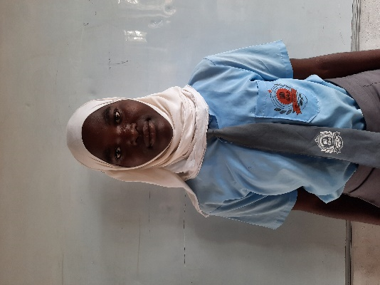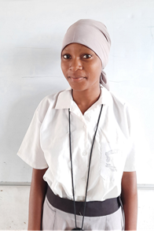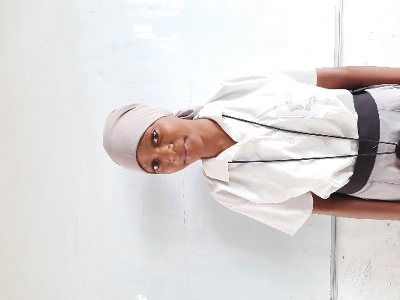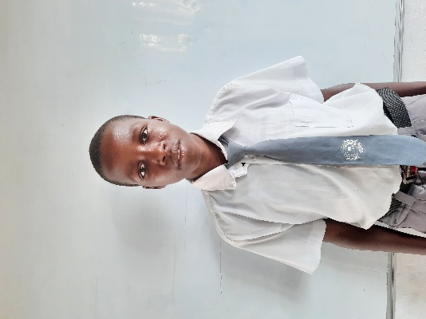

***Global Giving-TRLF Donation of Solar Lanterns to Kitere & Minhaj secondary schools, Tana Delta***

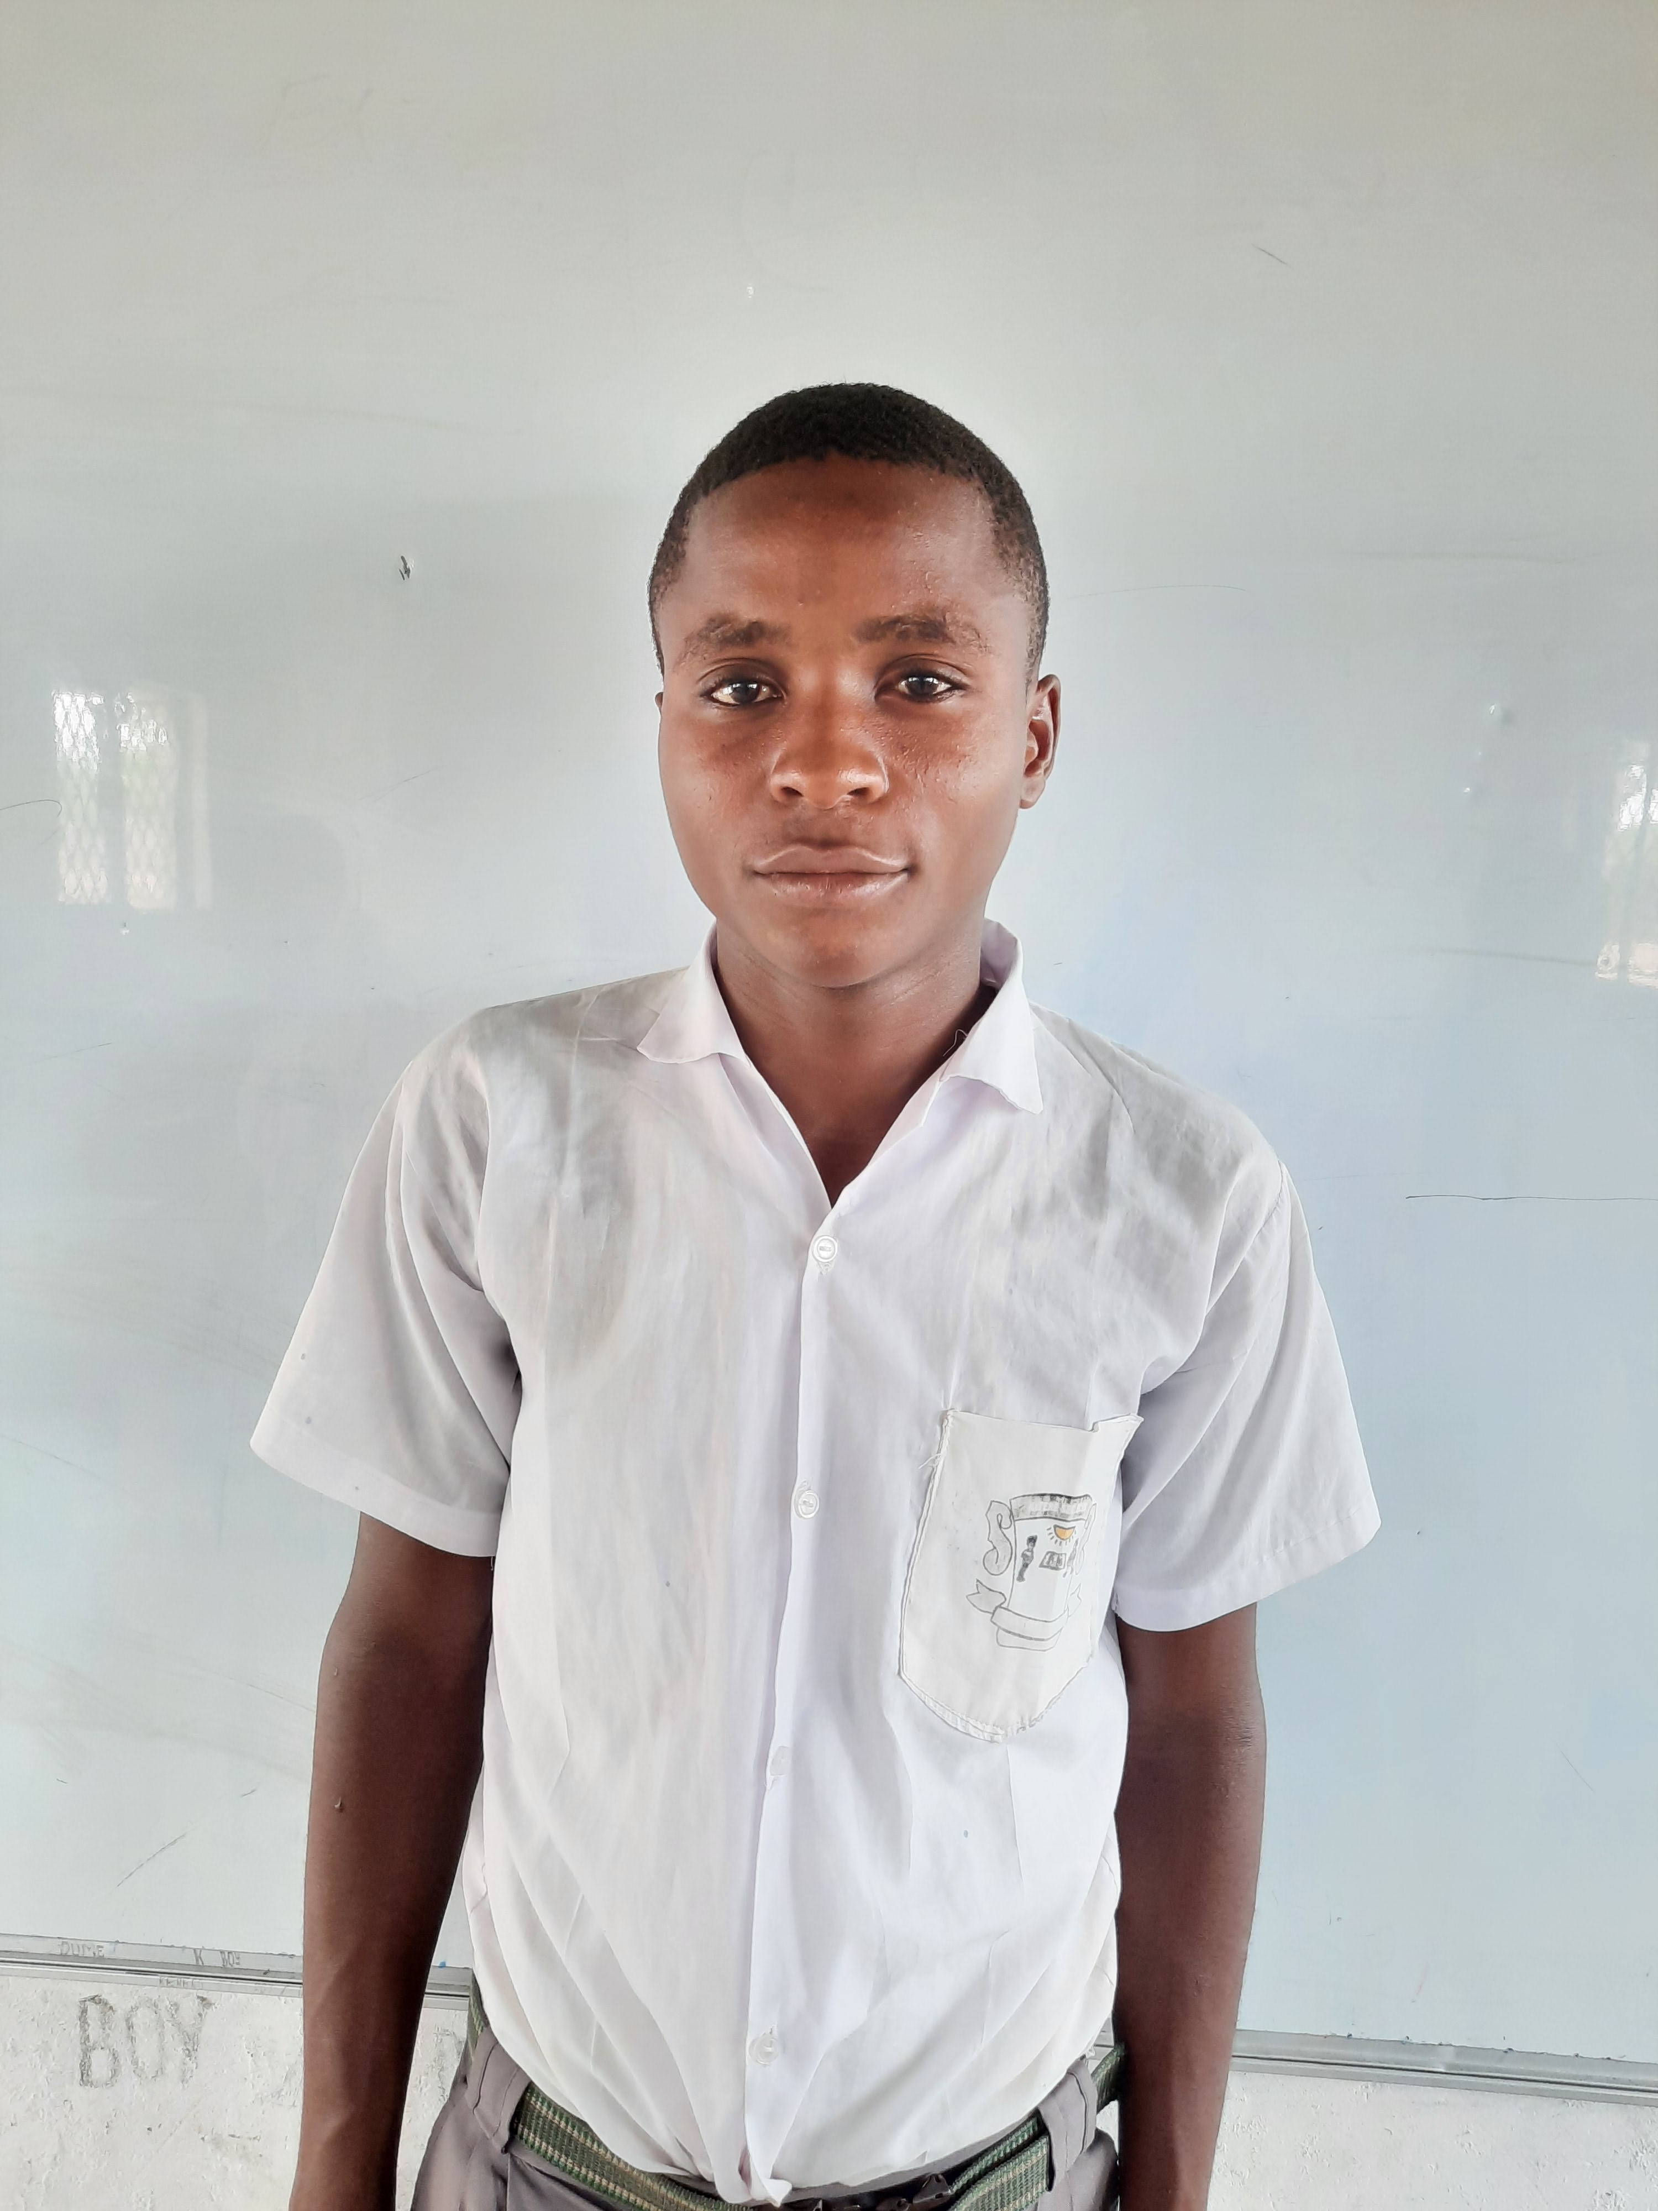

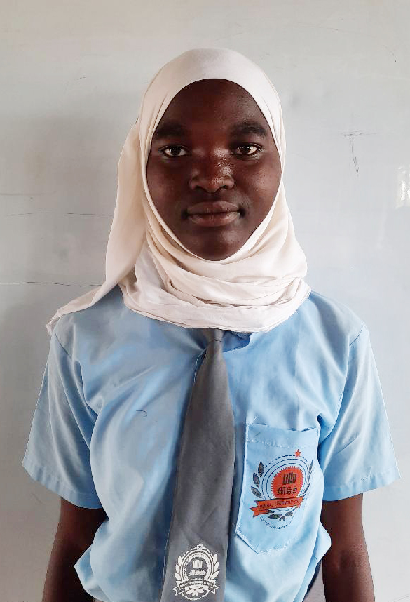

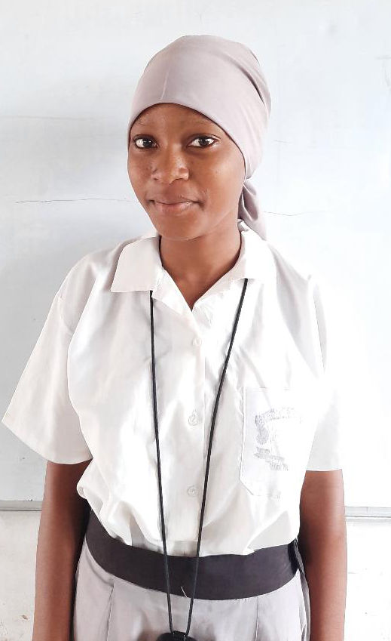

Name: Rukia M. Malibe

Village: Kitere

School: Minhaj Sec. Sch.

Age:17

Adm. No: 161/ Form 3

‘’Before I was not having night studies as I did not have light sources. Now with this solar lantern, I will be having night preps and I will be completing my assignments on time. My KCSE target is a B+’’.

Name: Bakar M. Athuman

Village: Kitere

School: Minhaj Sec. Sch.

Age: 15

Adm. No: 305/ Form 2

‘’Before I used candles lamps, it was expensive and sometimes my parents could not afford them. With this project, I can improve my grades. I will also be sharing the solar lantern with my 3 younger siblings’’.

Name: Zeitun Mpa

Village: Mnazini

School: Kitere Sec. School

Age: 16

Adm. No: 271/ Form 2

‘’I will have enough time to do my studies after my completing my housework every evening since I will be having the solar lantern.

With this solar lantern, I now have greater hopes that I can achieve my KCSE target of B+’’.

Name: Babwoya O. Komora

Village: Baomo

School: Kitere Sec. School

Age: 18

Adm. No: 231/ Form 3

‘’Every night I walk to my friend’s house to study. It was risky because of the wild animals around our village. This solar lantern will enable me to do my night studies keep without risks of wild animals and I will be completing my assignments on time ’’.

