BREAKING MENSTRUAL STIGMA THROUGH EDUCATION AND SUPPORT IN SCHOOLS.
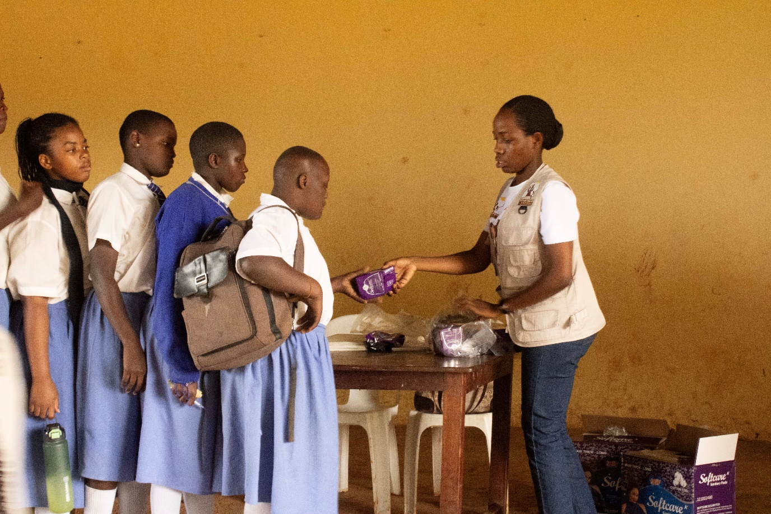
1. Background
Joy for Children Uganda is committed to promoting the health, dignity, rights, and well-being of children, particularly girls who face challenges in accessing menstrual hygiene information and materials. Menstrual hygiene education is essential in helping girls understand menstruation, maintain personal cleanliness, use sanitary products correctly, and manage their periods confidently while at school. It is also important to educate boys so that they understand menstruation, challenge harmful beliefs, and treat girls with respect.
Internationally, According to the World Health Organization (WHO) and the United Nations Children's Fund (UNICEF), only 39% of schools globally provided menstrual health education, while 31% had bins for menstrual waste in girls' toilets, based on emerging national data reported in 2024. The findings demonstrate that menstrual health remains a challenge because of inadequate education, limited access to sanitary products, insufficient water and sanitation facilities, and stigma surrounding menstruation. WHO and UNICEF emphasise that girls should be able to manage menstruation safely, with dignity and confidence (WHO & UNICEF, 2024).
In the sub-Saharan Africa. The WHO/UNICEF Joint Monitoring Programme reported that only 12% of schools in sub-Saharan Africa provided menstrual materials for free or for purchase, while only 11% had bins for menstrual waste in girls' toilets. These findings show the need for increased investment in menstrual health education, affordable sanitary products, appropriate disposal facilities, and supportive school environments (WHO & UNICEF, 2024).
The Government of Uganda, through the Ministry of Education and Sports, developed the Menstrual Health Guidelines for Schools and Education Institutions in Uganda (2023) with support from partners, including the United Nations Population Fund (UNFPA). The guidelines emphasise menstrual health education, access to safe and affordable sanitary materials, appropriate water and sanitation facilities, safe disposal of used products, and positive social attitudes towards menstruation.
Furthermore, a December 2024 report by Uganda's Office of the Auditor General found that 64% of female learners surveyed (138 out of 216) reported having missed school or classes because of menstruation. The audit also found that 22 of the 48 schools visited did not provide emergency sanitary pads or other menstrual health support. These findings relate to the schools and learners included in the audit and should not be interpreted as national prevalence estimates (Office of the Auditor General, 2024).
Joy for Children Uganda conducted a menstrual hygiene education and sanitary pad distribution activity at Kyambogo Primary School, targeting boys and girls from Primary Four to Primary Six. The sessions were led by Martha and Ahuura Doreen, Madam Prescious from Joy for children with the help of teachers in controlling the audience.We meet around 200+ students. The boys were very excited to hear about menstrual hygiene and some little girls in the lower-class P.4 and were hearing this for the information and seeing sanitary towels for the first time. This showed that there more need to sensitise schools on menstrual hygiene. One of the teacher madam Margret told us that some pupils during their periods they use toilet tissues as pads because they are not always given sanitary pads from home due to financial difficulties Madam Margret requested Joy for children to continue providing these sanitary pads because girls when they are in their periods they don’t always have pads.Also Girls were very happy to receive sanitary pads and requested for more.
2.Purpose of the study
To increase awareness among both boys and girls understand menstrual hygiene.
3. Objectives
To increase awareness among boys and girls about menstruation and proper menstrual hygiene practices.
To promote respectful attitudes towards menstruation and encourage a supportive school environment for girls.
To provide Softcare sanitary pads to girls to support their menstrual hygiene needs.
4. Activities Conducted
Joint Menstrual Hygiene Education Session
The activity began with a joint session involving boys and girls from Primary Four to Primary Six. The learners received information about menstruation, puberty, personal hygiene, and the importance of using appropriate menstrual materials.The session also highlighted the importance of maintaining cleanliness during menstruation and treating girls with understanding and respect. Boys were included to help them appreciate menstruation as a normal biological process and discourage teasing, embarrassment, and discrimination against girls.
Respectful attitudes towards menstruation and a positive supportive environment .
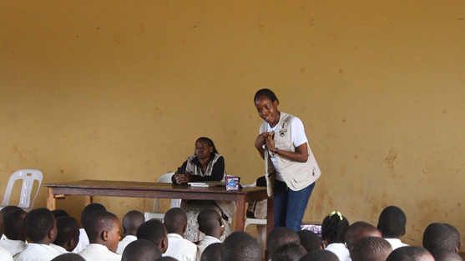
During the activity at Kyambogo Primary School learners from P.4 to P.6 were sensitised about menstrual hygiene, puberty, and the importance of respecting girls during their menstrual periods.The discussion emphasised proper use of sanitary pads, personal cleanliness, regular changing of pads according to individual needs and product instructions, handwashing, and seeking guidance from trusted adults when experiencing menstrual health concerns. The girls were also encouraged to approach trusted teachers, parents, caregivers, or health workers for further information. Both boys and girls participated in the initial sessions, helping them to understand menstrual hygiene, reduce menstrual stigma and encourage boys to become supportive classmates and friends. After the boys left, the session continued with the girls needs. The activity emphasised the importance of providing adequate sanitary pads, clean and private sanitation facilities, accurate menstrual health information and emotional support to help girls manage their periods confidently, maintain their dignity and participate fully in school activities.
JFCU staff encouraging students in regards mentrual health and hygiene.
Girls-Only Menstrual Hygiene Session
After the joint session, the boys left, and the activity continued with the girls only. This created an opportunity to focus more directly on girls' menstrual hygiene needs and concerns.The discussion emphasised proper use of sanitary pads, personal cleanliness, regular changing of pads according to individual needs and product instructions, handwashing, and seeking guidance from trusted adults when experiencing menstrual health concerns.The girls were also encouraged to approach trusted teachers, parents, caregivers, or health workers for further information .
Distribution of Soft care Sanitary Pads
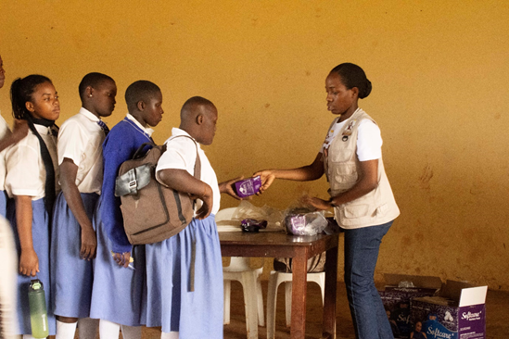
At the end of the activity, Soft care sanitary pads were distributed to the girls. However, the available pads were insufficient to meet the needs of all the girls who required them.Although the distribution provided practical assistance to some learners, the shortage limited the number of girls who could benefit from the supplies. This highlighted the importance of mobilising additional menstrual hygiene materials for future school activities.
Joy for children staff distributing pads to the girls.
5. Outcomes and Observations
- Learners received menstrual hygiene information in a school-based setting.
- Both boys and girls participated in the joint session, creating an opportunity to promote understanding and respect.
- The girls received a separate discussion focused on their menstrual hygiene needs.
- Some girls received Softcare sanitary pads for immediate use.
- The shortage of pads revealed a continuing need for practical menstrual hygiene support.
6. Challenges Encountered
- One of the teachers told us the some girls always use toilet papers when they are in their periods due to failure of parents and guardians to provide those needs due to financial difficulties.
- Inadequate sanitary pads,the available Soft care pads were not enough for all the girls who needed them.
- Need for continued education, Menstrual health education requires regular reinforcement as learners grow and experience puberty because other pupils were so excited and learning new things as well .
- Limited material support, the activity could not meet every girl's menstrual product needs, showing the importance of planning for adequate supplies before future distributions.
7. Recommendations
- Mobilise additional sanitary pads. Engage donors, well-wishers, and partners to provide sufficient sanitary products for girls who were not reached.
- Conduct regular school sessions. Continue menstrual hygiene education for boys and girls to reinforce accurate information and respectful behaviour.
- Strengthen school support systems. Work with teachers and school management to improve access to emergency sanitary pads, clean water, private toilets, and safe disposal facilities.
- Promote positive attitudes. Encourage boys to be supportive and respectful towards girls during menstruation.
- Plan distributions according to need.Coordinate with the school to estimate the number of girls requiring assistance and the quantity of sanitary products needed before each activity.
8. Conclusion
The menstrual hygiene activity at Kyambogo Primary School provided an opportunity to educate boys and girls from Primary Four to Primary Six about menstruation and the importance of proper menstrual hygiene. The girls-only session enabled more focused discussion of their needs, while the distribution of Softcare sanitary pads provided practical assistance to some learners. However, the available pads were insufficient for all the girls who needed them. Continued education, resource mobilisation, and collaboration with the school are necessary to support girls in managing menstruation safely, confidently, and with dignity.
PICTURES TAKEN WHILE IN THE FIELD.


