HER PERIOD SHOULDN’T END HER EDUCATION: VOICES FROM GIRLS WE MET AND THEIR PARENTS.
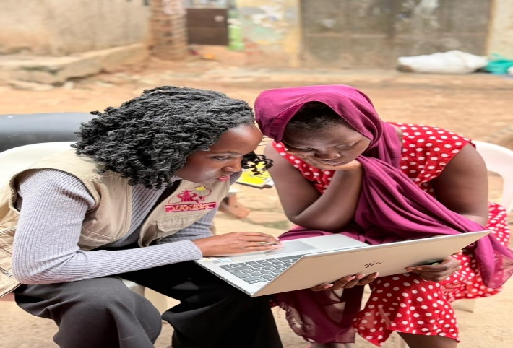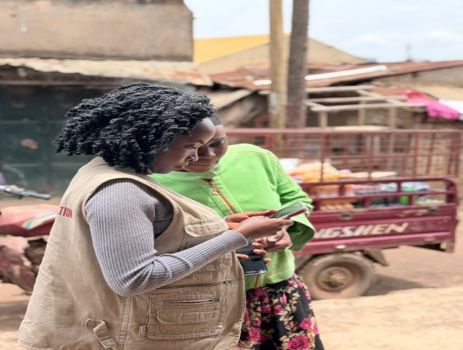
Background.
Globally, millions of girls miss school every month because they cannot safely manage their periods. In many low-income communities, one in ten girls in Sub-Saharan Africa misses’ school during menstruation due to lack of sanitary products, stigma, menstrual pain, inadequate sanitation facilities, and limited support systems.
In Uganda, menstruation continues to be a silent barrier to girls’ education and wellbeing. It is estimated that at least 23% of girls aged 12–18 drop out of school due to the onset of menstruation and lack of adequate menstrual management support. These repeated absences often contribute to school dropout, increasing girls’ vulnerability to child marriage, early pregnancy, and long-term poverty.
Through our “Sanitary Towels for Girls in Rural Schools” project, our team recently visited Makerere- Kivulu a slum community in Uganda to conduct a health and safety survey on menstrual health and hygiene, focusing particularly on girls who are currently out of school. These girls are often the least reached yet the most vulnerable, and understanding their experiences is essential in designing meaningful interventions in our programs.
Objectives.
To assess the health and safety challenges faced by adolescent girls regarding menstrual health and hygiene in the community.
To understand the experiences of out-of-school girls and how menstrual health challenges contribute to school absenteeism and dropout.
To identify knowledge gaps, myths, and cultural beliefs surrounding menstruation among girls and community members.
To engage parents and guardians to better understand their perspectives on menstrual health and girls’ education.
Activities accomplished
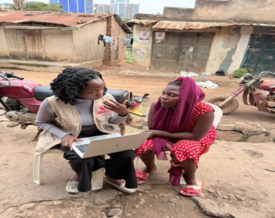
Health and Safety survey on menstrual health and hygiene.
During the visit, we held one on one conversations with at least 15 girls aged 13-19 years to learn about the realities they face when managing menstruation without adequate resources or support. Many girls shared that they do not have access to sanitary pads or even basic underwear, and are often forced to improvise with unsafe alternatives, such as cutting and using old clothes as makeshift pads. These practices not only affect their hygiene but also expose them to health risks, discomfort, and shame, often keeping them away from school or community activities.
JFCU Team member conduction one on one conversation with a girl during the community visit to understand challenges girls face managing menstruation.
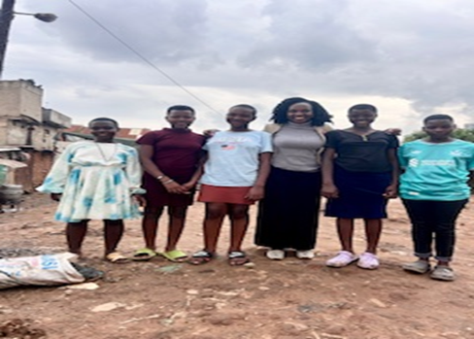
A concern that repeatedly emerged during the discussions was the severe and often unbearable pain many girls experience during their periods. Several girls described intense abdominal cramps, headaches, and body weakness that make it difficult to attend school. Without access to proper information, medical guidance, or supportive environments, many girls simply endure the pain in silence. Some reported staying at home for several days every month because the pain becomes overwhelming, which further disrupts their education and confidence.
Some of the young girls we spoke with in Makere Kivulu slum community.
Beyond the physical challenges, the survey also highlighted the social and safety risks surrounding menstruation. In communities where menstrual health is rarely discussed openly, girls often feel embarrassed to seek help or ask for sanitary materials. When asked whether girls should openly discuss these issues with adults, many responded “no,” and when asked if girls are unclean during menstruation, a number agreed, while others believed girls should not openly participate in activities. These responses reveal a significant information gap and persistent myths surrounding menstrual health. For girls who have already dropped out of school, this isolation is even deeper, and without the protective structure of school or economic opportunities, they are more likely to become victims of child marriage or early pregnancy, cutting short their childhood and future potential.
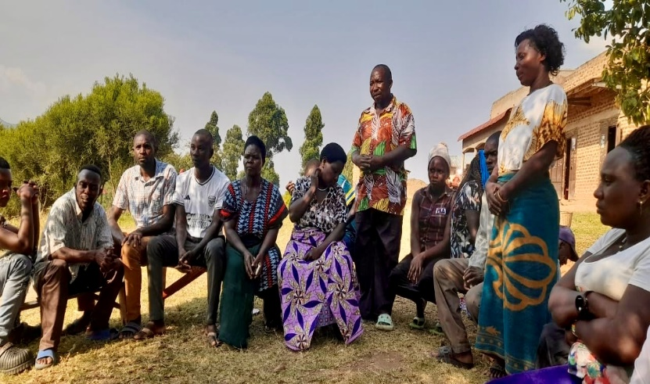
community Dialogue with some parents and guardian.
We also held a community dialogue where we spoke with parents, guardians, and community leaders and discussed some of the issues raise by these girls and to better understand their perspectives on girls’ education and menstrual health. It became clear that awareness and open dialogue around menstruation remain limited. Some parents acknowledged that economic challenges and lack of information make it difficult to adequately support girls during their menstrual cycles and also leads to failure to support their children to keep in school. These discussions reaffirmed the importance of engaging entire communities in conversations about menstrual health and the importance girls’ education.
Some of the parents and guardians participating in a community discussion on menstrual health, awareness and importance of keeping girls in school.
Lessons learned. | Future plans and Recommendations.
- Creating spaces for open discussion challenges stigma, strengthens community support systems, and ensure that girls are not forced to abandon their education because of something as natural as menstruation. | - We plan on creating groups of young girls in communities and in schools to train girls and on making reusable sanitary towels to help girls and women access affordable and sustainable menstrual products.
- Many girls experience severe menstrual pain, which affects their ability to attend school or participate in daily activities. | - Conduct targeted sensitization sessions for girls, especially those out of school and also those in school, to provide accurate information on menstrual health, pain management, and personal hygiene especially in schools and during holidays so that no girl is left out
- Menstrual stigma and myths remain common, with some girls believing they should not discuss menstruation openly or participate in normal activities during their periods. | - Creation of safe spaces especially school clubs and support groups in communities for girls where they can openly discuss menstrual health challenges and receive guidance and support from our monthly visits.
- There is still limited awareness among parents and community members about the importance of menstrual hygiene management and its link to girls staying in school. | - We are currently preparing for expanded community dialogues that will bring together parents, guardians, and local leaders in different communities to raise awareness about menstrual hygiene and emphasize the importance of keeping girls in school
Appreciation Note.
Thank you for continuing to stand with us and with the girls whose stories often go unheard. Your support makes it possible for us to listen, learn, and advocate for solutions that help girls stay safe, healthy, and empowered.

