“Educating Child Labor Victims in Pakistan”

Project Initiation Report
By Idara-e-Taleem-o-Aagahi (ITA)
Details of Project Leader:
Rohma Labeeb
Assistant Manager | Marketing and Partnerships
Idara-e-Taleem-o-Aagahi | Center for Education and Consciousness
(+92- 051) 232250 | rohma.labeeb@itacec.org | www.itacec.org
Flat # 204, 2nd Floor, Dossal Arcade
Blue Area, Islamabad

Table of Contents

Introduction of Idara-e-Taleem-o-Aagahi (ITA) 2
Mission Statement 2
Objectives of the Trust 2
Experience with Child Labor 2
Purpose of Project 3
Project Description 3
Target Age Group of Beneficiaries 3
Number of Direct and Indirect Beneficiaries 3
Geography Covered & Beneficiaries 3
Donors / Funders 3
Project Objectives 4
Project Sustainability 4
Timelines 5
Center 1- Dhok Darzain 5
Location 5
Duration 6
Types of Children Reached 6
Expected cost 6
Staff 6
Pictures of First Center 6

Introduction of Idara-e-Taleem-o-Aagahi (ITA)
Established in 2000, Idara-e-Taleem-o-Aagahi (ITA), also known as the Centre of Education and Consciousness, is a response to the profound crisis of education present across Pakistan. ITA aims to remove the barriers causing this education challenge and create a vibrant learning environment where each individual is given equal rights and opportunities throughout their learning years. ITA is a tax exempted nonprofit organization, registered under; the Registration Act 1860 in 2000, the Societies Act in 2006, and is certified by the Pakistan Centre for Philanthropy since September 2006. ITA is also registered and is in compliance with NGOsource that ensures that we are equivalent to a U.S. public charity.
“Idara-e-Taleem-o-Aagahi is a Public Trust, dedicated to promoting education as a comprehensive process for human and social transformation.”

Mission Statement
To actively pursue universal access and standard setting in education as a comprehensive learning experience for human evolution and consciousness by creating contemporary education systems for all children, youth and adults without discrimination due to gender, class, age, religion, color and ethnicity and, to address bottlenecks through timely resource mobilization and influencing of public policy.

Objectives of the Trust
- Create appropriate institutional arrangements to explore, experiment, research and implement quality alternatives committed to educational excellence in a global setting.
- Expand the landscape from education and learning to education, skills, livelihoods and entitlements; skills encompass both vocational and higher education
- Undertake institutional strengthening of public, not for profit private sector and community-based organizations for managing change providing quality education services through area-based approaches.
- Promote enabled learning based on principles and practices of education for global citizenship and sustainable development (ESD).
- Alleviate resource bottlenecks which prevent individuals and organizations from maximizing potential for benefiting society.
- Develop and promote information and communications system to access latest local and global evidence on education trends for influencing practice, policy and reforms.
- Document, network and organize inter-cultural exchanges with like-minded organizations locally, regionally and globally for sharing best practices, validating the work of the Trust as a global institution to promote the mission of Idara-e-Taleem-o-Aagahi.

Experience with Child Labor
ITA has been undertaking child labor projects since 2001 and has pioneered the concept of iterative mainstreaming which allows such children to enroll based on merit in formal schools (govt. And low cost private) depending on the availability of spaces in public sector. ITA has won the commonwealth award for DICs as an innovative scalable program by ILO.

Purpose of Project
According to the ILO Child Labor Survey, out of a total of 40 million children aged 5-14 years in Pakistan, 3.3 million are victims of Child Labor. Out of this, 264,000 children are working in 'personal and social services' being victims to Domestic Child Labor, the most hidden, invisible and inaccessible of all child workers. To ensure that these children get their right to free and compulsory education (according to Article 25A of the Constitution of Pakistan) Idara-e-Taleem-o-Aagahi (ITA) has set up a crowd funding initiative, opening drop in centers for such children in districts of Punjab & Islamabad Capital Territory (ICT).

Project Description
The projects aims to educate, counsel and support around 500 child labor victims, allowing them access to excellent transition/bridge programs with life skills and technical education. ITA seeks to open up to 8 drop-in centers for 1 year each in order to reach children engaged in worst forms of child labor in selected districts of Punjab and ICT. This will be done by providing bridge/non formal education, life skills and training to child labor victims. The drop in centers are designed to provide children with accelerated literacy programs, technical vocational training (for older children), health /hygiene knowledge, life skills and pyscho -social counselling.
The drop in centers will provide children between the ages of 7-16 with standards based non-formal education, encouraging withdrawal from child labor at the same time. The age group of 7-13 will be exposed to ITA’s accelerated literacy programs (in the subjects Math, English and Urdu) after which the aim will be to mainstream them into public schools in their community. Children/adolescents between the ages of 14-16 will be provided with Technical and Vocational Training where they can learn marketable certified skills (electrical/stitching/beautician) and other skills to enable them to access livelihoods and safe job options. Along with learning/skills there will be support for health/hygiene and life skills education, creative expression and counselling from ITA mentors.
Target Age Group of Beneficiaries
Children from the age group of 7-16

Number of Direct and Indirect Beneficiaries
Direct beneficiaries: 50-60 children per center x 8 centers = 400- 480
Indirect beneficiaries: 5 family members per child = 2,000- 2,400
Geography Covered & Beneficiaries
Punjab and the Islamabad Capital Territory

Donors / Funders
Donations from Global Giving

Project Objectives

- To contribute to the progressive elimination of Child Labor in the country, specifically Domestic Child Labor and other worst forms of child labor
- To protect over 500 children working as domestic servants/others, worst forms of child labor through the provision of a Basic Education & Life Skills Program
- To ensure progressive mainstreaming of the target children in the formal education system and alternative non- exploitative livelihoods
- To advocate and mobilize in favor of article 25 A right to education for all children 5-16 years of age and against worst forms of child labor/ Child Domestic Labor
- Provide health care, hygiene support, counselling and recreational facilities to extremely disadvantaged children.

Project Sustainability
Withdrawal will be encouraged for all children visiting our drop in centers through counselling them as well as their families by the Social Mobilizer. Children will be mainstreamed to schools only after the full consent of parents in order to minimize drop outs. After TVET skills are given to older students, they will be put in touch with potential employers/self-employment linkages to ensure they do not return to exploitive labor. The aim is to insure each child is given a better opportunity elsewhere and prevented from returning to exploitative work places.

Timelines

Each Center is expected to run for 1 year. If more time is needed for the center, it will be considered a new center and continued as needed.

Center 1- Dhok Darzain

*Launching in the week of World Day Against Child Labor- 15th June 2016
Location ZB-250/A Meharabad Road, UC 5- Dhoke Hassue
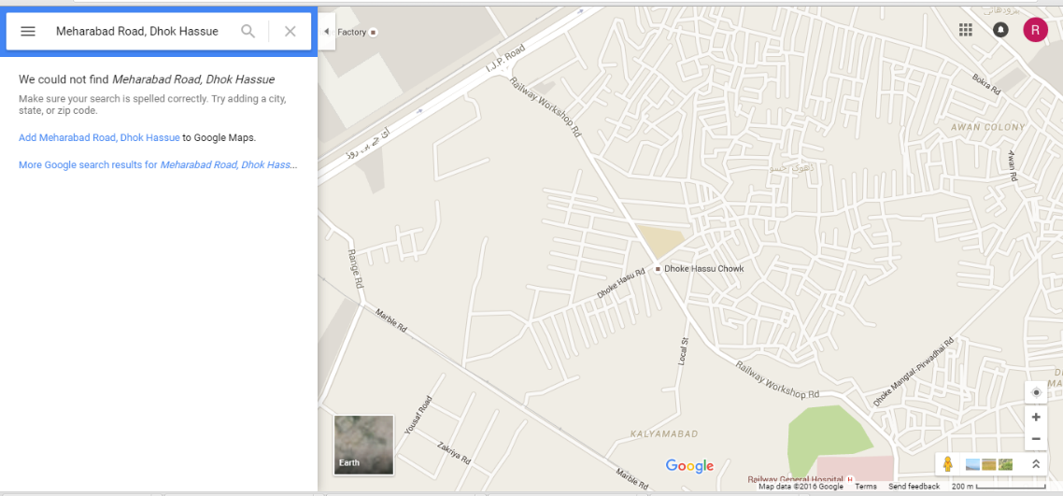
https://www.google.com/maps/search/Meharabad+Road,+Dhok+Hassue/@33.6256011,73.0241483,15.8z

Duration 6 months
Types of Children Reached Garbage pickers, vegetable market workers, street fruit sellers, domestic labor (mostly girls).
Expected cost $10 per child x 50-60 children= $500- $600

Staff
 | Position | Name | Qualification | Timings
1 | Social Mobilizer | Ejaz Khan | Bachelors | Full Time
2 | Center Manager/ Teacher | Uzma Rani | Bachelors | Full Time
3 | Non-Formal Education Teacher | Not hired yet | 2-3 years experience | Part Time
4 | Technical and Vocational Teacher | Sadia Jabbar | 2-3 years experience + Stiching Dimploma | Part Time

Pictures of First Center
