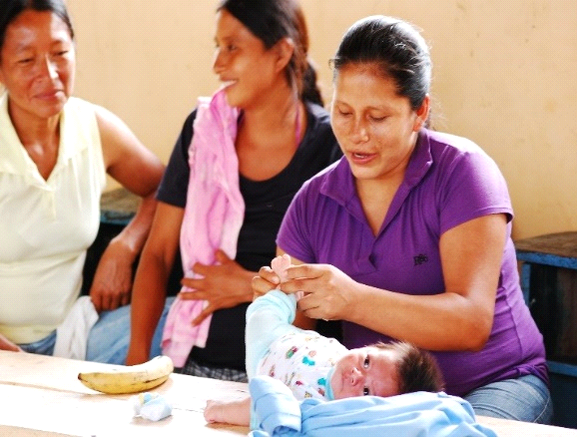
Improving Maternal & Child Health in the Napo Region of Ecuador
Project Location: Ecuador
Number of Beneficiaries: 1,500
Project Duration: 1 year
Total Budget: $ 65,754
Background
This project will be working with four communities in the Napo Region of Ecuador. Located in the Amazon jungle, these rural, impoverished communities face serious health and development challenges. With average family incomes at only around $ 200-300 per month, economic conditions are difficult. These Quechua and Spanish speaking communities rely primarily on agriculture and manual labor for income - where men typically go to find work in the city as carpenters or handymen, while the women take responsibility for growing crops at home. Most families have 7 to 10 children, and women marry very young - often becoming mothers at 15 or 16 years of age.
Since 2010, MAP International has been partnering with communities in the Napo Region to identify and address their health and development needs. Over the past year, MAP has been focusing on the urgent need for communities to address maternal and child health needs with a holistic strategy. Through community health education, MAP has been using the latest research on healthy early childhood brain development and the need to go beyond just clinically-based maternal and child health care. A comprehensive approach is needed to integrate best practices in comprehensive early childhood development with maternal and child healthcare. Families in the communities of the Napo Region have started to use these strategies, and significant impact is already being seen on health of mothers and young children.
Project Need
Access to high quality maternal and child health care is a serious issue in the four communities of the Napo region. Due to the considerable distance to the nearest clinics and health centers, women do not attend prenatal visits during their pregnancy – resulting in a host of poor health indicators for both mothers and children. For children, there are high rates of child mortality, chronic malnourishment, respiratory infections, and diarrhea, Mothers are experiencing high rates of maternal malnutrition, a high proportion of babies born with low birth weights, pregnancies spaced too closely together, and low rates of skilled deliveries.
Parents also lack knowledge and skills about how to create conditions for healthy early child development. Most communities in Ecuador have high rates of domestic violence and child abuse, and most infants and children grow up in families and communities with chronic stress. The latest research has shown that this toxic stress in early childhood can damage the infant’s developing brain and the body’s stress response systems -- resulting in high financial and emotional costs for individuals, families and society.
Together, this lack of knowledge and inadequate access to care has long term consequences on the health and development of children in communities in the Napo Region. As a result, there is an urgent need to start a comprehensive Maternal & Child Health project with community-based activities in the following areas:
- To promote the development of capabilities in infants and their families based on key health factors, with a focus on Early Childhood Development
- Maternal and child healthcare, workshops training, use of appropriate materials and accompaniment to health promoters with a focus on comprehensive early childhood development
- Home visits to pregnant mothers and to families with children under 3 years’ old
- Annual meeting of health promoters to measure impact and assess project progress
- Training and capacity building for parents in comprehensive Early Childhood Development (ECD)
- Creating comprehensive physical environments for Early Childhood Development
- Meetings with families to gather input and feedback on the program
- Parent training to use key ECD strategies with their children on a regular basis (educational, bonding/attachment, motor development, social skills development)
- Education on creating healthy family environments for nurturing infants and children
- Follow-up visits for mentoring and coaching with parents on maintaining good health, nutrition, and family care practices for their young children
- Access to key maternal and child health education, programs, and healthcare services
- Academic and on-hands training to health professionals and promoters.
- Health education on healthy timing and spacing of pregnancies
- Access to comprehensive pre- and post-natal care
- Access to skilled deliveries at health facilities
- Emotional support to mothers through pregnancy and post-partum periods
Expected Results
Through a comprehensive, integrated approach, this project can have a tremendous long-term impact on the health of women and children in the Napo Region -- especially in the critical area of healthy brain development in infants and young children:
Support in the creation of a Center to develop activities that facilitate learning on an Early Childhood approach
- Increased knowledge and skills of health workers for integrated ECD & MCH approach
- Educational materials on health prepared according with the context
- Better knowledge and skills of health promoters for integrated ECD & MCH approach
- Parents will be trained together with their children, through the provision of an appropriate learning environment for families and communities.

Healthy Early Childhood Development
- Parents gain increased awareness on creating better family conditions that lead to healthy early childhood brain development through: (1) Appropriate physical nutrition, (2) Emotional nourishment, (3) Cognitive nourishment, (4) Self-reliance, (5) Safe & enriching environments and (6) Improved family relationships.
- Families practice healthy strategies for conflict resolution and the prevention of violence.

Parents develop skills to communicate with their infants and to effectively respond to the four types of needs: connectedness, inquisitiveness, physical wellbeing, and autonomy/self-reliance. Parents learn how to create home environments that lead to healthy child development. Communities create environments that are favorable for healthy early childhood development.

Access to Maternal & Child Health Services
- Healthy pregnancies for women and increased birth weight for newly born infants
- Health workers are providing integrated care to pregnant women. including workshops, materials, and home visits
- Increased access to maternal and child healthcare from government health providers

Estimated Budget
Project Funding Needs | 2016 - 2017
Total Project Budget | $65,734

