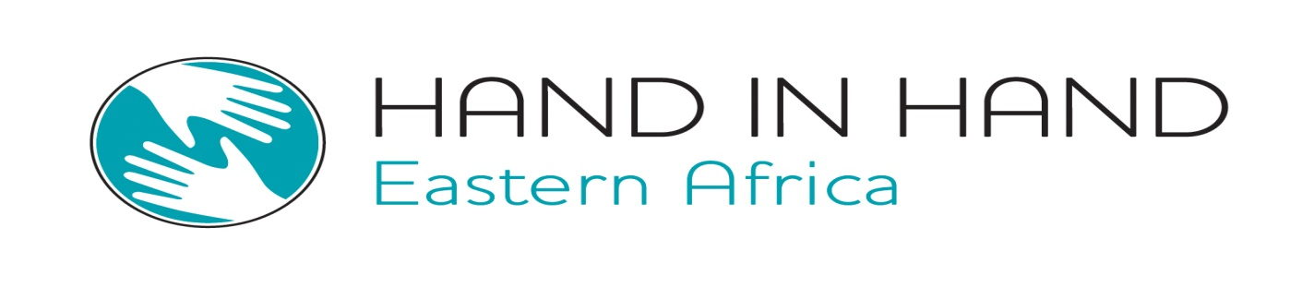

PROJECT PROPOSAL
ON
ENTREPRENEURSHIP TRAINING FOR THE REHABILITATED DRUG AND SUBSTANCE ADDICTS

BY
HAND IN HAND EASTERN AFRICA
Address: P.O Box 8562-00100, Nairobi, Kenya.
E-mail: info@handinhand-ea.org
Contact person: Ms. Pauline Ngari.
Email: Pauline.Ngari@handinhand-ea.org

JANUARY, 2016

Project summary
Drug and substance abuse is a problem that countries throughout the world have had to contend with for centuries. Globally, UNODC estimates that between 155 and 250 million people, or 3.5% to 5.7% of the population aged 15-64, had used illicit substances at least once in the previous year (World Drug Report, 2014).

Drug addiction has been a rising problem in Kenya for several years, as hard substances, such as heroin, are moved from Asia to Europe via East Africa, often stopping in Kenyan hands. A study conducted in 2012 in Kenya and published in the International Journal of Academic Research in Business and Social Sciences found out that, the majority of the clients in the treatment centers were in the age group 20-30 years

The Government of Kenya recognizes the dangers/problems of a society that large number of its population is drug and substance abusers. The treatment centers do not seem to offer entrepreneurial trainings to the addicts but only clinical and psychological interventions. Equally, there are no frameworks to support the rehabilitated individuals in terms of enterprise development skills to get back to normal lives in most rehabs, thus making them dependant on their families and the community at large.
The proposed project will focus on addressing the entrepreneurship training and enterprise development gaps among the rehabilitated individuals in Kenya with the aim of ensuring that, rehabilitated individuals are trained on entrepreneurship skills, facilitated to access mobilize and access business start-up capital in order to be independent and be beneficial to society thereby making them have gainful self employment.
By implementing this project, Hand in Hand Eastern Africa will train 250 youths from rehabilitation centres in Kiambu County in order to provide them with entrepreneurial skills. In the one year project period, this will result in 175 enterprises and 228 jobs. Hand in Hand Eastern Africa will work closely with the key stakeholders at National and County Government levels as well as with development partners in order to realize the objectives of the proposed project
After one year of piloting the project in Kiambu County, the ambition is to turn the project into a pay for success contract model and scale it up into other affected areas facing similar problem by identifying donors and investors for the innovation.

Table of Contents
Project summary 2
1 Introduction 4
1.1 Situation analysis 4
1.2 Problem analysis 5
2 About HiH EA 6
2.1 Operating Model and Road Map for HiH EA 7
2.2 HiH EA Transformational Change (Road Map) 7
3 Project Goal 8
3.1 Specific Objectives 8
3.2 Proposed Project Activities 8
4 Project Budget 9
5 Potential Long Term Impact 9
6 Sustainability 9
7 Timeframe 10
8 Partners 10

Introduction
Drug and substance abuse is a problem that countries throughout the world have had to contend with for centuries. Globally, UNODC estimates that between 155 and 250 million people, or 3.5% to 5.7% of the population aged 15-64, had used illicit substances at least once in the previous year (World Drug Report, 2014).

Across the globe, alcohol and drug abuse is a major challenge to young people. Indeed, use of alcohol and drugs continues to emerge as a strategy for most young people to cope with their prevailing problems such as unemployment, neglect, violence, sexual abuse and poor academic performance (NACADA, 2012). Abuse of drugs not only holds back the economy, but is also a blow to the country as its youth and work force become less productive.

Drug addiction has been a rising problem in Kenya for several years, as hard substances, such as heroin, are moved from Asia to Europe via East Africa, often stopping in Kenyan hands.

Situation analysis
UNODC World Drug Report, 2010 indicate that Africa is now both a narcotics (heroin and cocaine) market and a redistribution point for other destinations. This associated with the ease of availability, affordability and accessibility of alcohol, tobacco, cannabis and miraa/khat has rapidly escalated abuse especially among the youth.

A study conducted in 2012 in Kenya and published in the International Journal of Academic Research in Business and Social Sciences found out that, treatment centers for drug addicts was dominated by male clients (65%) of respondents interviewed and of which the majority of the clients in the treatment centers were in the age group 20-30 years (58%).

The government of Kenya has put legislative frameworks and legislations to manage and control drugs and substance abuse. In Kenya there are 19 legislations in place addressing issues of drugs and substance use. However, these are aimed at controlling abuse, offer rehabilitation services and do not necessarily provide entrepreneurship training for the addicts but only on psycho-social support .
There are 43 private rehabilitations centers around Kenya all approved by NACADA in addition to the publicly owned institutions, thus making them 48 rehabilitation centers in the Country. In Mathari hospital for instance, which is one of the treatment and rehabilitation centers, in the year 2014 to 2015, the outpatient substance abuse clinic treated about 821 patients. At any given time all the 51 beds in the rehabilitation ward beds are always full with each client staying for 90 days for treatment. Most of Kenya’s rehabilitation centers are focused on the support of the immediate and extended family, not only for the financing patient care, but also as an African alternative to the traditional half-way house system for gradual re-entry into the real world. Most of the residential rehabilitation centers in Kenya offer the 12 step and the therapeutic program which involves clinically managed and medically managed residential services.

Problem analysis
Abuse of alcohol and drugs can cut a wide swath of damage across a life, affecting not only the user, but also friends and loved ones. The effects drugs and alcohol have on our society are disastrous. Millions of lives have been ruined, and many lives ended before their time. A sustained culture of knowledge entrepreneurship requires an infrastructure based on networks and clusters, which governments and development partners can facilitate
The Government of Kenya recognizes the dangers/problems of a society that large number of its population is drug and substance abusers. It is for this reason that the government in collaboration with other agencies has initiated initiatives aimed at addressing drug and substance abuse and among youths and adults in and out of school. This problem impacts negatively on the academic, social, psychological, economical and physiological development among the abusers.
The treatment centers do not seem to offer entrepreneurial trainings to the addicts but only clinical and psychological interventions. Equally, there are no frameworks to support the rehabilitated individuals in terms of enterprise development skills to get back to normal lives in most rehabs, thus making them dependant on their families and the community at large. Entrepreneurship trainers assist individuals to assess their entrepreneurial orientation and potential. The most common models offered are the 12 step program and the therapeutic model. The entrepreneurial model can be introduced during the third phase, commonly known as the exit phase of treatment where the addicts are being prepared to reintegrate and fit back into society normally. Research indicates that active participation in treatment is an essential component for good outcomes and can benefit even the most severely addicted individuals. Rehabilitation centers should require drug addicts to be responsible, conscientious, pay attention to learning achievement, and attend entrepreneurial oriented activities. They should provide a pathway for drug addicts to turn their talents and energies toward their own innovative ideas. Therefore Hand in Hand Eastern Africa, has spotted the opportunity to impart entrepreneurial skills to the rehabilitated individuals and help them start their own enterprises and create jobs through the integrated enterprise development and job creation model

About HiH EA
Hand in Hand Eastern Africa (HiH EA) was registered in 2011 as a Non-Governmental Organization (NGO) in Kenya with a vision to alleviate poverty through creation of enterprises and jobs. HiH EA is also a member of the HiH global network and mandated to work within the Eastern Africa region under the network. In Kenya, it currently has operations in 23 Counties through 20 field branch offices and gradually reaching out to other Counties in the Country. HiH EA has operations in Rwanda and plans are underway to open operations in Tanzania. HiH EA is funded by donors/Investors mainly; Swedish International Development Agency (Sida), Larkarmissionen-Sweden, Safaricom Foundation, KIVA, Post code Rotary-Sweden and over 25 individual donors supporting various community development projects

Vision: Alleviation of Poverty, Through Enterprise and Job Creation.
Mission: To Work for the Economic and Social Empowering of women, youth and men and therefore the Society, by supporting the Creation of sustainable Enterprises and Jobs.

Current project implemented by Hand in Hand Eastern Africa in Kenya
- Peace and Prosperity through job creation - An innovative path for Kenya’s Youth
- Sida project
- Village Uplift project
- Integrated enterprise development training and adult literacy project.

Operating Model and Road Map for HiH EA
The operating model below shows the approach and key pillars for the organization

HiH EA Transformational Change (Road Map)
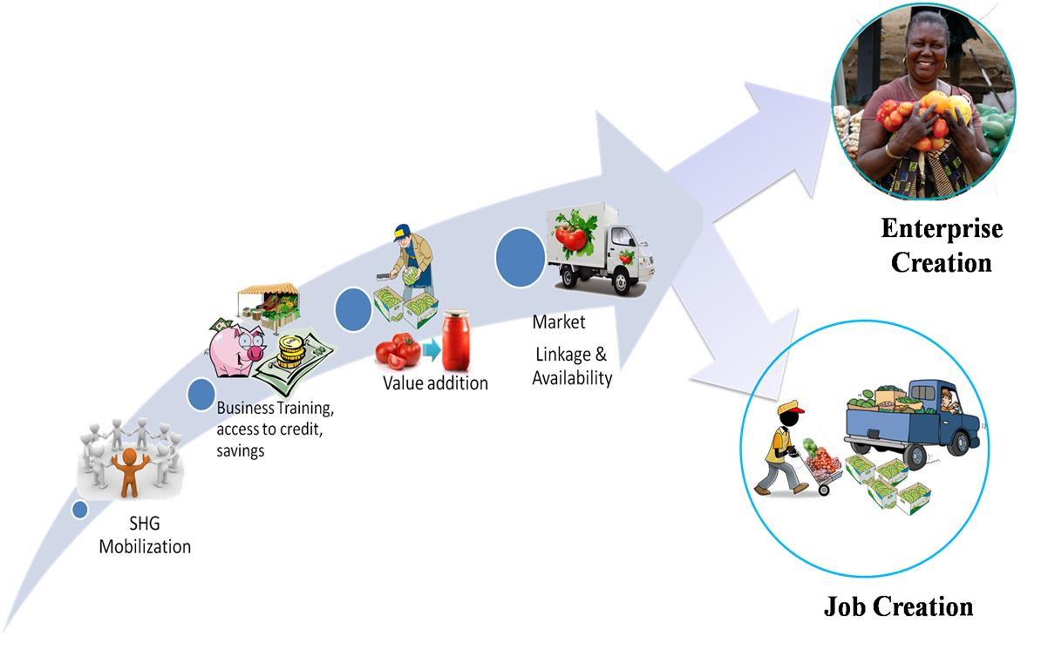
The above figure shows the theory of change for the organization in addressing poverty for the economically marginalized in society and how the interventions geared towards addressing poverty are implemented in phases.

Project Goal
Socio-economic empowerment of 250 youths rehabilitated from drug and substance use in Kiambu County, Kenya

Specific Objectives

To achieve the above goal, the following specific objectives will be pursued:-
- Training of the rehabilitated youths on enterprise creation and development
- Facilitate access to credit for the rehabilitated youths to develop their enterprises
- Creation of sustainable enterprises and jobs for the rehabilitated youths

Proposed Project Activities
- Mobilization of the rehabilitated youths into groups
- Trainings on savings mobilization, enterprise development, financial management and value addition
- Develop linkages and partnerships for the rehabilitated youths
- Facilitate access to financial services for the rehabilitated youths to nurture their enterprises

Activities Schedule (Gantt chart)
Activity | Quarter 1 | Quarter 2 | Quarter 3 | Quarter 4
Mobilization of the rehabilitated youths into groups

Trainings (Entrepreneurship modules-Savings mobilization, enterprise development, financial management, value addition, environmental conservation and access to finance modules)
Develop linkages and partnerships for the rehabilitated youths

Facilitate access to financial services for the rehabilitated youths to nurture their enterprises

Project Budget
Total project budget (all figures in USD $) | 12 Months
 | USD($)
Mobilization of the rehabilitated youths into groups | 2,000
Trainings for youth(Enterprise development modules) | 10,000
Linkages and partnerships development | 5,000
Facilitate access to financial services for the rehabilitated youths to nurture their enterprises | 3,000
Local project staff and Travel costs | 25,000
Monitoring and evaluation | 5,000
Total | 50,000

Potential Long Term Impact
- The project will direct impact/benefit 250 rehabilitated youths in Kiambu County and indirectly impact on 1,000 community members along the value chain
- Create 175 youth enterprise
- Create 228 jobs by rehabilitated youths thereby impacting positively on their socio-economic aspects of life

Sustainability
In order to ensure that, the intervention has long term and sustained impacts, Hand in Hand Eastern Africa will gear to do the following;
- Ensuring quality trainings on technical aspects of various innovations or business ideas
- Establishing linkages for the rehabilitated youths and connect them for continued support
- Ensuring that, the entrepreneurship modules are embedded in the rehabilitation training curriculum in order to reach a wider audience
- Through the incomes earned from the enterprises run by the rehabilitated youths, they will be financially sustainable hence able to meet their basic needs as well as that of their families

Timeframe
12 months

Partners
- Hand in Hand Eastern Africa will work closely with NACADA, development partners and the relevant departments of national government as well as County governments to ensure that the project succeeds. Equally, the organization will work closely with the private sector to support the initiatives further which will be critical for sustainability of the intervention.
- With the support of Kiva (a non-profit micro lending organisation), Hand in Hand Eastern Africa will set up an online micro lending platform to facilitate credit provision to young Kenyan entrepreneurs in this project (aged 18 and above). Additionally, rehabilitated youths can access funds from Hand in Hand Eastern Africa’s enterprise incubation fund (EIF)

Entry Point for Entrepreneurship Training in the Treatment of Drug Addicts: A Case Study of Rehabilitation Centers in Kiambu County, Kenya
NACADA website
Daily Nation, 10th November, 2015
List of counties: Busia County, Nyamira, Elgeyo Marakwet, Embu, Bungoma, Bomet, Laikipia, Kirinyaga, Siaya, Narok, Nyandarua, Muranga, Homa bay, Kericho, Kajiado, Kiambu, Migori, Baringo, Machakos, Nairobi, Kisii, Nakuru, Makueni

