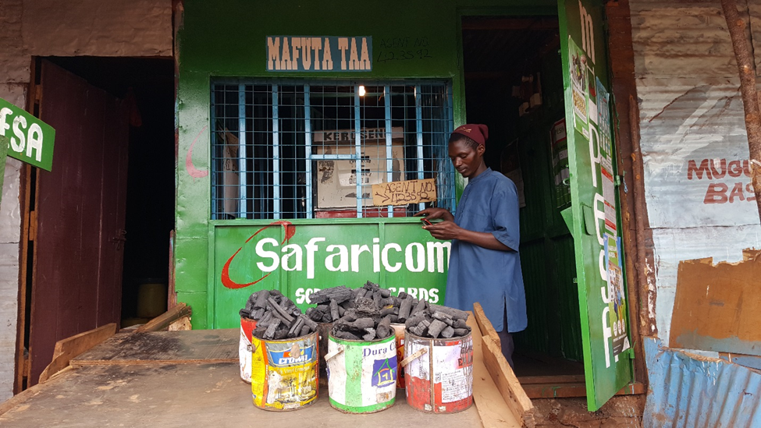
Figure 2: Timothy at his charcoal business.

