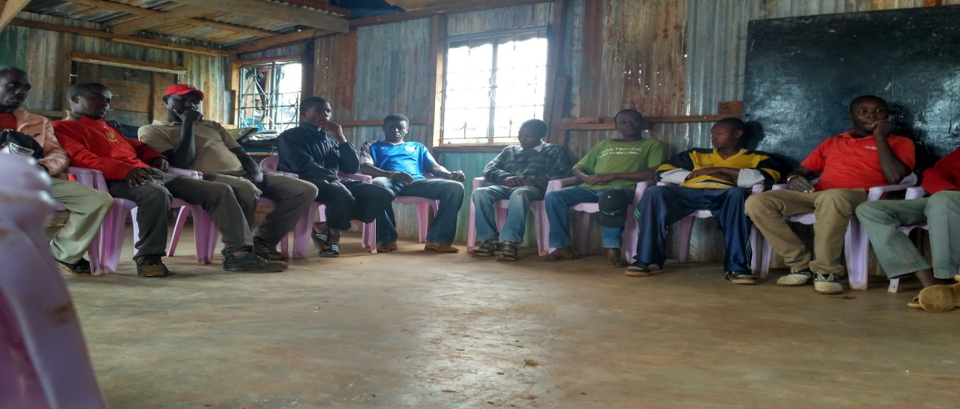
Mashujaa Rehabilitation Youth Group keenly following the entrepreneurship training facilitated by Valentine Nanjala - HiH EA Trainer.

