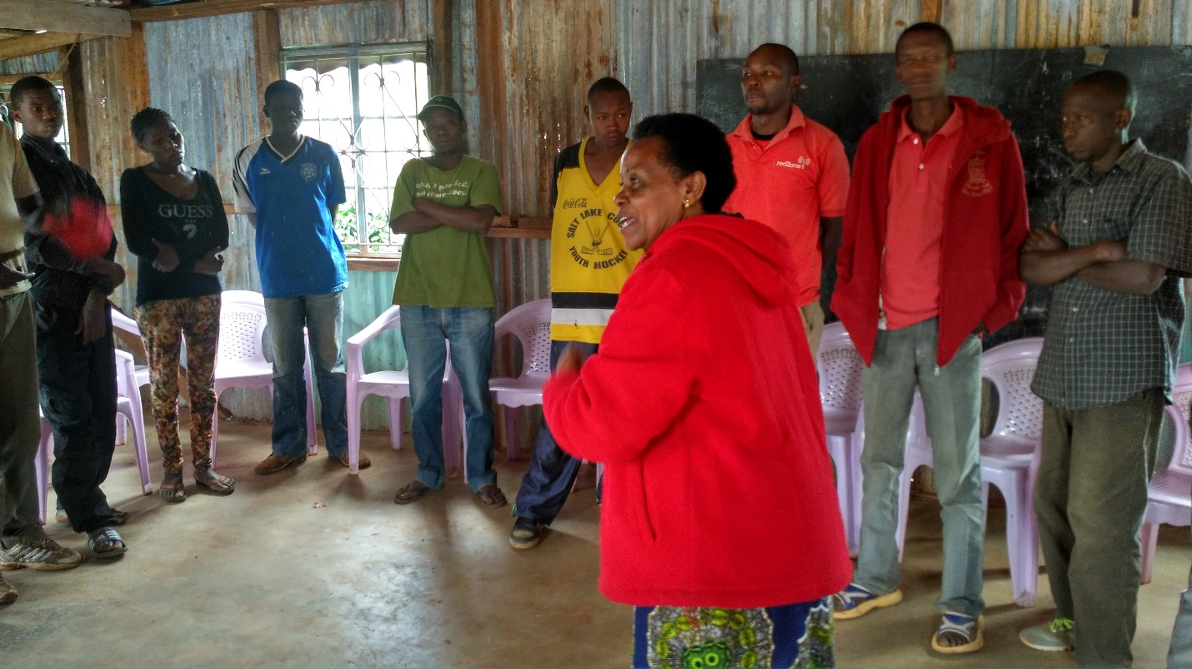
Mashujaa Rehab Kiambu youth in counselling session by one of the church volunteers.

