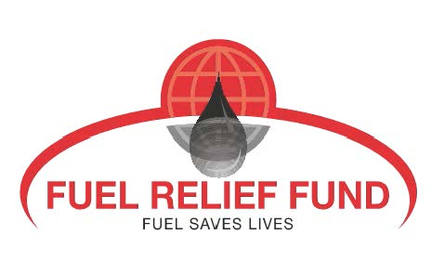
Ecuador Earthquake: Save Lives by Helping Us Source Fuel!

A devastating 7.8 magnitude earthquake hit Northern Ecuador on Saturday, April 16. The rising death toll from the earthquake, collapsed buildings and shattered streets stood at 350 on April 18. At least 2,000 more are injured, and up to 100,000 are left without power, homeless or otherwise affected. The damage is in the billions of dollars already with hundreds of homes destroyed.
No earthquake of this size has hit Ecuador since the 1970s – for the majority of Ecuadorians, this is the largest disaster ever experienced. Family members are missing. Vulnerable children, women, elderly, and disabled are suffering in the cold on the streets without water, food, or shelter of any kind.
Fuel Relief Fund exists to help those in need after a major disaster – by sourcing and then giving victims, local governments, and humanitarian response organizations fuel for vehicles and generators. It is the only NGO in the world that does this, an independent operational support partner of United Nations Office for the Coordination of Humanitarian Affairs (UN OCHA). We have been at every major disaster over the past nine years including the Nepal earthquake, the Great Tōhoku earthquake and tsunami in Japan, typhoon Haiyan in the Philippines, and the Haiti earthquake.
A volunteer First Response Team will be in Ecuador by April 19. What they need is funding to match the FRF First Response Fund (that covers primary expenses to deploy to the disaster site) to purchase and transport fuel to those who need it most – wherever they need it most.
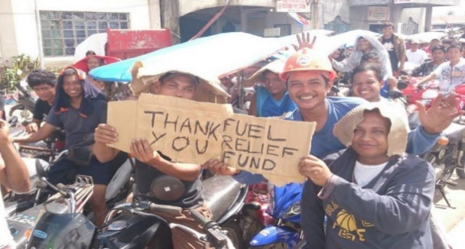
Priorities on the ground will be assisting survivors with free fuel for their generators to power dark nights, to run necessary medical equipment, and for other basic needs, like charging mobile phones to inform family members that they are safe. They will need fuel for their motorcycles, cars, and other vehicles, to seek shelter, food, water and medicine. Further, fuel will ensure generators, light and fuel supply for search and rescue to reach outlying communities as well as to power medical stations to treat the injured.
Help us with a donation today! We will be there – the more funding we can raise, the more fuel and power we can give, and the more lives we can save.
Contact: Melisa Lindros, Executive Director +1.909.322.1481 mlindros@fuelrelieffund.org

