SDMC – School Quality Enhancement Program (SQEP) Progress Report

- Name of Organisation: Learning Links Foundation
- School Name: SDMC School, Pushp Vihar Sec 3 (1 and 2)
- Reporting Period: April 2018 - July 2018

SECTION 1 – PERFORMANCE AGAINST KPI’s
 | School 1 | School 2 | School 3 | School 4 | School 5
Enrolment
Last Year (as of 15th March 2018) | 175 | 147
Beginning of Year (as of 1st April 2018) | 239 | 140
Current (as of date) | 270 | 186
Target (end of year) | 245 | 175
Student Attendance
April-July | April – 85%  May – 77%  July – 87% | April 83%  May 78%  July 72%
August – November
December – March
Year to Date Average
Teacher Attendance
Year to data average | 95% | 85%
Student Retention
Year to data average | 92% | 90%

STUDENT ACADEMIC GROWTH
(Please include grade-wise data discussing either a. Student growth from baseline levels or b. Achievement against grade level expectations. Please fill in percentage of students in each category. You can use your own definitions for the categories – please provide an explanation.)
SCHOOL | Grade | Below Average | Average | Above Average | Absent
School 1 | Nursery | N/A | N/A | N/A | N/A
School 1 | Grade 1 | 44.7% | 18.4% | 21.02% | 15.8%
School 1 | Grade 2 | 18% | 33.4% | 30.7% | 17.9%
School 1 | Grade 3 | 27.10% | 29.7% | 24.2% | 19%
School 1 | Grade 4 | 26.7% | 20% | 46.7% | 6.6%
School 1 | Grade 5 | 12.10% | 36.30% | 39.40% | 12.20%
School 2 | Nursery
School 2 | Grade 1 | 47% | 26% | 16% | 11%
School 2 | Grade 2 | 33% | 26% | 18% | 23%
School 2 | Grade 3 | 36% | 28% | 13% | 23%
School 2 | Grade 4 | 18% | 31% | 22% | 29%
School 2 | Grade 5 | 19% | 47% | 26% | 8%
School 3 | Nursery
School 3 | Grade 1
School 3 | Grade 2
School 3 | Grade 3
School 3 | Grade 4
School 3 | Grade 5

SECTION 2 – SCHOOL PROGRESS REPORT
Note: Please keep the updates provided in this section brief (1-2 sentences)

- Significant Developments

- Infrastructure
  - A new room is set up with TLMs and floor sitting for students of KG on the ground floor in the morning shift
  - White boards and soft boards were installed in all the classrooms to showcase important information and to display students work on the wall.
  - Water cooler and RO has been installed due to Mrs Lajwanti ji’s (Principal) consistent efforts.
  - Minor electricity repairs were done in the school premises
  - During Summer, staff members painted BALA and floor games in the play ground area for a more student friendly environment

- Community and Parent Engagement
  - Student mobilisation drive was continued consistently in April by the social worker in the nearby areas Khanpur, Tigdi, Madangir and Devli. During the drive parents were also informed about the right process of getting enrolled and various schemes in school.
  - April onwards, parents were supported in opening up of student’s bank account, Adhar card updation and information on SC/ST certificate.
  - Parent Teacher Meetings have been conducted monthly in this academic session. The emphasis has always been on student punctuality, health and habit and learning outcomes
  - A mega PTM was organised in July where an informative session was conducted on the importance of nutritious food by Ms Sonali Shivlani and Dr Namrata from Rimedo. This session was facilitated by The Education Alliance

- School Events – academic, extra-curricular and teacher development
  - SMC committee has been formed in both shifts and have become functional. The challenges discussed in SMC meetings are about student safety while dispersal, transparency about mid may meal and student attendance.
  - 8 interns joined our first ever summer internship. All interns were B.el.Ed/B.ed students. Each intern was given a maximum of 7 students from the Uddyam group. Interns were supported through weekly reflections, resources and consistent mentoring. The interns also displayed leadership by doing whole school activities like nukkad natak, treasure hunt etc
  - Students participating in Buniyaad were given individual one on one attention. Their emotional, behavioural and academic learning were recorded in a descriptive report
  - A 50 days summer camp was organised under MCD's mission Buniyad for classes 3, 4 and 5. The total numbers of students enrolled under the program were 107. The teaching methodology was more focussed towards interactive activity based learning.

- Teachers and School Staff
  - Government teachers of both shifts along with art and craft teacher worked after summer camp hours to create working TLMs for students. They created TLMS for academics, classroom management, and behaviour management.
  - The government teachers of grade 3,4 and 5 were consistently during the summer camp and worked dedicatedly to improve the learning levels of Uddyam and Utkarsh group.

- Special Events / Visits
  - In the month of April, 4 CLAP talks were organised where 15 students from both shifts participated and learnt about 4 different countries (Afganistan, Nigeria, Spain and Belarus). CLAP talks were organized by an organisation named Clap Global: it’s a platform that enables a unique exchange of cultures by helping international travellers to visit local classrooms and engage in meaningful and often surprising conversations with students
  - Rimedo conducted a nutrition awareness sessions with students and parents. The students and parents were sensitized about eating habits and importance of healthy food.

- Others
  - 20 students from morning shift were provided a chance to visit the exhibition organised at Vigyaan Bhawan on the World Environment Day
  - An event was organised on "Biodiversity Day' in the school premises. There were multiple activities planned for students from Origami, to a Power point presentation and a nature walk.

- Important Events Planned in the Next 4 Months
  - Independence day celebration
  - Teacher’s Day
  - Diwali Celebration
  - Inter zonal sports competition
  - Bal Diwas celebration

CASE STUDY
Rohit from Class 4

In school, we come across so many students with different needs and challenges. Rohit is also one of them, with hidden talents and challenges. During the initial days of our intervention, we observed that he was not much expressive in classroom and as per his class teacher he was an average student. But he used to hesitate whenever asked a question or asked to read.
With time and our classroom practices, we were able to figure out that he had a sensitive nature and was not comfortable with everyone in the classroom. He hardly had any friends. But he often gets upset when bullied by his friends. He had never been noticed by the teachers which resulted in distrust from his end for the teachers and made him inadvertent. Moreover, he never got the chance to be comfortable about sharing his feelings with anyone, which was the major reason behind his emotional instability.
His mother was also struggling enough to find out the exact reason behind Rohit’s lack of attention and engagement in the class. That is why her mother used to interact regularly with the teachers for important updates.
Learning Links team has been closely working with him and other students with similar challenges. He regularly attended the ‘NEEV’ classes, an LLF initiative under which we worked directly with the students who needed special attention and motivation. We worked towards building a healthy connection and create an environment to make Rohit comfortable. This helped us in understanding the positive side that Rohit had. And there was an amazing change in his behaviour towards us, other teachers and his classmates.
With time, we observed positive transformation in his behaviour as well as his learning level, Similar changes were observed by her mother and she was very happy with it.
His class teacher was also very surprised, when he asked him to read a lesson in class and without hesitation Rohit was able to read it fluently. In class, Rohit became a peer teacher and helped his classmates in reading and doing other simple exercises.
With these small but important achievements, he has been able to gain confidence in himself and now whenever a teacher asks a question in class, he is always ready to answer.
In a recent assessment, he is on ‘Ujjwal’ level in Hindi, ‘Utkarsh’ level in Mathematics and ‘Uddyam’ level in English. We are hopeful that very soon he will escalate to ‘Ujjwal’ level with his hard work and consistency.
Rohit’s transformation has encouraged us to work progressively in this direction and focus on students with the similar struggles.

Pictures

- Teacher Training for Project Buniyaad
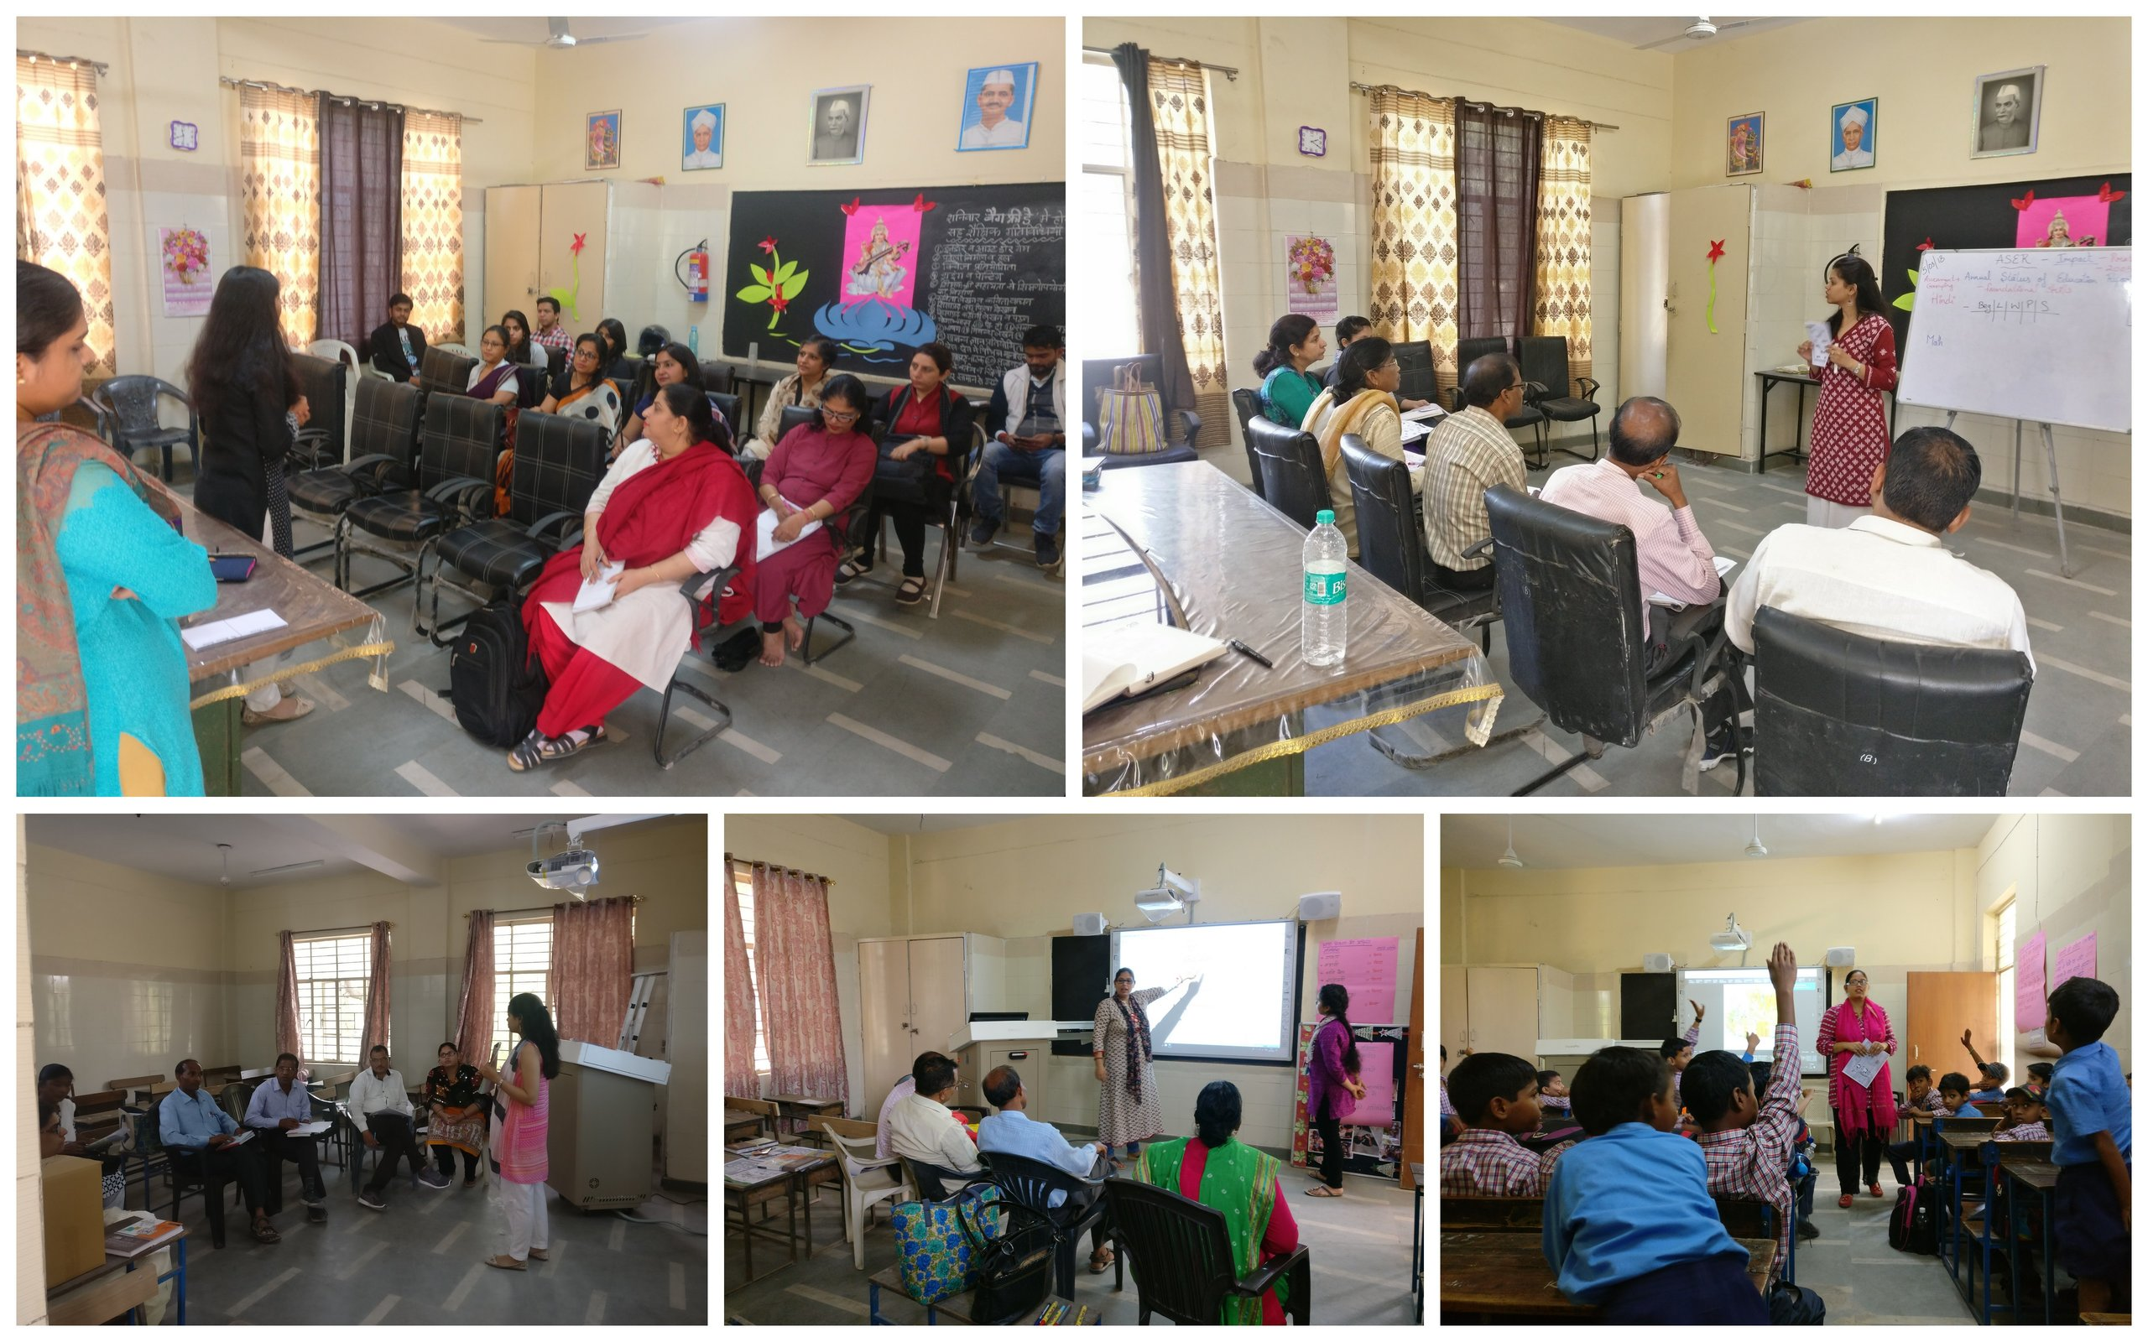

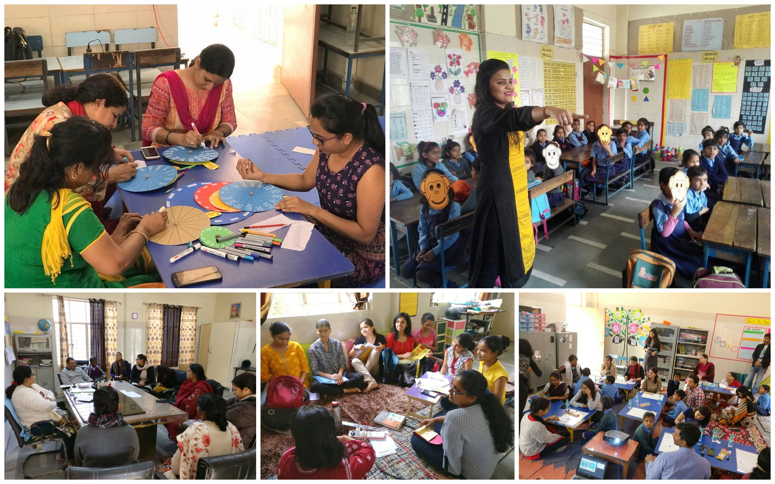
- Collaboration and Planning sessions

- Buniyad
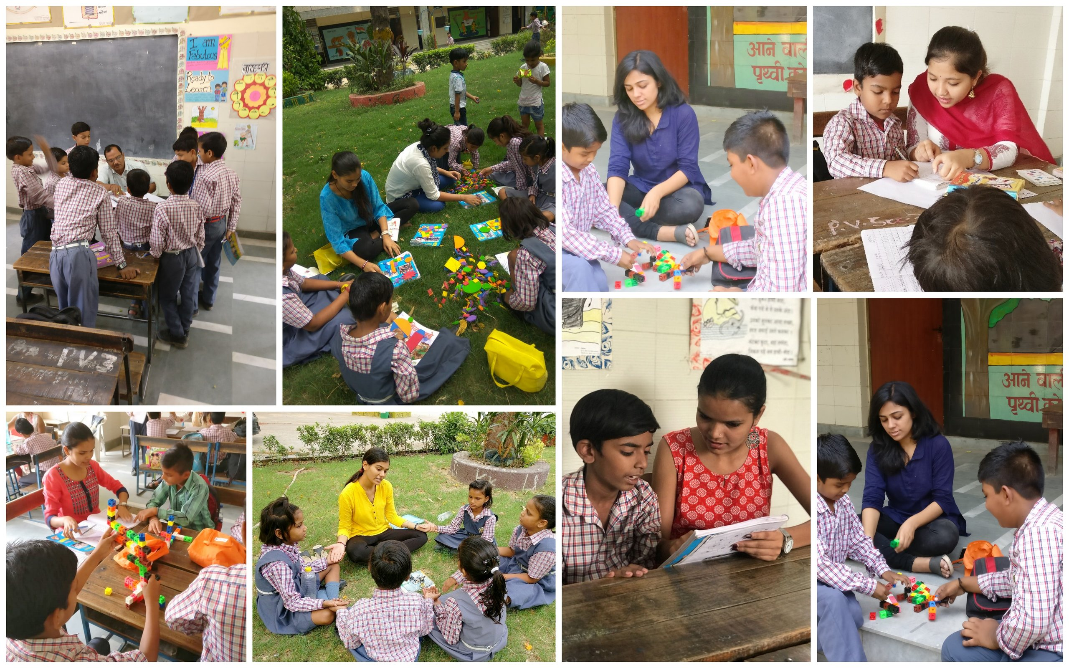

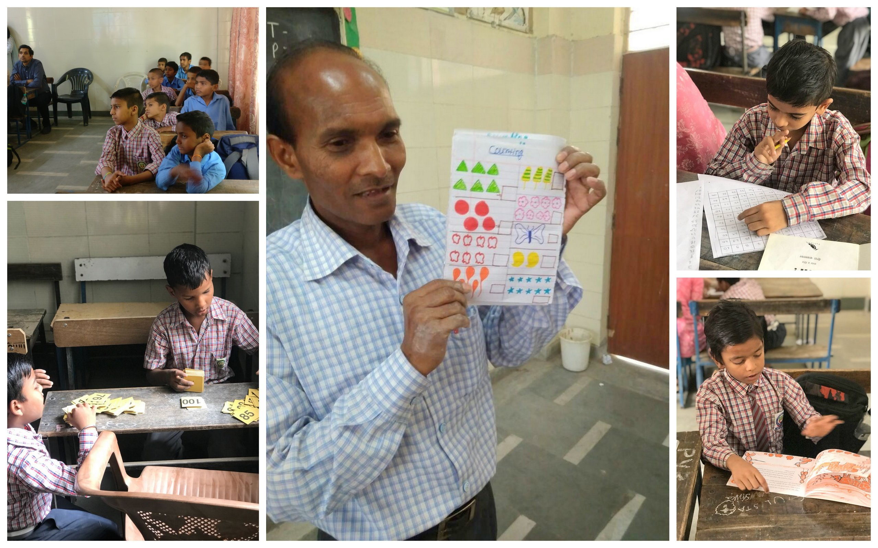
- Learning with activity based approach

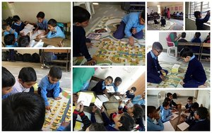
- Student leaders budding up with emergent learners

- Access and Exposure
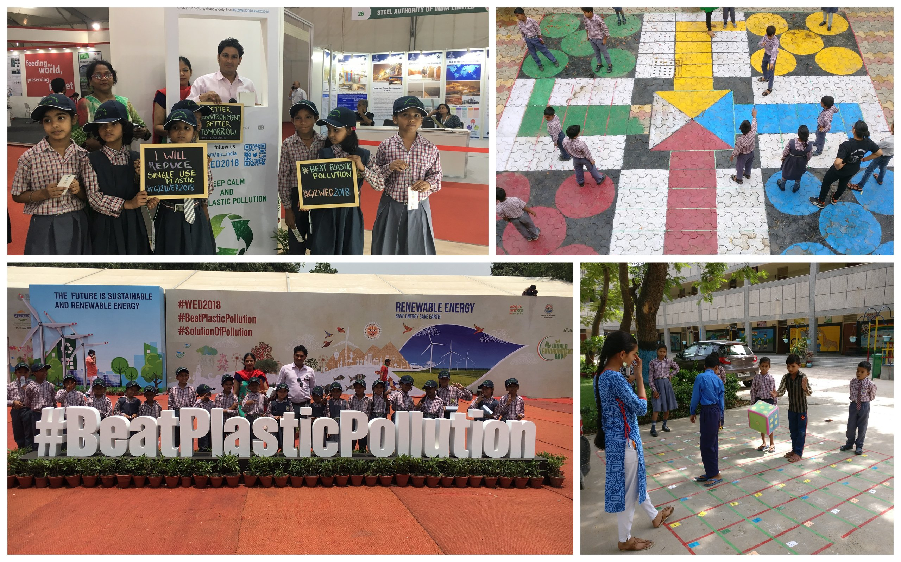

- Learning by doing
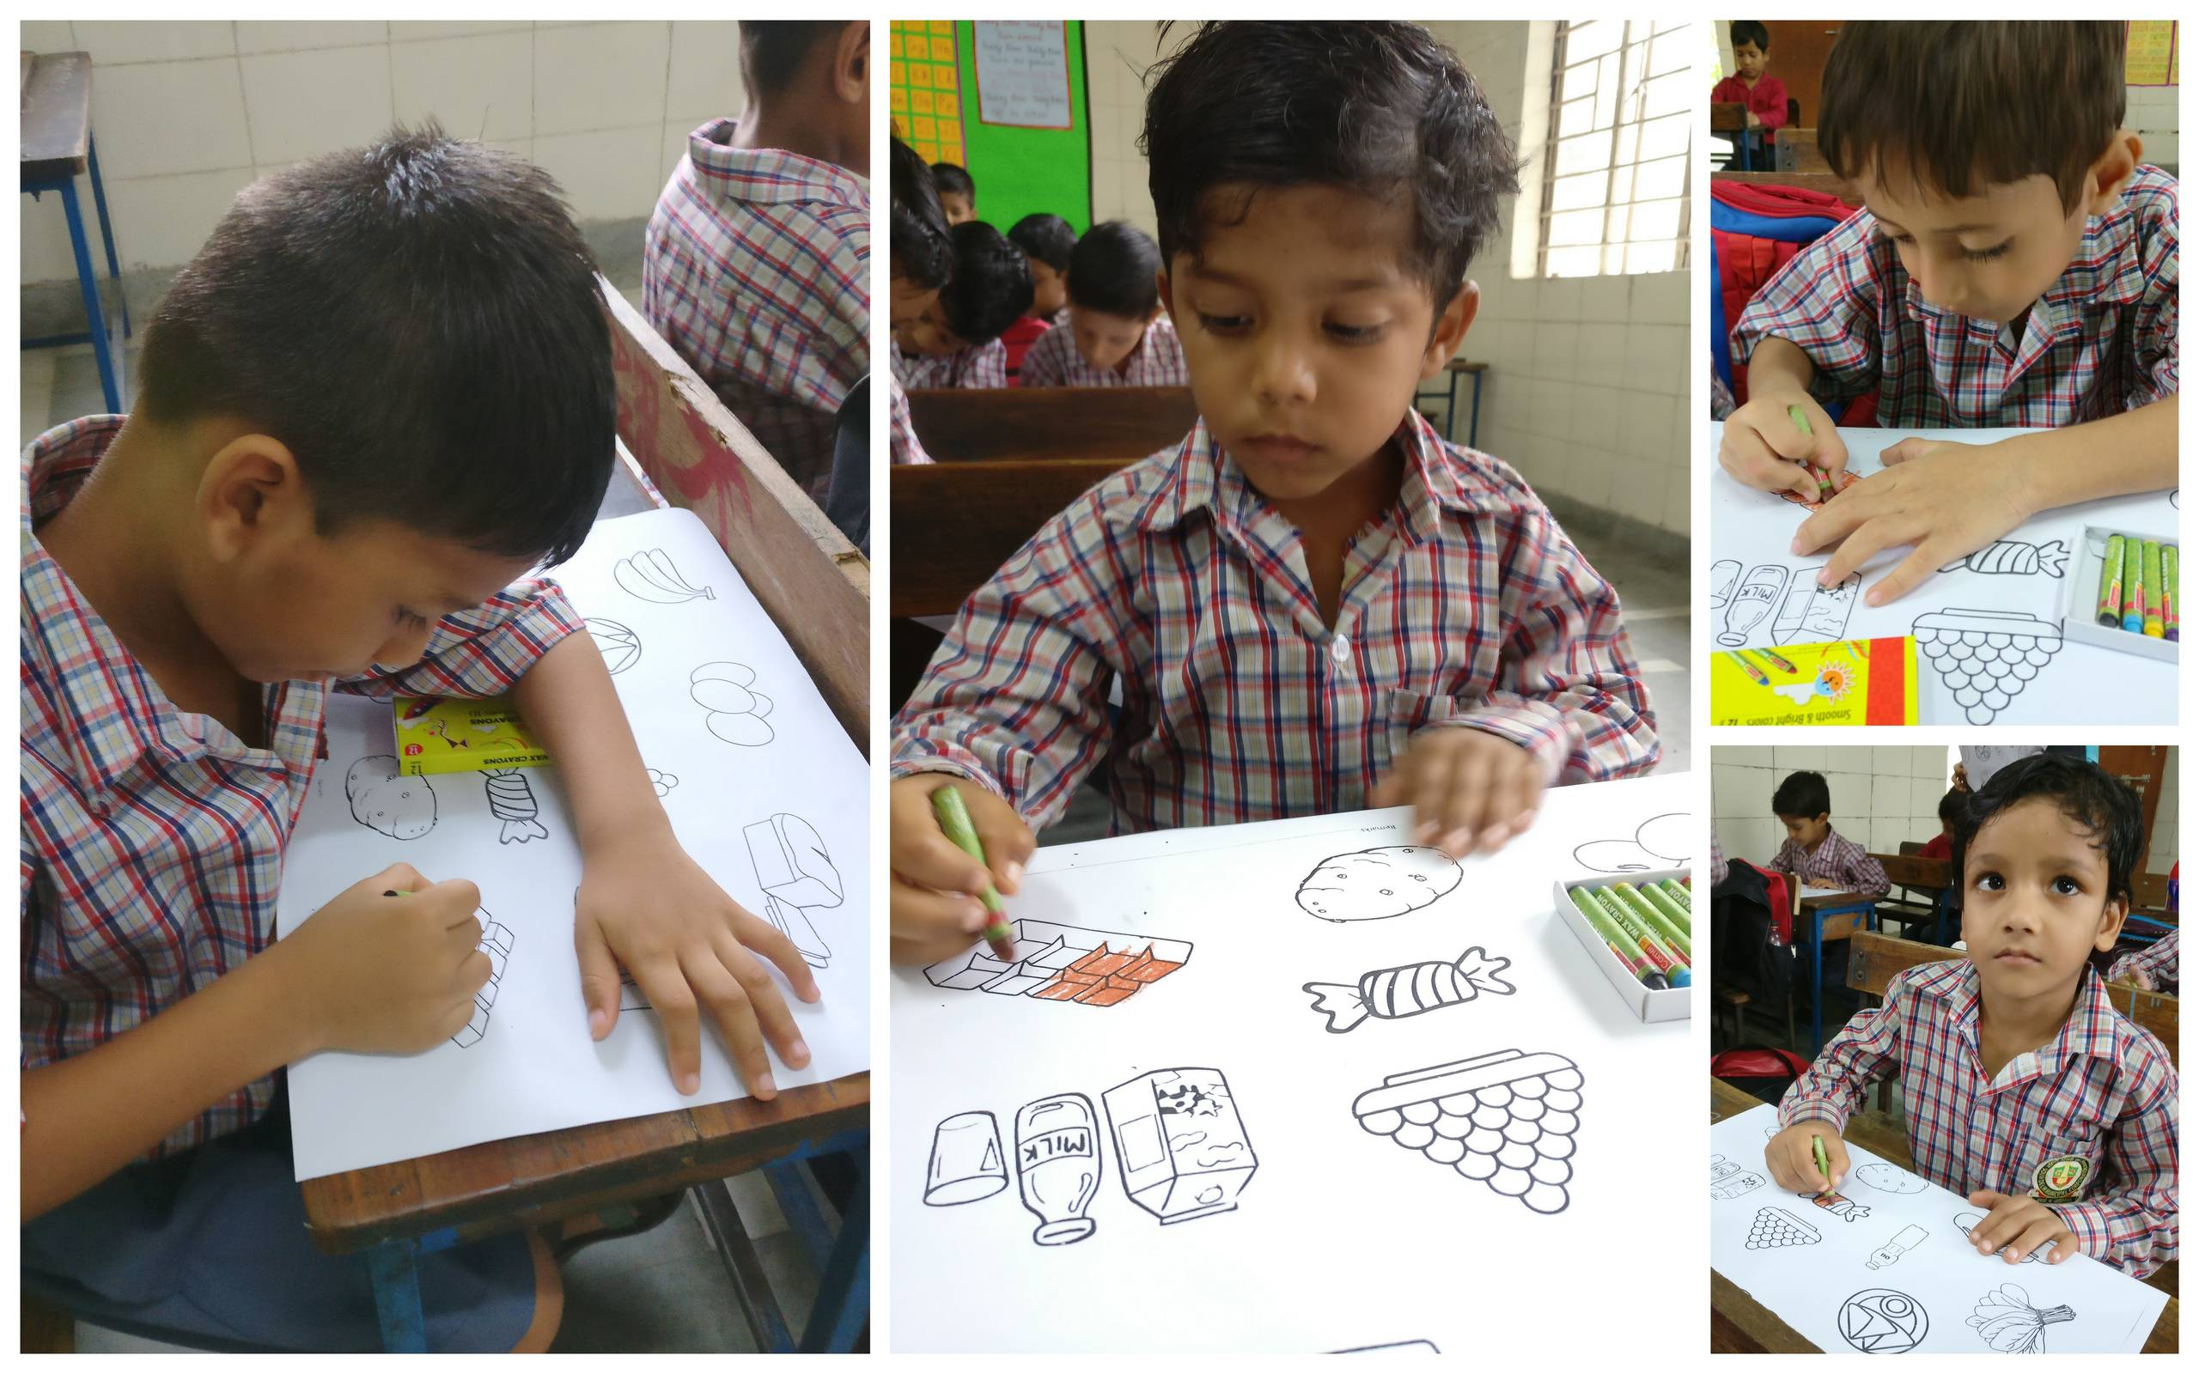

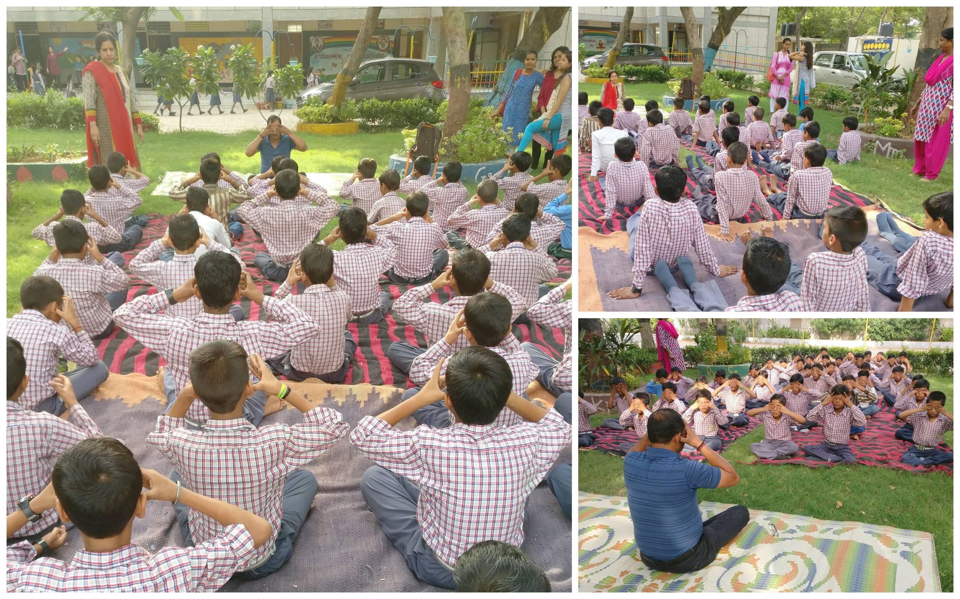
- International Yoga Day
- Nutrition Awareness Program in School
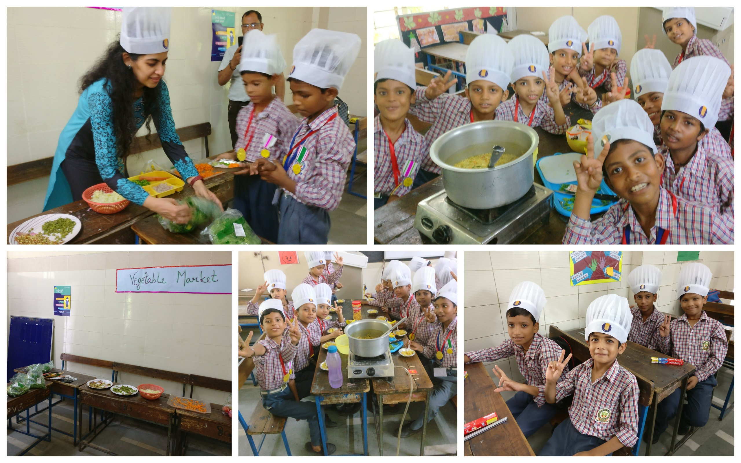

- Mega Parent Teacher Meeting in school
