ANNUAL REPORT – LEARNING LINKS FOUNDATION SDMC SCHOOL Pushp Vihar (Girls and Boys)

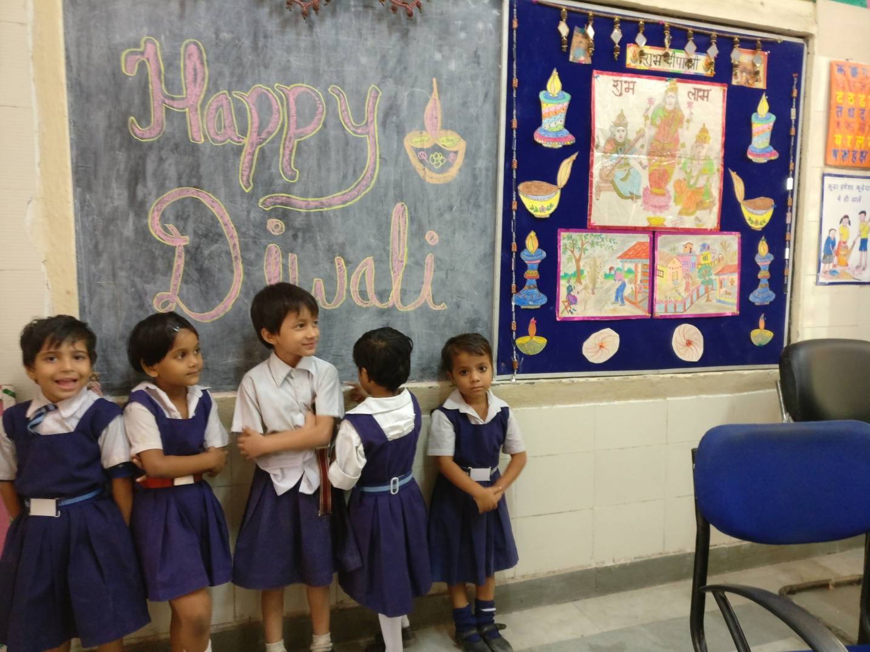
Executive Summary

- Key Developments

In the month of November, Learning Links Foundation shifted to two new schools SDMC Girls School, Pushp Vihar Sector 3 and SDMC Boys School, Pushp Vihar Sector 3. We started our intervention from the beginning of November. In the first week at Pushp Vihar, we started strong by conducting a vision and goal setting session with the government staff of both the shifts. We also conducted a small session where we explained the government staff about our model and how will our intervention look like.

- Enrolment:
LLF has been constantly working in both the schools to ensure the enrolment increases in the shifts. After sincere mobilization we were able to enroll 45 students in morning shift and 31 students in the evening shift

Attendance: Student regularity was a big concern as there were close to 50% of the students who were irregular. In order to increase student regularity we started providing transport support to students who were coming from far distance. Intensive home visits and daily phone calls to irregular students were also planned. This was followed by investing parents through PTM to ensure student regularity.

- Classrooms:
As per our model, we have direct intervention in all the 6 (including nur) classrooms of girls shift and 5 classrooms of boys shift. We directly mentor teachers on one on one basis. The LLF teacher and government teacher sit together and plan together. Another constant are of focus has been to ensure that the classrooms are lively and print rich. This is ensured by displaying teacher learning aids and student work which creates a positive environment of learning. The classroom walls are divided into sections for displaying learning material for different subjects. Apart from different subject areas we have also given a significant place to trackers, student’s zone, scribble wall and reading corners in the classroom. Students are well aware of all of these sections in the classroom. The teaching material, charts and mobiles are being changed and updated regularly. In classrooms, the changes were done according to the current themes of the unit and chapters.
In class Nur, 1 and 2, the seating arrangement is done in a way which helps students to collaborate and work together which inculcate the value of teamwork.

- Teachers:
In the girls shift, we have 1 principal and 5 government teachers for 6 classrooms. In the boys shift, we have 1 principal and 5 government teachers for girls shift. We are slowly working towards creating a co- planning and co teaching model in both the school where the SDMC teachers work in collaboration with the teachers from Learning Links Foundation. Also, we have provided detailed teacher instructional plans (TIP) in bi-lingual language mapped with NCERT curriculum to ensure that teachers are well resourced and planned. Regular mentoring happens by observing teachers and debriefs.
Infrastructure:
One of the major reasons of shifting to the new schools was unavailability of infrastructure in the old school. In the new school premises, we have a huge well maintained building with spacious classrooms. We had challenges related to electric fans as 80% of the school fans did not use to work. LLF helped in getting repair of fans and also similar electric work like fixing switch boards in all classrooms. Also, we installed an electronic bell to ensure that structured classes are happening. Extensive efforts were undertaken to maintain the look and feel of the school.

- Special Events:

Republic Day Celebration

On 25th January 2018, we celebrated Republic day in both the shifts separately. The chief guest for the event was Mrs Rekha Sankhla, Counsellor and Mr Naresh Sankhla. Students and teachers came together in both the shifts and prepared some lovely cultural and patriotic performances. The principals of both the shifts addressed the audience and gave a speech.

Mega Parent Teacher Meeting (PTM)

A mega PTM was organized in all the MCD Schools on the last working day of January. Our school also organized a Parent teacher meeting. We created an agenda based on the requirement of the students and school. Since exams are approaching in March we sensitized parents about the importance of coming to school regularly to ensure students are learning. We also addressed the topic of self study and what should be the role of parents in this. Later parents were sent in their child’s classroom and shared with the teachers, their feedback about the teaching process in the school. Teachers also gave specific feedback to each parent about their child’s development and academic growth.

In the remaining academic year, we plan to celebrate Holi by sensitizing our future generation around water conservation and importance of using natural colors instead of chemical colors.

- Our Students

- Enrolment and Attendance

In the last 3 months, Learning Links Foundation team has been able to build the visibility for the school in multiple nearby communities (Khanpur, JJ Colony, Subhash Camp, Tigri, Dakshinpuri, Sangam Vihar, Madangir etc.) Sustained and intensive community mobilisation efforts included extensive survey of communities around the school, partnership with aanganwadis, community meetings and door to door mobilization drives.

There were 45 new admissions in the girls shift and 31 new admissions in the boys shift. These students took transfer from Krishi Vihar School to the new school as they could see the growth in their children. Parents of existing Pushp Vihar students welcomed the intervention in the school and supported us in our efforts to improve the learning atmosphere of the school.

- Classroom Engagement

Eventually, Students have developed a good learning attitude and they are getting excited about learning in a more interactive way. Listening and learning skills are being gradually inculcated among the students who carefully follow the teacher’s instructions. Teachers regularly make changes in the physical environment of the classroom as per various themes. Different sections are made in the classrooms for all subjects where relevant materials are displayed and are used as TLMs by the teachers. Worksheets are becoming a habit of every child now. Many effective classroom management strategies are being used by the teachers like attendance tracker, behavior trackers and performance trackers to keep a track of their academic and behavioral developments. In All grades, a student reading corner is being maintained to motivate students to finish their tasks quickly and help them utilize their time efficiently instead of sitting idle. The classrooms are joyful and learning is engaging.

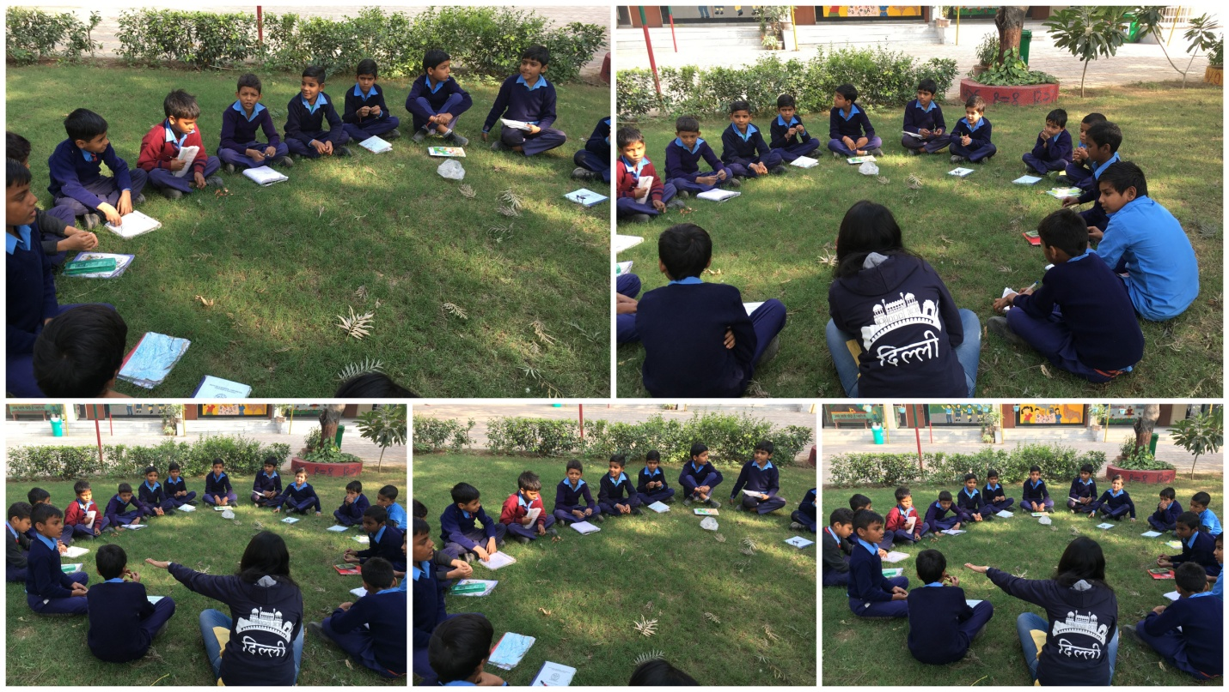
Circle Time
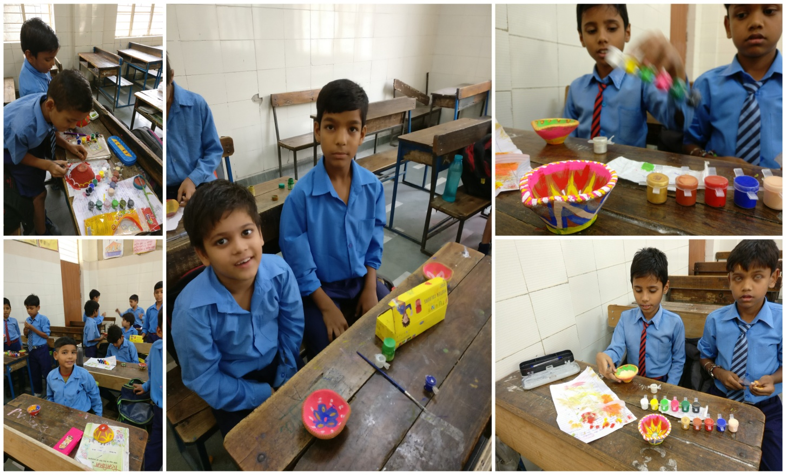
Diya Painting

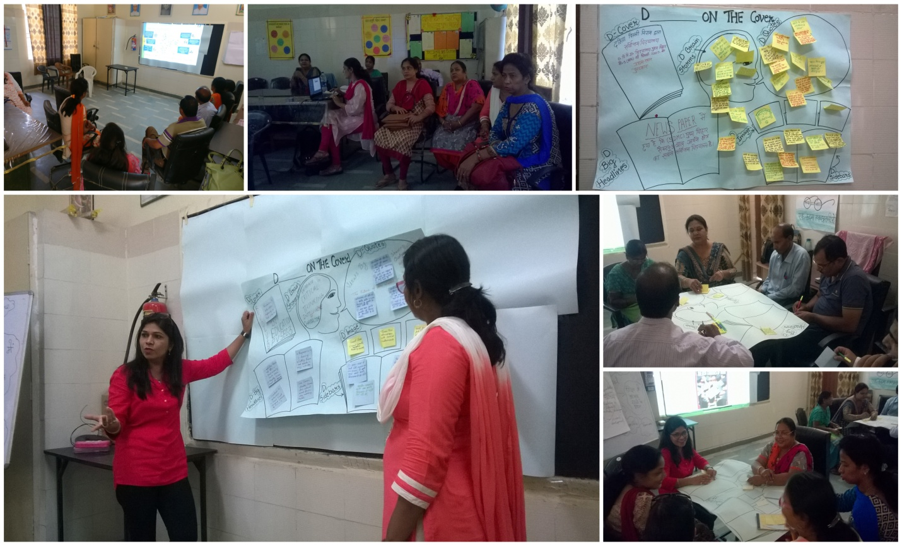

Visioning Exercise with government teachers
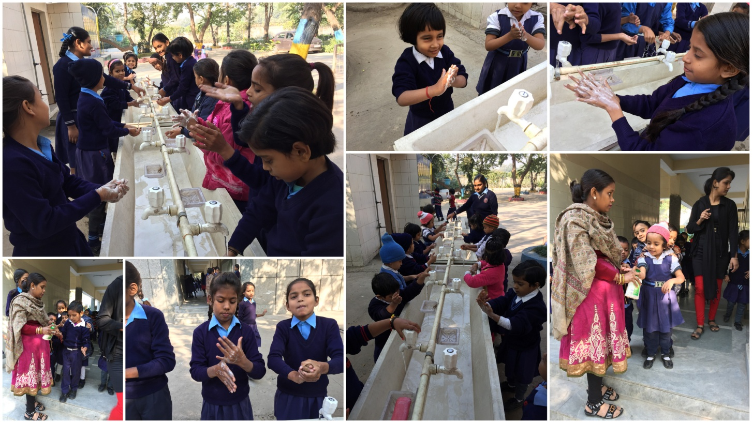

Hand washing Exercise

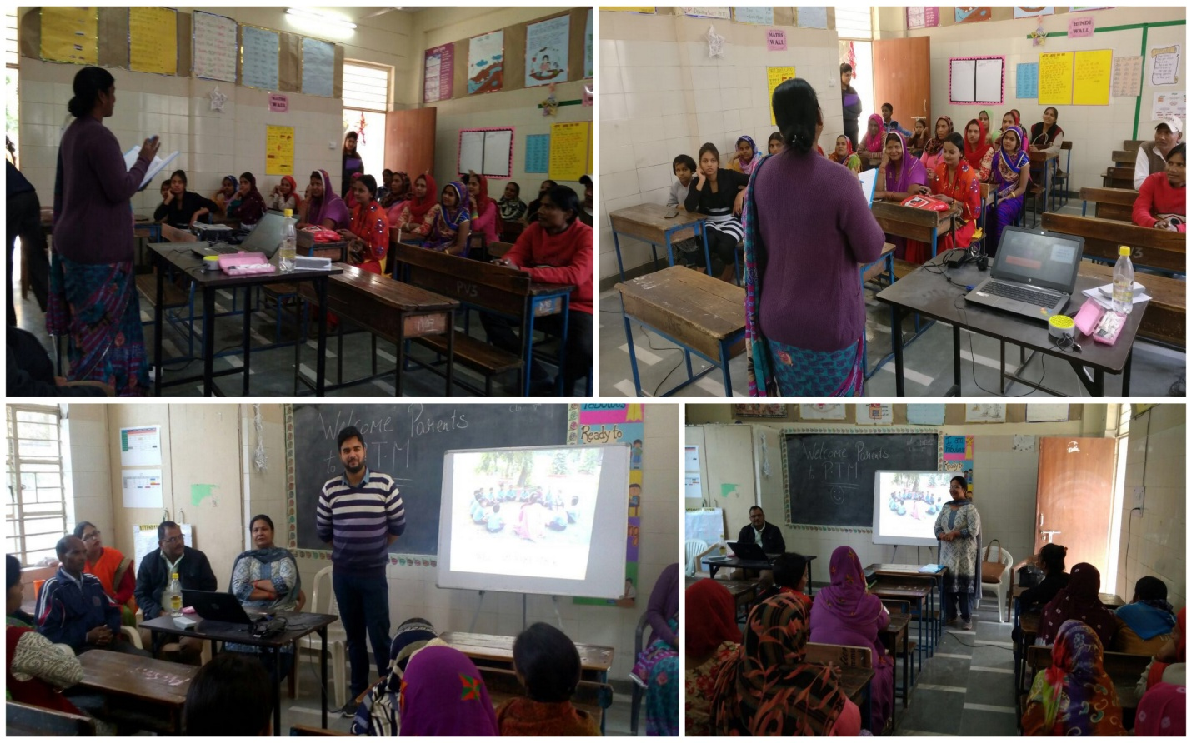

Parent Teacher Meeting (Boys Shift)
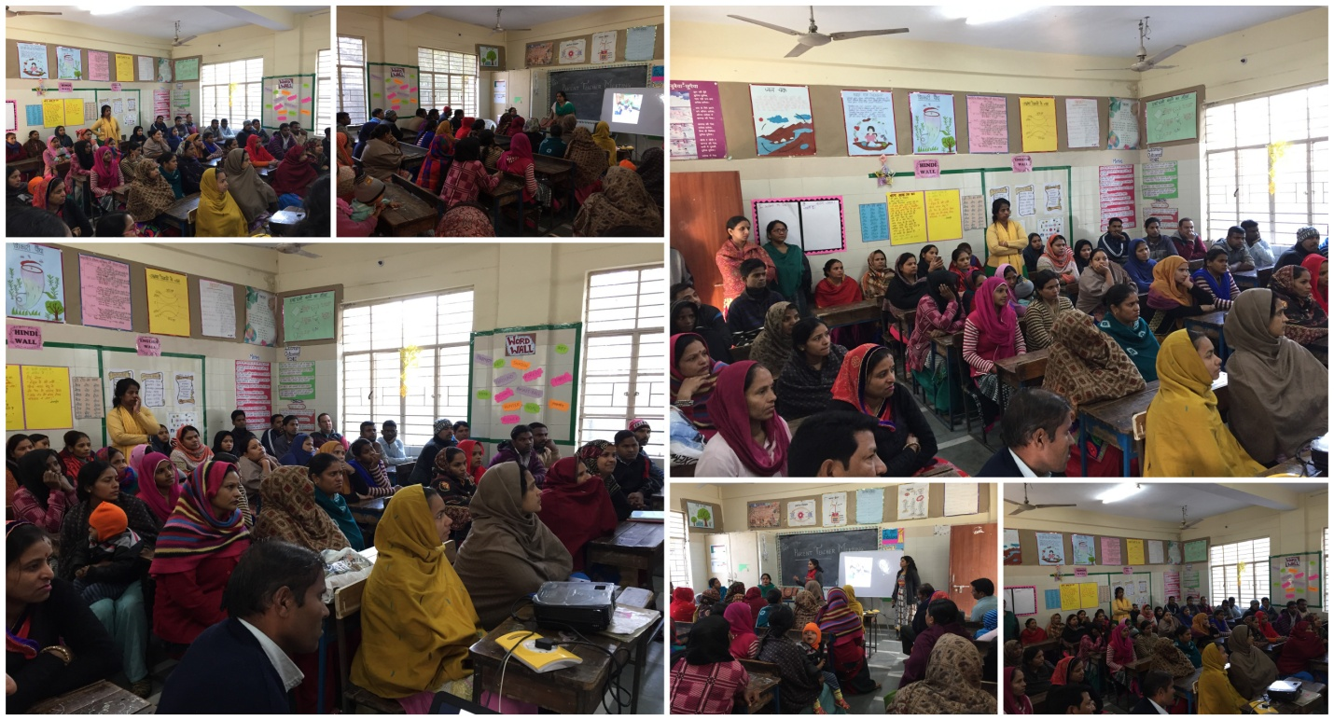
Parent Teacher Meeting (Girls Shift)
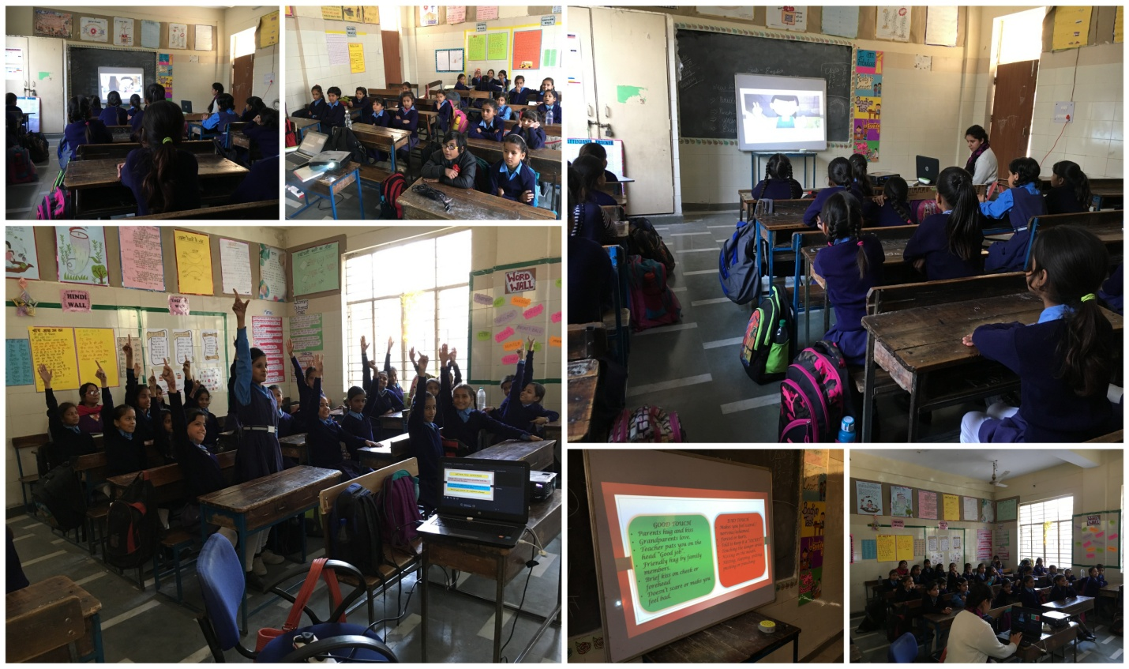
Good Touch and Bad Touch Session
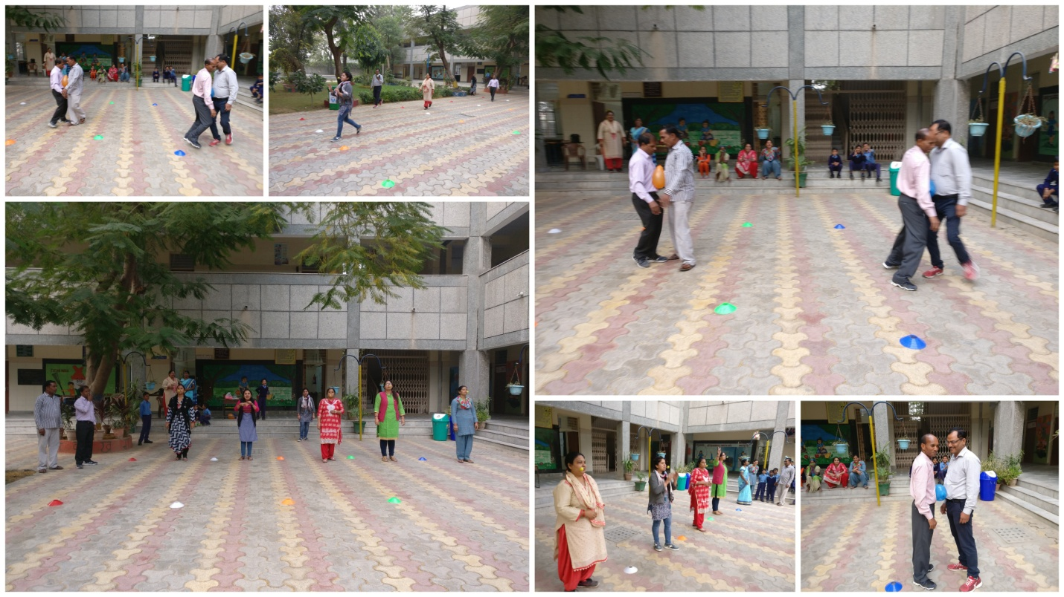
Team Building Activity with Staff

