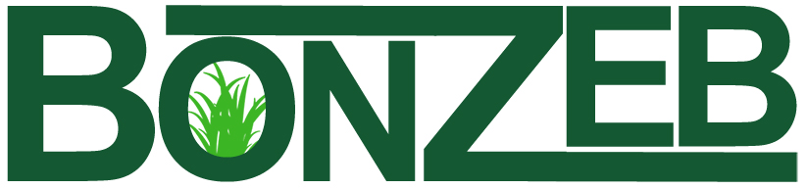

The good grass solution
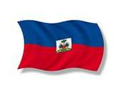
Edify Haiti’s People, Economy, and Environment
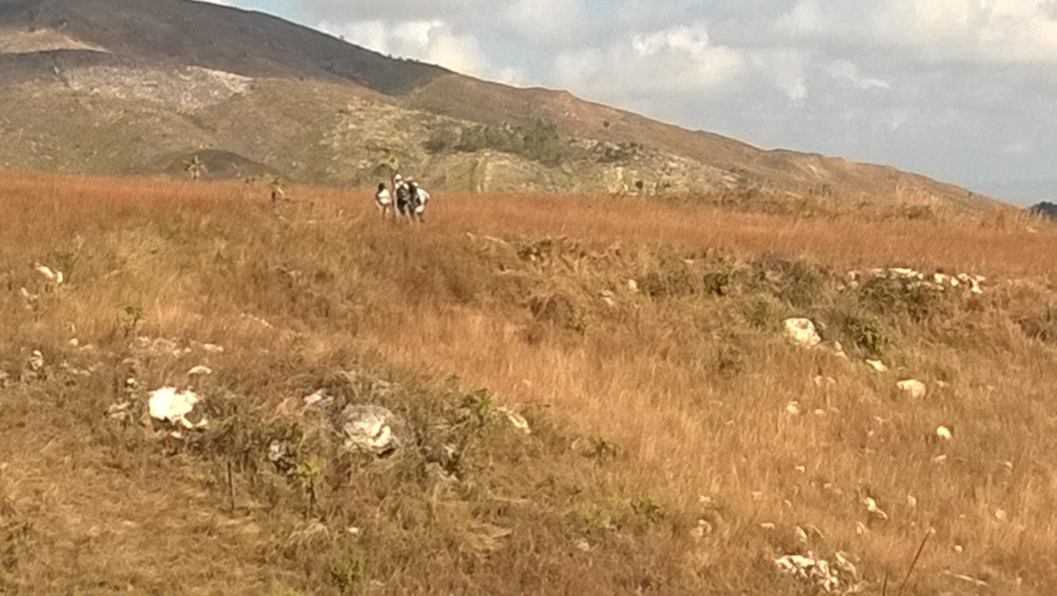
Thomonde property

BonZeb, Inc. P.O. Box 3553, Gresham, OR 97030 503-333-5959 tstein@bonzeborg.com www.bonzeborg.com

The Mission
Create living-wage jobs, while establishing Haitian owned and operated small businesses, through the production of affordable charcoal using environmentally sustainable biomass and a financially sustainable business model and to work with other NGO’s and organization to serve Haiti’s poorest families.

Vision
- Provide an environment that enables and encourages right-relationships with God, other people, and God’s creation.
- To promote collaboration and networking with businesses and organizations working in Haiti and in alternative energy projects throughout the Caribbean.
- To use these relationships to support self-sufficient businesses throughout Haiti which provide services to people of every economic status and develop educated, capable professionals from within the local community.
- To increase the awareness of the plight of Haitian people through service and immersion projects and mission trips.
- Collaborate with businesses and organizations working in Haiti and throughout the Caribbean adding value to the joint effort via our renewable energy technology and methods.
- Facilitate the creation and growth of truly sustainable businesses in Haiti and the Caribbean.

Core Values
In order to fulfill our mission, achieve our goals and implement our vision, we believe that treating others with Dignity, Respect, Compassion and Integrity are keys to success. We also believe that proper Stewardship leads to true Sustainability and long term success.

Building quality lives and strong communities through...
DIGNITY
We will
• treat everyone as we ourselves want to be treated
• treat others with honor and appreciation
RESPECT
We will
• demonstrate our esteem for the worth of all life and creation through our acceptance and appreciation for all
• believe in the inherent dignity of all people
• honor self and others through words and actions
COMPASSION
We will
• strive to help eliminate the suffering of those we employ, serve and collaborate with
• understand the circumstances and viewpoints of others
• develop the capacity to forgive others and ourselves
• promote a peaceful, caring and safe community
INTEGRITY
We will
• say what we believe and do what we say
• be honest with ourselves and others
• demonstrate fairness in our judgments and actions
• fulfill commitments and promises
STEWARDSHIP
We will
• be responsible for overseeing and protecting all our resources, human and natural
• take ownership of our behavior
• be reliable and trustworthy
SUSTAINABILITY
We will
• believe that true leadership begets leaders
• find positive ways to contribute to the broader
community
• share time and talents with others

The Situation
The average American can name two facts about Haiti: It has recently been struck by a devastating earthquake, and it has been called—countless times—the poorest nation in the western hemisphere. These two facts, which on their own have moved many to action, fail to paint a full picture of the island nation. The Haitian people have not only been hit by earthquakes, but also by hurricanes and tropical storms. The environment has been degraded and squandered by basic need and mismanagement. In addition to environmental disaster and economic hardship, Haiti has also suffered years of political instability, making it a challenging place to live.
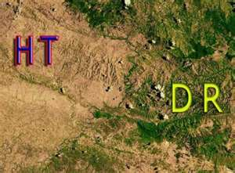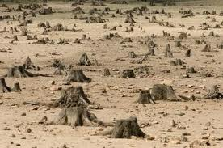
Haitian/Dominican Border Deforested Land

The devastation is dramatically impacting both the agricultural and economic state of the country, which in turn contributes Haiti’s poverty level. Nearly 98% of the country’s forests have been destroyed for construction and energy, compared to only 40% in 1923. Deforestation has a direct effect on soil erosion, with an estimated 15,000 acres of topsoil washed away each year. Erosion damages more than plants and trees; it also damages productive infrastructure such as dams, irrigation systems, roads, and coastal marine ecosystems. Soil erosion also lowers the productivity of the land, worsens droughts, and eventually leads to desertification, all of which increase the pressure on the remaining land and trees. As famines ravish various parts of the country, it is obvious that something must be done to curb deforestation.

The major cause of deforestation and environmental degradation in Haiti is charcoal production. Haiti has extremely limited access to modern energy services; over 70% of the energy used in Haiti is derived from wood and other biomass. Several million trees are cut to produce millions of tons of wood charcoal every year. (It takes approximately two average-size trees to produce a ton of charcoal). Charcoal is then sold for use in cooking and baking. The wood charcoal industry is a source of income for many Haitians. They understand that their actions are ruining the country’s environment, but, at the same time, have no other choice to survive.
Charcoal is a leading cause of deforestation, but it also represents a large proportion of income. Approximately 70% of Haitian household energy needs are met using firewood and charcoal; and at least 30% of family income is spent on charcoal for cooking in Port-au Prince. Converting from wood charcoal to alternative cooking has the potential to both save the environment and lower fuel costs for the average Haitian.

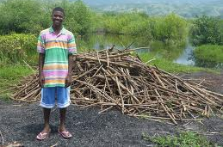
Collection of wood for carbonization

The Solution
BonZeb is seeking to bring a truly affordable and sustainable solution to Haiti. It is inevitable that the current charcoal industry, which is based on the destruction of trees, will completely deforest the country within the next 2-3 years. They are already cutting down mango trees for charcoal. Without an alternative source for cooking fuel, the cost of charcoal will skyrocket beyond the present average household cost of $1.25 per day. With 25% to 40% of average income of 80% of the population being spent on cooking fuel, any increase in cost will be devastating to the already impoverished population.

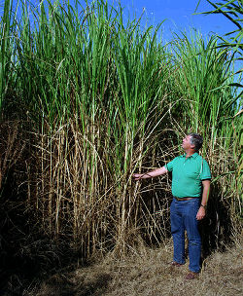
BonZeb has developed a low-tech method for processing various feedstocks—native grasses grown by local farmers—into charcoal briquettes. This process has to potential to lower the cost of charcoal by 40% to 50% and will decrease the need to use trees for charcoal.

BonZeb will work with local farmers, landowners, small business entrepreneurs, NGO’s and communities to grow these feedstocks and will utilize local labor for manufacturing. This process will create new small businesses, jobs and new skill sets (management, processing, storage, shipping, marketing, and sales) and will foster economic development within the rural communities.

BonZeb’s initial focus has been to develop the process for converting grass into charcoal and to build relationships with Haitian government officials, landowners, NGOs, and other organizations and businesses that are open to collaborating on this project. BonZeb has developed a process that is 95% human-powered for the conversion of feedstocks into high quality and low-cost charcoal.

BonZeb foresees that in three years, the company will be in position to create at least twenty-five small business opportunities and to continue to expand operations until each Department has sufficient plants to sustain that region. With each small business employing approximately 125-175workers (at full capacity) and producing 1,500 metric tons of charcoal annually, the overall goal will involve 250 small businesses creating approximately 40,000 jobs (F.T.E.) and producing over 400,000 metric tons of charcoal per year. This amount of charcoal is enough to service over 1,200,000 homes, while lowering the projected cost to the end-users significantly.

BonZeb has the potential to revolutionize the way Haitian people live by lowering the cost of fuel for cooking; creating new skilled jobs; and, eventually replanting the forests and improving the environment. Although this product will not solve all of the complex and engrained issues that Haiti is experiencing, it will have an impact on lives of millions.
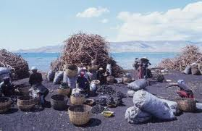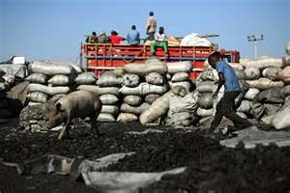
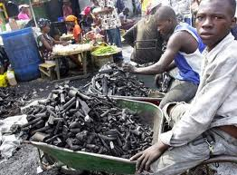
Charcoal Sorting Process Marketplace 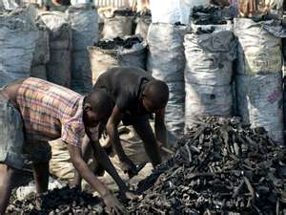
Goals
Job Creation

- Job creation will primarily be in agriculture (planting, harvesting, and transportation); unskilled and skilled factory workers; construction (factories and infrastructures); administrative and professional staffs; transportation; marketing; and sales forces.

Economic Development

- Create 40,000 jobs paying a living wage and placing them rural areas with the greatest economic impact.
- Donate 50% of net revenues by building infrastructure, which will add additional jobs to local economies.
- Increase money available for other needs for the end users.
- Facilitate the use of fuel efficient stoves (current models are most efficient using briquettes).
- Enable Micro-financing for farmers by empowering them to become suppliers of our feedstock through long-term purchase agreements.

Agricultural Development

- Facilitate the cultivation of approximately 18,000 hectares of perennial feedstock. This is approximately 10% of the unused arable land in Haiti.
- Increase soil fertility and improve reforestation survival rates after the first 10-year rotation of the feedstock.
- Utilize a non-invasive crop that is indigenous to Haiti.
- Enable the growth of existing nurseries and green houses, as well as new enterprises to grow feedstock cuttings.

Educational Components

- Agricultural education through face-to-face interaction with BonZeb’s degreed agronomists.
- On the job training for unskilled, semi-skilled, skilled and professional workers.
- Applied business management and administrative programs for staff, professional workers, and interns.
- Ecological and environmental internships.
- Financial and economic stewardship for vendors, suppliers, employees and local community.
- Adoption of new forms of fuel and energy-efficient cooking methods.

Ecological and Environmental Development
- Improve soil fertility through use of unused arable land and perennial feedstock.
- Reduce deforestation by providing a viable alternative.
- Assist in reforestation efforts by building soils and soil fertility and encouraging conversion of feedstock land into forest at the end of the first feedstock rotation (12 years after planting).
- Reduce Greenhouse gas emission.
- Create lower carbon footprint than current feedstock and production methods.
- Reduce erosion through additional land-coverage with feedstock and reduced demand for trees as feedstock.
- Utilize a crop and land that is not in competition with food crops or land used for food crops.
- Work with and through government liaisons in agriculture, energy, environment, and ecology.
- Our customers will be current suppliers of carbonized wood charcoal (wholesalers), public markets, and local vendors (retailers).
- Work closely with other non-profits and NGOs in order to educate the general public about the need to conserve current forest lands and replant the denuded areas.

Donations can be made on our website at: www.bonzeborg.com or through GlobalGiving or at
BonZeb, Inc. PO Box 3553, Gresham, OR 97030

Country Profile: Haiti. Library of Congress Federal Research Division (May 2006).
Malik, Boulos A. "Forestry."
Activity Data Sheet: Haiti – Environmental Degradation Slowed.
Replacement of Wood Charcoal in Haiti, By Max Massac, P.E., 1998.

