A Project of: - Give a Smile to 3000 Slum Children in Odisha
Implemented by: - Ruchika Social Service Organization
A Project of :- Give a Smile to 3000 Slum Children to Attend School
Implemented by:- Ruchika Social Service Organization

We are happy to present the 3000 Slum children to attend school project before the donor agency and all other well-wishers. This was the most difficult one and we had to take a lot of difficulties to cross this quarter of intervention due to unexpected outbreak of Corona pandemic in India in March 2020.

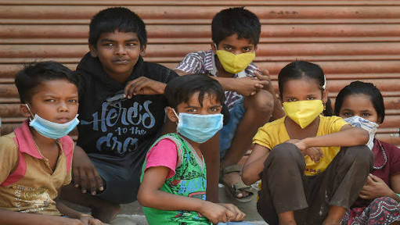
Impact of Corona virus on the slum children :
There are more than 436 slum settlements in Bhubaneswar across the railway lines and other vacates lands which contain almost 35 % totalpopulation of Bhubaneswar city. As we all know that there are a multitude of factors that escalate the susceptibility of these informal settlements to Covid-19 infection. The dearth of clean and unshared drinking water and sanitation facilities, inadequate attention to personal hygiene, poor living conditions, food and income insecurity, and lack of access to quality healthcare expose residents in urban slums to significant risk because they ensconce fundamental environmental conditions which foment the contraction and transmission of the disease.
Widespread job, income loss and economic insecurity among families are likely to increase rates of child labor, sexual exploitation, teenage pregnancy, child marriage, trafficking of children and forced begging.As the national death toll from COVID-19 increases, large numbers of children will be found orphaned and vulnerable to exploitation and abuse.
Added family stresses related to the COVID-19 crisis – including job loss, isolation, excessive confinement, and anxieties over health and finances – heighten the risk of violence in the home, including both between partners and by caregivers against children. The United Nations secretary-general has reported a “horrifying” global surge in domestic-based violence linked to COVID-19, and calls to help lines in some countries have reportedly doubled. Child abuse is less likely to be detected during the COVID-19 crisis, as child protection agencies have reduced monitoring to avoid spreading the virus, and teachers are less able to detect signs of ill treatment with schools closed.
Covid-19 has impacted nearly 300 million kids studying in 1.4 million schools in India due to lockdown and closure of schools. The impact is more severe for disadvantaged children and their families especially those living in slums, causing serious interrupted learning, compromised nutrition, childcare problems, and consequent economic cost to families who could not work.

Corona virus outbreak impacted Remedial education
The COVID-19 has resulted in schools shut all across the country. Attending online classes everyday has become the new normal for students during this lockdown. As schools are shut because of the lockdown to contain the spread of corona virus, online class have taken centre stage in student’s life now.During this pandemic situation our Remedial children are out of the classroom. It affects strongly the children of slums as they do not access e-learning facilities. A number of children do not access a smart phone for the purpose. However with a well-built effort, we are able to reach out the remedial children living in the slums with e-learning processes.Everything is running online to ensure appropriate learning for their children and engage them in curricular activities. Parents and Basti Education committee members are being well guided by the teachers to manage the situation and talk about the corona virus with their children. Remedial teachers and cluster educators are working on the issues and reaching to remedial children. The objective is to enhance their academic proficiency at par with their peers in the school. Now our cluster educators are making in every subject lesson videos and uploading videos in YouTube. This YouTube link is sharing to our slum children to continue their education.
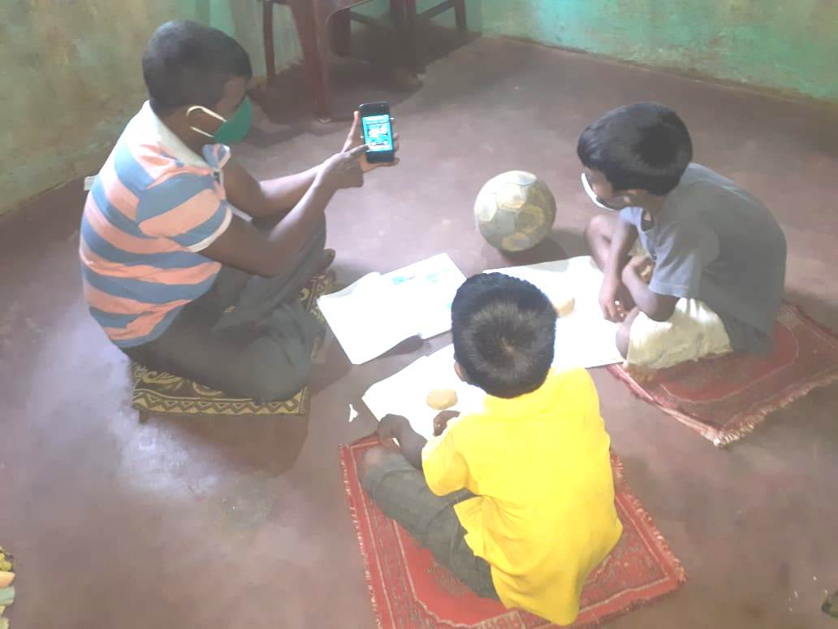
Transfer of knowledge through Online classes during COVID-19:-
The Corona Pandemic has resulted in the closure of schools across the country. Education has changed dramatically over the last 7 months, with a considerable rise of e-learning, whereby teaching is executed and on digital platforms. The situation has forced the schools to shut down and enforced students to stay at home. In the mean time children as well as parents feel emotionally and psychologically drained. The knowledge component is more natural to deliver in online mode. In view of the gravity of the situation, Ruchika started E-learning for remedial children soon after the lockdown was imposed. All the children were tried to be linked to the mobiles and a suitable timing was identified for each centre for e-learning. Supervisory team designed course contents in YouTube and sending the YouTube link to children and parents. The teachers also tried to do follow up to know whether all the students are studying or not. Online classes have been conducted by teachers to ensure smooth running of academic activities.

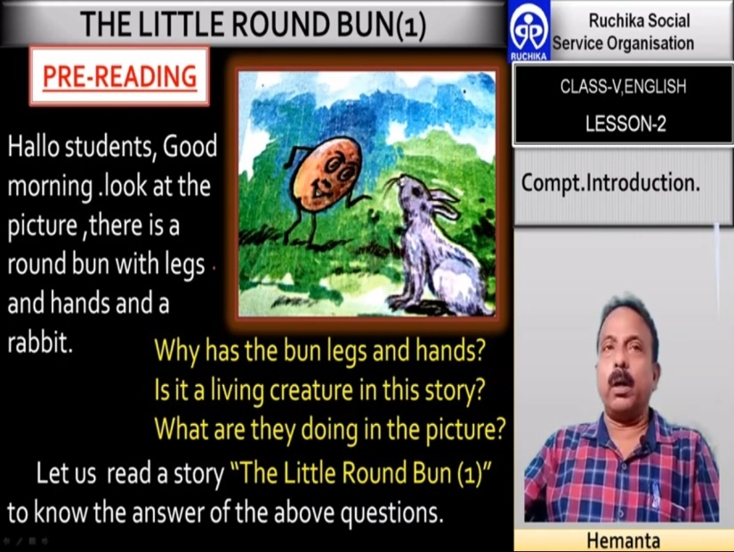
Assessment was carried out through the assessment sheets after completion of each topic, thus confirmed continuous and comprehensive evaluation. Teachers and parents are connected on Whatsapp group. Teachers are making the most use of technology like YouTube and other social media platforms to make the students updated and engaged. In the new order of social distancing, homes are the new classrooms. Whatsapp and You Tube are now helping teachers to connect with students and conduct classes during the lockdown.

Co-curricular Activities during lockdown
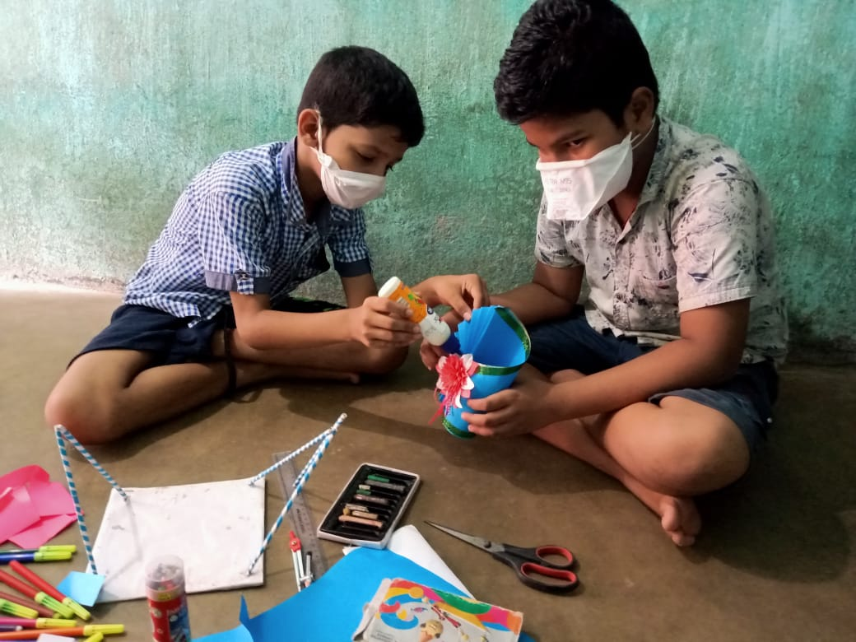
Co- curricular activities are where children’s learn more about themselves.Co-curricular activities are those activities which are undertaken along with academic studies. Co-curricular activities are very important part in the Remedial Education program to develop the student’s personality such as intellectual development, emotional development, social development as well as to strengthen classroom learning. During the lockdown it was mandatory for all to stay at home. In this situation our remedial teachers have prepared new TLM for classroom teaching and encouraged children to prepare the TLM at home. This was only possible through WhatsApp group and online teaching. Because we know learning never stops.

Social distancing is being exercised through e-learning
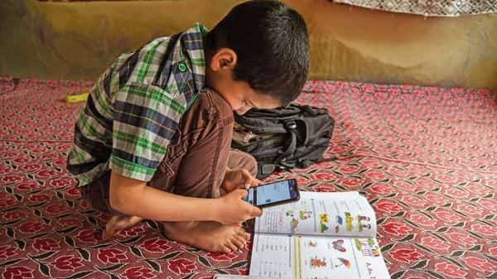
Corona virus is a highly infectious caused severe acute respiratory syndrome. It mostly spread among individuals during close contact now resulting in millions of death. COVID-19 is referred as pandemic due to its severity and also as the greatest global health crisis.Amidst the regulations of social distancing and self isolation, the students if allowed to attend schools may not be able to exercise the safety precautions in an effective manner. It would be very touch to control the students from playing or touching each other which might make the situation of virus spread out of control. Online classes are providing the same quality of education in the comfort of their homes thereby helping in securing their future and also in controlling the virus spread.

Teaching children preventive measures from COVID-19

Corona virus infection is a global emergency. Over the few months there is a rapid increase in the number of cases and deaths due to Corona virus infection. It is very important to minimizing this risk of infection for which we need to adopt appropriate prevention measuresas there is no specific treatment and immunization available to date to address this serious issue.

It has been found that prevention is the best option for controlling the rapidly spreading infection of Corona virus.Children were trained and educated about the basic hygiene like hand wash, maintain social distance, stay at home and so on. Following are some of the preventive measures taught to the children during the pandemic.
- Clean your hands at least 10 times a day using soap and water. Follow all 08 steps of hand washing processes for 30 seconds.
- Maintain a safe distance from every one (at least for 2 metres).
- Don’t touch your eyes, nose or mouth.
- Cover your nose and mouth with your bent elbow or a tissue when you cough or sneeze.
- Stay home and do not go out.
- Use mask when you go out in emergency.
- If you have a fever, cough and difficulty breathing, seek medical attention immediately.

We not only teach them what to do, we also teach them how to do it and explain the children why to do this.
Provision of Mental health and Psycho-social support to Children

In the current context of lock down and restriction of movements, children have constrained access to socialization, play, and even physical contact, critical for their psychosocial wellbeing and development. School closures are preventing children from access to learning and limiting their interactions with peers. Children sometimes feel confused and at loss with the current situation, leading to frustration and anxiety, which increase with the overexposure to mass and social media, especially among adolescents. Some adults may struggle to find ways to explain and communicate with children about the current situation in a way that is understandable by this age group, which add frustration and disquietude.
A manual has been developed by Childline India Foundation to support CHILDLINE supporting children affected by the COVID-19 pandemic. The manual is activity-based and so minimal supervision or guidance is needed. There are activities for two age groups – age’s six to ten and 11 to 19. By use of these activities we continue to support the children living in slums to ventilate their anxiety and stress. We have translated the Manual into Odia. Our Odia Translation Manual has been distributed to all Child Care institutions of Odisha by Child Line India Foundation and govt. of Odisha.

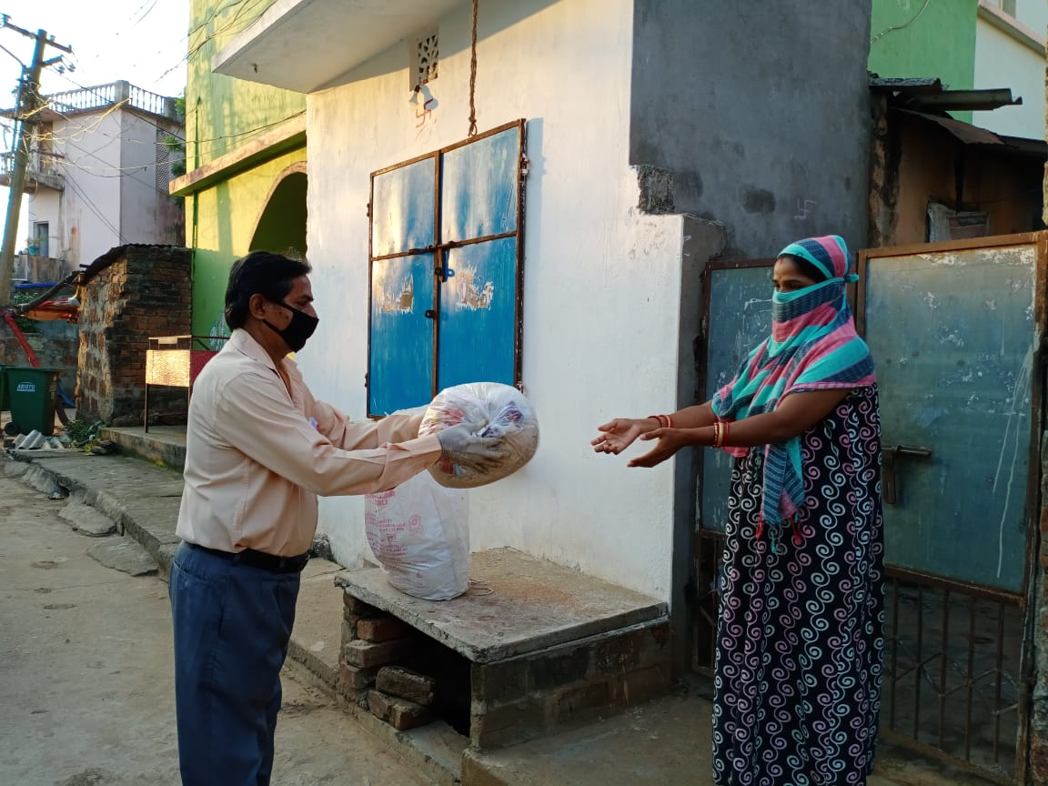
Community Sensitization during COVID-19 lockdown: -

COVID-19 continues to constitute a public health emergency in Odisha. So, with this emergency Ruchika trained Remedial teachers, BEC members and Adolescent groups to spread awareness in the community on use of mask, hand washing with proper procedure, maintain social distance, avoid touching nose and mouth, follow lockdown guidelines etc. Since the outbreak of the COVID -19 pandemic in Odisha, Ruchika have helped the communities to cope with the effects of the pandemic, sensitized community people as well as distributed Masks, Soaps, provided rations to the needy ones and teach hand wash procedure to remedial children. In this situation our BEC members and Balika Mandal members played an important role. They not only educated the community, they also prepared masks by themselves and distributed to the people in order to save them from the Corona virus infection.

Empowering and Educate Adolescent girls in the time of Covid-19:-
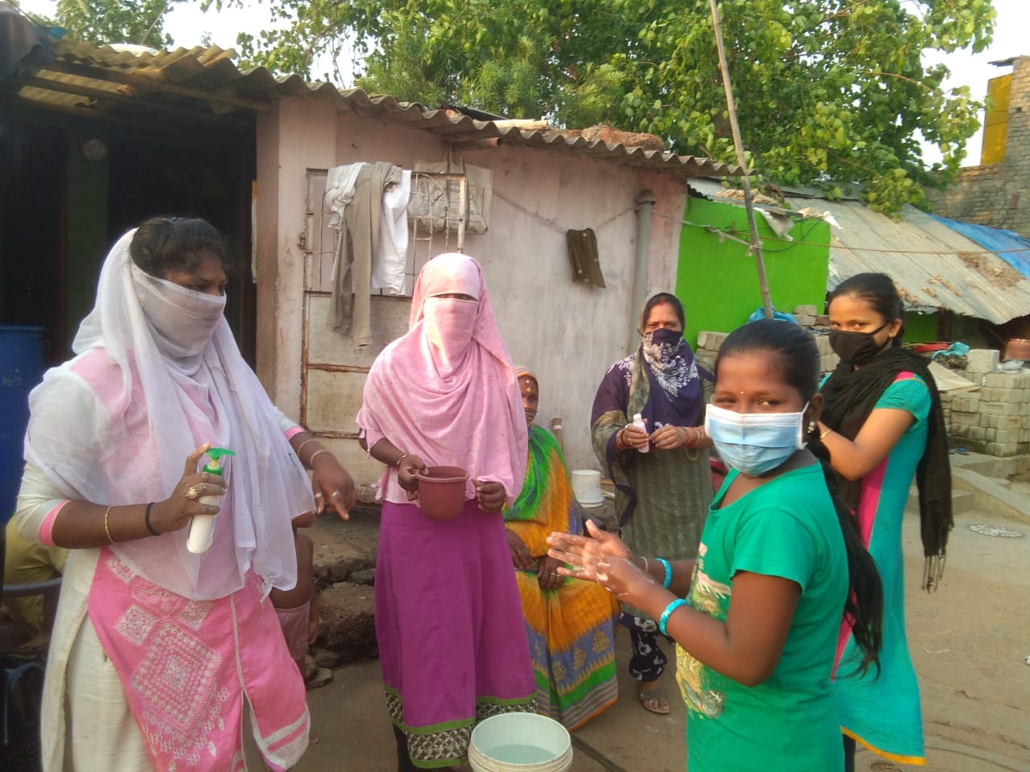
Balika Mandal Members are playing vital roles to educate community in the context of Covid-19. They are encouraged and trained to meet the crisis as their participation is playing vital role. Balika Mandal members are stitching masks and distributing to community people as well as to our remedial children. In the same time, they are educating to their community people on wearing of mask, proper handwash, maintain social distance, and follow all Covid-19 guidelines.

Promote Information sharing on Covid-19

The right to access information and digital technology are playing a critical role in the global fight against the Covid-19. In this crucial time Ruchika welcomes the immense efforts of communicate information to slum people to tackle the current Covid-19 crisis.
Ruchika sharing wellbeing tips and support mental health crisis to community people. Our remedial teachers are always reminding remedial children and community people on proper handwashing; maintain social distancing and wearing of masks.

Engagement of parents and BEC in e-learning
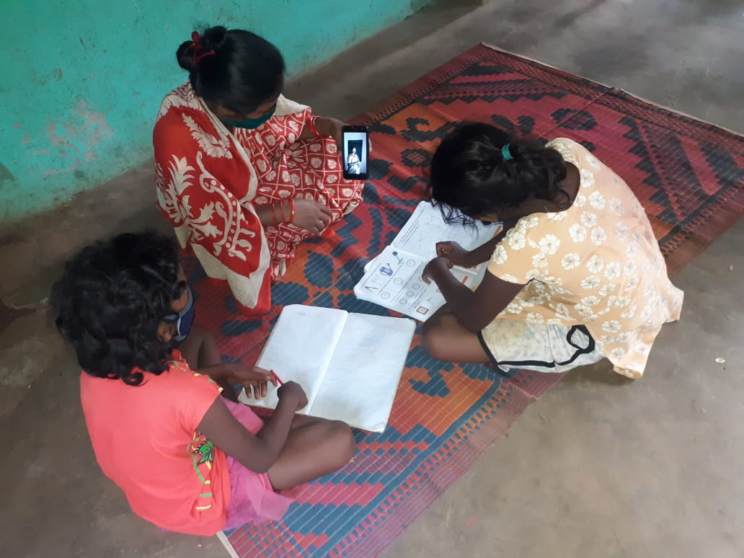
Covid-19 is an unfortunate situation that has upturned each sector around the globe. The education sector is the one that is facing the greast impact. Online education is a very important part of education. Parents are the first and foremost teachers of every students. In case of online learning, now parents are supporting to their children in their studies. In our remedial teaching teachers and supervisory staffs are uploading videos of learning sessions on You Tube which parents are watching and teaching their children accordingly. In the same way our BEC members are trained to lookover the studies of our remedial children. Those parents are having no Smartphone for e-learning we have connected them with BEC and Balika Mandal Members to continue their studies. This is a group effort to achieve the objective of e-learning.

