**Educate 3000 Marginalized slum children in Odisha.**

**Implemented by: Ruchika Social Service Organisation**

Slum children face a particularly complex set of challenges affecting their development and the fulfilment of their rights. Urban areas contain diverse groups of disadvantaged and marginalised children, street children, orphan or single parent children, runaway children, working children such as rag pickers, construction workers, factory workers or domestic workers, child beggars, children of migrant labourers, children with special needsand so on. Education is a fundamental right of all children in India. Yet many children those who living in the slum do not have adequate access to government school. Primary Education in India suffers from many deficiencies. In addition, the government schools do not appropriately plan to address their education needs discouraging their enrolment and eventually leading to high rate of drop-outs from school.

In order to impart quality education to these marginalized slum children Ruchika started its first initiative in the form of Platform school in the year 1985 in Bhubaneswar. In addition, Ruchika is running Remedial Education centre inslums of Bhubaneswar and providing remedial coaching to marginalized slum children. The Credo of Ruchika is “If a child cannot come to school, the school must go to the child”. With the implementation of Right to Education Act, Ruchika aims to support enrolment and retention of 3000 underprivileged slum children in Government schools through its remedial education centres.

**Goal and Objectives of the Project:**

The Programme Objective was to reach out to all the slumchildren of Bhubaneswar to increase academic proficiency and targeting a significant reduction of drop-out in the schools as well as ensuring Right to Education Act, in its true spirit in the target area.

Specifically, the programme focused on improving the lives of the marginalized slum children through a three-pronged approach:

* Provision of Specialized Remedial Education to enhance academic proficiency. The approach identifies children with low proficiency and designs appropriate before or after school remedial support including competency building, counselingparents and children, family visits, etc.
* Community mobilization to raise awareness on quality education and greater involvement of the parents and community at large in the education system
* Specific activities with school authorities, district level authorities and the Education Department (Government of Odisha) to ensure quality of education as well as realization of maximum provisions of Right to Education Act 2009 (RTE).

The programme aimed at directly benefiting slum children through remedialeducation centres and school going children through activities implemented in slums and in neighbourhoodschools.

**Ruchika’s Intervention:**

Marginalized kids especially those live in the slums lag at all stages of education. When earning a livelihood and taking care of the members of the family becomes a primary matter of concern in one’s life, education stands a little or, very often, no chance of pursuance. For the millions of underprivileged people in India, education is a high-priced luxury, and this negative outlook continues on with every new generation.

Ruchika intervenes in 65 most vulnerable slums of Bhubaneswar for last 10 years. The objective of the program is to bring a sustainable and right based change in the community by using Remedial Education as a platform. It targets children in the age group of 6 to 11 years with remedial coaching, 12 to 18 years of girls and boys with learning life skills including Reproductive Health Rights, Community with education and awareness on child rights and other human rights.

Changing the attitude of people and making them role models, making universal schooling a people’s movement and upgrading the academic skill and proficiencies of all children at par with the non-slum children studying in the school, training them to demand their rights, and creating a conducive environment in the slums to ensure all rights and putting all children into the safety net are some of the huge tasks the organization has planned in these slums. It needs time to educate and strengthen the care givers and duty bearers and to enable them to fulfil their obligations towards children. This urges the organization to continue intervention at least for two more years in the same slums. During the forthcoming two years, the organization plans to strategically focus on developing strength of the children as well as the community, care givers and duty bears to be the role models and protagonists of Child Rights activism.

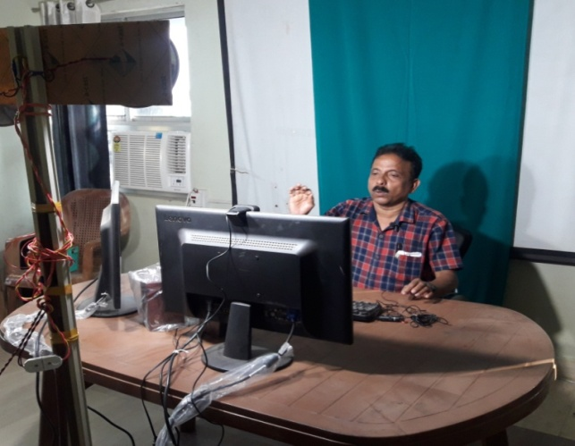**Remedial Education for the Marginalized Slum Children:**

The Remedial Education Programme has been running in 65 slums of Bhubaneswar. Due to the second wave of Covid 19 pandemic all schools have been closed in odisha and have not reopened. The dreams of school going children are badly affected by the second wave of the Covid-19 pandemic. Therefore, Ruchika is continuing e-learning classes for children.We started producing effective educational videos in OBS studio for the children. We set up an informal but well-built studio in the organization’s office. All the supervisory team learned how to make OBS video. After preparation of videos, we uploaded them in the organization’s YouTube channel which was created only for creating a learning platform for all children. This helps children to better access as well as parents in all over Odisha. All the Cluster educators and remedial teachers are doing the follow-up of the class and conducting assessment to evaluate the academic progress.

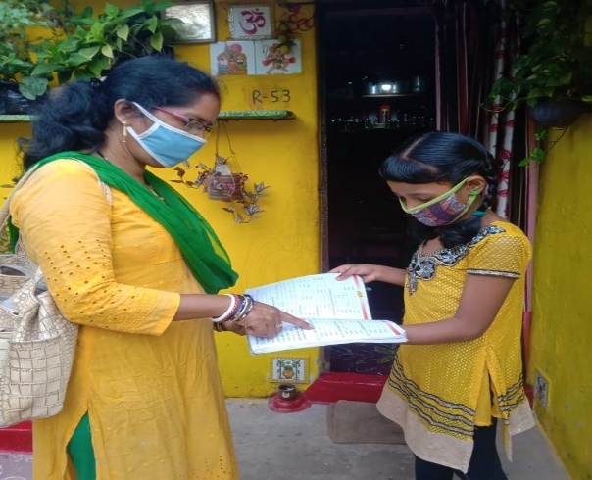There are also several other issues connected to education, like deteriorating level of nutrition among school children because of unavailability of mid-day meals from schools, Psychological problem due to due to disruption in education or no contact with peers, infection in the households, making the issue more complex. At the same time many of the slum parents have no smartphone as well as internet. However, Ruchika is able to reach to the children as well as their parents by engaging Balika and Basti Education committee members in the e-learning process. they are helping to the children to access the e-learning videos those who have the smartphone. The members of BEC have been taking responsibilities and helping resolving the community level issues. The low performers of children, low school attendance of children, late starters and no starters as well as slow learning capacities of children were given importance in the process.

**Covid-19 & the risks to slum children:**

Residents of Urban slums, informal settlements and low-income neighbourhoods endure living conditions that make it challenging to protect against covid-19. It isnearly impossible to physically distance in the slum where several families shelter under one roof, sharing cooking facilities, toilets and water points with other households, and where there is insufficient access to public spaces.

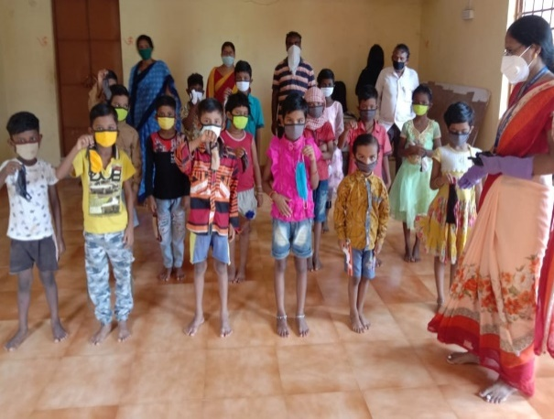

In such environmental it is quite impossible for children to practice all preventive measures of covid-19. Children faces heightened treats to their safety and well-being. At the same time children are facing a multitude of physical, mental, social and economical risks. In such difficult situation, Ruchika helped to slum children by provide psychosocial support, counselling and continuing their education through e-learnig. At the same time Ruchika has been teaching all preventive measures of covid-19 as well as distributed mask, soap and providing rations to the neediest during this pandemic.

**Teaching children preventive measures from COVID-19**

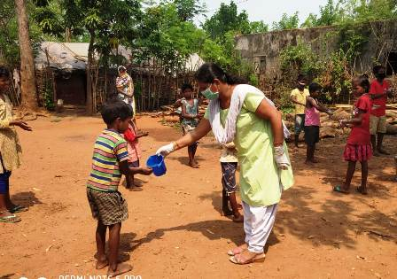

Corona virus infection is a global emergency. Over the few months there is a rapid increase in the number of cases and deaths due to Corona virus infection. It is very important to minimize this risk of infection for which we need to adopt appropriate preventive measures as there is no specific treatment and immunization available to date to address this serious issue.

In past months children have understand the basic concepts of disease prevention and control. The key insights from past months children are continuing their studies more effectively and are more concerned about COVID-19,children are improving & spreading hygiene measures through their home only. The protection of children is particularly important. Precautions are necessary to prevent the potential spread of Covid-19. In this serious situation Remedial teachers have been teaching about the basic concept of diseases prevention and control. While Covid-19 continues to spread it is important to teach the preventive measures to children as well as whole community for further transmission, to reduce the impacts of the outbreak and to support control measures.

**Psycho-social support to Children during Covid-19 pandemic:**

In the current context of lock down and restriction of movements, children have constrained access to socialization, play, and even physical contact, critical for their psychosocial wellbeing and development. School closures are preventing children from access to learning and limiting their interactions with peers. Children sometimes feel confused and at loss with the current situation, leading to frustration and anxiety, which increase with the overexposure to mass and social media, especially among adolescents. Some adults may struggle to find ways to explain and communicate with children about the current situation in a way that is understandable by this age group, which add frustration and disquietude.

A manual developed by UNICEF and Childline India Foundation to support children affected by the COVID-19 pandemic has been translated into Odia by the Program Manager of Ruchika. The manual is activity-based and so minimal supervision or guidance is needed. There are activities for two age groups – age’s six to ten and 11 to 19. By use of these activities we continue to support the children living in slums to ventilate their anxiety and stress. However, this translation booklet now have been used in different child care institutions and government schools as well as by the parents of different families to provide psycho-social support to the children during the pandemic.

**Community Sensitization during Covid 19 Pandemic:**

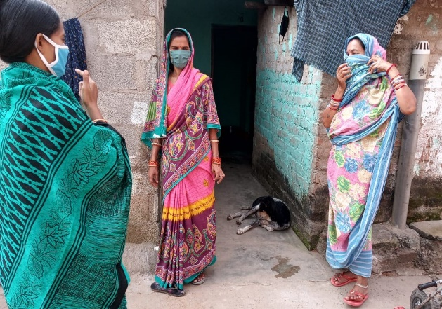

COVID-19 continues to constitute a public health emergency in Odisha. So, with this emergency Ruchika trained Remedial teachers, BEC members and Adolescent groups to spread awareness in the community on use of mask, hand washing with proper procedure, maintain social distance, avoid touching nose and mouth, follow lockdown guidelines etc. Since the outbreak of the COVID -19 pandemic in Odisha, Ruchika have helped the communities to cope with the effects of the pandemic, sensitized community people as well as distributed Masks, Soaps, provided rations to the needy ones and teach hand wash procedure to remedial children. In this situation our BEC members and Balika Mandal members played an important role. They not only educated the community, they also prepared masks by themselves and distributed to the people in order to save them from the Corona virus infection.