Educate 3000 Marginalized Slum Children in Odisha

Education is a fundamental right of all children in India. Yet many children those who living in the slum do not have adequate access to government school. Primary Education in India suffers from many deficiencies. The paucity of financial resources, weak institutional structure of primary schools, Indifference of parents, alienation of schools, inappropriateness of curricula, ineffectiveness of teachers, inertia in administrative and supervisory machinery, multitude of languages and dialects, extensive inefficiencies in operation in general and reinforced by particular in equities are some of the failure to provide fair opportunity to children from less privileged backgrounds. In addition, the government schools do not appropriately plan to address their education needs discouraging their enrolment and eventually leading to high rate of drop-outs from school. In order to impart quality education to these marginalized slum children Ruchika started its first initiative in the form of Platform school in the year 1985 in Bhubaneswar. In addition, Ruchika is running Remedial Education centre in slums of Bhubaneswar and providing remedial coaching to marginalized slum children.
Goal and Objectives of the Project:
The Programme Objective was to reach out to all the slum children of Bhubaneswar to increase academic proficiency and targeting a significant reduction of drop-out in the schools as well as ensuring Right to Education Act, in its true spirit in the target area.

Specifically, the programme focused on improving the lives of the marginalized slum children through a three-pronged approach:
- Provision of Specialized Remedial Education to enhance academic proficiency. The approach identifies children with low proficiency and designs appropriate before or after school remedial support including competency building, counseling parents and children, family visits, etc.
- Community mobilization to raise awareness on quality education and greater involvement of the parents and community at large in the education system
- Specific activities with school authorities, district level authorities and the Education Department (Government of Odisha) to ensure quality of education as well as realization of maximum provisions of Right to Education Act 2009 (RTE).
The programme aimed at directly benefiting slum children through remedial education centres and school going children through activities implemented in slums and in neighbourhood schools.

Ruchika’s Intervention:

Marginalized kids especially those live in the slums lag at all stages of education. When earning a livelihood and taking care of the members of the family becomes a primary matter of concern in one’s life, education stands a little or, very often, no chance of pursuance. For the millions of underprivileged people in India, education is a high-priced luxury, and this negative outlook continues on with every new generation.

As per the baseline study, poverty damages childhood with significant effects on a child’s physical and mental health, as well as educational achievement. It limits the expectations of the child’s ability to perform well in school, constantly reminding him/her of the miniscule chance he/she has to overcome adversity and poverty. On the other hand, in most slums children are the first generation learners and there is no role model in the family or in community who can guide or pursue them for the better future with quality education. It also projected in the Baseline that the learning abilities of boys and girls of studied schools did not reflect a healthy picture. It is found to be worst in second language i.e. English.
As a protagonist of child rights activism, Ruchika Social Service Organisation has been providing education to the most marginalized children especially those living on the streets, slums and railway stations of Odisha. Its flagship programme – Enhancing academic proficiency through Remedial Education has been proved to be a most successful and innovative one in the state of Odisha which aims to create an effective model of community based academic solutions for government and other private initiatives in the country. The model emphases on diagnostic solutions, adopting innovative strategies in teaching learning process for faster learning and creativity, empowering the children to be change makers to transform the society as a whole and mobilizing community for greater involvement in education processes and to be role models for achieving universalization of quality education. The programme of Ruchika has succeeded in bringing more than 50,000 slum, street and railway children to school since its inception in the year 1985.
Ruchika intervenes in 65 most vulnerable slums of Bhubaneswar for last 10 years. The objective of the program is to bring a sustainable and right based change in the community by using Remedial Education as a platform. It targets children in the age group of 6 to 11 years with remedial coaching, 12 to 18 years of girls and boys with learning life skills including Reproductive Health Rights, Community with education and awareness on child rights and other human rights.
Changing the attitude of people and making them role models, making universal schooling a people’s movement and upgrading the academic skill and proficiencies of all children at par with the non-slum children studying in the school, training them to demand their rights, and creating a conducive environment in the slums to ensure all rights and putting all children into the safety net are some of the huge tasks the organization has planned in these slums. It needs time to educate and strengthen the care givers and duty bearers and to enable them to fulfill their obligations towards children. This urges the organization to continue intervention at least for two more years in the same slums. During the forthcoming two years, the organization plans to strategically focus on developing strength of the children as well as the community, care givers and duty bears to be the role models and protagonists of Child Rights activism.

Remedial Education for the Marginalized Slum Children:
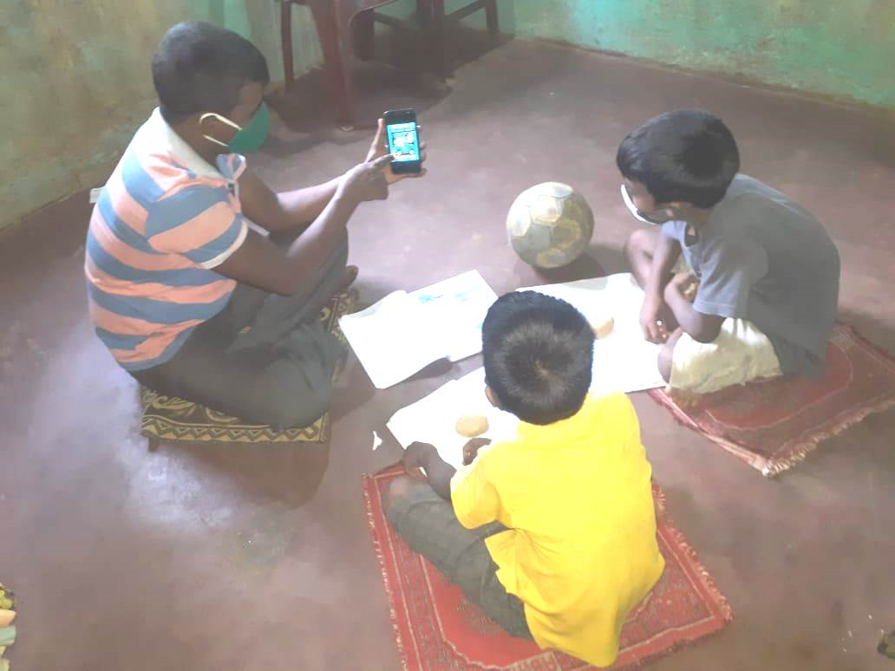
The Remedial Education Programme has been running in 65 slums of Bhubaneswar. The organisation used community sheds to run the program. Friendship strategy was followed. The teachers developed work plan in advance and were imparting remedial coaching accordingly. Due to the Covid 19 pandemic all schools have been closed in odisha and have not reopened. Therefore, Ruchika is conducting e-learning classes for children. All the cluster educators have prepared the lesson videos and uploaded in You-tube for better access to children as well as parents in all over Odisha.
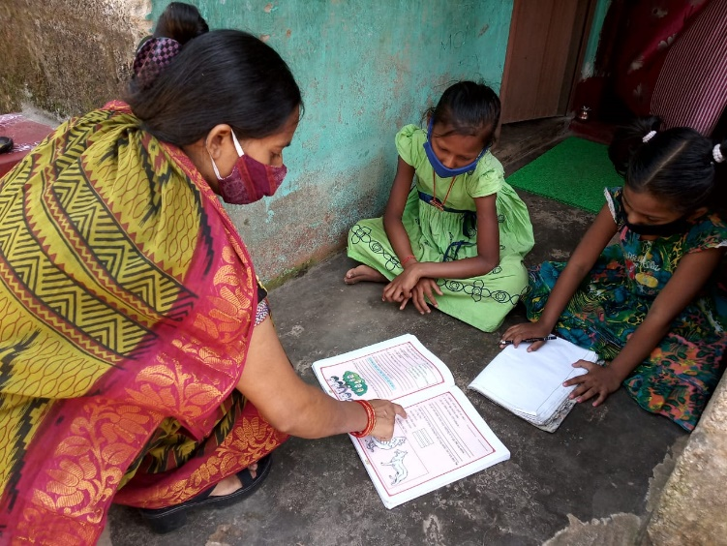
All the Cluster educators and remedial teachers are doing the follow-up of the class and conducting assessment to evaluate the academic progress. The teachers identified academic proficiency among the children getting ready to appear the annual evaluation and were helped strategically to overcome the academic difficulties.

The remedial teachers also visited the government schools where the children are studying and found out the learning difficulties of the children from the teachers and accordingly prepared plan of action. The Cluster Educators were focused on the academics issues of the children.

The low performers of children, low school attendance of children, late starters and no starters as well as slow learning capacities of children were given importance in the process.

Activities with Govt School teachers during Covid-19

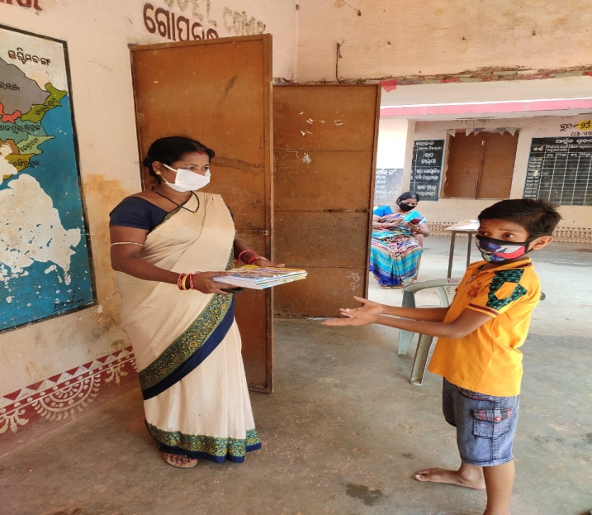
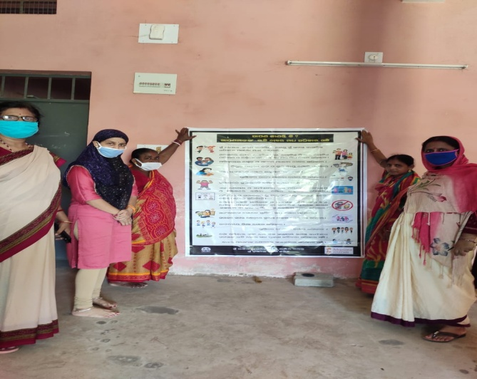
Children’s are out of school due to school closure in response to COVID-19. The sudden closures of the schools have disrupted the flow of learning of the students and the existing method of imparting knowledge of the educational institutes across the world. In the given condition Odisha Govt. has been conducting e-learning and Books have distributed among the students.In the mean time our remedial teachers have helped to govt school teachers in distributing textbooks to the homes of school children and distributing mid day meal token. Remedial teacher have also helped in the process of enrolment of children in Govt. school. Child protection policy posters have posted in intervention Govt School. This mutual cooperation’s during COVID-19 have built good rapport among them.

Community Sensitization during Covid 19 Pandemic:
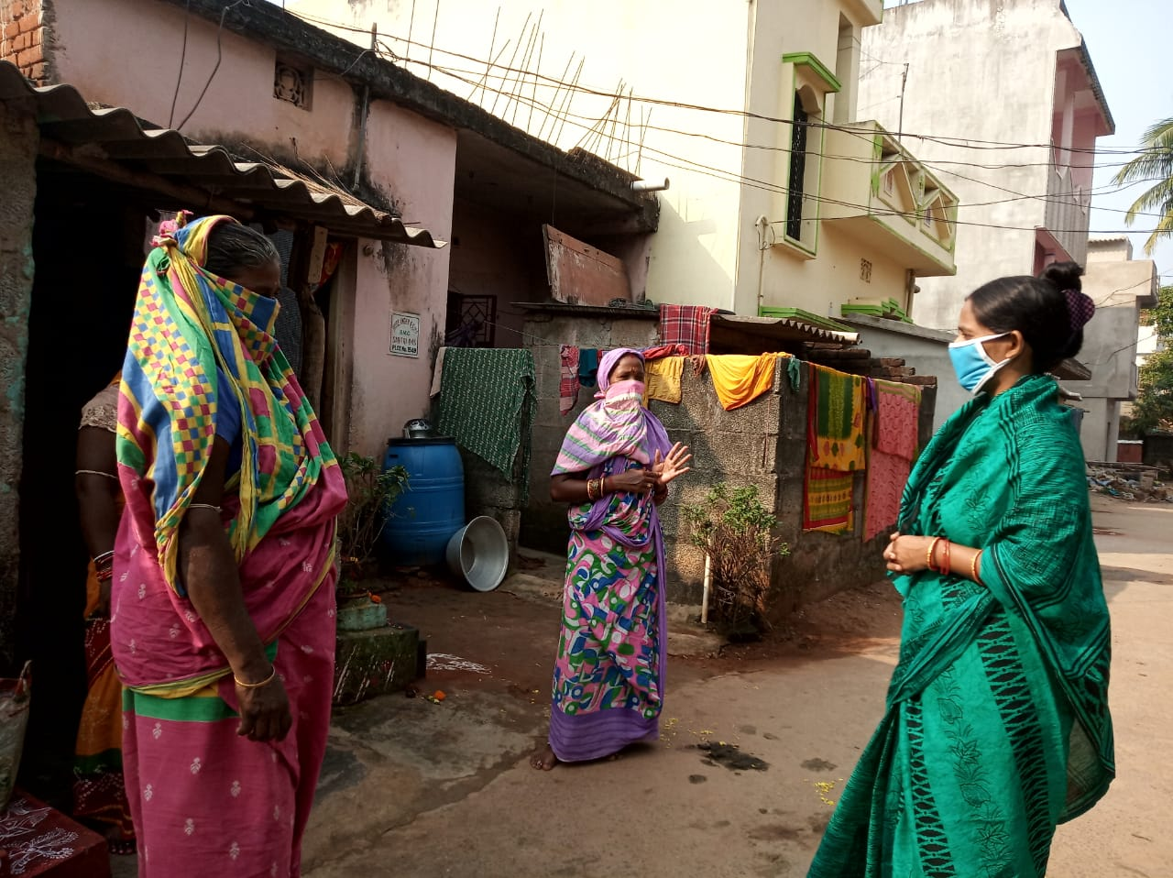
COVID-19 continues to constitute a public health emergency in Odisha. So, with this emergency Ruchika trained Remedial teachers, BEC members and Adolescent groups to spread awareness in the community on use of mask, hand washing with proper procedure, maintain social distance, avoid touching nose and mouth, follow lockdown guidelines etc. Since the outbreak of the COVID -19 pandemic in Odisha, Ruchika have helped the communities to cope with the effects of the pandemic, sensitized community people as well as distributed Masks, Soaps, provided rations to the needy ones and teach hand wash procedure to remedial children. In this situation our BEC members and Balika Mandal members played an important role. They not only educated the community, they also prepared masks by themselves and distributed to the people in order to save them from the Corona virus infection.

Monitoring & Evaluation:

An intensive monitoring was done during this quarter. The Program Manager, Head Educator, Cluster Educators, all have visited the field and tried to run the program in full spirit. The Community issues at different pockets were resolved. All most every day the monitoring team visited their target area as per plan.

An effective MIS was prepared to monitor the activities of the program. The Basti Education Committees were trained and given responsibilities to monitor the program. The members of BEC have been taking responsibilities and helping resolving the community level issues.

