Educate 3000 marginalised slum Children in Odisha

It is our proud privilege to present the report of the remedial education project before the donor agency and all other well-wishers. The project has been successfully completed. During this intervention the project has crossed several milestones and hurdles but eventually it completed almost the project target being achieved.

Threat of Corona Virus:

In the beginning of the year intervention, the organization has faced a serious challenge of Corona virus when the World Health Organisation has declared the new Corona virus outbreak - COVID-19 as a global pandemic. Only a few times in the history of mankind have human beings as a race faced challenges beyond their comprehension. With advances in science, this phenomenon has become a rarity.

India scrambles to escape from the Corona virus crisis. Corona virus pandemic continues to wreak havoc across states and take a toll on multiple economies.
Though Odisha has taken a proactive step well in advance even before the identification of first Corona positive case, it is struggling with several positive cases by now. The government of Odisha is aware that the State’s public health infrastructure is neither adequate nor is equipped to bear the burden of patients influx in the stage III (community transmission) spread of the virus.
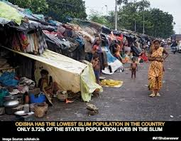
The breadth and depth of such challenge is staggering in a country like India where hundreds of millions of citizens are destitute and countless millions live in packed urban areas (slums) with poor sanitation and weak public health system.

As we all are aware of the fact that, the spread of the corona virus (Covid-19) in slums will surely be faster than in the non-slum areas we seem to be tracking so far. Bhubaneswar itself is surrounded with 436 slums proliferated in shanty areas with a population of more than 4.5 lakhs of which over 1.5 lakhs are children. Overcrowding, lack of clean water, poor sanitation, social dependency, larger number of human contacts, low disease immunity of dwellers, besides poor medical facilities make for tremendous speed and size of virus transmission in these slums. It is a noted fact that, the poor quality of air in Bhubaneswar slums especially those spread across railway lines are a common cause for respiratory diseases that further reduces the respiratory tract’s ability to shut the corona virus down.

How do we discuss self-quarantine with a person sharing a tiny shanty with 8 people in a slum? How do we advise social distancing to a daily labourer? How do we advise a person to priorities hand sanitizers who struggles for one meal a day? On the other hand slums are an integral part of the city’s economy as that is where a majority of workers and domestic help stay.

Children are worst affected by Covid -19:
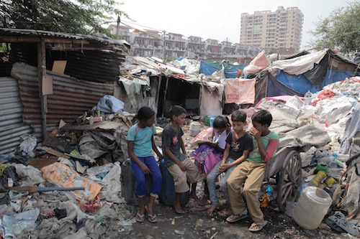
The disadvantages are disproportionate for under-privileged learners like slum children who tend to have fewer educational opportunities beyond school and they are first generation learners. When schools close, parents who are almost illiterate are often asked to facilitate the learning of children at home. Hence it is expected that the prolonged lockdown will result serious implications over the slum children as enlisted below.
- Student drop-out rates tend to increase as an effect of school closures due to the challenge of ensuring all students return to school. Disadvantaged, children of single parents are more likely not to return to school after the closures are ended, and the effect will often be a life-long disadvantage from lost opportunities.
- The academic proficiency of slum children will drop down dramatically as nobody is there in their family to academically support them during lockdown. Hence when schools open cannot adjust with their peers (non-slum children) having higher proficiency, thus may tends to drop out from the school.
- The parents will be compelled to focus on restoring their livelihood after lockdown and will further neglect the children’s education.
- The economic crisis of families due to a strong bang on livelihood due to prolonged lockdown may compel the slum parents to push their children into labour sector and permanently close their doors to school.

Hence it is imperative to immediately start an effective technology based solutions in the field of education to bring the slum children back to the proficiency level at par with their peers in the school along with a strong community mobilization initiative to prevent post lockdown dropout and to close the doorway for children to enter into labour force.

Technology Inclusions in Remedial Centres :

Ruchika has pioneered imparting technology based academic solutions in the name of Remedial Education in the slums. This is a strategic step by step academic solutions which includes identification of exact academic issues, preparation of appropriate academic plans, identification of competencies, helping children through friendship education approach to acquire the required competencies, comprehensive competency assessments at the end of each competency and follow Friendship Education strategy in order to quickly improve the competency level of the learners at a faster rate with creativity and without any fear factor.

In order to sustain the intervention and restrict further dropouts, the organisation would mobilize the families, communities and school authorities. The Education Committees formed and the members will be trained to take responsibility of the program at closure of intervention.

The intervention aims to review and improve the learning competencies in three core subjects – English, Odia and Maths. The teachers assist the children to identify actual academic issues/ deficiency and find a remedy to enhance proficiency. They also help their friends in learn the competencies, by forming pairs and groups as necessary. This process has enabled not only in learning but also in reviewing and planning their school tasks and preparing for school assignments. Over and above the project aims to achieve universal enrolment, retention, reducing rate of dropouts and ensuring provisions of RTE in school. This year an additional component has been added to empower the adolescent girls to become change makers. Hence at the ultimately the Rights of the Children to Free and Compulsory Education will be achieved in its true sense in our target intervention area and a successful model will be in place for all the concerns.

Remedial Education:
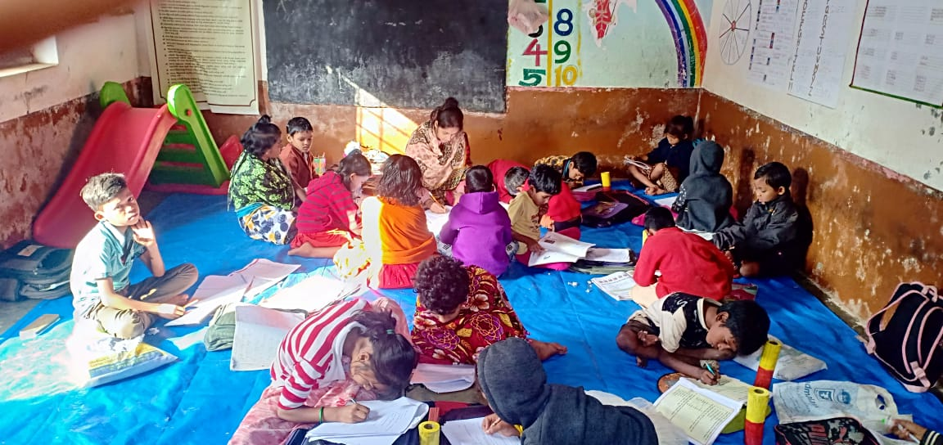
For the first two months of this quarter Remedial Education programme was running regularly in slums of Bhubaneswar. The students who were found lagging behind, in the course of action were treated with special remedial coaching with individual attention on every Saturdays. The Remedial teachers followed competency-based coaching and friendship approach while teaching the students in the remedial center. Attention was given to make the classroom interesting and interactive. Remedial teachers were using different teaching learning material (TLM) in the classroom. Child participation in the education process was given first priority.On every Saturday nature observation was conducted by teachers in which the children visited different beautiful places and observed the nature.

Introducing on-line learning:
Since second half of March the Corona Virus outbreak in India changed the life style of the people. Children and adults suffered economic and food crises. People lost their jobs and livelihood. The prolonged lockdown seriously affected the lives of the children. The teachers of Ruchika were not able to reach out to the children physically.

But soon after the state and national lockdown was declared Ruchika team thought of to reach out to the children through e-learning processes. In this process the team

- Identified the children whose family has a smart mobile phone with net facility.
- All the children were tried to be linked to the mobiles and a suitable timing was identified for each centre for e-learning.
- Teachers and supervisory team designed course contents with voice messages, video messages, charts, assessment sheets and instructions to the students and parents.
- The complete syllabus was divided into sets and stored in different whatsApp groups.
- Each teacher formed a student’s group and started sending the course contents.
- The teachers also tried to do follow up to know whether all the students are studying or not.
- Assessment was carried out through the assessment sheets after completion of each topic, thus confirmed continuous and comprehensive evaluation.

In this way we were able to reach out to over 75 % children who were on role. However we also learned that 10 to 20 % of our children have been migrated to their native villages. Now we have started follow up to those children and trying to ensure that they come back to Bhubaneswar or if not they start learning through e-learning process.

Co-curricular Activities:
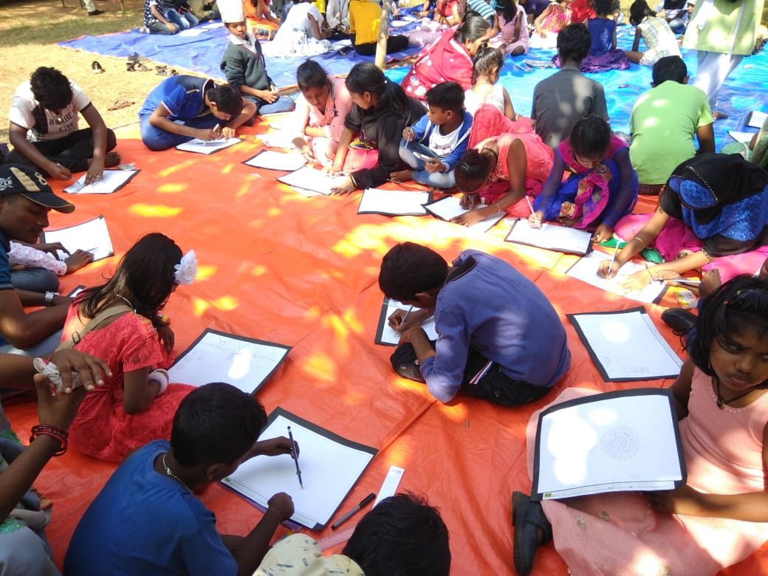
Co-curricular activities are those activities which are undertaken along with academic studies. For the development of a child, curriculum is not only the single criteria. The holistic development of the child is possible if classroom teaching is supplemented with co-curricular activities. This enhances the child’s individual emotional, social
and spiritual growth. Co-curricular activities are very important part of education to develop the student’s personality as well as to strengthen classroom learning.

Our remedial teachers have been conducting interesting, joyful and creative activities in the centres and in the community to attract the children to participate in the teaching learning process. During this quarter drawing competition, debate completion, dance and origami work was conducted at different centres.

Participation in Aparajita Program:

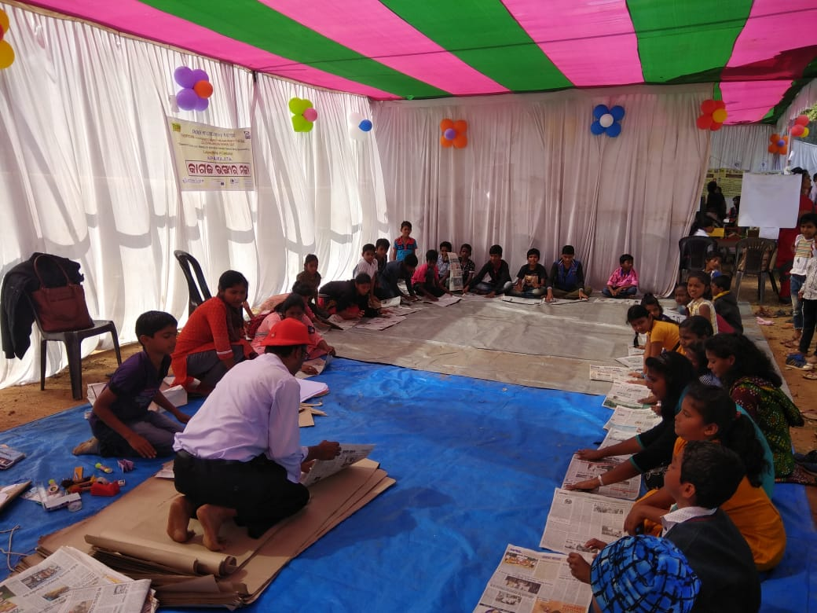
Aparajita – a program on child rights was organised by CHILDLINE, Bhubaneswar on 18.1.2020. About 500 children participated in different activities like games, painting, origami, drama, dance etc. during the program. They interacted with reputed artists, film stars, politicians, teachers and people from different segments of society.

Sri Samir Ranjan Das, Honb’le Minister, Deptt. of School and Mass Education was the Chief Guest and Sri Ananta Narayan Jena, Honb’le MLA, Bhubaneswar (Madhya), Smt. Sulochana Dash, Commissioner for Persons with Disabilities, Odisha, Sri. Sitansu Kumar Rout, OAS (SAG), Collector & District Magistrate, Khordha, Sri Anup Kumar Sahoo, IPS, DCP, Commissionerate Police, Bhubaneswar
Dr. Sarthak Sarangi, IPS, Sup. Of Police, Vigilance , Bhubaneswar, Sri Kamaljit Das, OAS (I), Manager, SMART City, Bhubaneswar, Sri Arka Laha, Sr. Program Coordinator, CIF, Kolkata, Dr. Haraprasad Mishra, Director, Regional Science Centre, Bhubaneswar , Sri Nilakantha Tripathy, Chairperson, Child Welfare Committee, Khordha, Dr. Parsuram Moharana, Chairperson, Addl. Child Welfare Committee, Bhubaneswar, Smt. Banishree Pattanaik, District Child Protection Officer, Khordha, Ms. Andrea Cardona, EU Volunteer from Sweden, Ms. Tatyana Ivanova, EU Volunteer from Indonesia, Sri Gurpreet Singh Khurana, Director, Ruchika High School etc. joined with the children and interacted with them. The members of Child Welfare Committees counselled the children and discussed with them on adolescent issues.

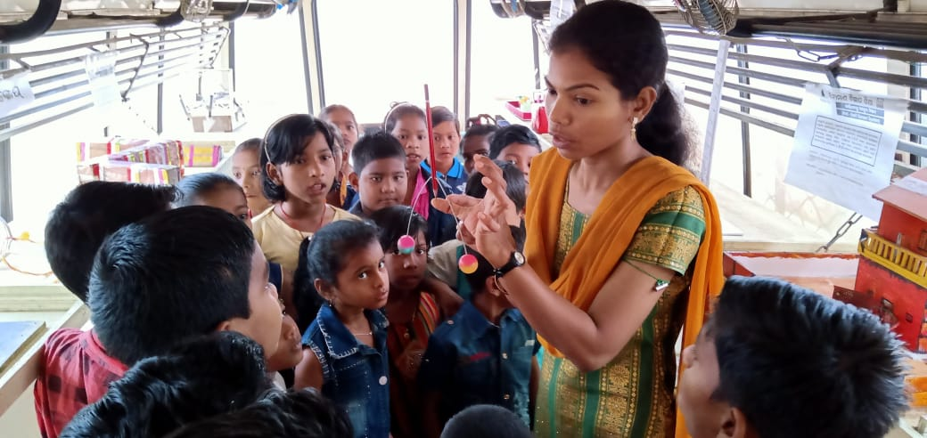
Science on Wheel:

Science on wheels is a bus full of science models which visits the remedial education centres regularly. It also visits government schools in our intervention area. The objective of the model is to create interest among the children on science and technology. It helps to enhance immensely the limits of their curiosity. During this quarter the bus has covered total number of 40 remedial centres and 40 Govt. Schools in the intervention area. Students observed the science models and put many questions about the preparation, functioning and utilities of the models in social life.

Exposure Visit to Regional Science Centre:-

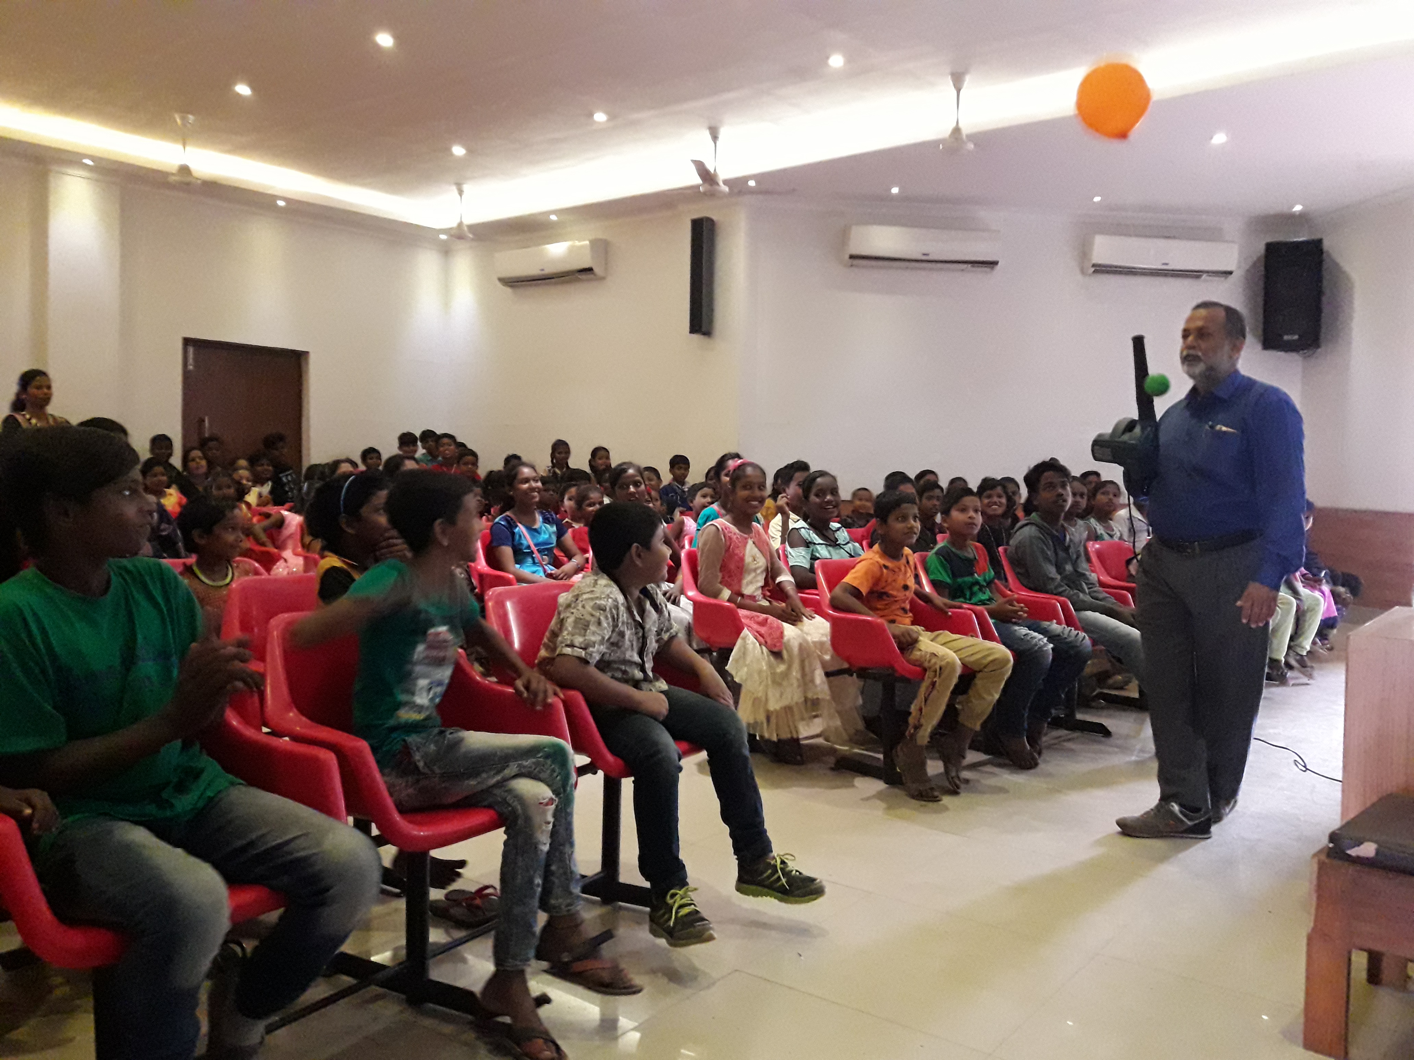
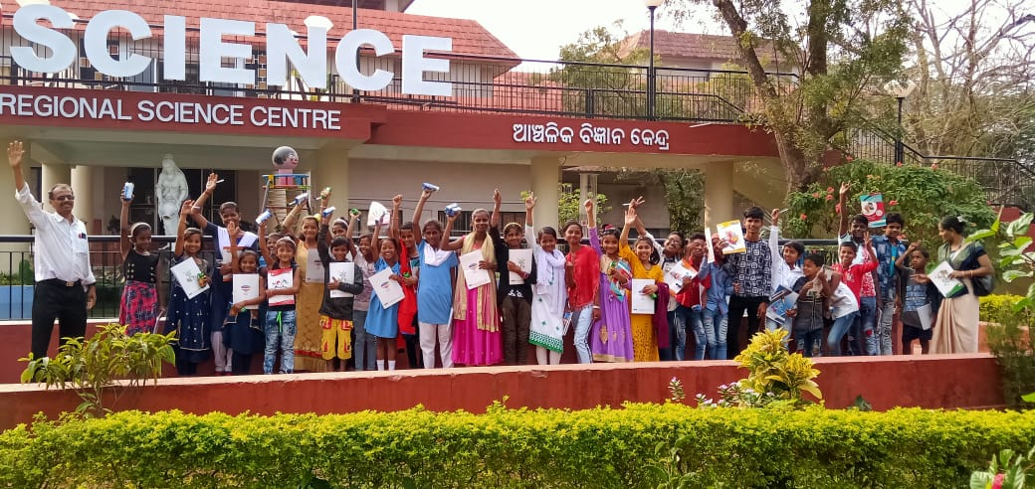
In order to provide Science Education to our Children Ruchika organised an exposure visits for children to Regional Science Centre, Bhubaneswar. The objective was to create interest among the slum children in Science and to enhance scientific knowledge among them. 1293 No’s of children the children of remedial centres visited the Science Centre during January 2020. The program continued for a week time.

With our request, Regional Science Centre provided free transport, snacks and a small take-home gifts for the children who visited the centre. Children visited all the science models and learned working of these models. Mirror house, the infinite well, infinite train etc. were very interesting for the children. A team of Scientists from Science centre demonstrated various scientific experiments before the children which helped to increase the scientific knowledge among the children. The children were also amazed to experiment with the set up in the science park that amplified sound. They observed how sound travels through metals and had fun time with the playing materials available in the park.

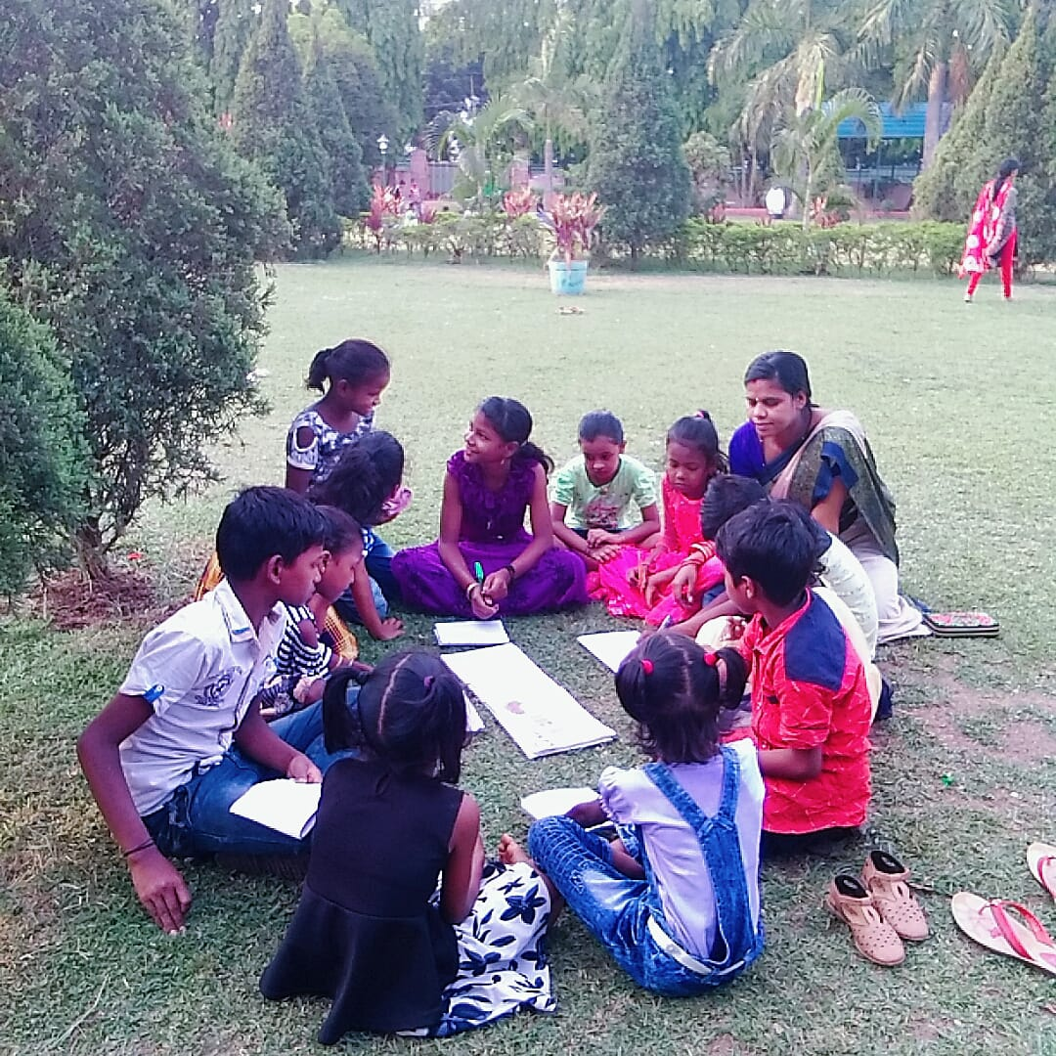
Nature Observation

Nature observation is a process of interaction with natural environment. Its purpose is to educate the children in terms of environment. It allows children to learn by doing and experiment with ideas. It is a part of our regular curriculum. On every Saturday the children visit different beautiful places and observe the nature. In open environment children are able to observe the natural environment around their school, home or community. All the students were given a nature study note book in which they are free to record their observations with words, drawings and also write the poems. This activity made them to love the nature and learn from the nature. This activity provides countless opportunities for discovery, creativity and problem-solving ideas among the children.

Activities in Government School:
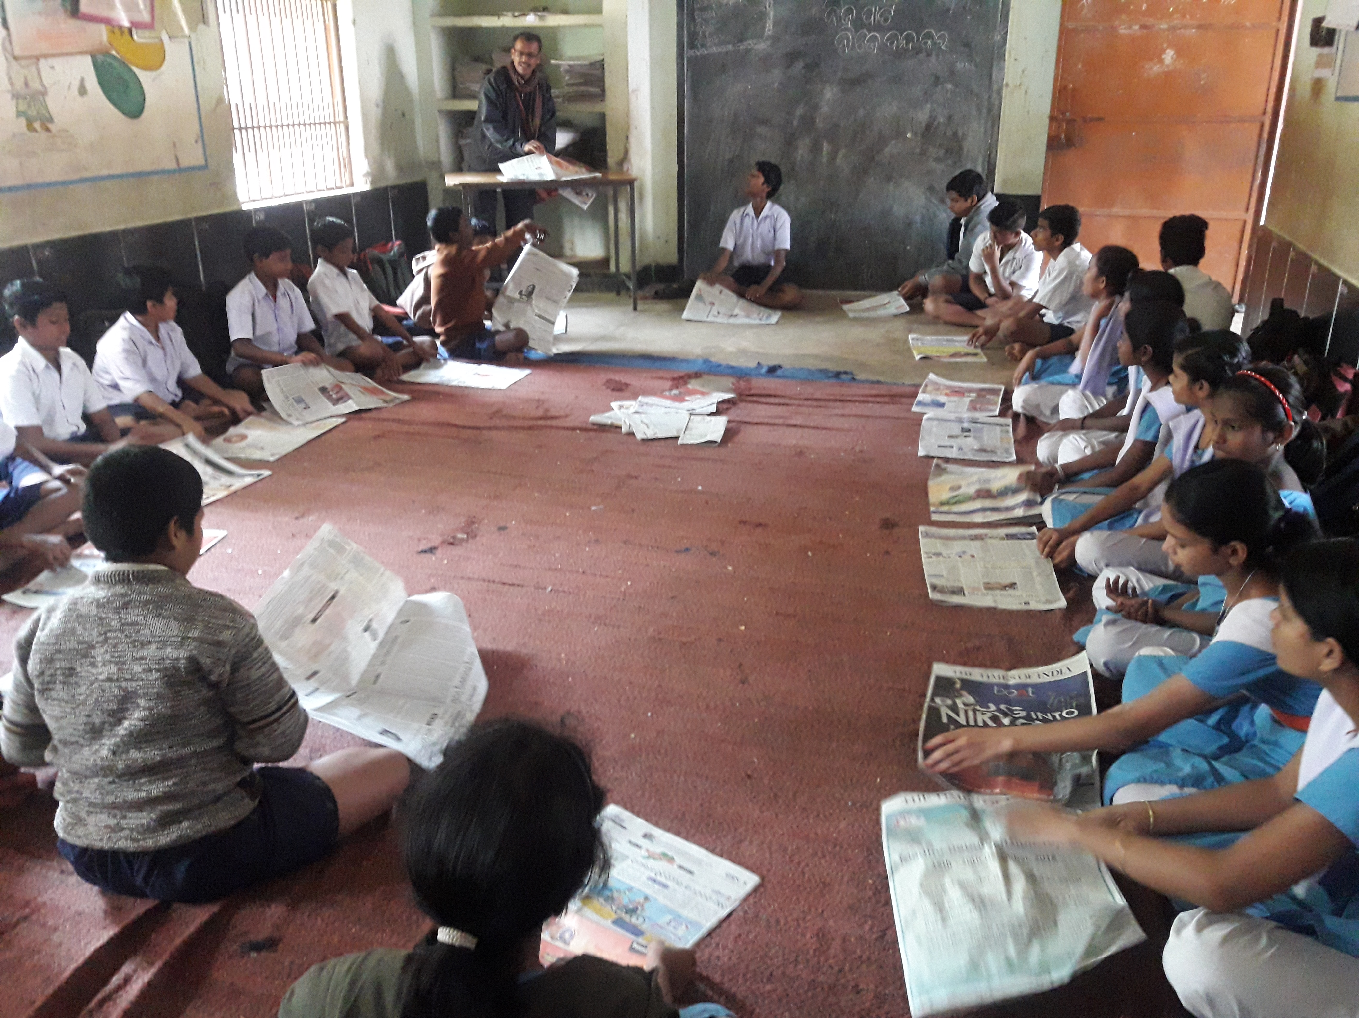
The remedial teachers and the supervising staff regularly visited the government school in the intervention area. This time RTE posters have been pasted in Govt School and teachers have been trained on RTE and its proper implementation to reduce dropout. The Supervisory team also conducted co-curricular activities i.e is Origami, Painting and Art exhibition, joyful games etc. The school teachers helped the supervisory staff and also learned from the process.

Monitoring &Evaluation:

An intensive monitoring was done during this quarter. The Program Manager, Head Educator, as well as Cluster Educators, all have visited the field and tried to run the program in full spirit during this quarter. The Community issues at different pockets were resolved. All most every day the monitoring team visited their target area as per plan.

An effective MIS was prepared to monitor the activities of the program. The Basti Education Committees were trained and given responsibilities to monitor the program. The members of BEC have been taking responsibilities and helping resolving the community level issues.

Activities with BEC Members:
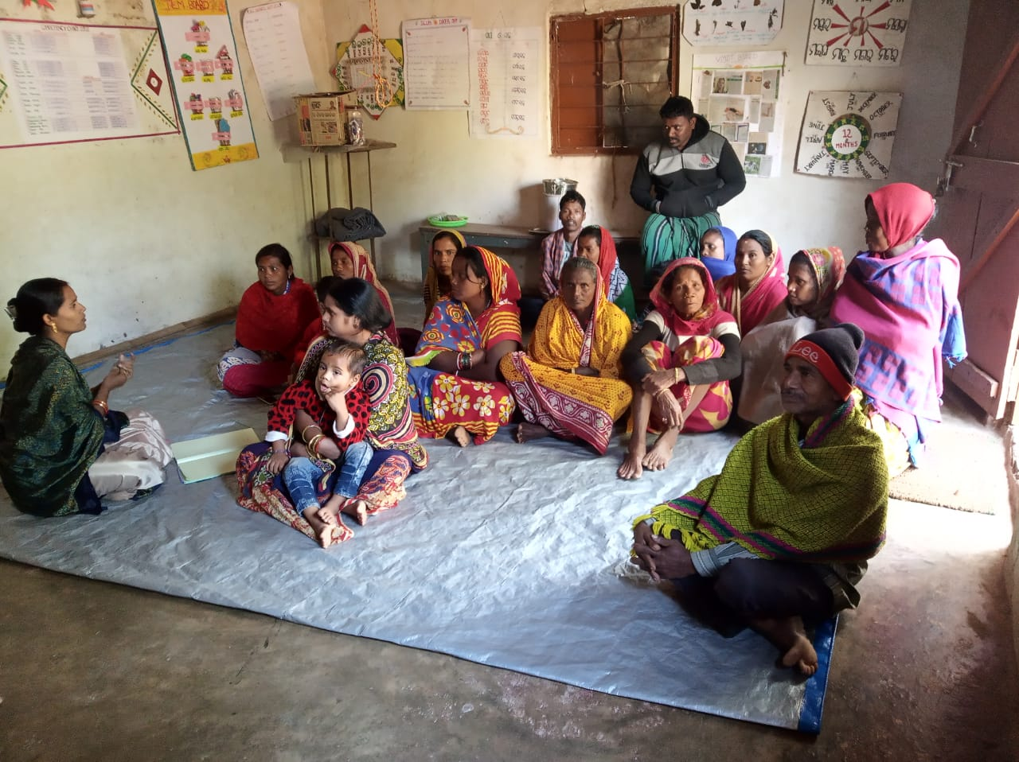
Basti Education Committee Meetings have conducting once in a week by our Remedial teacher in their individual remedial center. In this meeting BEC Members participation is given top priority.The discussion was given on the relationship between the school and community in implementing RTE, role of the members of Basti Education Committee to bring a change in the education scenario of slum areas, identification of dropout .

Observation of International Women’s Day:
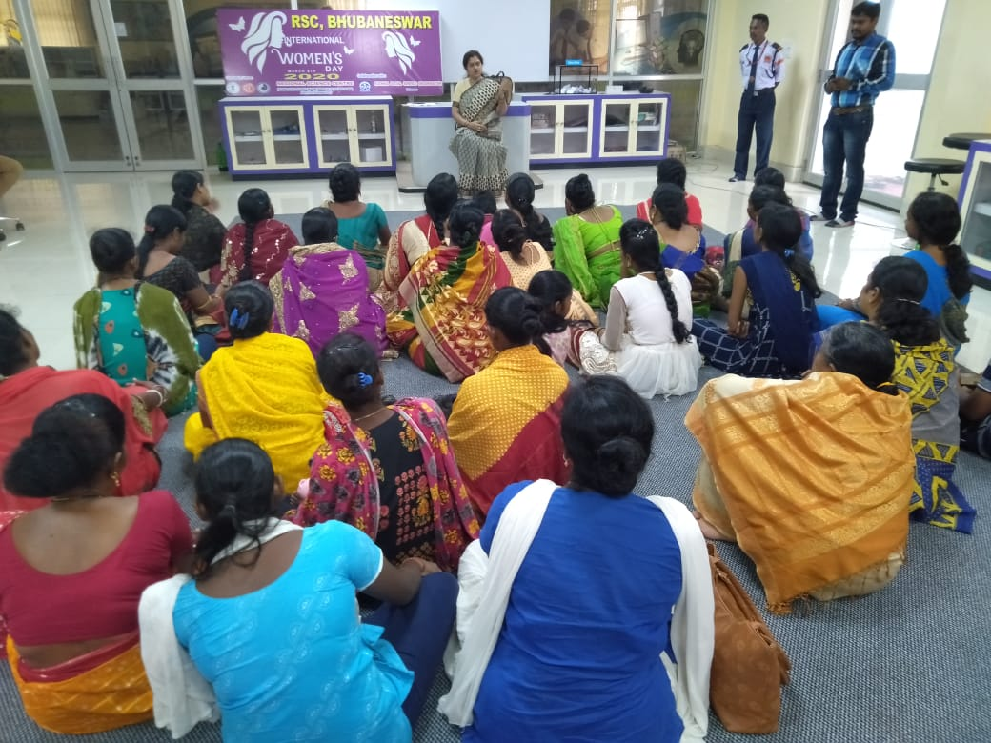
In this quarter on 8th March, 2020 Ruchika observed “International Women’s Day” jointly with the Regional Science Centre. The women from the intervention slums and women BEC Members visited Regional Science Center. Social Activist Dr. Jharana Dash was invited who discussed with the women on different social issues relating to women. She also discussed about the rights of women and empowered them to fight for their rights.
.
Quarterly Review Meeting: -
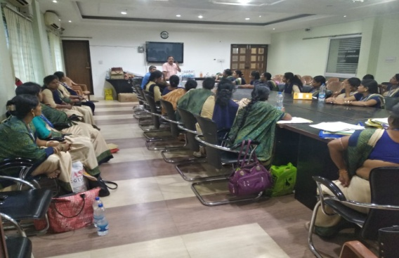
A quarterly review meeting was organized in the premises of Ruchika Resource Centre. All the remedial teachers and supervisory level staff attended the meeting. Implementation of Continues Comprehensive Evaluation (CCE) of students was also reviewed. The student’s assessment and competency test series were also reviewed. The academic progress of students, staff discipline, community mobilisation, school mobilisation, challenges faced during the quarter etc. were reviewed on a participatory approach.

Staff Capacity Building program:

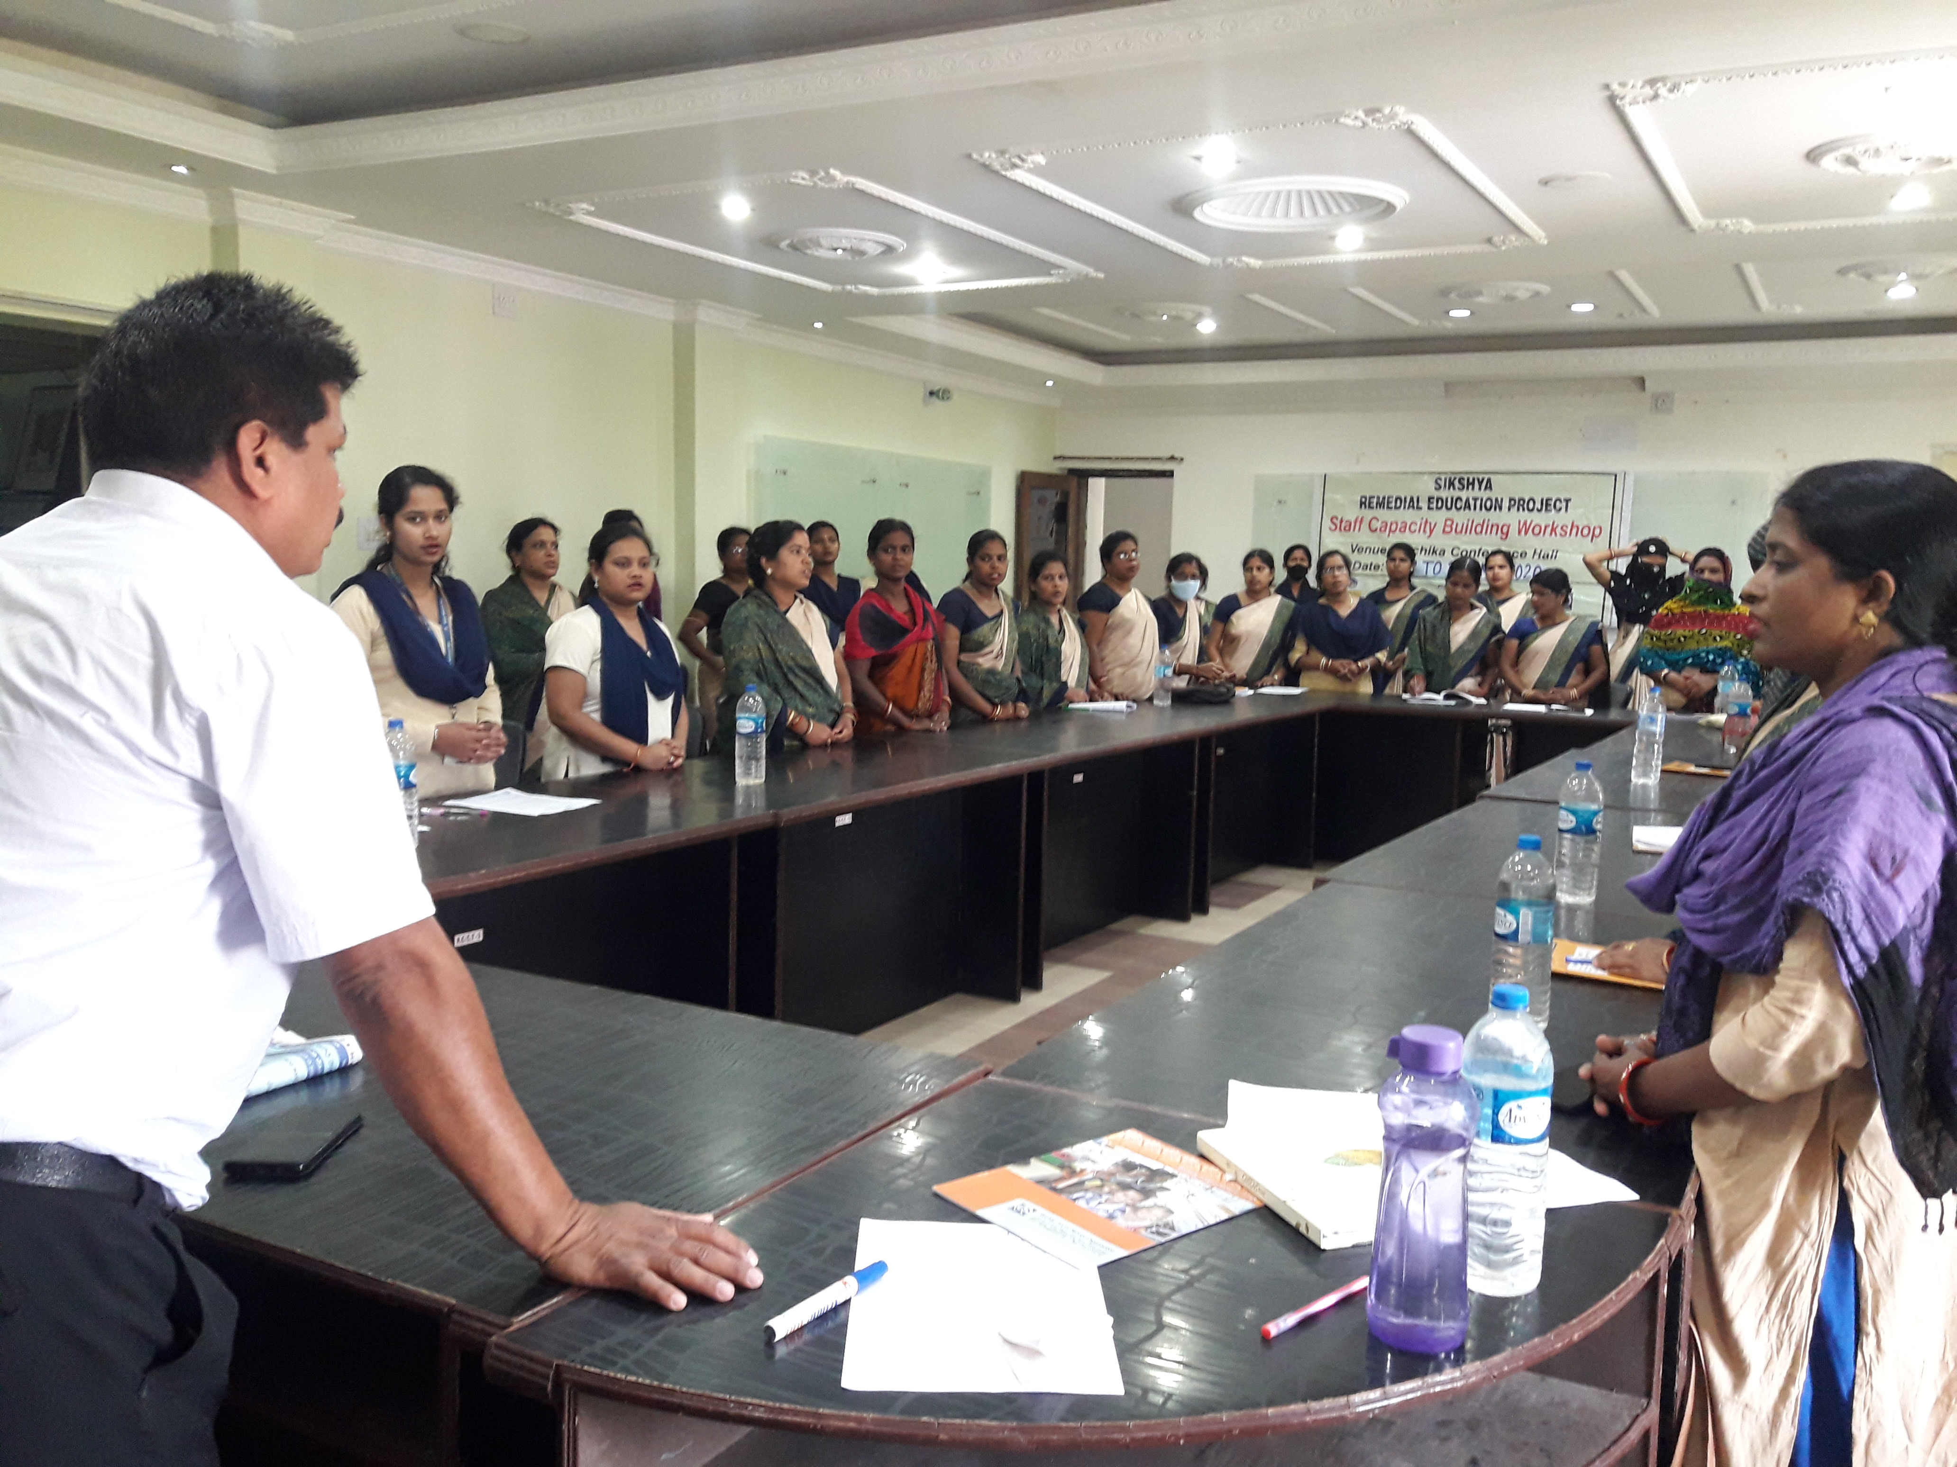
Two days Staff Capacity building program were organized in the premises of Ruchika Resource Centre. In this training program classroom management and Preparation of Innovative TLM was discussed. All remedial teachers brought their old TLM from their individual centre and shared with others and exchanged their ideas. New TLMs were prepared during these two days workshop. All remedial teachers were also educated on COVID-19 so that they can teach the community and the children about social distancing, hand washing techniques, use of mask etc.

