PROTECTING THE LIVES OF MOTHERS AND CHILDREN
A PROJECT PROPOSAL

TO SUPPORT

THE CONSTRUCTION OF LAVATORIES & HAND WASHING FACILITIES FOR AYEBODE
PRIMARY HEALHCARE CENTRE (PHC)
A POOR RURAL COMMUNITY
IN
IKOLE, LGA, EKITI STATE.

A J.E.O.F HEALTH INITIATIVE 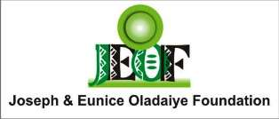

JANUARY 2016

CONTENTS
- Introduction
- Project description & justification
- Project goals and objectives
- Project deliverables, outcome & benefits
- About The Ayebode PHC
- Project benefit to sponsors
- Project Budget
- Project Timeline & Action Plan
- Pictures
- JEOF Profile

1.0 INTRODUCTION
The role of primary health care (PHC) is to serve as the first line of defense against illness and disease. "Primary health care plays a central role in health care systems worldwide, as it can offer families cost-effective services close to home, eliminating trips to specialists and hospitals. Primary health care is essential and it forms an integral part both of the country’s health system and it constitutes the first element of a continuing health care process. Primary health and community care is the most visible and commonly used part of the health system as such the importance of the primary care system for improving health outcomes and managing costs creates a stronger health system associated with better health outcomes and at lower costs, particularly for women and children.
It is therefore sad to see the deplorable state of most PHCs across the country that otherwise should be better positioned to meet the health need of the community they serve. Primary health and community care services face unique challenges and have come under significant pressure to address the diverse range of community health needs. Regrettably, the rural populations in Nigeria are seriously underserved when compared with their urban counterparts. About two-thirds of Nigerians reside in rural areas (http.//www.fao.org/country profiles/index.asp) therefore they deserve to be served with all the components of Primary health care, which is supposed to be the bedrock of the country's health care policy, is currently catering for less than 20% of the potential patients.
The Joseph & Eunice Oladaiye Foundation (JEOF) seeks to bridge this gap by providing intervention to Primary Healthcare Centres in rural communities with the provision of a conducive and hygienic working environment by providing lavatories (toilets) as well as training on healthy practices for health workers personnel in underserved PHCs across Nigeria.

2.0 PROJECT DESCRIPTION
According to Mr. Tope Babalobi, an European Union Expert on sanitation, Ekiti State had the highest rate of open defecation practice in the South West. Over 1.7 million people practice open defecation in public spaces. Also, according to the Disease Control Priority Project, a decent toilet primary health care reduces disease by addressing the health care of children, women and men including prevention and treatment. It reduces the economic costs of ill health; assures medical coverage for poor people, a group most in need of it; reduces the use of emergency and hospital visits; facilitates the control of routine illnesses; and increases patient compliance and acceptance of medical treatments.
However, providing adequate services as mentioned above is impossible without the required provision of basic hygiene facilities like toilets hand washing facilities as well as bathrooms. The Joseph and Eunice Oladaiye Foundation (JEOF) supports underserved PHCs in rural areas with medical supplies, capacity building and empowerment of communities through awareness, mobilization, and community support, as regards refurbishment, training, information sharing and continuous learning to enhance the utilization of PHC services by rural populations.
2.1 PROJECT JUSTIFICATION
While most PHC facilities are in various state of disrepair, with equipment and infrastructure being either absent or obsolete, one of the hindrances to the development of health especially in Nigeria has to do with the poor and insufficient infrastructure of PHCs. The Ayebode PHC serves more women as it also serves as a maternal centre. Unfortunately, the centre presently lacks a proper and decent toilet for the high number of women that visit the centre. Other shortcomings of the centre are; a lack of a borehole facility, lack of training for medical support personnel such as the community health workers among others.

3.0 PROJECT GOAL
The major goal of the Health for life project is to improve the health and well being women and children living in Ayebode, as well as other rural community members by providing a decent lavatory for the Ayebode Primary Health Care Centre as well as teach residents on the need to imbibe healthy practices.
3.1 SPECIFIC PROJECT OBJECTIVES:
- To end the indignity of open defecation that women (especially pregnant women) have to go through.
- To decrease to a significant level the high rate of infection associated with unhygienic practices.
- To decrease infection (sexual and reproductive) among women.
- To improve the hygiene and standard of living of women.
- To educate women, especially mothers on safe health practices on maternal and reproductive health.

4.0 PROJECT DELIVERABLES, OUTCOMES & BENEFITS
Table 4.1
DELIVERABLES | OUTCOMES | BENEFITS
Provide sanitary facilities and improve on existing facilities. | Build 3 units of toilets and bathrooms for the PHC, including hand washing facilities. | - Improved hygiene for mothers and their newborn.  - Reduction in the spread of infectious diseases, especially for women & children.
Promote awareness and training for patients, health workers against infectious disease, prevention and control of locally endemic diseases. | Organize one day training for local medical health workers. | - Developing capacity  - Strengthening awareness  - Sensitized population, especially women.
Promote awareness and training for health workers against infectious disease, prevention and control of locally endemic diseases. | Organize one day awareness campaign for mothers (and youth, men) on prevention and control of infectious diseases.  Especially Lassa fever, etc. | - Improved sensitization and awareness. For mothers and their families.
5.0 ABOUT AYEBODE PRIMARY HEALTHCARE CENTRE
PRIMARY HEALTH CARE CENTRE IN FOCUS
Name: Ayebode Primary Healthcare Centre & Maternity Centre
State: Ekiti State, Nigeria
Population served: Over 7,000
The PHCs current challenges
Since the goal of the PHC is to provide a high standard and affordable care for villagers and other neighbouring residents, it is therefore pertinent that these centres are adequately equipped to meet the growing needs of the populations.
The Ayebode PHC lacks proper sanitary facility (bathroom and toilets). Patients are forced to use a makeshift latrine built outside of the Centre, they also lack beds for nursing mothers and most the facilities available have been run down. A major and pressing need required for the Centre include:
Table 5.1
ITEM CATEGORY | SUB ITEMS
Sanitary Facility | 3 units of Toilets and 2 Bathrooms, (for medical personnel male and female patients, hand wash sinks.

7.0 BUDGET & FINANCING PLAN FOR CONSTRUCTING THE TOILETS
ITEM | DETAILS | QTY | TOTAL (NGN) | TOTAL (USD)
Sanitary Facility  Construction of 3 units of toilets & bathroom | - Toilets  - Bathroom  - Hand wash sink | 3  2  3 | 3,000 000 | 15,000
Bore Hole for steady water supply.  Electrical work & others | Drilling  - | - | 700,000  400,000 | 3,500  2,000
Total Cost |  |  | 4,100,000 | 20,500
Table 7.1 *1.00 USD = 200 NGN

7.2 PROJECT SUSTAINABILITY
The Joseph & Eunice Oladaiye Foundation will be responsible for the on-going monitoring and evaluation of the facility to ensure that a high standard of hygiene is maintained. The Foundation will also ensure the continued maintenance of the facility through community engagement. Community members will be charged a very small token (N20) to provide cleaning materials for the facility. The funds generated will be managed through a credible and transparent process from within the community.

8.0 PROJECT TIMELINE & ACTION PLAN: Project Commences March –April 2016
DELIVERABLES | START | END | ACTION BY | ACTION PLAN
Community mobilization meetings and selection of community support officers | March 5 | March 6 | JEOF Team & Town Heads | JEOF meets with local town heads and community members for town hall meeting as well as to select monitoring committees to ensure project is well executed by local artisans.
Mobilization of local artisans and workers | March 6 | March 7 | JEOF Team | Local artisans that have agreed to work at the least cost with quality materials are mobilized.
Commencement of structural refurbishment of PHC | March 7 | April 16 | JEOF Team & local officials | Work commences at the site immediately.
Project commissioning | April 20 | April 20 | All stakeholders | Project is commissioned as a public event with sponsors/donors in attendance.
Health sensitization to local villagers on healthy practices & free treatment | April 20 | April 20 | Specialist from Eagle | Villagers are sensitized on important health practices and ownership of the PHC.
Project completion report | April 30 | April 30 | JEOF | Project completion report is sent to project donors/funders.
Project report (3 months) | August 30 | August 30 | JEOF | Project report for 3 months evaluation

9.0 PICTURES
The Makeshift Toilet at the Ayebode Primary Healthcare Centre.
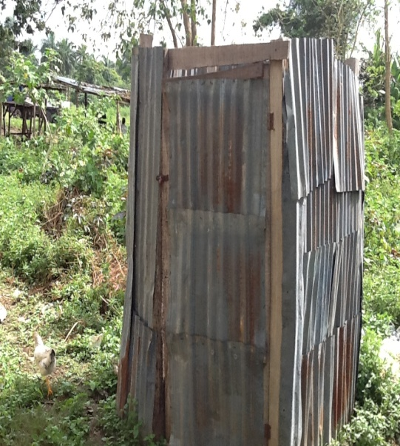
Picture 1: The improvised pit at the Ayebode PHC by pregnant women, men and children.

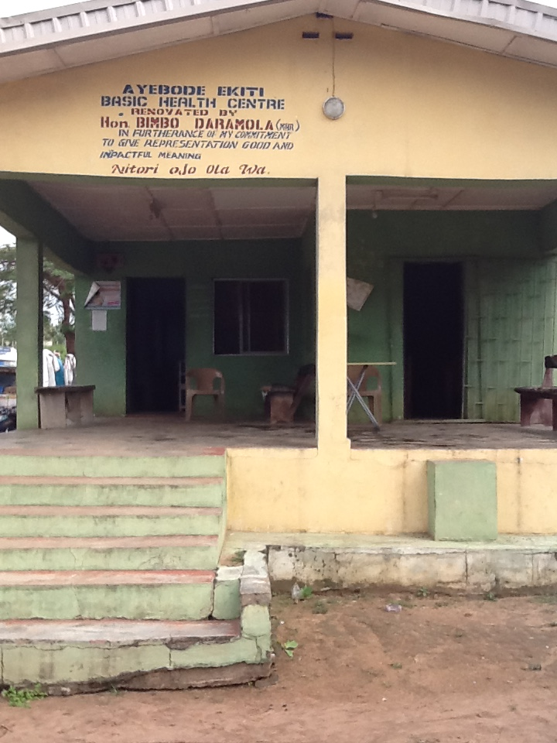
Picture 2: the Front view of the PHC
The Shallow well that provides water for the Maternity Centre as well as part of the community.
A young girl enters into the well to get unclean water.
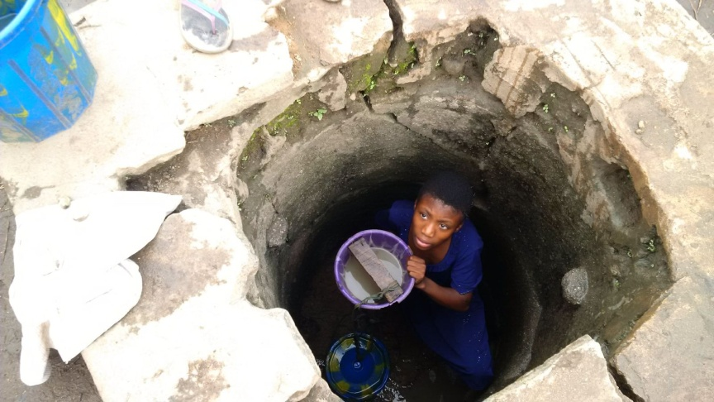
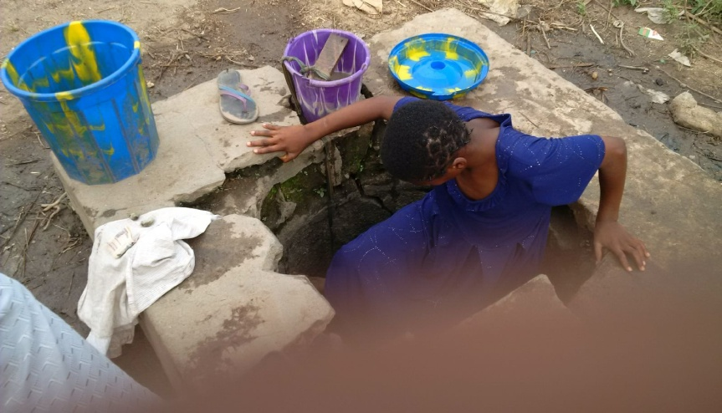
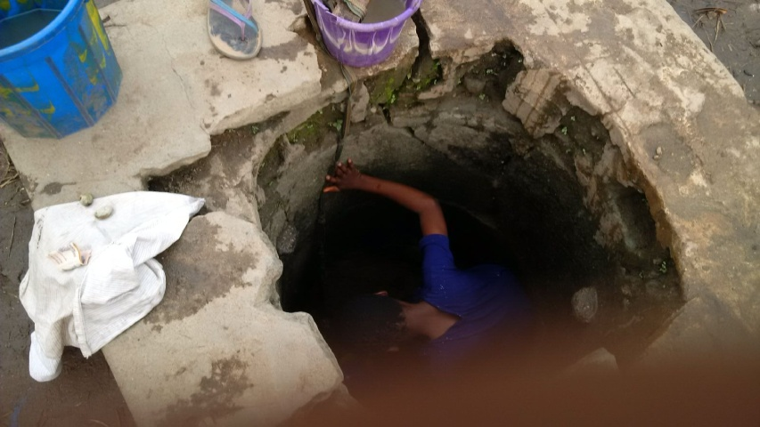

10.0 ORGANIZATIONS PROFILE
About the Joseph & Eunice Oladaiye Foundation (JEOF)
The Joseph & Eunice Oladaiye Foundation (JEOF) is a not-for–profit and non-governmental organization established in 2008 to immortalize the memory of the late Chief Joseph Ojo Oladaiye, a hardworking, humorous and consummate humanitarian who cared about the plight of the less privileged. The Foundation is passionately dedicated to the provision of support services to the less privileged and underserved people in the society especially in the areas of educational development, healthcare initiatives and empowerment for women and youths through vocational skill acquisition. Since its establishment eight years ago, over 7,000 less privileged and underserved people have been impacted through our programs.
Mission: To use cost-effective approach to deploy the resources of the Foundation towards the achievement of its goals, using the most accessible, value-adding, transparent, consistent and passion driven programs.
Vision: To build a compassionate not-for-profit organization committed to the development of Human kind.
Core Values:
- Social responsibility,
- Empowerment,
- Resourcefulness,
- Value addition,
- Integrity,
- Compassion,
- Enterprise

Board of Trustees
- High Chief Ademola Oladaiye - Chairman
- Mrs. Kafilat Araoye - Financial Secretary
- Mr. Kola Alofe - Secretary
- Mr. Babatunde Famoroti
- Chief Lanre Esan
- Mr. Oyebode Omilabu
- Mr. Lekan Ajisafe
- Chief (Mrs.) Olabisi Oladaiye

Management Staff
- Mrs. Clare Henshaw - Program Director
- Mr. Omololu Shoneye - Accountant & Administrative Manager
- Miss Chidinma Nwoko - Program Officer
- Mr. Syllabus Onajobi - Web/IT Manager

Partnership/Donations Received
- Western Union Foundation (School Library Project) $20,000 (on-going project)
- Mobil Producing Unlimited Nigeria (refurbishment of public school toilets) N1,910,000 (completed)

10.1 CONTACT DETAILS
Physical Office Address: Joseph & Eunice Oladaiye Foundation
Plot 3B, Block 95 Omorinre Johnson Street
Off Admiralty way
Lekki Phase.

Email: info@jeof.org , clare.henshaw@jeof.org
Website: www.jeof.org
Blog: https://www.thehopebyjeof.wordpress.com

Telephone 234-1-8164793838, 8093550552

