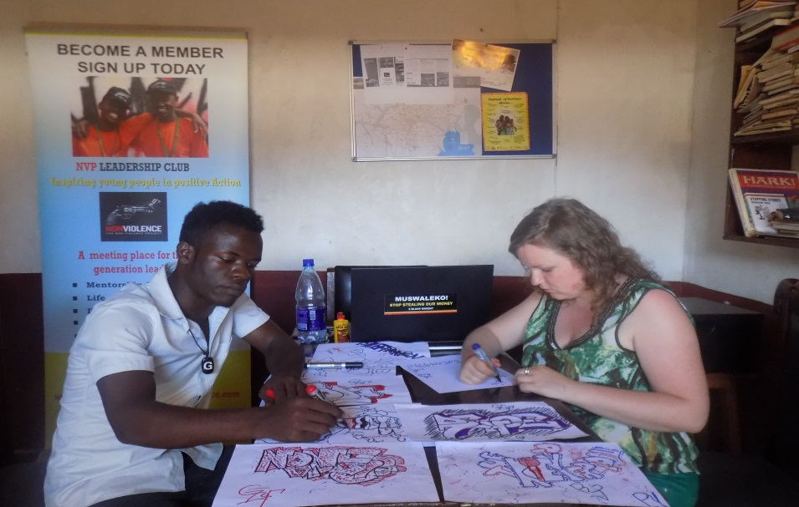
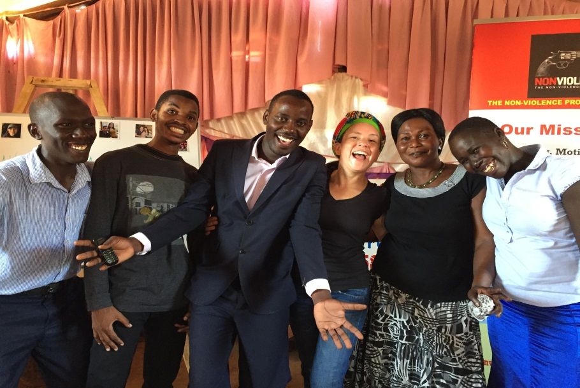
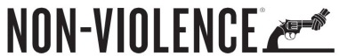
Dear friends
SKILLS EQUIPMENT FOR OUR COMMUNITY EMPOWERMENT CENTRE IN UGANDA’S SLUM

Am Eddy Balina, Team Leader at The Non-Violence Project Uganda a non-profit organization that is transforming communities through peace building, education and entrepreneurship development. We have pioneered several successful projects such schools for peace, women empowerment project and sports education reaching more than 20,000 beneficiaries directly since 2011.
In 2014 we started a community Empowerment Centre in one of the most impoverished slums in Uganda, Jinja District, Bugembe, and Budhumbuli. Bugembe has the highest prevalence of HIV/AIDS in Eastern Uganda, many children were orphaned by the scourge and many are now staying with grandparents or guardians, the level of teenage pregnancy is worryingly high coupled with early marriages and domestic violence coupled with high levels of youth unemployment.
We have so far empowered over 100 women with hands on skills training in tailoring, hair dressing, briquette making, agricultural skills and business management skills. 70% of the beneficiaries have started their own businesses and we helped them form saving and loan groups in order to boast their businesses and grow into successful entrepreneurs pioneering change and development. . Our idea is far from mere handouts but a sustainable agenda to empower emerging youth and women entrepreneurs in this community. We have collaborated with the community and partners to acquire the 7 sewing machines and 2 computers.
However the challenge now is limited equipment, we have acquired more space to conduct the training,. Am now drumming up for support from you all our friends and supporters to join in this noble fundraise and donate towards buying 5 more sewing machines. One for making sweaters, electric sewing machine, finishing machines and shoe making machine, 5 computers for computer literacy and chairs for the community Empowerment centre that will directly empower 200 youth and women annually. We need to raise $3000
Thanks for standing with us.

