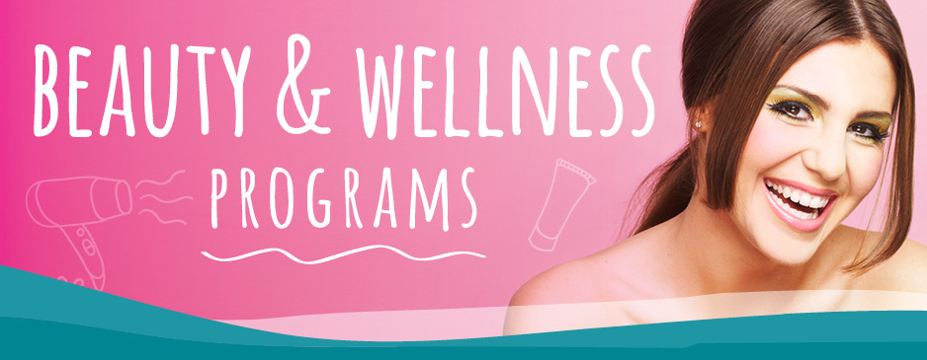
SUBMITTED TO:
GLOBALGIVE
SUBMITTED BY:
NATIONAL SOCIAL SOCIETY
ORGANISATION PROFILE:
ORGANISATION SUBMITTING THE PROPOSAL:
National Social Society
Registered Office:
D-195, Kusumpur,
Vasant Kunj,
New Delhi-110057
Phone: +91-9717544908
Email: info@indianss.org
Web Link: www.indianss.org

Legal Status:
National Social Society (NSS) is a legally registered organization by The Government of India under The Society Registration Act 1860. NSS is also registered under 80G, FCRA Government of India. An independent, non-profit and non-governmental organization, NSS is dedicated to aiding those less fortunate with the focus on vulnerable children. Its purpose includes providing valuable education to the poor and underprivileged children of India.
Introduction of National Social Society (NSS) :
We have started in Jan 2007 Name of “Lakashya ek nai Asha" now registered in National Social Society New Delhi India .our aim to every child is educated, (Motivation for Education) national social society a non - government development organization working on issues affecting the education, with a special focus on children. It is because ‘Every child has right education that the organization exists and works towards making that possible.
National Social Society is registered NGO at national level. and work activity with youth & children education lives in community & slums, village in New Delhi and Rajasthan (Jaipur & Dausa). Established on September 2008, our goal is to impart youth education & accept any challenge in Society.
Our focus is on finding poor children’s from slums areas who had to drop out of school due to any reason and making sure that they get their education to literacy .we get them admitted on the basis of 25% EWS category or as per the government rules. We have huge number of children’s admitted in school every year.
Some of the Past and Present Programmes:
1) Youth Organisation for Social Service
2) Literacy for the Dalit Children
3) Skill formation for the Youth
4) Life Skill Education for the Adolescent Girls on
5) Reproductive Health
6) Girl Child Education Promotion
7) Water and Sanitation
8) Environment Awareness Campaign
9) Awareness Generation on Social Issues
10) Empowerment of Persons with Disabilities
MISSION AND VISION:
Social Change through youth action with education is building a Society for all age youth in
community & Village.
1. To encourage the formation of various local groups
2. To support and cooperate with persons and groups already engaged in similar
activities.
3. To raise the required human and other resources to achieve the group objectives.
4. To provide opportunities to individuals living outside India who wish to participate
in NSS activities in India.
“Recognition of educated youth in activist society.” The organization dedicated to change in India by focusing on India education system
CORE VALUES:
1) Accountably and Transparency
2) Human rights
3) Responsibility
4) Confidentiality
5) Respect for others
6) Commitment and trust ship
7) Networking
8) Performance and team working
9) Peace culture and pluralism
10) Serving the people in equal approach in line with our Organizational slogans.
11) Mutual respect and partnership with the development humanitarian actors’ include human rights and media groups (Agencies).

PROJECT SUMMARY
TITLE OF THE PROJECT: Empowerment of women and the backward class through vocational training on Beauty and Wellness.
Executive Project Summary:
We are centering our this undertaking in light of the Beauty and Wellness Sector, since we need to produce occupation in this division for the Women's and individuals from the regressive class such as the SC,ST and so forth. In spite of the fact that this segment is generally ladies commanded yet they are for the most part from the urban communities, along these lines we need ladies' from the provincial territory to effectively take an interest in this section and get their appreciation, and improve their life increasingly and progressed.

The wellbeing business in India is ready to touch Rs. 1,00,000 crore (Rs 1 trillion) by 2015, with an intensified yearly development rate of 15-17%, from about Rs 70,000 crore in 2012 , with a conceivable lack of ~600,000 talented faculty by 2016. FICCI-PwC report had gauge that the quantity of individuals utilized in the Wellness space could possibly practically treble from more than 1 million lakh in 2011 to 3 million by 2015

The real difficulties confronted by the Indian Wellness space on the aptitude advancement front are as far as the deficient accessibility of preparing base, institutionalized preparing educational programs (particularly at the passage level), the nonattendance of value coaches in adequate numbers, less demanding money related access to result connected abilities preparing activities, as additionally a general lost thought about the advantages of professional preparing. Matters have not been aided by the way that the Wellness area in India is still generally disorderly and divided, with an exceptionally set number of organizations in the sorted out space having a container India vicinity. The ability shortfall postures amazing danger to the development and extension of the entire excellence and wellbeing industry.

The area needs to meet up on one stage at the national level so that a strong string between the individuals who require a vocation, the individuals who will set them up for it and the individuals who will utilize them are in a state of harmony. There are sufficient examples of overcoming adversity in the nation to share and enough space to grow.

Our objective recipients, will be for the most part the ladies' and the Backward classes since they don't get much chance to shoe their ability. We will be putting forth them professional transient courses going from a couple of months to some s long as 01 year. These courses will incorporate both hypothetical and in addition pragmatic learning, for them, with the goal that they can get their aptitudes appropriately set in the functional application. Endless supply of this venture, they will be effectively ready to place themselves in different excellence parlors', or as part more business perspective, they can open their own particular parlors' and therefore it will be a decent wellspring of salary for them furthermore they will get their required recognisation and admiration in life and also society. With this they can suitably stay joyfully and improve their life more.
TARGET BENEFICIARIES: We are focusing our project on the Women's, Girls, SC, ST, BPL category persons, who do not have much exposure to the outside world of opportunities.
AGE: Our targeted age group will be from 15 - 30
SECTORS AND SKILLS TARGETED: Our target sector will be Beauty and Wellness Sector and the skills that we are targeting will include Hair Cutting and Designing, Make up, Beauty Therapy, Spa, Body Massaging.
DURATION OF THE PROJECT: The duration of the project will be of 01 year.
PROJECT LOCATION: The location of the project will be Dausa or Jaipur in the state of Rajasthan.
TOTAL COST OF THE WHOLE PROJECT: The whole project will cost around INR 15 lakh's.
TOTAL GRANT REQUESTED: The total grant requested will be around INR 15 lakh's.
NUMBER OF EXPECTED BENEFICARIES: As many as possible from the targeted backgrounds.
DURATION OF TRAINING: The duration of training will be around from 6 months to 1 year, depending on the nature of training they are undergoing.

PROJECT PROPOSAL FORM
What is the rationale for the project?
It is well known to all of us, that in India, the women's and the backward classes are the most neglected. They are always devoid of any facilities as well as any empowerment. So, we are focusing on the empowerment of women's as well as the backward classes so that they get their deserved respect and stature in the society and can prove that they are also not less than anyone.
Now when it comes to choosing the state of Rajasthan for our project, is due to the fact that in Rajasthan, the area being a desert area, there the women's and the backward classes are the most neglected and most un-aware of the outer world. So, we are focusing on this domain for the most benefit of these persons as a whole and in a broad view for the benefit of the society. Moreover the another cause for the selecting the location as Rajasthan because, in this field our company has been working previously also, so the sector condition, its topography and other features, are well known to us and hence we want to work in this sector.
What is the project aim and objectives?
The Empowerment of Women is particularly socially and monetarily weaker segment by guaranteeing their entrance to, and control over, assets through a maintained procedure of assembly and merging of all the on-going techno-administrative at work preparing programs.
➢ To enhance the monetary state of the ladies and the regressive class.
➢ To give best different option for the ladies and its united for their supportable life
➢ To decrease the drudgery of ladies and the retrogressive class in the group.
➢ To expand wage without negative consequences for neighborhood society.
➢ To enhance the status of ladies and the retrogressive class in the task territories.
➢ To enhance the job state of the ladies and the regressive class.
➢ To enhance the social state of the destitute individuals.
➢ To advance social equity by upholding for the privileges of ladies and youngsters and Creating more prominent open doors for them to appreciate better quality.
➢ To expand ladies' ability to acquire ideal instruction, wellbeing and nourishment for themselves and their youngsters particularly for young ladies.

➢ To instill enthusiasm for mainstream and good instruction undertaking measures for the social and financial improvement of the people regardless of standing, id
Who are your target beneficiaries?
Ladies strengthening in India is a testing errand as we have to recognize the way that numerous social abhorrence is a profound established rehearsed in India in numerous structures since a huge number of years. The vindictiveness is not going to leave in a couple of years or so far as that is concerned by endeavoring to work at it through irresolute endeavors. Figuring laws, enactments and strategies are insufficient as it is seen that a large portion of the times these laws and arrangements simply stay on paper and now and then when it works the exploited ladies remain quiet for the purpose of honor and regard of crew. Indian ladies made for penance; this is originating from the earliest starting point of human conception. In one hand we adore Goddess Laxmi, and in other hand we do female feticide, in one hand we are cheering for Saina Nahwal and other hand we are ceasing our own little girl to go outside, In one hand we acknowledged the decision of Prime pastor Indira Gandhi and as an afterthought we are not acknowledge a solitary choice made by our own ladies.

What an incidentally! The ground circumstance then again just continues as before and in numerous cases compounds further.
Thus it is very clear from the above that, why our target audience is woman, because they are the most deprived and thus we will focus mainly on the empowerment of them as well as the backward class, so that they get their place in the society.
How do you plan to implement the project?
To implement the project, we will implement a Project Director, 2 X Field Level Executives, and 1 X Project Co-Ordinator. These field level executives will entertain the work of the ground level and will regular update the Project Co-Ordinator about the day-day work of the Field Representative and the Project Director will give monthly report to the company about its progress.
Now, coming to the plan and process of the vocational training:
1) We will have short term courses(6-8 months) on Hair Designing, Make-Up etc
2) We will provide long term training(10 -12 months) on Spa, Body Massage, Bridal Make-Up etc.
Thus these kind of courses with practical support will help the woman's and the people from the backward class, to not only brush up their knowledge of theory but also give them a practical exposure of the real time environment and working.
Our Objectives:
1) Conducting Industry and business sector studies to decide the aptitude crevice in key fragments in the Beauty and Wellness industry on an on-going premise
2) Development of Occupations/Skills Catalog and Occupational Standards
3) Creating mindfulness about the Beauty and Wellness industry
4) Involving all partners – bosses, learners, the scholarly world and professional bodies – in the expertise advancement exercise
5) Accredit/Affiliate preparing suppliers and Certification of learners/workforce
6) Facilitate/Conduct Training of Trainers and Training of Assessors
7) Establish/encourage in-house Training Centers and Centers of Excellence
8) Set up a powerful Labor Market Information System (LMIS), and
9) Benchmark Indian excellence and wellbeing training with worldwide guidelines.
Please give brief information on the skills sector and the training courses that form part of your project.
According to the late E and Y-FICCI wellbeing report 2013 the present business sector size of Beauty/Wellness class is Rs. 15000 corers and will develop at the rate of more than 35-40% consistently. The excellence business today envelops much more than beautifiers and healthy skin items, however they are still a noteworthy part of the segment. The business will require 6, 00.000 excellence experts over next couple of years. With developing mindfulness that rises above the peripherals of huge urban areas and residential areas, the magnificence and wellbeing industry discovers its execution till the eradication of humankind
Now, coming to the plan and process of the vocational training:
1) We will have short term courses(6-8 months) on Hair Designing, Make-Up etc
2) We will provide long term training(10 -12 months) on Spa, Body Massage, Bridal Make-Up etc.
Besides this we will provide regular mock practice, so that the skills incurred by them are wary and remain apt in their mind.
What is the expected outcome of the project?
The outcome or result of the project will be blast according to our expectation.
Qualitative Outcome:
The Qualitative Outcome of the project will be very good, as we will be able to produce some of the best talents in the Beauty and Wellness Sector, so that they become the best in-class talent for the industry. Our vocational training will be so very designed, that they will provide you a real high time experience so that you get a professional feeling and in-hand experience.
Quantative Outcome:
The Quantative outcome will also be huge as we will target each and every family to be a part of this great endeavor. Moreover, if we get full support, then we will be able to generate hundred's thousand of perspective employees in span of 1 year and will be able to settle up their life.
What is the cost per beneficiary for the project? How do you justify the efficiency of the cost?
The cost per beneficiary will be around INR 1500 - 1800 per beneficiary.
Though one can say that the money spent behind them is quite a huge amount, but the outcome of this amount for the society is quite larger than the present. So in the long term the society will be benefitted in all aspect and hence we will be able to recover much more times than this cost. Thus keeping this fact in mind, the spending of the money is justifiable.
Does your project have any innovation?
The project have not as such any innovation but the project is unique in its kind, because in India no other such project has been taken, in which we will find where vocational training is being given to ladies or women or backward class, so that they do empower themselves and earn respect.
Thus this thing should be taken into consideration as well.
Do you perceive any challenges in implementing this project?
The project is in itself a challenge, where the challenge is in itself is to bring out the woman's from their traditional work culture and thinking. They are not as modern as cities, hence they have never seen the fact of woman working in the field. So, first challenge will be to break this myth and continue with the work of bringing woman and the backward classes out of their houses.
The grant received from NSS will be our ultimate source of money, to spend in this project. As we all know, our project area will be villages of Dausa and Jaipur, hence there the most challenge is to bring woman out of their house. Thus if we do charge them for these vocational training then we will never be successful in our motive as they do not have that amount of money to spend and secondly they will not spend any money for this. Well we can compensate the amount of fund gap, if any from the training provided in the cities, where we will charge but as many minimum as possible just to get the requisite fund for this pilot project. But the project will be targeted to be free of cost.
What are your plans for sustainability of the project?
The sustainability plan for the project to continue, if the grants received from NSS will be insufficient for the project are,
We will go for paid training of persons from the metros, where the people are much aware of these facts and hence will be able to get good amount of possible customers. The amount collected from them, if no subsidy is provided to them will be used fully for the programme and the efficient management of the project.
What according to you is the scope of scaling up and replicability of your proposed project?
Though the project has not that much scope of upgradation, but the possible upgradations will be opening centers in name of our country in these cities to provide these youths and workers a placement after training to showcase their talent and earn a good lively hood. In major scale, the upgradation will be opening of professional company like VLCC to provide best in class services.
What according to you should be the reasons for approving the grant for this project?
The various reasons for approving the grants are:
1) The project thought is unique and first of its kind.
2) The benefitted groups are the most under-privileged and un-ware of these services for their empowerment to have a good lively hood.
3) This project will change the scenario of these places for ever and dedicate them with a good lively hood.
4) They will become educated and get respect in family as well as society.

PROJECT FINANCIALS

S. No | Budget Head | Description | Unit cost | Quantity | Costs in INR |  | (in INR)
 |  |  |  |  | Project cost requested | TOTAL AMOUNT IN INR
a. | CAPITAL COSTS
1 | BASELINE SURVEY | TO SELECT THE ACTUAL PLACE | INR 10000 | 1 | 10000 | 10000
2 | CLASS ROOM | FOR CONDUCTING CLASSES | INR 10000 | 2 X 12 | 240000 | 240000
3 | EQUIPMENTS | FOR REAL HAND EXP. | INR 50000 | 2 | 100000 | 100000
4 | TRAINING | TO GET THEM LEARN | INR 10000 | 1 X 12 | 120000 | 120000
5 | MARKETING | BUYING OF THE REQUIRED THINGS | INR 10000 | 1 X 12 | 120000 | 120000
6 | EXPERIENCED STAFF VISIT | TO GET THE EXPERIENCE | INR 10000 | 1 X 12 | 120000 | 120000
b. | OPERATION COSTS
1 | FULL TIME TEACHERS | TO DO THE TRAINING | INR 10000 | 2 X 12 | 240000 | 240000
2 | BOOKS AND COPIES TO THE STUDENTS | TO WRITE AND READ | INR 1000 | 100 | 100000 | 100000
3 | COUNSELLORS | FOR OVERLL DEVELOPMENT | INR 3000 | 4 | 12000 | 12000
c. | ADMINISTRATIVE COSTS
1 | PROJECT DIRECTOR | TO ADMINISTER | INR 20000 | 12 x 1 | 240000 | 240000
2 | MONITORING OFFICER | TO MONITOR FIELD WORK | INR 10000 | 12 x 2 | 240000 | 240000
3 | POSTAGE AND TELEPHONE | TO DO DAY TO DAY WORK | INR 5000 | 1 | 5000 | 5000
GRAND TOTAL |  |  |  |  | INR 15,47,000. | INR 15,47,000. | INR 15,47,00.
GRANTT CHART
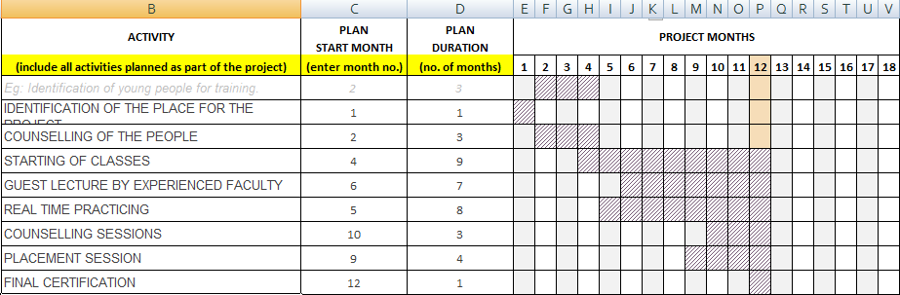

PROJECT LOG FRAME
