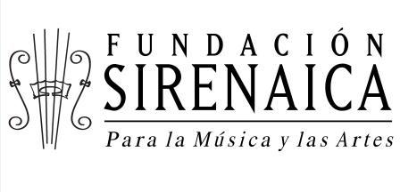

Train the trainers to become Choir Directors

Sirenaica´s Foundation is a nonprofit organization created as a City Program in 2001; its mission has been to transform lives through choirs. We are convinced that by providing opportunities, looking in the eyes with love and respect great things can be accomplished. Through these values of love, gratitude, strength ,joy and respect, we can form even the most vulnerable child, transforming them as well as their environment, this is why train the trainers is a project with multiplying effects.
The idea is to create a Directors School, were the chorister’s have the opportunity to grow within the foundation, in order to empower them providing all the tools to complete their professional training it be as singers, directors as well as professors.
In 2015 we ended up with 1200 students in 71 choir groups throughout the most vulnerable vicinities in the city of Medellin with a total of 5 choir levels, having auditioned more than 150.000 children.
The total value for this project rises up to 14000 USD, but we have sought for other donations and we are now needing the amount of 5000.
I you wish to have more information about the project, please feel free to write to us.
Email: eliescobar1@hotmail.com

Regards,
Elisa.
GlobalGiving Project Leader

