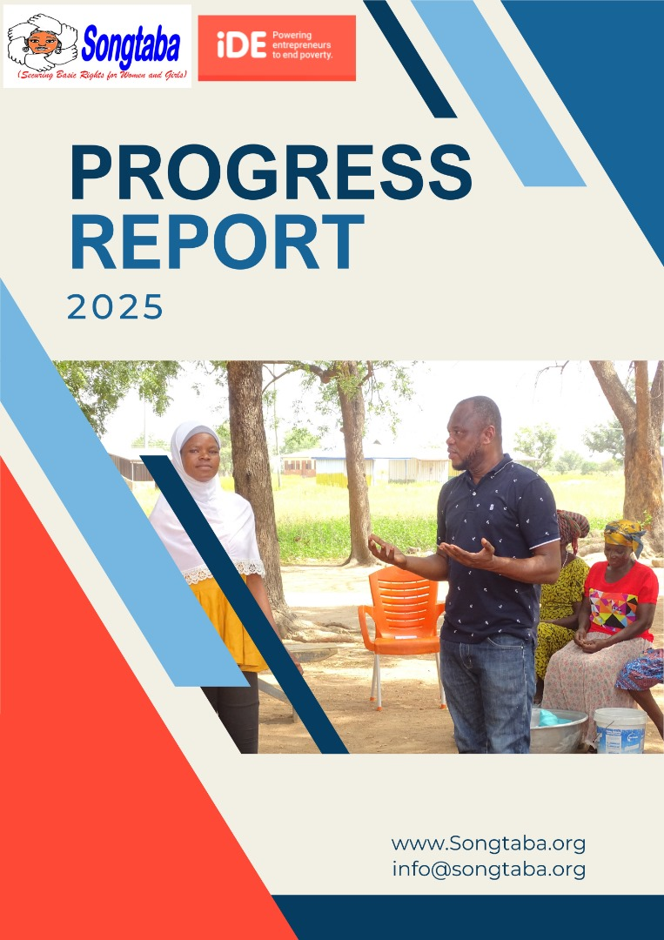

Year 2
SAMADU-SONGTABA

Executive summary
The Her Time to Grow (HTTG) project, led by iDE Ghana in partnership with SONGTABA, made strong strides in its second year toward economic empowerment of women in agriculture. Building on Year 1’s groundwork which focused on empowerment trainings and basic leadership training, Year 2 focused on scaling up to new communities and deepening the capacity of VSLA groups.
A major highlight was a two-day Training of Trainers (ToT) for 103 Farmer Business Coordinators and Farmer Business Advisors across the zones of influence. The training equipped them with practical tools in REFLECT methodology, leadership, group dynamics, and financial management. Using participatory methods like group work and role-play, the training helped facilitators support inclusive, well-governed farmer groups and promote women’s leadership.
Additionally, a gender barrier assessment was conducted across all four regions, identifying cultural, institutional, and social barriers limiting women’s participation in agricultural leadership and economic decision-making. The insights gathered informed the training content, ensuring its relevance to the realities of women farmers.
This year’s progress has laid a strong foundation for scaling impact through step-down trainings, bringing the project closer to its goal of transforming agriculture into a more inclusive and sustainable space for women.
A significant highlight of the ToT was its participatory design, incorporating practical demonstrations, group discussions, real-life drama, and role-play exercises, ensuring participants could apply key concepts in real-world settings. The training emphasized building inclusive and cohesive farmer groups, fostering women’s leadership, and ensuring sound financial practices.
REPORT
The Her Time to Grow project (HTTG), in its second year, continues to champion the economic empowerment of women across the agricultural value chain in Northern, Savannah, and Upper East and Upper West regions of Ghana.
To support this objective, a two-day Training of Trainers (ToT) was organized for 103 FBCs and FBAs. These frontline facilitators are instrumental in sharing knowledge with smallholder farmers. The training focused on four thematic areas: REFLECT methodology, group dynamics, leadership, and financial management/bookkeeping. Participatory Rural Appraisal (PRA) tools and interactive learning methods were employed to foster practical understanding.

3. Participant Profile
Region | Total Participants | Men | women
Northern | 36 | 25 | 11
Savannah | 13 | 9 | 4
Upper East | 28 | 21 | 7
Upper West | 26 | 19 | 29
Total | 103 | 74 | 29

1 REFLECT Methodology
The first session focused on introducing participants to the REFLECT approach (Regenerated Freirean Literacy through Empowering Community Techniques) a participatory learning methodology rooted in the educational theories of Paulo Freire. REFLECT integrates adult literacy with participatory rural development, encouraging communities to explore their social and economic realities through dialogue, analysis, and collective problem-solving.
Facilitators began by unpacking the foundational philosophy of REFLECT, which positions literacy not merely as the ability to read and write, but as a tool for critical thinking, self-empowerment, and transformation. The training emphasized that the REFLECT approach goes beyond delivering information it builds confidence, fosters leadership, and nurtures ownership of development processes, especially among marginalized groups such as women, youth, and persons with disabilities.
Participatory tools and techniques
Participants were introduced to a variety of Participatory Rural Appraisal (PRA) tools, which form the backbone of REFLECT facilitation. These tools enable communities to visualize, analyze, and communicate their lived experiences in a structured, inclusive way:
- Social maps: Used to identify power dynamics, resource distribution, and inclusion/exclusion within the community.
- Daily activity calendars: Help analyze gender roles by mapping out the time men and women spend on various daily tasks.
- Transect walks: Allow participants to assess environmental and infrastructural conditions by walking through their community.
- Matrices (e.g., access/control matrix): Help compare who in the community has access to and control over resources such as land, income, education, or agricultural inputs.
Through small group work and plenary discussions, participants engaged in hands-on exercises simulating real-world facilitation scenarios. For instance, they constructed a gender access/control matrix that revealed disparities in resource ownership, prompting debate on power, equity, and the roles of men and women in agriculture.
Participants reported that the visual, dialogical nature of REFLECT helped demystify complex social issues and made learning more inclusive and engaging. The ability to draw and discuss rather than rely solely on text-based methods was particularly appreciated, given the varied literacy levels in rural communities.
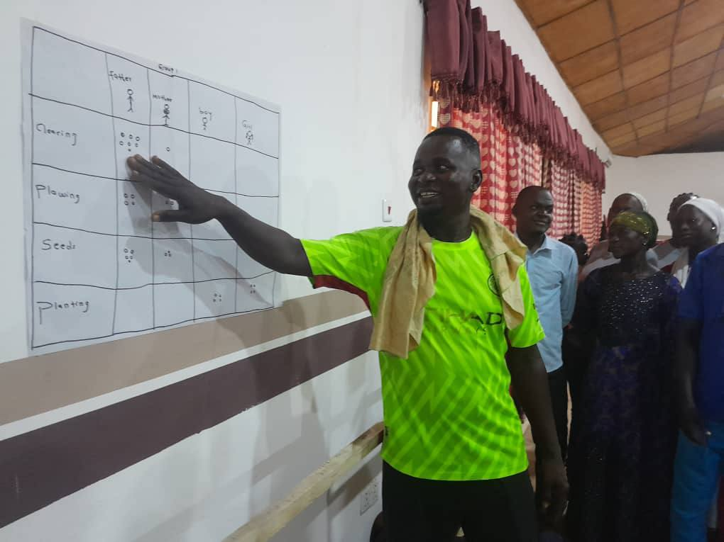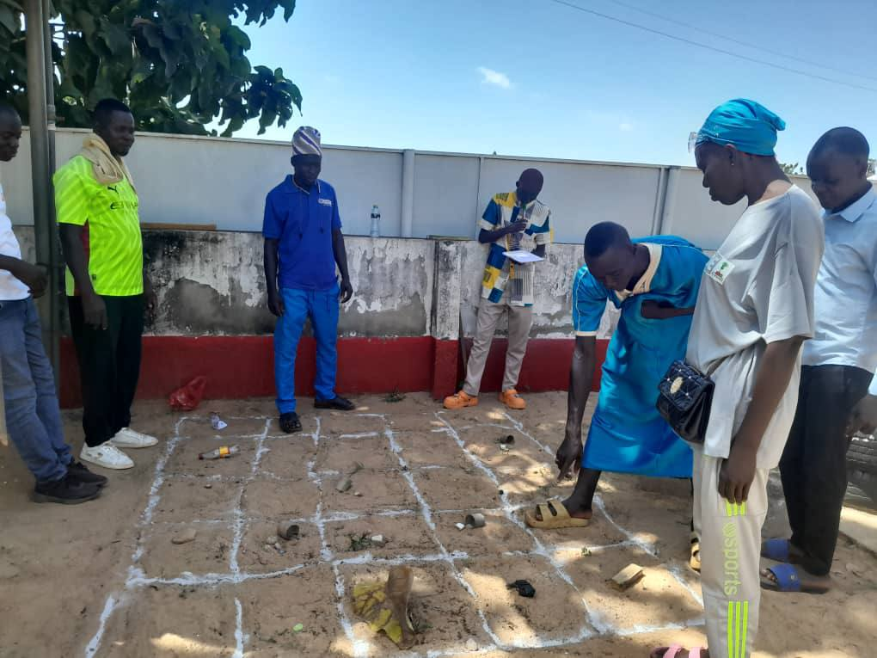
Participant Insight:
"This will significantly help our community development. When people understand their own realities and talk about them, they find better solutions together."

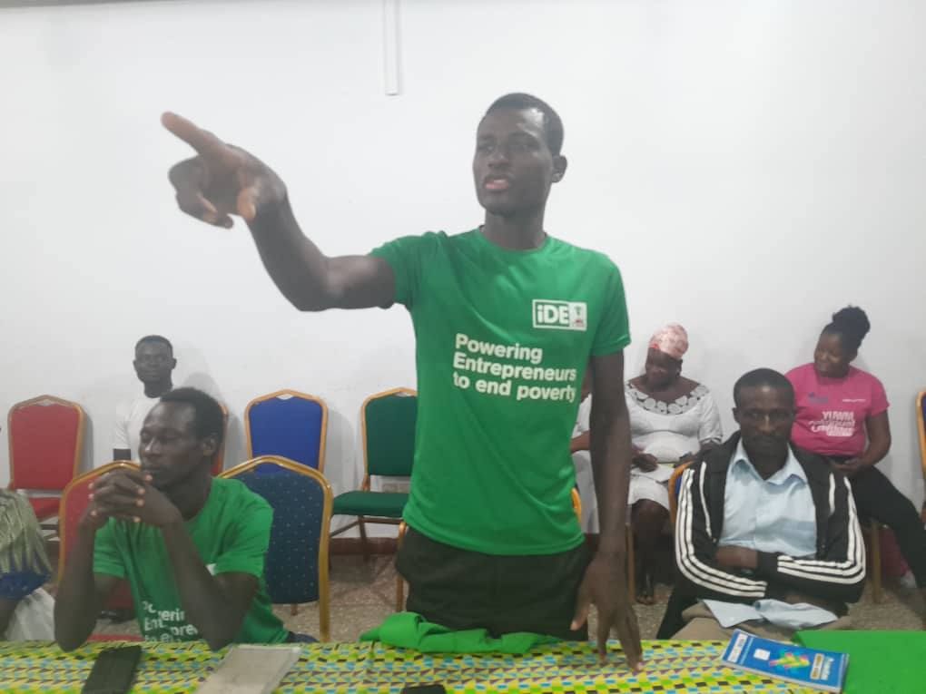

Group Dynamics and Conflict Management
Participants learned about group development stages forming, storming, norming, performing, and adjourning and how to manage conflicts effectively. Through role-playing, they practiced resolving conflicts within farmer groups, ensuring that they could navigate challenges to maintain group cohesion.

Leadership Training
The leadership component focused on empowering women to take on leadership roles in agricultural projects. Participants explored various leadership styles, democratic, transformational, and autocratic and discussed how to adapt these approaches to suit the needs of women smallholder farmers. Special emphasis was placed on empowering women leaders, recognizing the unique challenges they face in agricultural settings.
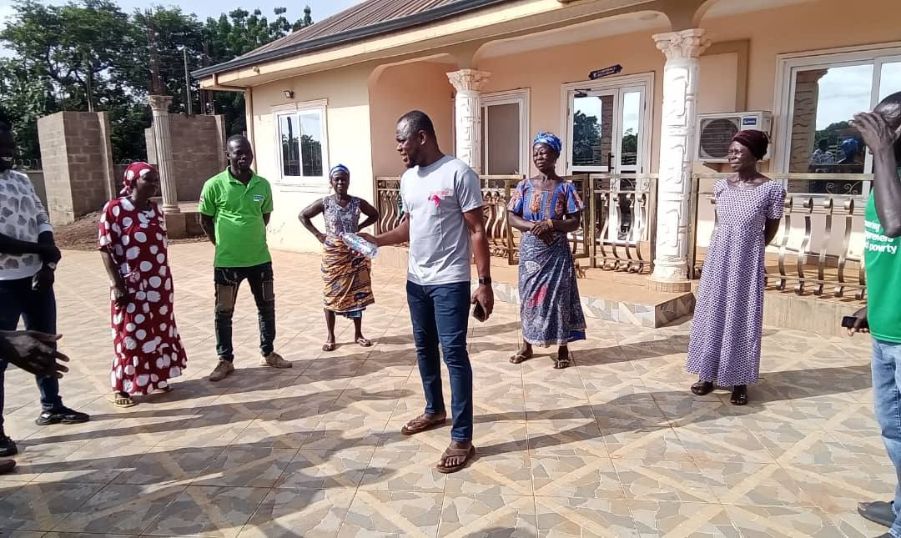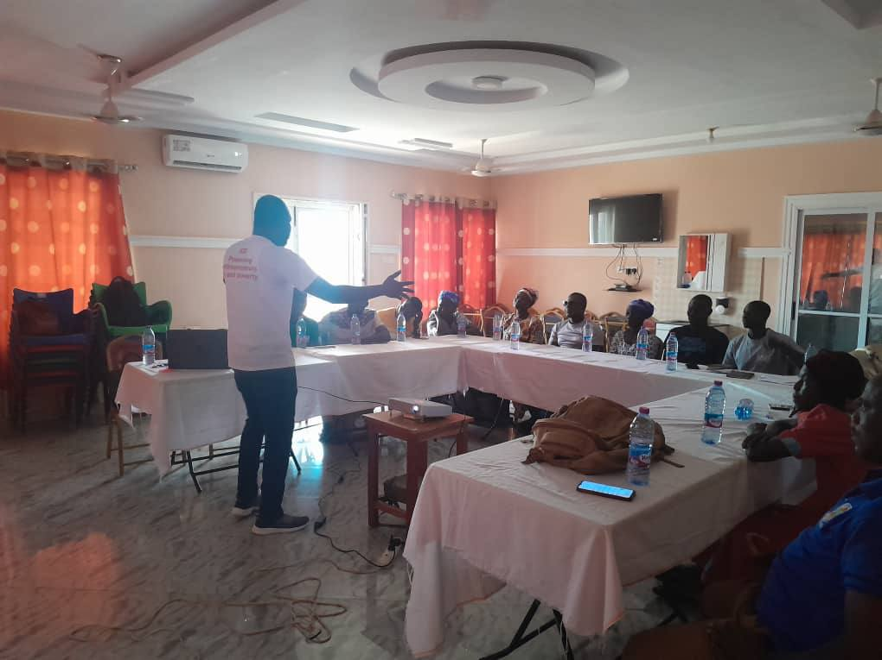
Financial Management & Bookkeeping
The training also provided financial management and bookkeeping skills, which are crucial for ensuring the sustainability and success of smallholder farming. Topics covered included budgeting, saving, and transparent financial practices. Participants engaged in practical exercises such as preparing budgets for farming seasons and maintaining accurate records using a cashbook.
A real-life drama exercise demonstrated the negative consequences of poor financial management, reinforcing the importance of sound financial practices.
Gender Barrier Assessment
A key element of Year 2 was the gender barrier assessment, which identified cultural, institutional, and social challenges limiting women’s participation in agricultural leadership and economic decision-making. The findings from this assessment informed the content of the training, ensuring that it was tailored to the realities women face in the target regions.

The most valuable takeaways from the trainings?
- “The budgeting techniques and how to plan for both short-term and long-term financial growth were very helpful. I now feel more confident in guiding farmers on how to allocate their resources effectively.”
- “I learned how to maintain proper records of income and expenses, which is a skill I can immediately apply in my role. The hands-on cashbook activity was particularly useful in making the concept clear.”
- “The session on transparency in financial dealings was eye-opening. I now understand how important it is for farmer groups to be transparent to build trust and maintain accountability.”
- “I gained a better understanding of different leadership styles, especially how to adapt them depending on the dynamics of the group. I feel more equipped to support women leaders in our farming communities.”
- “The emphasis on empowering women leaders was incredibly valuable. I now have strategies to help women develop the confidence to take on leadership roles.”
- “The role-play exercise was one of the best parts of the training. It helped me better understand the real-world challenges that women face when leading, especially societal pressures and resistance from their peers.”
Conclusion:
The two-day TOT training was a resounding success, equipping FBCs and FBAs with the necessary skills to empower women smallholder farmers through the REFLECT methodology, leadership development, and effective financial management. The incorporation of real-life drama into the training allowed participants to connect theory to practice, providing a deeper understanding of the challenges faced by smallholder farmers.
By the end of the workshop, all participants had demonstrated improved skills in group facilitation, leadership, and financial management, which they can now transfer to the women farmers they work with. It was evident that this training would lead to stronger, more cohesive farmer groups, empowered female leaders, and better-managed financial resources, ultimately contributing to the long-term success of smallholder farming communities.

