Plot 7 Francis Egunyu Road, Madhvan ward, Pece Division Gulu Municipality, P.O Box 692 Gulu

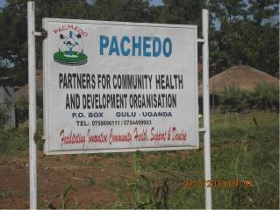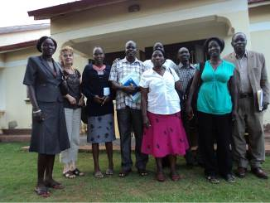
PACHEDO Board of Directors pose for a Group Photo after the Annual General Meeting

PACHEDO PROFILE
Contact Person
- Omali Simon Peter- Executive Director
Telephone- 0783 860 531
E-mail: simonomali@pachedo.org

Registered With:
NGO board as a National Non Government Organization with Registration No. 9230
Regional Area of Work: Greater North and North Eastern Regions of Uganda

Districts of Active Programmes Implementation:
Northern region
- Acholi Sub Region: Gulu, Amuru, Nwoya
- Lango Sub Region: Lira, Kole, Oyam and Alebtong
- Karamoja Sub region: Moroto, Napak and Amudat
- Teso Sub region: Soroti, Amuria and Katakwi

Funding Partners (Donors)

- Private Sector Foundation/European Development Fund
(ALREP) - Enhance processing capacity, quality and Business
Performance
- VSO/UKAID - Psychosocial Support and Life Skills project
- HORIZONT3000 - WASH and Food Security Project
- Jolien & the Netherlands Friends of Children - Young Mothers & Youth empowerment Programme
- Mail Box International USA - Child & Youth Ministry & Support project
- DKA- Vienna Austria - School based WASH promotion
- AID Africa -De-worming and Fungal Infection Partnership Project

Major Areas of Focus (Thematic Areas)

- HIV & AIDS Prevention, Care and Support and Adolescent Reproductive Health.
- Mental Health care and Psychosocial support
- Water, Sanitation and Hygiene
- Promotion and protection of the rights of vulnerable children, women, Older Persons, unemployed youth and Persons With Disabilities (PWDs)
- Peace building, conflict prevention and management.
- Food Security and Sustainable livelihoods

Who we are?
PACHEDO is a Local Non-Governmental Organization (NGO), registered by National NGO Board with Registration No.S.5914/9716. The organization operates in the 10 districts of Northern and North eastern Uganda. In the North, PACHEDO operates in the 3 districts of Acholi sub-region namely; Gulu, Amuru and Nwoya. In the Lango sub-region, we operate in Lira, Kole, Oyam and Alebtong districts, Karamoja Sub region: Moroto, Napak and Amudat districts with its main offices in Gulu and field coordination offices based in Lira, Soroti and Moroto towns.
PACHEDO was founded in 2007 by aboard of Community Development Workers and Health Workers and Academicians with a broad range of international and local expertise and experience in the NGO sector as well as in Academia. The organisation was established with aim at supporting communities live a dignified, healthy, and productive life, socio-economically empowered to innovatively meet and demand for their basic needs and rights, which is the ultimate goal of the organization.

What we do: Since its inception, PACHEDO has been committed in providing Community Development services particularly in the areas of;
      - Promotion and protection of the rights of vulnerable children, women, Older Persons, unemployed youth and Persons with Disabilities (PWDs) including
      - Promotion of Food security and sustainable livelihoods in conflict, post conflict and disaster affected communities of Greater North including North eastern Uganda. With the key interventions targeting technical training on improved Agronomical practices, marketing and market linkage, farming as a business/value addition and Commodity approach, VSLA model among others.

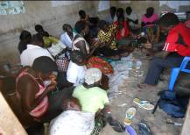
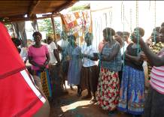

Young Mothers (Formally Abducted & Survivors of Violence undergoing Beads Making Apprenticeship Training supported by Jolien & Friends of Children- Netherlands

      - Peace building, conflict prevention and management

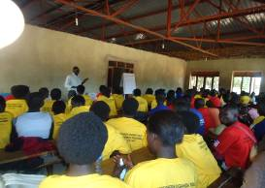
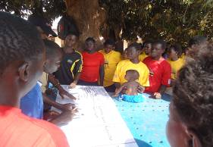

PACHEDO Staff facilitates Conflict Mediation & Problem Solving Skills for Youth identified with psychosocial problems, Project supported by VSO/DFID

The community health services include; Mental Health care and psychosocial support, Water, Sanitation and Hygiene, HIV & AIDS Prevention, Care and Support and Adolescent Reproductive Health.
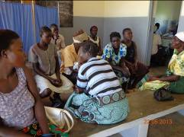
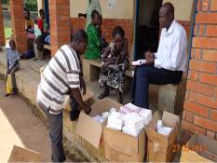

PACHEDO Psychiatric Clinical Officer conducting a Community MH Outreach Clinic in Bungatira Sub County - Gulu District

Our target populations specifically include: vulnerable children, women, Unemployed Youth and men exposed to violence and exclusion; the mentally ill, Persons living with HIV & AIDS, Adolescents with reproductive health challenges, unemployed youth, the older persons and persons with disability.

Management Structure: PACHEDO is managed and Governed by a well structured system, governed by supreme body of the Board of Directors constituted by seven (7) Members from relevant Organizations, Academic Institutions, Faith based institutions within Uganda. The Board of Directors (BoD) supports the organization in Policy formulation, effectively representation of the organization in resource mobilization and in approving the appointment of the Executive Director. Below the BoD is the Senior Management Team, whose key responsibility is resource mobilization for the relevant growth and Development of the Organization. PACHEDO has five (5) Senior Programme Managers, all based at the Main office in Gulu. Three (2) Programme Coordinators are based in field Coordination Offices in Bala, Kole District, and Gulu. Each field office has a total of 6 field staff and 1 support staff.
MISSION: “To contribute to community health, social protection, and livelihood security through empowering communities, civil societies, and government support systems in impoverished, conflict, and disaster affected areas”.
Mode of Services Delivery: PACHEDO is a community based direct implementer of interventions and services. The organisations has adopted the participatory interactive community managed approaches in the delivery of its services; promoting inclusive community preventive and curative interventions in managing their own development and reconstruction processes. Through these approaches, PACHEDO facilitates community health diagnosis, Participatory Disaster Risk Assessment (PDRA) as used in Community Managed Disaster Risk Reduction (CMDRR), Community Led Total Sanitation (CLTS) approach and in community support systems strengthening model. Thus, local communities engage in their self reflection, enabling them to assess and understand their own situations, generate action plans and fully participate in action plans implementation.
Other key strategies include technical capacity building in psychosocial support, life skills for the young people, child protection and, community mental health, prevention of gender based violence, HIV/AID infection prevention and social support and care for orphans and vulnerable children. We work in tandem with UN agencies, Government, international and local NGOs and other civil society agencies and educational institutions and the general community. The community approach enhances our delivery systems by building sufficient community based safety nets and support systems skills base, especially for youth support programmes and, in especially working with existing formal and non-formal institutional agencies and traditional support structures.

