
  water project PLAN

pre-construction phase
☐ | Site-visit and initial meeting with the potential beneficiaries.
☐ | Determine if the project is needed and feasible in the neighborhood. Search for any existing water infrastructure nearby. Inquire for any future plans to put up water infrastructure in the area (e.g. SAS, BESIK)
☐ | Gathering of base line data for water consumption rate per household and prospective use of water.
☐ | Organize community. Meet the members, introduce JSS mission, present project overview
☐ | Plan the construction phase. Contact contractors and SAS and put contract in place.
☐ | Conduct topographic survey of all the identified sites of water outlet in order to determine the suitable location of the bore and the height of the main tank and the most suitable power supply.
☐ | Design the complete water installation system and the service layout.
☐ | Sign written agreement with community and perform the traditional rituals requested by the community.

CONSTRUCTION PHASE
☐ | Construct temporary perimeter fence in the target site of the water pump.
☐ | Coordinate the execution of the boring hole underground with the service provider and the community.
☐ | Install the pump and the power supply module in order to generate the water. Construct protective chamber for the pump.
☐ | When water source is accessed, run the pump 24 hours or as prescribed by the operations and maintenance manual in order break-in the pump.
☐ | Construct the water tank, install the automatic switch, and secure the power control box inside an enclosed chamber or facility. Steel structure is preferred for future mobility.
☐ | Run a laboratory test of water samples in order to determine if it is potable and safe for household use.

POST-CONSTRUCTION PHASE
☐ | Install water pipes and assign water accessible outlets around the community.
☐ | Train beneficiaries to take various responsibilities in order to plan for the maintenance.
☐ | Organize the official handing-over of the finished project to the community with all the stakeholders present. Some traditional ethnic rites may be held in this hand-over ceremony.
☐ | Prepare a narrative report of the whole engagement.

maintenance plan
☐ | Measure once every month the volume and pressure on every water outlet, update consumption rate of the people and match with the optimal production of the pump. Any discrepancy may warrant for intervention by the entire community.
☐ | Keep a record of irregular functioning or interruptions in water supplies as they arise. The record includes, date, time, observation, interventions made, results. JSS to monitor this record-keeping in order to foster consistency and regularity.
☐ | Hire local service provider for the regular 3-month tune-up of the pumping system. Refer to the Operations and Maintenance Manual of the electric pump.
☐ | Document the notable changes in the lifestyle and health conditions of the beneficiaries in order to determine the short-term and long-term impact of the project.
☐ | Conduct an annual water safety lab tests every three months or more frequently in cases of prevailing water-born deceases in the community.
☐ | Invoke any agreed accountabilities in addressing the repair of any damages or maintenance issues.

PROTOTYPE OF WATER SYSTEM USING SOLAR-PANELS

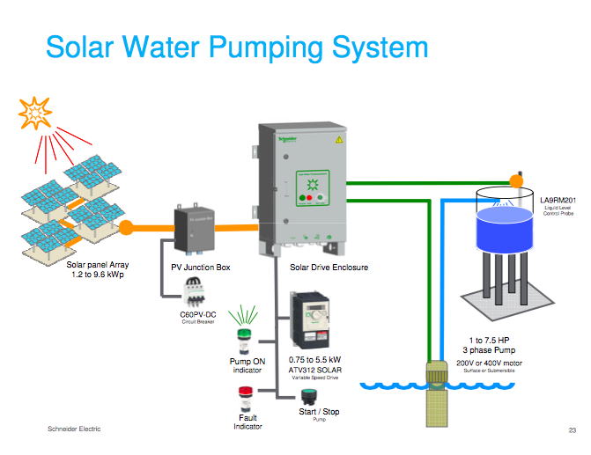

emergency plan
☐ | In case of water contamination. Shut down pump immediately and shut off all water outlets with “out-of-order” notices. Conduct water laboratory tests and inform local health officials for medical interventions. Gather the community and seek for consensus on any course of action to take.
☐ | In case of water pump break-down/malfunctioning. Call the contractors and conduct any preventive measures prescribed by the operations and maintenance manual.
☐ | In case of natural calamity. Organize communities to store sufficient water supply and shut down pump before the onset of any predictable natural disaster. Conduct water laboratory tests after the calamity.
☐ | In case of accident like drowning inside the water tank and electrocution. Bring the victim to the nearest hospital and apply the 24-hour preventive shut-down of the whole water system.

developing a green environment

☐ | Conduct a “green resource” mapping of the targeted community.
☐ | Identify strategic priority areas where water catchment is high.
☐ | Conduct regular tree-planting activities. Organize groups and plant as many suitable trees.
☐ | Conduct forums on taking care of environment, “green culture” and waste management.
☐ Monitor the changes in the environmental conditions of the community and measure the impact of this project component.

