ANOTHER HOPE CHILDREN’S MINISTRY

PROJECT REPORT

PROGRAMME/DEPARTMENT:
PROJECTS IMPLEMENTED: SUSTAINABLE SKILLS AND EMPOWERMENT FOR THE YOUTH

MONTHLY REPORT FOR: MAY 2016

PERSON SUBMITTING THE REPORT:

NAME: KIBIRIGE TIMOTHY

POSITION: ASSISTANT PROJECTS CORDINATOR

PHONE CONTACT:

EMAIL ADDRESS:tkibirige@anotherhope.org

SUBMITTED TO: SUPERVISOR MR. KASOZI DANIEL. EMAIL: dkasozi@anotherhope.org

DATE OF SUBMISSION: 8TH JUNE 2016

PROJECT LOCATION
JJEZA TOWN, MPIGI DISTRICT ALONG MITYANA ROAD
PROJECT INFORMATION
  - Overview of the project and its objectives (In half a page summarize what the project is about and provide the overall goal of the project and its specific objectives)
The project aims to reduce the unemployment rate among the youth and increasing the number of youth joining vocational schools rather than Degree course that have no ready jobs.
Objective
The Project Goals and Objectives is To reduce vulnerability and dependency among the young people by 20% in 5 Districts of Central Uganda (Kampala, Mpigi, Wakiso, Mityana and Mubende) Our objectives are:

1. To mobilize and sensitize over 12,000 youth in the Districts of Central Uganda

2.To advocate and mainstream vocational training skills with other trainings.

3. To reduce the problem of unemployment by 10% of the youth by training them in Vocational skills.
4. To provide 40% of Counseling what have we accomplished so far

Activities that have taken place:
- Renovation of the four classroom blocks. The block was found in a depleting state and management saw to it that renovating this building to start classes by the year 2016 was relevant. After consultation with the engineers, the materials were bought and the renovation was started. The renovation is still going and below is the pictures so far of what has taken place.

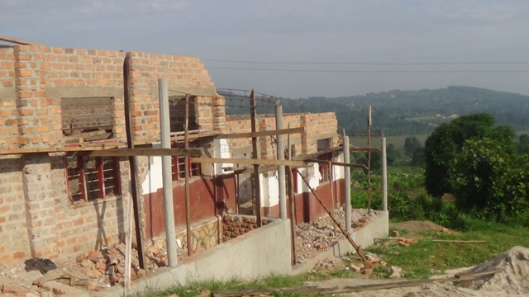

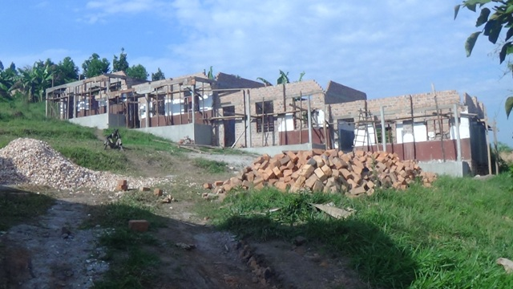

- Principal of the Vocational school: The Principal of the vocational school was recruited and now he is going to be working on a lot of things such as building the curriculum, registering the vocational school, looking for the relevant trainers among others.
- Mpigi District officials were met and discussed about the plan for the vocational school.
Future plan
- Continue with renovation of the school
- Work on the full construction plan of the vocational school
- Fundraising more
- Working on the work plans

Prepared by: Mr. Kibirige Timothy Designation: Assistant Project Coordinator

Date: 10 June 2016 Signature: ………………………………………….

- Approved by: Mr. Kasozi Daniel: Designation: Deputy Director programs

Date: 1th June 2016 Signature : …………………………………………………….

