Early Childhood Education Centre for Orphans

Project Summary
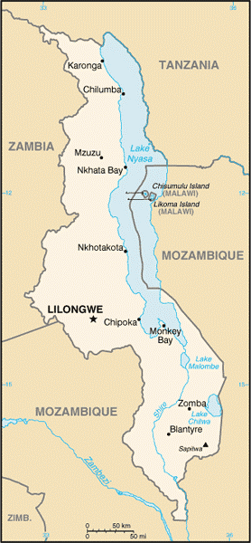
This project will construct a classroom at Mbonani Village, Balaka district - Malawi and shall provide a meal, medical care, learning materials and critical literacy support services to 100 hopeless orphan who have no idea of what their future holds for them. Orphans who have a meal or none a day. Abandoned and some leaving in a child headed family. The project shall give hope and a smile.
What is the problem
In rural Malawi villages where people struggle to provide for their own basic needs, caring for orphans can pose severe hardship. Orphans often leave school, unable to afford school fees or forced to spend their days working. Child labor, abuse, early marriage, early childbearing, and low educational attainment are common. We intervene to alter the trajectory of orphans' lives, empowering them with a quality education, a supportive living environment, and the tools to build vibrant futures.
There are 100 orphan around Mbonani Village in Balaka District according the office of social welfare. These are unable to attend early education due to poverty as a result of loss of parents. They don't have nutritious food, medical care and good facilities for early education. A few continue attend school under dilapidated old church structure. This has brought no interest for some to go to school. Many have lost lives due to improper care.

Solution

Recognizing the transformative power of education, we work to provide orphans with the best academic foundation possible. Philadephia Foundation shall provide quality education by constructing a nursery school, supplying teaching and learning materials, medical care and day meals for the orphans.
Expected Result
This project will provide classroom, nutritious meals, medical care, to starving and orphan children. Caregivers will be trained in nutrition and child care.
Potential Long term impact
This project will educate 100 orphans and their care givers. Abandoned children shall have a better future and higher expectation for a better living. Children will experience a different life and this will prevent much loss as it is happening.

Long-Term Impact

Philadephia Foundation believe that educating orphans has power to shape not only their destinies, but that the collective power of educated individuals can influence the destiny of Africa herself. We are committed to provide poor, marginalized children with the opportunity to grow into educated, engaged, self-reliant citizens of Malawi and the world.
Monitoring and Evaluation
The project shall be monitored continuously by Philadephia field officers that will be working hand in hand with the local elected committee.
Meetings shall be conducted with local leaders, the set committee to assess any gaps and needs to be addressed as the project progresses.
Every step of the project shall be evaluated to find areas for improvement in the next step.
Reports shall be submitted to the trustees and the donor.
After completion of the project a financial report shall be submitted to the donor highlighting successes and challenges.

See Budget and BOQ below

