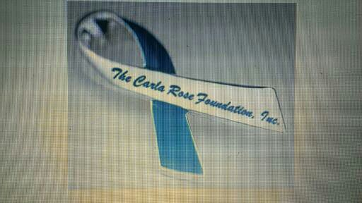
March 2016

Dear Donors,
Hello, My name is Joseph A. Brown and I am the Founder/President/Director of The Carla Rose Foundation, Inc. What i am proposing is a meeting of the minds, talents, experience, desires, and benefits for cancer patients and others that will build a network of Holistic providers with the most technologically advanced protocols for testing, evaluating, educating, and then referring patients to the many different non-toxic treatments and therapies that are readily available to them. I am proposing a center that would be in a house setting. 4-5 bedrooms with 2 en-suite bathrooms with a shower and tub. A big open kitchen and space for gatherings, courses, training, seminars, etc. 2 consultation/treatment rooms, a space for fitness, pool or outdoors. Equipment would be bought as the budget increases, and there would be monthly membership fees and consultation for new members. I would also like a space outdoors or a sprouting shelf for organically growing food for use in the educating of cancer patients to cook for themselves and others. This would be a day center and operate on the weekends as a place for seminars and workshops as well as testing and evaluating.
I started The Carla Rose Foundation, Inc. to raise money to offer assistance to cancer patients that have decided, on their own, to have their issues treated by Alternative/Holistic therapy. We assist in the cost of treatment only, for those people to go to whatever clinic they choose and the people we've helped all decided to go to clinics outside of the United States. What i am proposing includes some of the treatments and education that patients may not receive or even be offered here in the U.S. We are a non profit, 501(c)3, tax exempt organization. The foundation is looking to receive donated funds and resources as well as grants that will help to fund the foundation's cause.
There is a protocol that i'd like to pattern our center after and it will include some equipment that you may or may not be familiar with. Ex: Sauna domes, PEMF Mat, PEMF Ringer, Multi Wave Oscillator, BCX Rife device, Ozone Generator, and others. Training will be provided for the correct and efficient use of these devices. Sure there are a lot of issues and specifics to work out but, i'd like to know if the Holistic community is behind this so I can begin to get together and implement a plan and draw up contracts to be able to get our referral network together while completing our plans for this center and others like it around the country. This space will be staffed with a certified cancer coach and the number of assistants needed by the coach within a budget to run the center.
All referrals will be to our registered network of Holistic providers, naturopaths, nutritionists, holistic dentists, oncologists, wellness centers, detox clinics, etc. I can be reached at: 864-838-4974. You can also see our history at: www.TheCarlaRoseFoundationInc.org, www.Facebook.com/CarlaRoseFoundation, and on Twitter @CarlaRoseFdn.

