**Peace School for Afghan Refugees and Host Communities**

**Photo Report – November 2019**

**Participation in speech competition**

The students of peace school participated in the speech competition. The theme was Independence Day. Student from the 5th grade was awarded special prize.

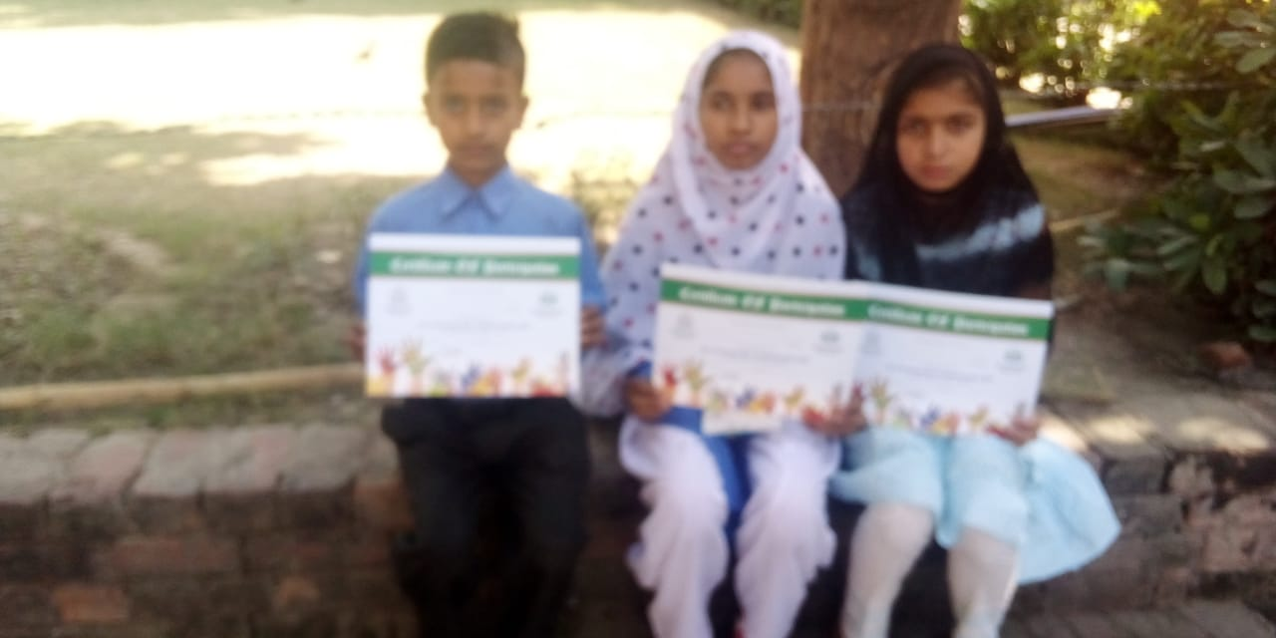

**Prize Distribution Ceremony**

Prize distribution ceremony for the position holders was held at the premise of Nazarya e Pakistan Trust. Parents and the principal were there to receive the prize

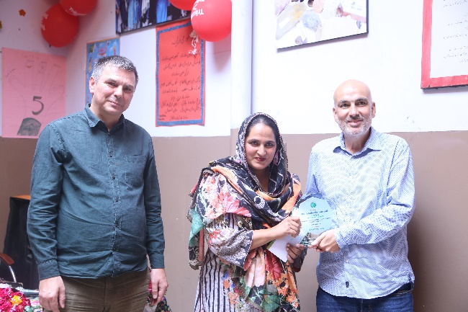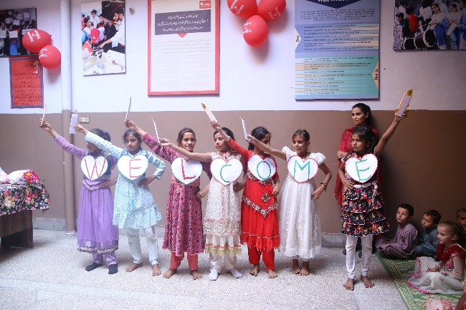

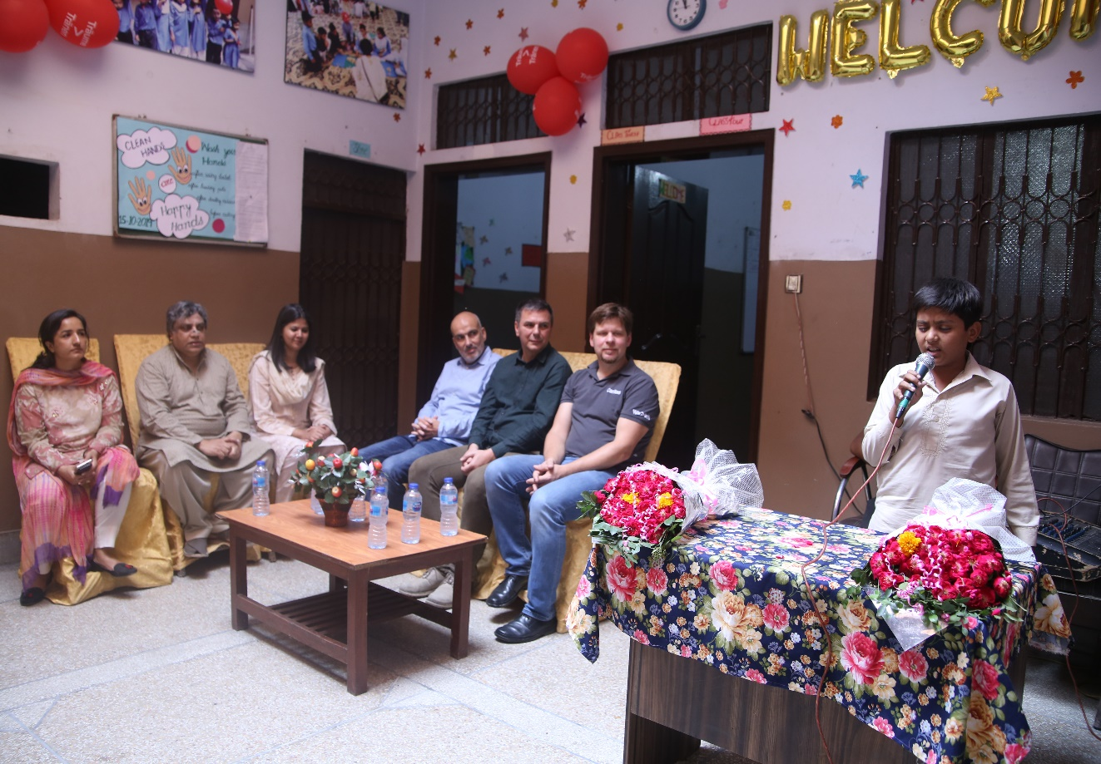

**International peace day**

International peace day was celebrated at Peace schools.

**Drawing competition on peace day**

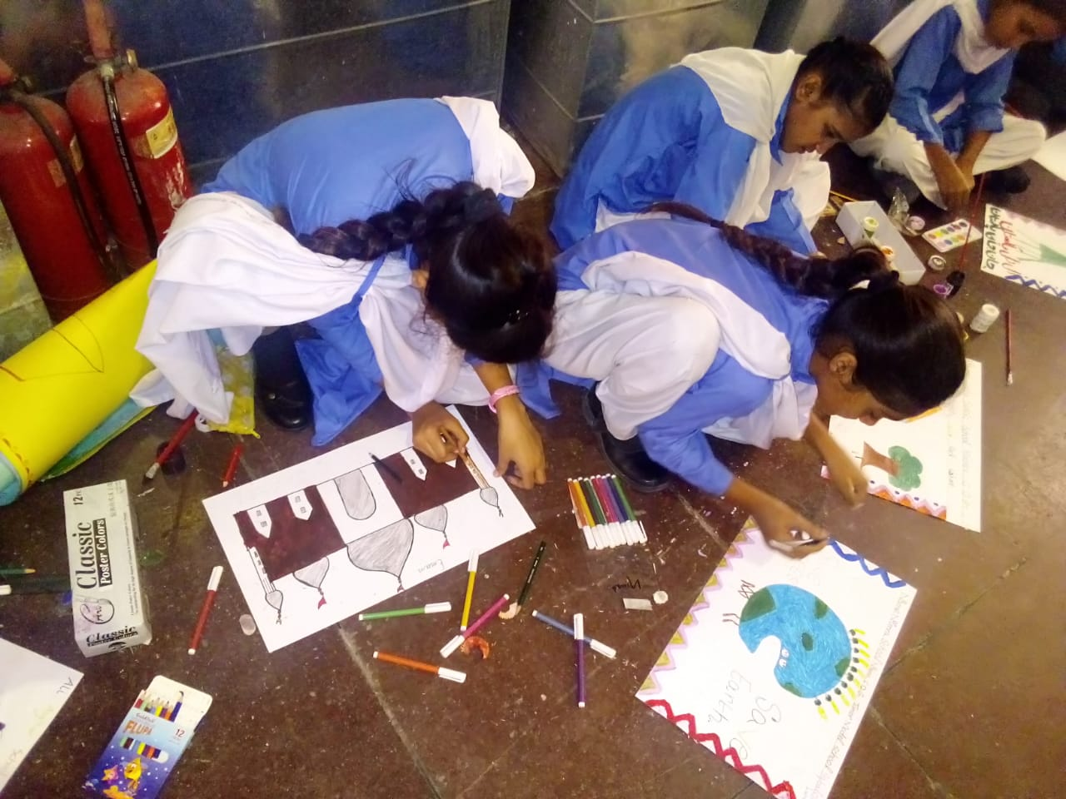

The drawing competition was also held among the students on peace day

**Teachers day**

Teaches day was celebrated. Students made cards to show their respect and love for their teachers.

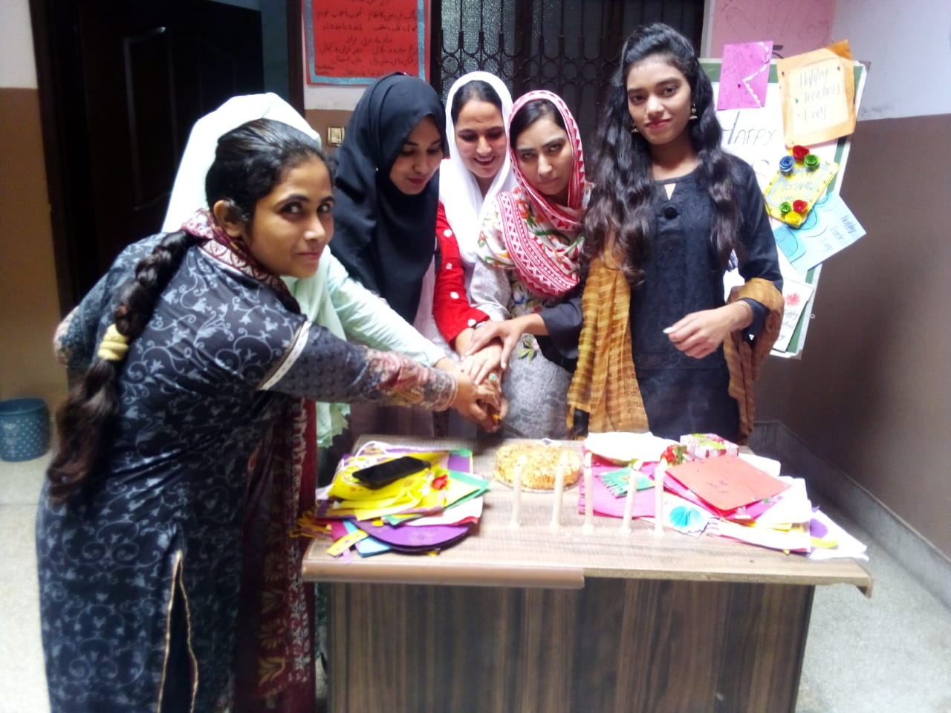

**Mothers meeting**

Mothers meeting held at peace schools where the mothers discussed the issues of their children and also shared their challenges of the daily life.

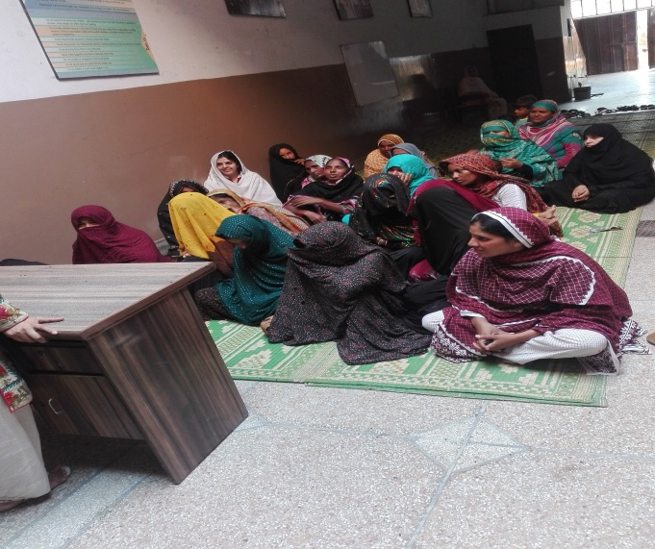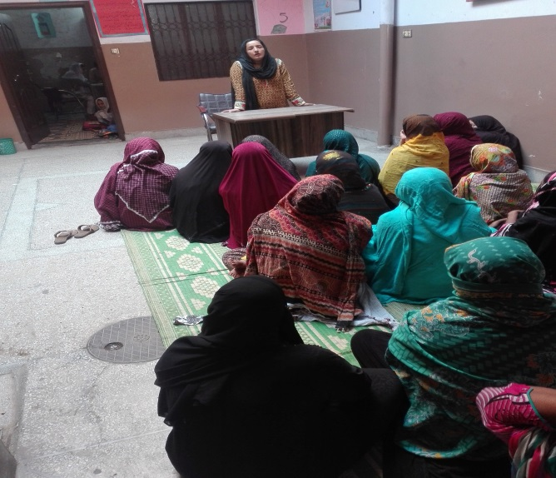

**Visit to Lahore Science Mela**

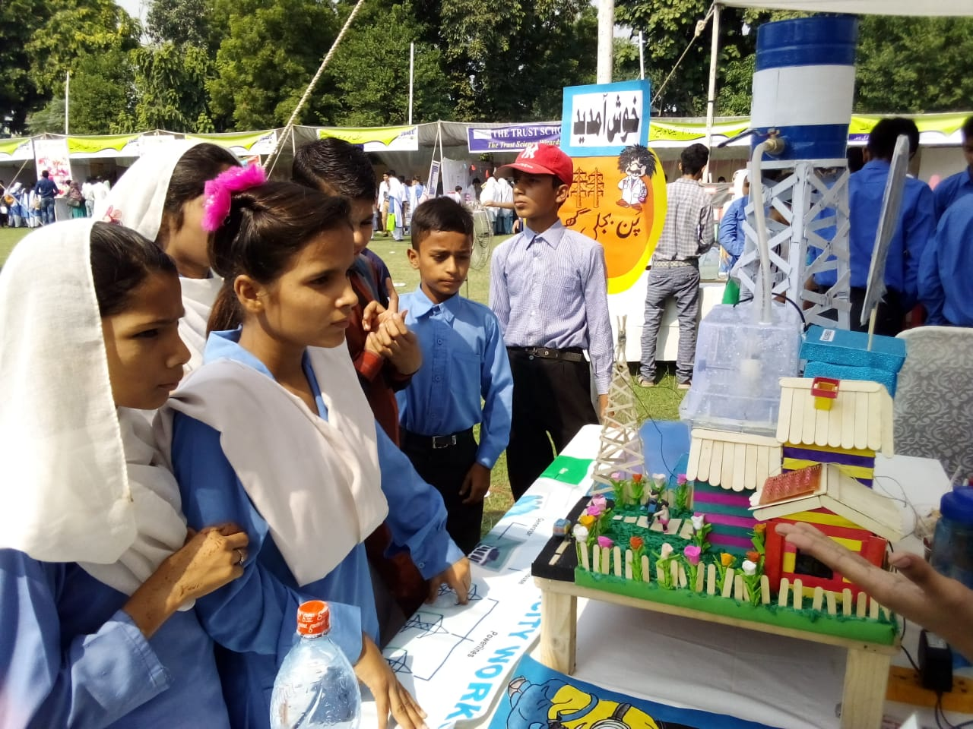

Students from the Peace schools attended the Science Mela and learn about the different concepts beyond the textbooks.

**Fun activity with prep class**

The fun activity was arranged with the students of the prep class. Students blow the balloons and had fun with the little activity.

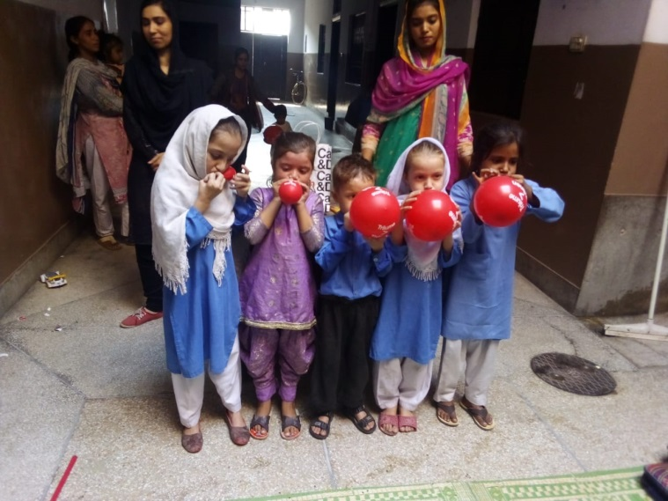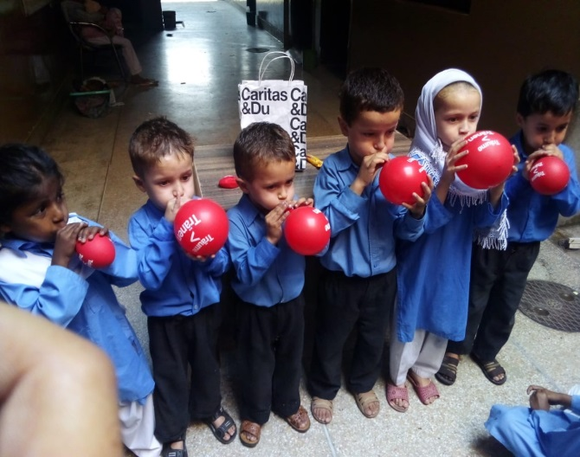

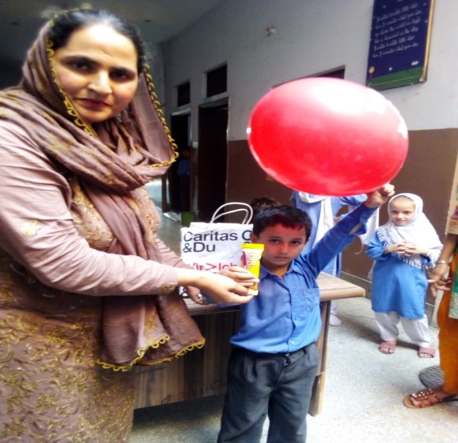

Global Handwash day

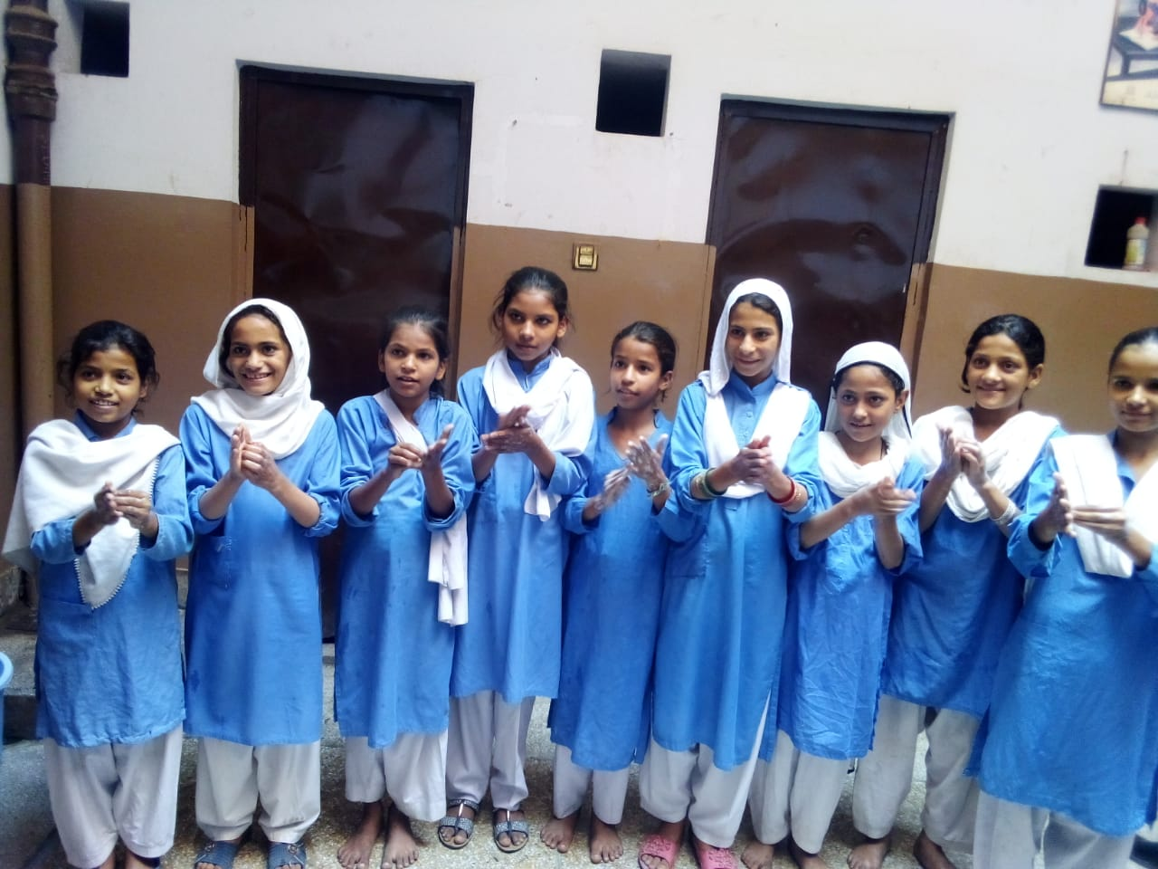

**Prize distribution ceremony**

Prize distribution ceremony and the staff appreciation ceremony held at peace schools. The students who participated in the competition performed their songs and presented

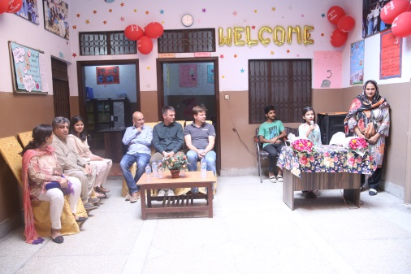 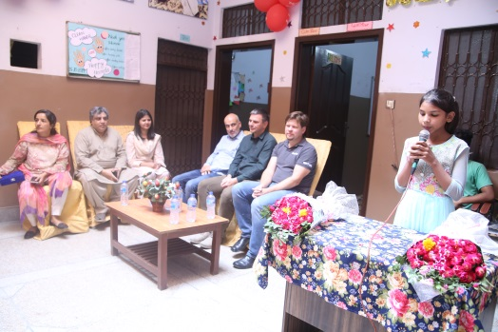

**Practice class for drawing competition**

**Drawing capitation at Alhamra**

The inter school drawing competition held at Alhamra arts council, Lahore. Students from the peace school participated in the competition.

**Polio Awareness Campaign**

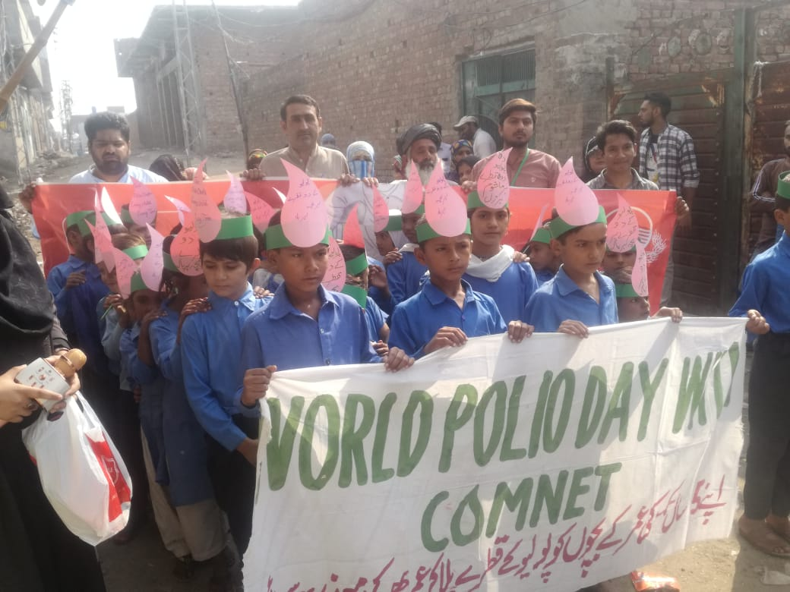

On world polio day an awareness session held at peace school and the walk within the community with the students and the influential of the community held.