**Peace School for Afghan Refugees and Host Communities**

**Report – 1st –November 2019-15 February 2020**

**01.11.2019**

**Colour recognition activity**

The school conducts regular activities with the students of the Prep and the 1 class.

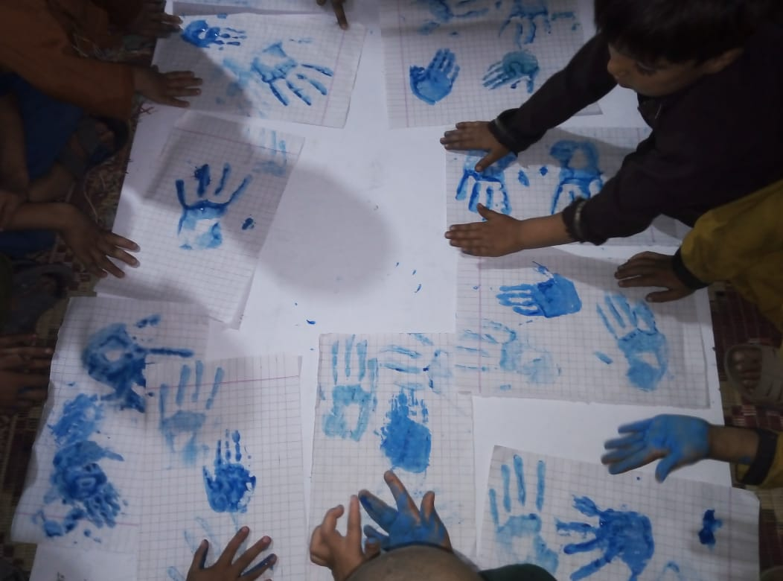

**09.11.2019**

**Peace Activity**

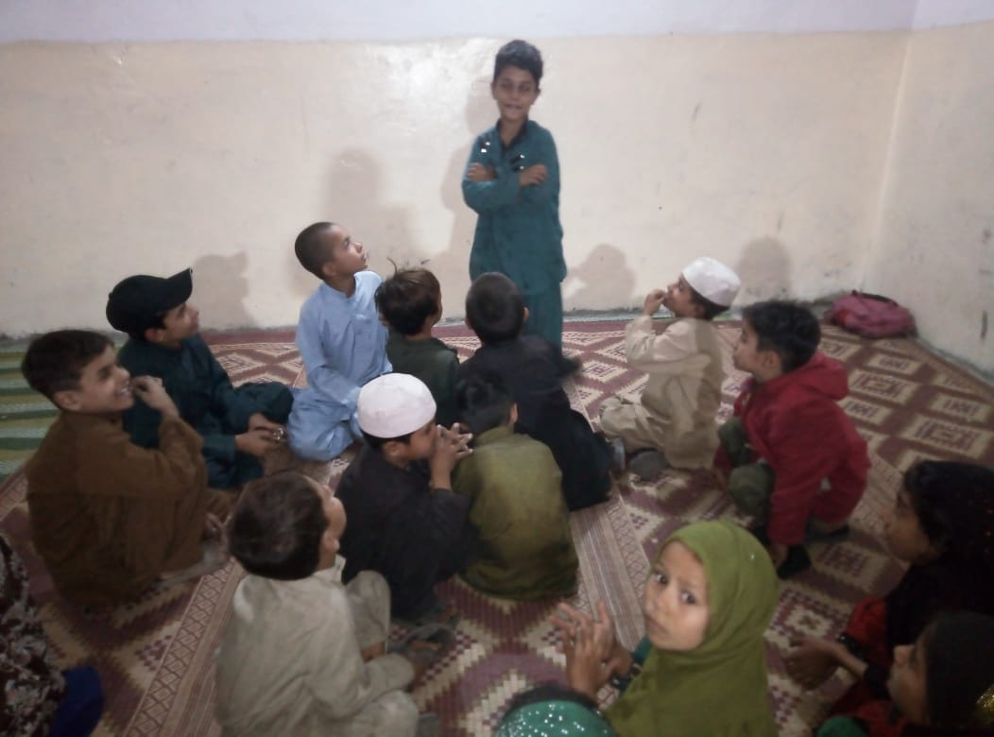 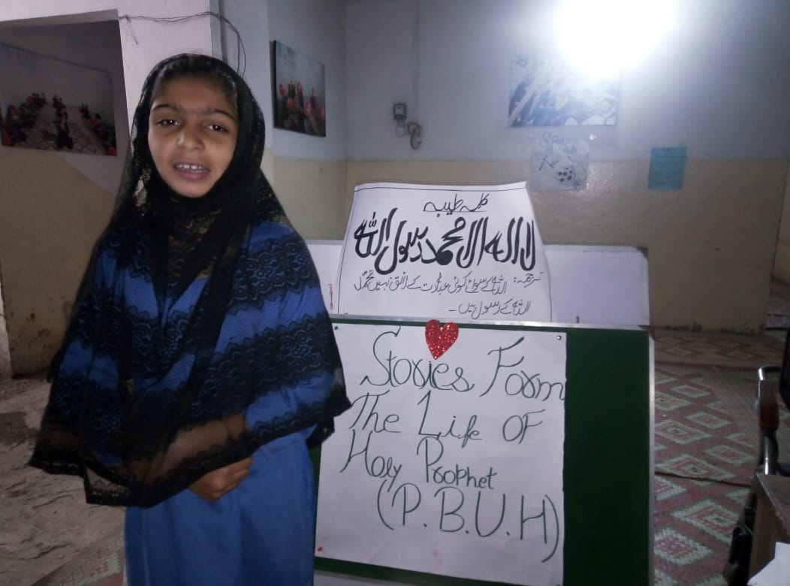

**19.11.2019**

**Awareness Raising-World Toilet Day**

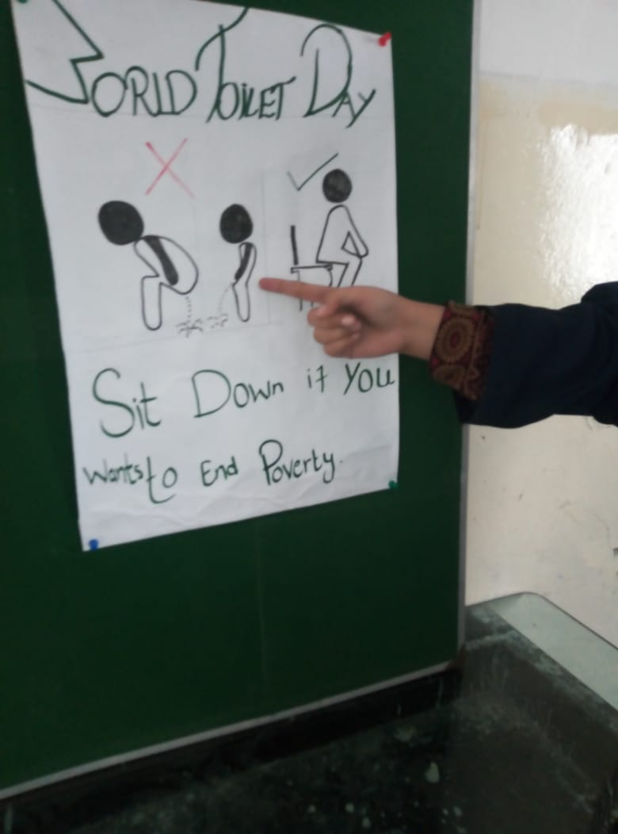 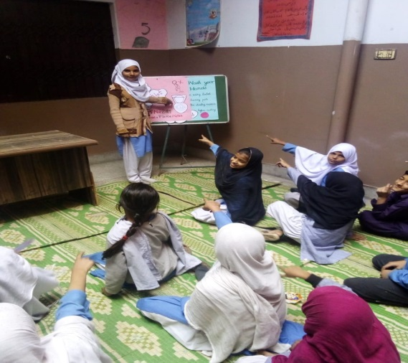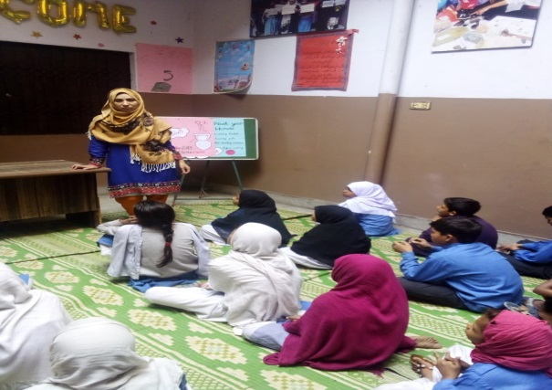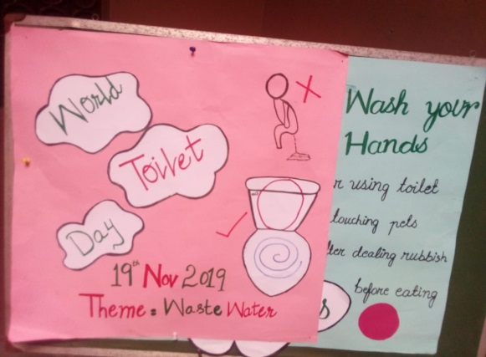

**20.11.2020**

**Universal children day**

For Children's Day, many activities were organized by schools and, that focus on having fun and lively activities that kids of the peace school participated and enjoyed.

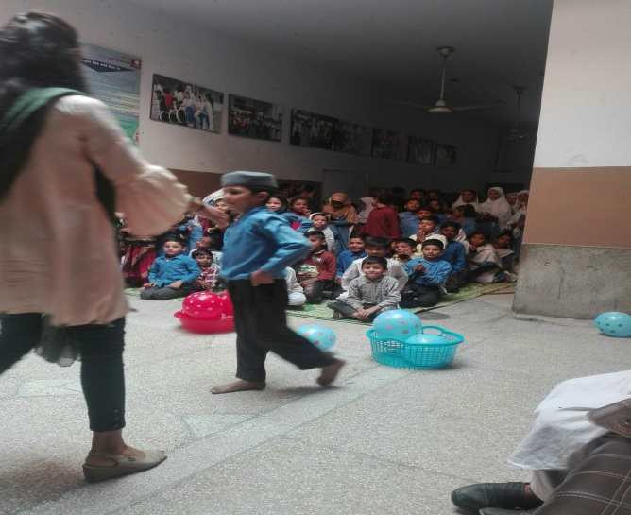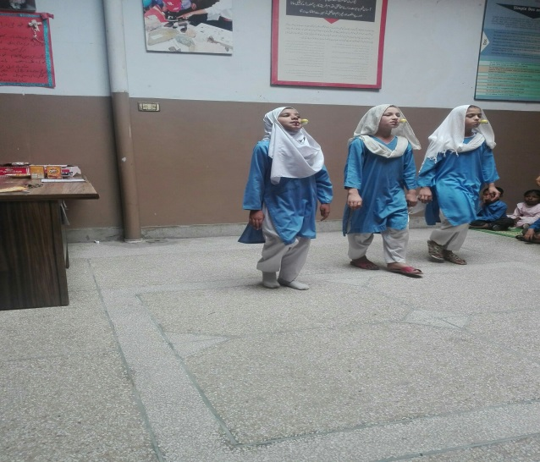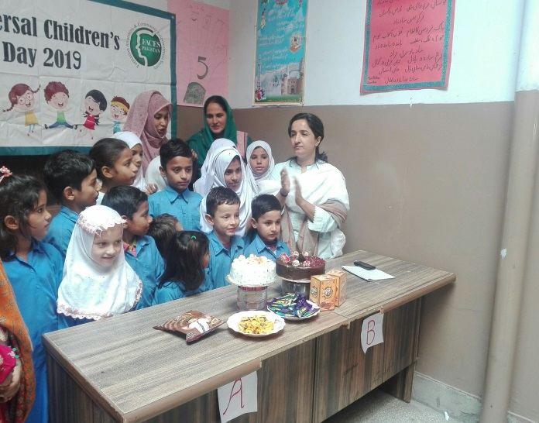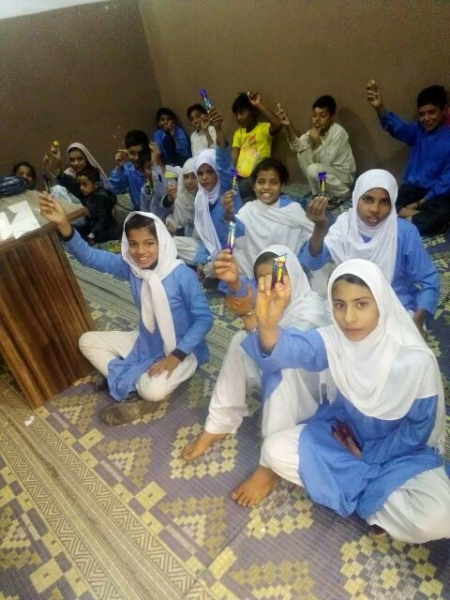

**25.11.2019**

**Mothers Meeting- 16 Days of Activism**

Mothers meeting held at peace schools to mark the significance of 16-days of activism.

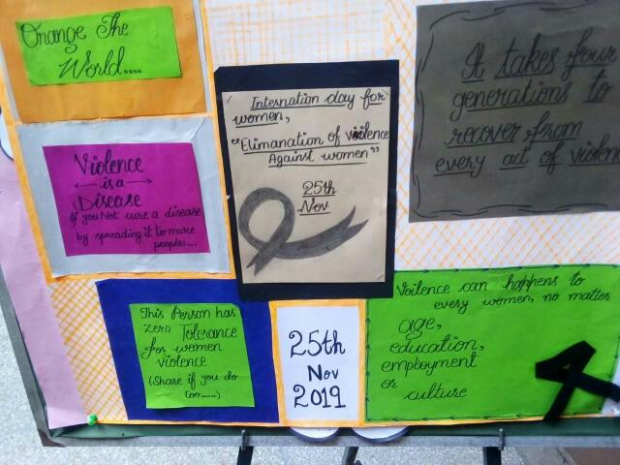 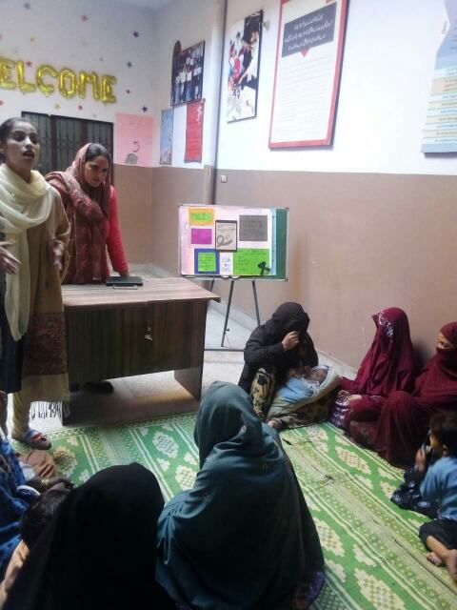

**20.12.2019**

**Result announcement**

The result of the 3rd term examinations was announced and the successful students were awarded with the appreciation award.

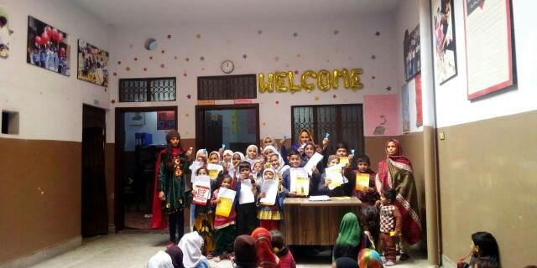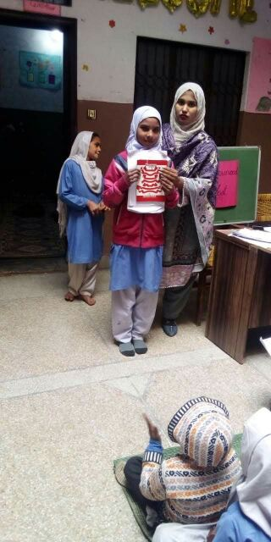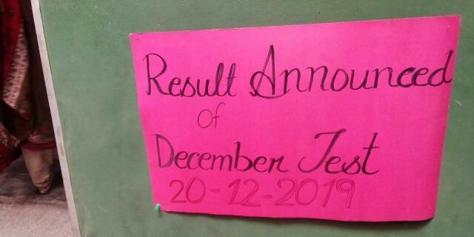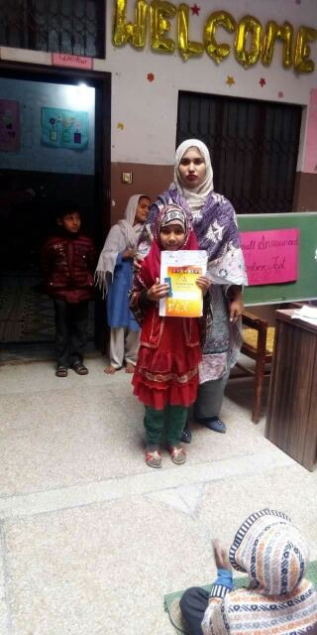

**22.01.2020**

**Children Literature Festival Lahore**

The students of the peace school participated in the festival.

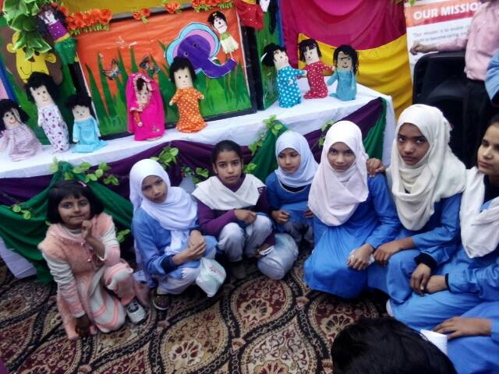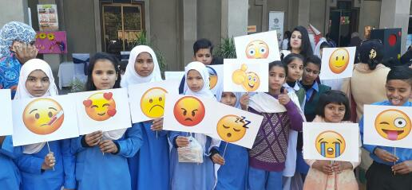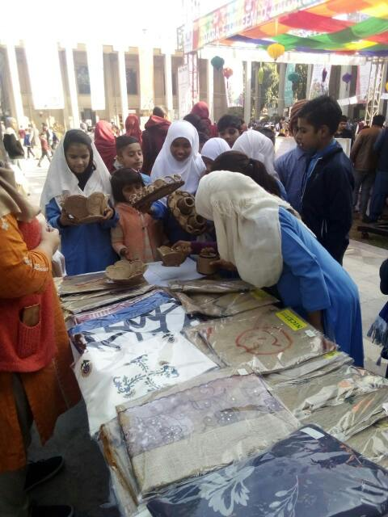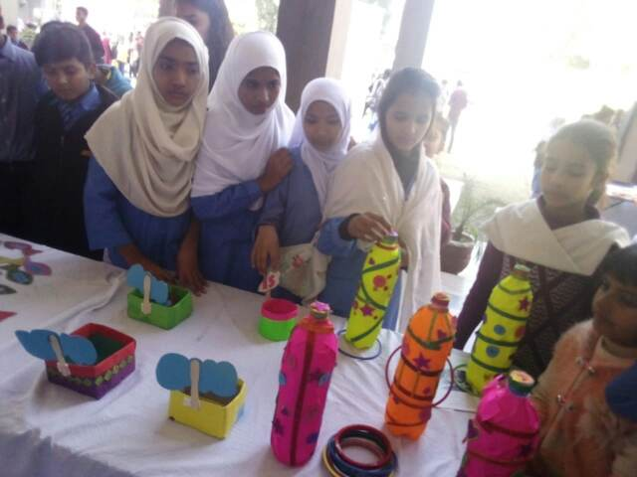

**24.01.2020**

**Snowman Making**

Keeping in view the winters, the fun activity was held at school.

